Software Methods and Tools

Fall 2015

Solution for Assignment 8

Due on 11:59PM, Monday, December 7, 2015

Sri Harsha Chennavajjala

sc9v9@mail.umkc.edu

**Screenshot of Tetris folder hierarchy:**

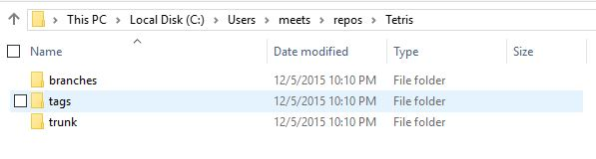

**Screenshot that shows the content of the source code folder in the repository:**

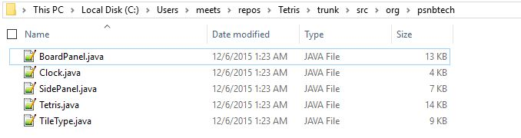

**Event #1:**

**Revision change for Tetris.java file:**

|  |  |  |  |  |
| --- | --- | --- | --- | --- |
| **Event** | **Repository** | **Tom** | **Susan** | **John** |
| 1 | 2 | 1 | 1 | 2 |
| Description | John updated Tetris.java. So revision changed from 1 to 2 Tom's revision is not changed Susan's revision is not changed John updated Tetris.java so revision changed from 1 to 2 No conflicts were observed | | | |

**Screenshot of revision versions of repository and working copies of Tom, Susan and John:**

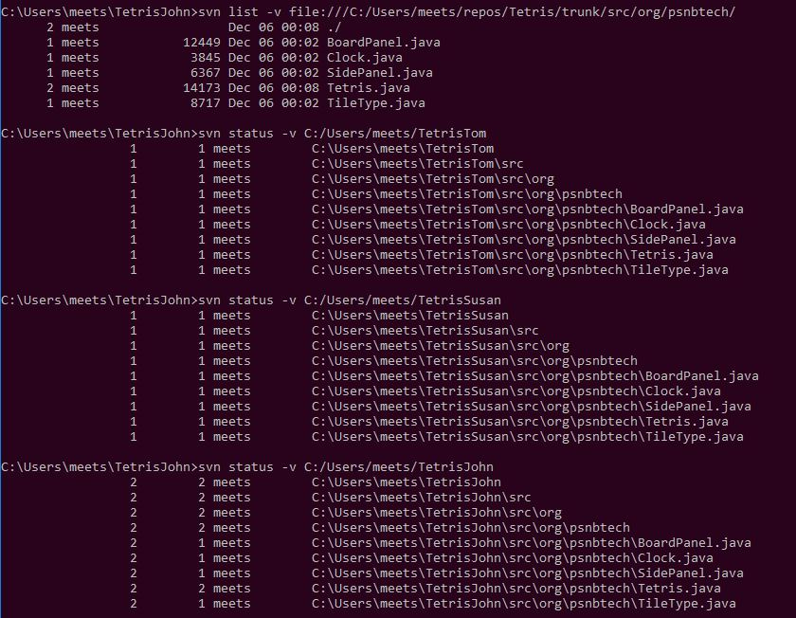

**Event #2:**

**Revision change for Tetris.java file:**

|  |  |  |  |  |
| --- | --- | --- | --- | --- |
| **Event** | **Repository** | **Tom** | **Susan** | **John** |
| 2 | 2 | 1 | 2 | 2 |
| Description | No change in the revision version of repository No change in the revision version of Tom Susan updated her working copy with repository. So revision changed to 2 No change in the revision version of John No conflicts were observed | | | |

**Screenshot of revision versions of repository and working copies of John, Tom and Susan:**

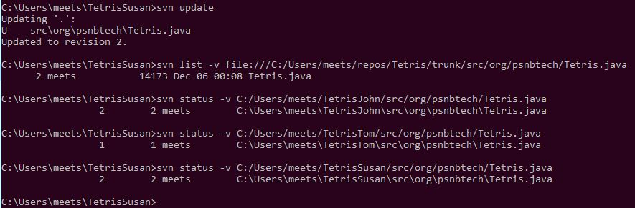

**Event #3:**

**Revision change for Tetris.java file:**

|  |  |  |  |  |
| --- | --- | --- | --- | --- |
| **Event** | **Repository** | **Tom** | **Susan** | **John** |
| 3 | 3 | 3 | 2 | 2 |
| Description | After resolving the conflicts, repository revision was changed to 3 Tom updated Tetris.java to a new version 3 and resolved the conflicts and committed his changes to repository. Here Tom’s Tetris.java file conflicts with repository’s Tetris.java file. In this case, *svn* asks us to what decision we need to take. I selected to merge the files by keeping Tom’s changes in the final revision. Finally, I’ve selected the “*conflicts resolved*” option. No change in the revision version of Susan No change in the revision version of John | | | |

**Screenshot of revision versions of repository and working copies of John, Tom and Susan:**

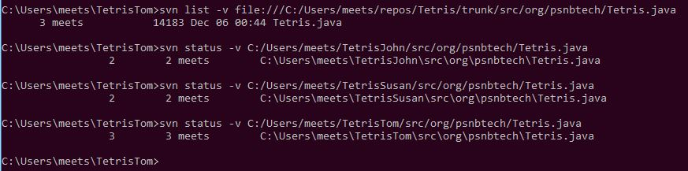

**Event #4:**

**Revision change for Tetris.java file:**

|  |  |  |  |  |
| --- | --- | --- | --- | --- |
| **Revision change for Tetris.java** | | | | |
| **Event** | **Repository** | **Tom** | **Susan** | **John** |
| 4 | 3 | 4 | 2 | 2 |
| Description | No changes to Tetris.java file. Son revision stays at 3 in Repository Tom changed Clock.java, so revision of Tetris.java also changed to 4 in his local working copy No change in the revision version of Susan No change in the revision version of John No conflicts were observed | | | |

**Revision change for Clock.java file:**

|  |  |  |  |  |
| --- | --- | --- | --- | --- |
| **Revision change for Clock.java** | | | | |
| **Event** | **Repository** | **Tom** | **Susan** | **John** |
| 4 | 4 | 4 | 2 | 2 |
| Description | Updated revision number of Clock.java to 4 in Repository. Tom changed Clock.java, so revision changed to 3 No change in the revision version of Susan No change in the revision version of John No conflicts were observed | | | |

**Screenshot of revision versions of repository and working copies of Tom, Susan and John:**

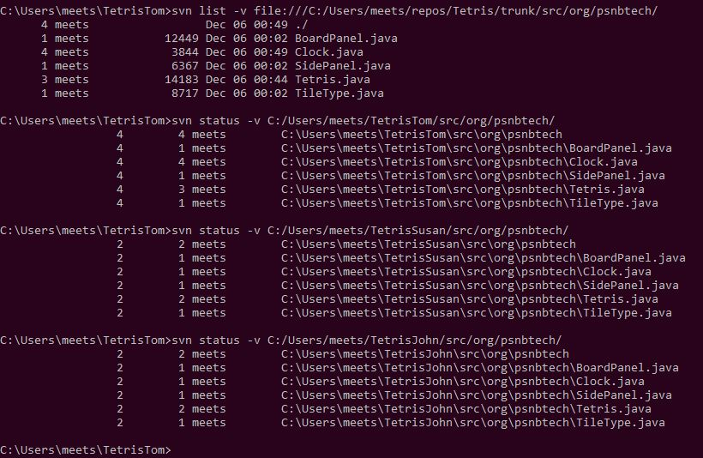

**Event #5:**

**Revision change for Tetris.java file:**

|  |  |  |  |  |
| --- | --- | --- | --- | --- |
| **Event** | **Repository** | **Tom** | **Susan** | **John** |
| 5 | 3 | 4 | 2 | 2 |
| Description | No change as Tom already synchronized his working copy in Event 4 No conflicts were observed | | | |

**Screenshot of revision versions of Susan, Tom, John and repository:**

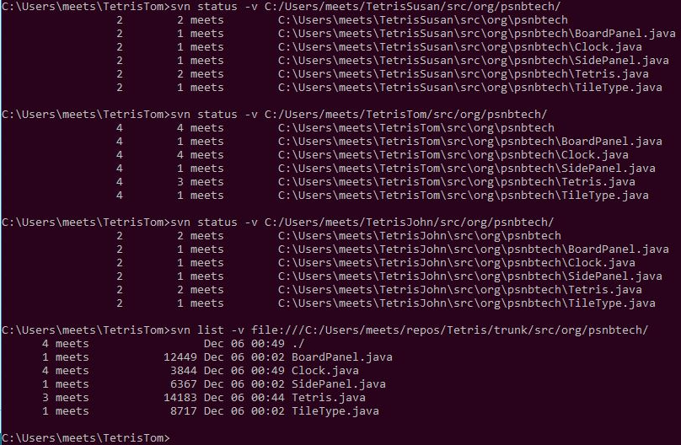

**Event #6:**

**Revision change for Tetris.java file:**

|  |  |  |  |  |
| --- | --- | --- | --- | --- |
| **Event** | **Repository** | **Tom** | **Susan** | **John** |
| 6 | 3 | 4 | 4 | 4 |
| Description | No change in the revision version of repository No change in the revision version of Tom working copy Susan got the head revision(4) John got the head revision(4) | | | |

**Screenshot of revision versions of repository, John, Tom and Susan:**

