**SMT 5555 Assignment 3 Solution – Sri Harsha Chennavajjala (16210893)**

**Tetris Sequence Diagram**

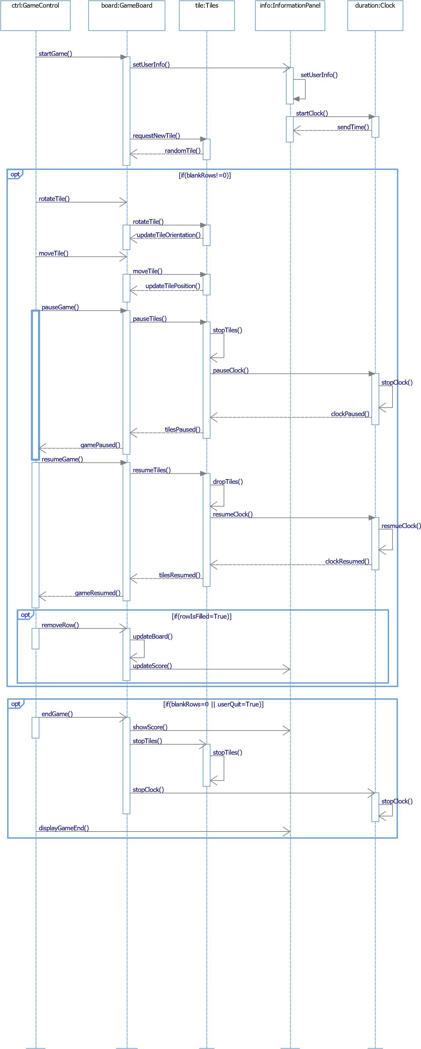

The main modules that comprises of the Tetris game are:

1. GameControl – Used to perform user actions like rotate tile, pause or end the game.
2. GameBoard – This module is responsible for storing the tiles, clearing the filled rows etc..,
3. Tiles – This module will provide random tiles to GameBoard. It is also responsible for rotating the tiles.
4. InformationPanel – This module will display the game information like user name, duration of game play, score etc..,
5. Clock – This module is responsible for noting down the time duration that the user has played the game. This module should pause when the user pauses the game and should resume when the user resumes the game.

In the above sequence diagram, GameControl will initiate the game. GameBoard will instruct InformationPanel module to set the user information and clock information.

GameBoard will receive a random tile every time from Tiles object.

GameControl will enable the player to move or rotate the falling tiles. This functionality will be implemented in Tiles module. The changes will get implemented in GameBoard.

The tiles will keep on falling one after other until there is at least a free row in GameBoard.

The user can pause or resume the game by using GameControl.

During the pause state, the tiles will stop falling, and also the clock will stop.

When the user selects the resume button, GameControl will inform the Tiles module to drop the tiles and the Clock module to resume the timer.

At any point of time, if a row is completely filled, then the GameControl will ask GameBoard to update the board by removing the particular row and bringing down the remaining rows. At this point of time, the user score will get updated.

If the user quit the game or there are no free rows available, then the state of the game is “Game Over”. At this point of time, GameControl will inform GameBoard to stop the game. GameBoard will ask the InformationPanel to display the final score and game duration. Tiles module will stop dropping the tiles. Finally GameControl will exit the Tetris game.

**Tetris - State Chart Diagram of object of GameControl class:**



GameControl class is responsible for starting a new game, pausing, resuming and ending the game.

The above state chart diagram will depict the state of GameControl object at different situations of Tetris game.

The method startTetris() will initialize the object of GameControl class.. The initial state of this class is New_Game as shown in the above state diagram. The condition for entering this state is initializing all the required parameters like setting username, difficulty level etc..,. The condition for exiting this state is “The user presses the ‘Start Game’ button”. i.e., calling startGame() method.

From New_Game state, the next state can be starting the game which is Start_Game state. At this state the initial score of user is zero and timer will be at zero. The state of the object of GameControl will change if the user selects to pause the game or to quit the game. Internal transitions of Start_Game state are nextTile(used to drop random tiles), updateTime (used to update the timer), removeRow (used to clear the completed rows).

If the user selects to pause the game, the status of the object of GameControl will change to “Pause_Game” state. Once the user selects to resume the game or to quit the game, the state of this object will change accordingly. If the user choose to resume the game, the state will change to “Start_Game”. If the user choose to quit the game, the state will change to “Game_Over” state. “Pause_Game” state has some internal transition states to pause the timer and to pause the falling tiles.

If the user choose to end the game or there are now free rows on the gameboard, then the status of GameControl will change to “Game_Over” state. From this state the user can choose to restart the game or to exit the game console. This state has one internal transition state to display the final statistics of the player like score that he made and the duration that he played etc..,