**Project Report**

Zechen LAI

ID: 1005701297

**Description:**

The purpose of the program is to create a platform that enables renter to book shelters, host to rent houses.

The main challenge of the program is time. Having assignments of other 3 courses make it difficult to start early and add more function to the program. Starting the program late may be unfair for anyone to be my partners. Thus, I choose to work on my own. Most requirement has been finished and I created a console-based interface, while some complicated functions and sophisticated GUIs could not be supported in this demo.

Other challenge is to achieve the last two reports. Viewing cancellation is not supported because the activities is completely deleted after cancellation in this demo. Searching for words is very complicated. It is finally be achieved by using the function “substring index()” and a helper table from MySQL.

**Assumptions:**

1. One account can only be either host or renter, however, a person may hold multiple account, which means Social Insurance Number is not unique in the database.
2. A user can only comment on another once if and only if they appear in one activity of booking.
3. The range for searching by longitude and latitude is +1/-1, the shelters out of this range will not be considered.
4. No shelters with the same name owned by a host.
5. Renters can only book once for a day. If they want to stay for a period of time, they need to book continuous days separately.
6. Once a comment is created, it cannot be deleted, even if the activity or account is deleted.
7. Users will operate strictly by the rule, that is, No input out of expectation

**ER diagram:**

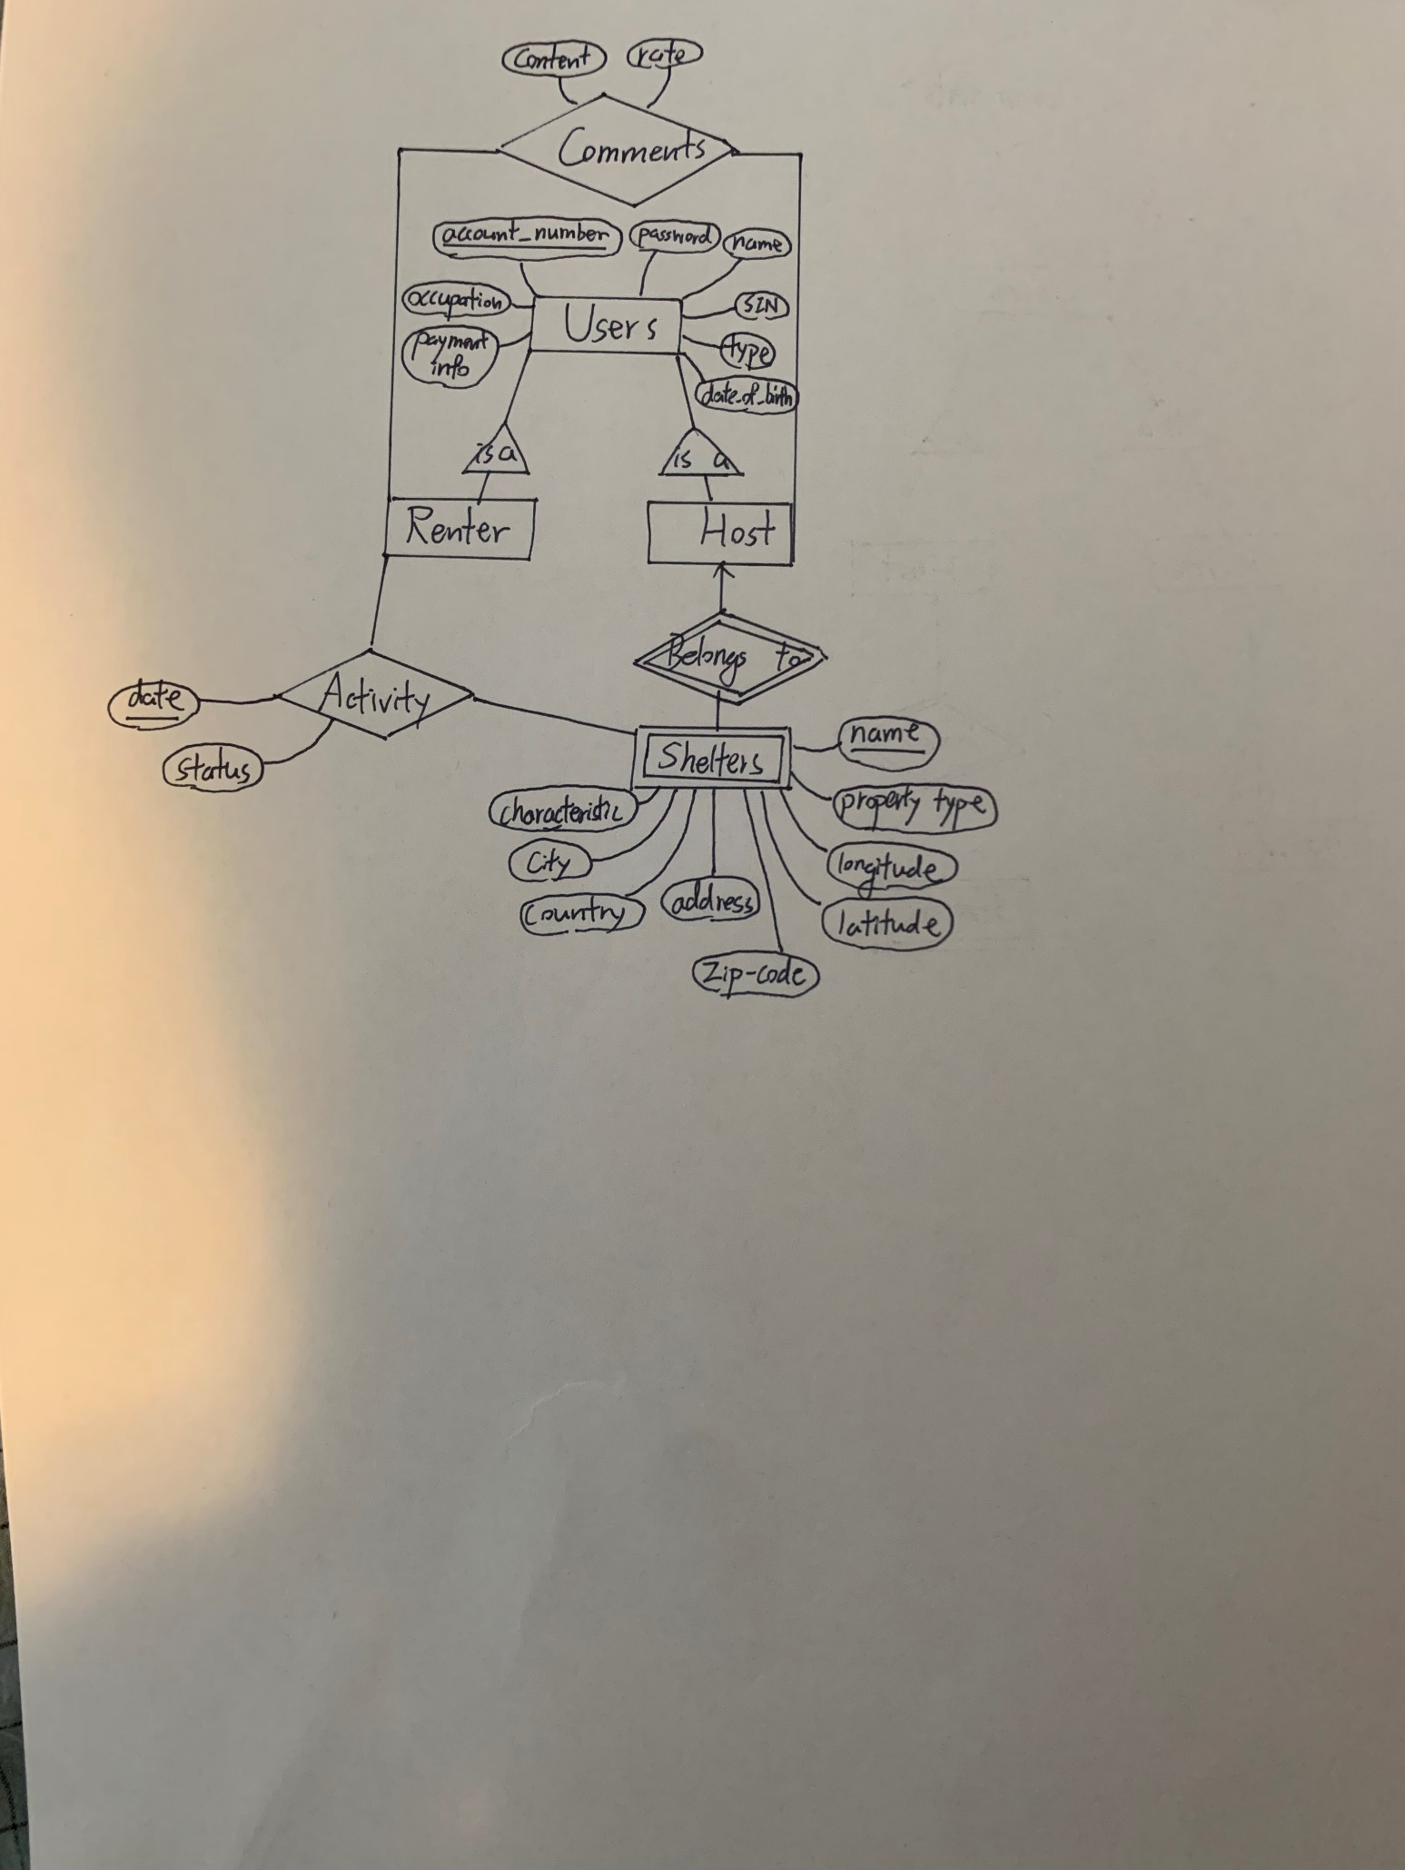

**Relation schema & Sets:**

Users (account number, password, name, Social Insurance Number, Type (Host/Renter), date of birth, occupation, payment info)

Shelters (account number, name, property type, longitude, latitude, zip-code, address, country, characteristic)

Activity (date, status, account number (of host), name (of shelter), account number (of renter))

Comments (account number (of commented user), account number (of poster), content, rate)

**DDL statements:**

create table Users (

user_account_number integer PRIMARY KEY,

user_password varchar(50) NOT NULL,

user_name varchar(50) NOT NULL,

SIN integer NOT NULL,

user_type integer NOT NULL,

user_address varchar(100),

date_of_birth date NOT NULL,

occupation varchar(50),

payment_info varchar(100) NOT NULL

);

create table Shelters (

s_name varchar(50),

s_host integer references Users(user_account_number),

property_type integer ,

longitude real NOT NULL,

latitude real NOT NULL,

s_address varchar(100) NOT NULL,

characteristic varchar(100) NOT NULL,

price real NOT NULL,

city varchar(50),

country varchar(50),

zip_code varchar(50),

primary key (s_name, s_host)

);

create table Activity (

a_date date ,

a_host integer references Shelters(s_host),

a_shelter varchar(50) references Shelter(s_name),

a_renter integer default NULL,

a_status integer default 0,

primary key (a_date, a_host,a_shelter)

);

create table Comments (

content varchar(200),

rate integer,

commented integer,

poster integer,

PRIMARY KEY (commented, poster)

);

**Source code:**

Link:

<https://github.com/NeverSD/CSCC43-Project.git>

**User Mannel:**

In the console of Java, enter integers to choose the options displayed. Options of Activities can only be shown like a maximum number of 9, if you reach the upper limit, you can delete some to show more.

For host, you can add or view current shelters registered in “Manage Shelters”. Select a current shelter or register a new one using 0-9. When visiting an existed shelter, you can view the information and activities associated with it. In option “Check Information”, you can view all the information of the shelter, and change its price (Only if there are no on-going activities associated with the shelter). In option “Check Activity”, you can view all the activities associated with it. For activities On Going, you can change their status to Done after this activity is processed. For activities already Done, you can comment on your renters. You can also choose “Remove” to cancel an On Going activity, or delete an activity already Done.

For renters, you can choose ‘Book a shelter’ to start booking. You can search a shelter by longitude/latitude, city or zip-code. It will add as an On Going activity, and you can view it in ‘View Activity’. In ‘View Activity’, similarly, you can change the status of an On Going activity, or comment on your renter through a Done activity. You can also use ‘Remove’ to cancel a future activity, or delete an activity already Done.

For every user, you can choose ‘View Comment’ to see all the comments on you. You cannot edit or delete them. You can choose ‘Delete Account’ if you no longer need it. Your account, registered shelters and activities will be deleted; however, the comments will still exist.

**System Limitation:**

Recording cancelled activities is not supported yet.

Searching a long period of time is not supported yet.

There is only text-based interface in console in this demo.

The program is not able to check the current time yet.

Selecting existing amenities is not supported yet.

**Possible Improvement:**

A sophisticated GUI can be created in the future.

By linking the program with current time, we can change the status of activities automatically in the future.

By adding a new table, cancellation can be recorded and viewed by users or in reports.

A limitation of password may be set, so that the security of account can be improved.

It may be possible to let users edit there profile freely in the future.

Adding more functions like leaving message to the host may be possible in the future.

Selecting amenities and advising a price may be added in the future.