CS 255 Project Two: DriverPass System Design Document

The document below presents the proposed DriverPass system design with the use of UML, including requirements for the implementation of customer account access, driving-lesson reservations, online learning and practice tests, staff scheduling, lesson records, reporting and administration.

UML Diagrams

UML Use Case Diagram
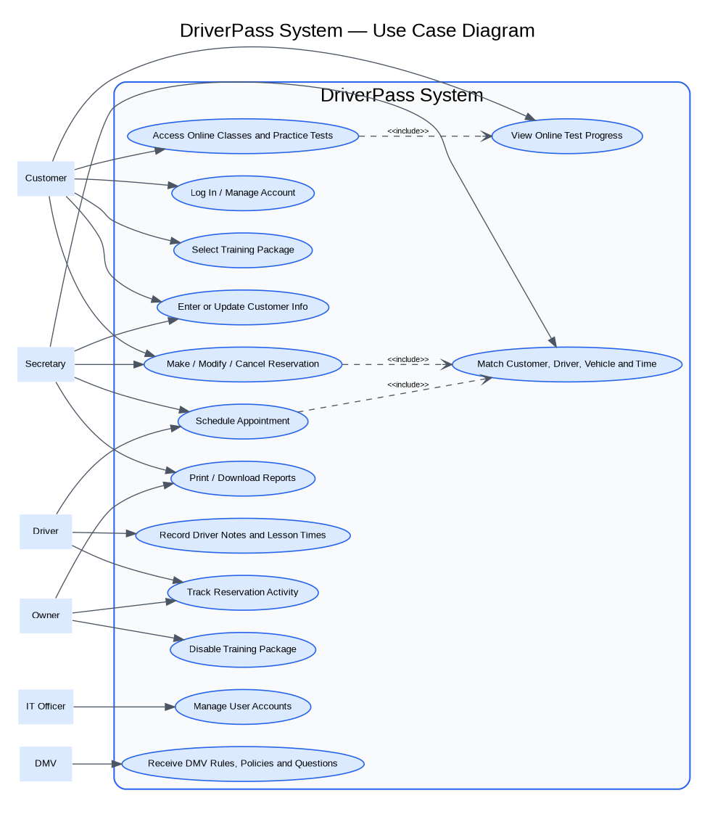

UML Activity Diagrams
Activity Diagram 2: Completing an online practice test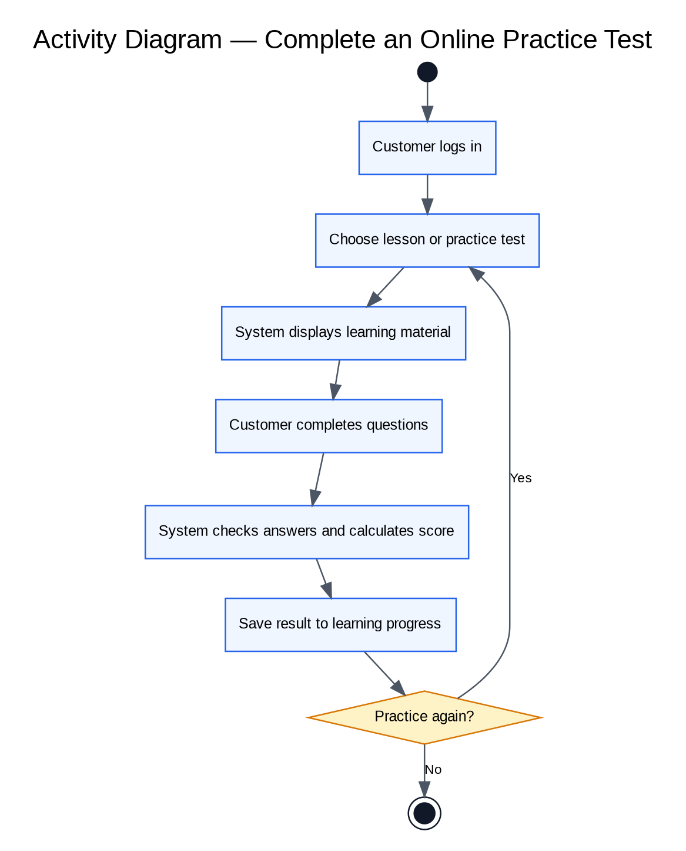
Activity Diagram 1: Booking a driving lesson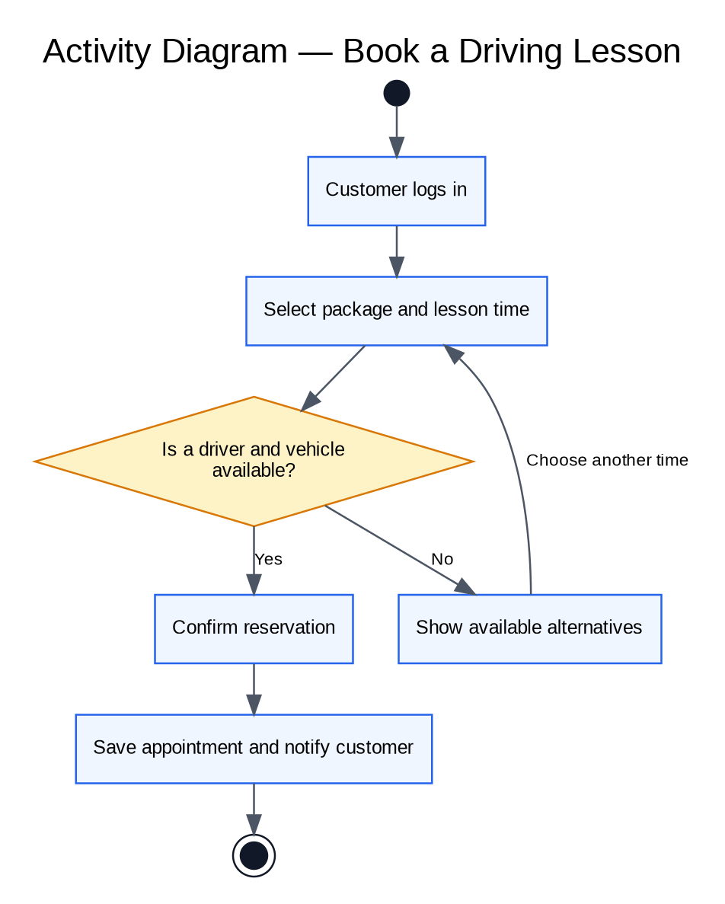

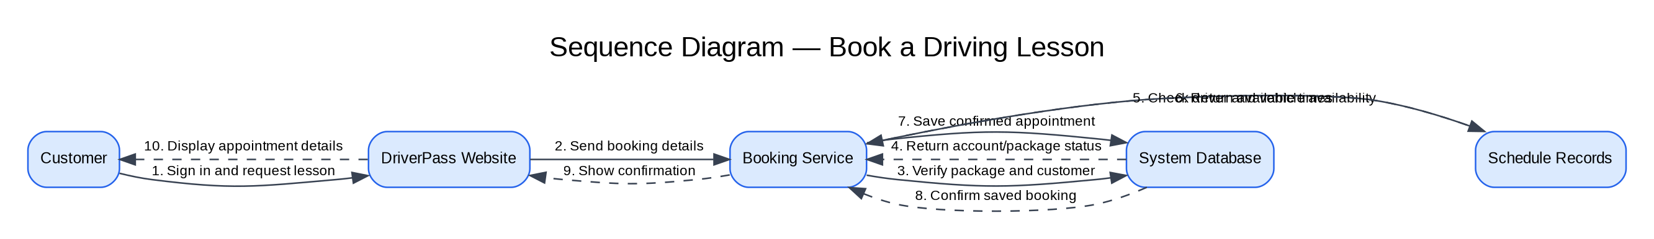

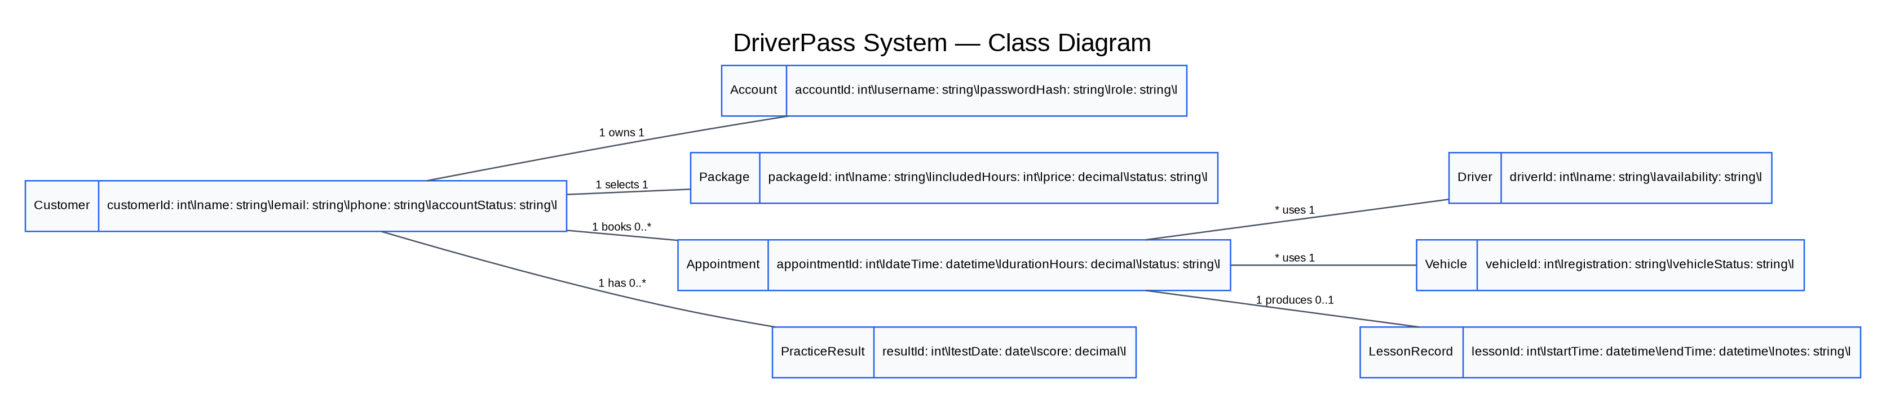
The suggested DriverPass system is to be a web-based application for customers and employees. It is expected to meet the requirements established for the Project One course, which include providing the online registration and account access, selection of training packages, driving-lesson reservations, identification of the required drivers and vehicles, practice tests, tracking of the progress, maintenance of the records of completed lessons, reports, and DMV learning information. Here are the technical requirements that are to be considered in the implementation of the project.

Hardware

• Customers and staff will require the use of desktop computer, laptops, tablets, and/or smartphones to access the application via web browsers.

• DriverPass employees will need to have access to reliable computer hardware and internet to carry out their administrative roles, such as coordinating rides, managing the customer accounts and information, and analyzing reports.

• The hosting environment will require sufficient hardware capacity, memory, storage, backup, and concurrent user capability.

Software and tools

• Web-based application that handles the customer and staff processes of account access, viewing of packages, scheduling and management of appointments, online learning, and reporting.

• Relational database that stores data about customers, accounts, packages, appointments, drivers, vehicles, lesson records, practice-tests results, and others with appropriate relations.

• Supported server operating environment, web/application server, database administration tools, development, and test environments, which may be selected by the implementation team.

• Email or another service for message sending as a method of notifying customers about reservations, changes, cancellations, and other important updates.

Infrastructure and availability

• Ensure secure hosting with encrypted web connections (HTTPS/TLS), routine backups, monitoring, and a documented recovery process.

• Separate development, testing, and production environments for changes to be verified.

• Responsive pages that work on common screen sizes and accessible navigation for customers and staff.

• Consistent availability records to reduce the double-booking of drivers or vehicles.

Security and access control

• Individual accounts and strong authentication, and the passwords should be stored as hashes.

• The role-based permissions for customers, secretaries, drivers, owners, and IT officers. All users should only be able to view or modify information relevant to their role.

• Inputs, sessions, logs of important administrative and reservation changes, and protection of sensitive data are to be protected against unauthorized access.

• Encrypt sensitive data in transit, protect stored backups and database access with least-privilege permissions.

Key assumptions and items to confirm

The design assumes that DriverPass will provide accurate package details, staff schedules, driver/vehicle availability, and required DMV update process. The integration details with DMV systems and payment processing were not specified in the assignment materials available here and must be confirmed before implementation.

Interfaces and user interactions

• Customers can sign up online, while the authorized secretaries can input/update any given customer's data that registered through an agent.

• Customers can view training packages available and select a preferred package to schedule their lessons, with the system providing clear indication of acceptance or reason for any time requested that is not available.

• Staff interfaces should provide relevant views for scheduling of appointments, matching of drivers and vehicles, notes on lessons, management of packages, and reports among other tasks.

Quality assurance and maintainability
• Test normal and exception paths, including invalid sign-in, unavailable lesson times, cancellation or modification, and missing required customer information.
• Verify that overlapping reservations cannot assign the same driver or vehicle to two lessons at the same time.
• Documented requirements, version control, code review, and deployment checks should be used to ensure that updates can be tested before they reach customers.

