**SQL**

The "history" table is in the attached file test.db (SQLite). history issue_key – unique task key status – task status minutes_in_status – the number of minutes the task spent in the status previous_status – the previous status of the task started_at – time of creating the task status, unix milliseconds ended_at – time of the task transition to another status, unix milliseconds.

SQL 1

Write a query that will output the average time tasks of each group spend in the "Open" status. Conditions: By group, we mean the first character in the task key. For example, for the key "C-40460," the group will be "C." A task can transition to the same status multiple times. Convert the time to hours rounded to two decimal places.

SQL 2

Write a query that will output the task key, the last status, and its creation time for tasks that are currently open. Conditions: Tasks are considered open if their last status at the moment is not "Closed" or "Resolved." A task can transition to the same status multiple times. Format the query so that, by changing the date, it can be used to search for open tasks at any point in time in the past. Convert the time to textual representation.

PYTHON

Create an interactive application using one of the web frameworks (streamlit/dash/panel), based on the following layout:

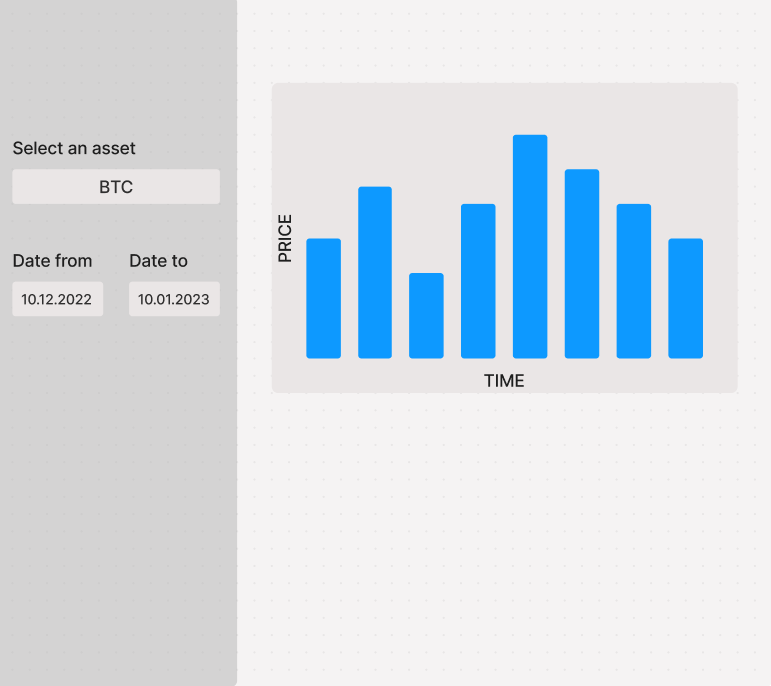

Historical data and the list of assets need to be obtained using an API:

<https://docs.coincap.io/>