**CHAPTER 1**

**INTRODUCTION**

**1.1 INTRODUCTION:**

The FitFabe app introduces a paradigm shift in the landscape of online food ordering by seamlessly blending the convenience of food delivery application with the health-conscious focus of fitness tracker application. While traditional food delivery services prioritize speed and variety, often overlooking the nutritional value of the offerings, FitFabe redefines this approach. By integrating food delivery application’s robust platform with fitness tracker application’s commitment to wellness, the app revolutionizes the way users perceive and interact with food delivery.

Unlike conventional food delivery apps, which may inundate users with a plethora of options lacking in nutritional value, FitFabe offers a curated selection of wholesome meals tailored to diverse dietary preferences and requirements. Whether users are seeking vegetarian, gluten-free, low-carb, or other specialized options, the app provides a range of choices that prioritize health without compromising on taste or convenience.

Moreover, FitFabe goes beyond merely offering healthy options; it educates and empowers users to make informed decisions about their dietary intake. Through features such as detailed nutritional information, personalized recommendations, and access to expert insights on nutrition and wellness, the app fosters a culture of mindful eating and conscious consumption.

In essence, FitFabe represents a fusion of innovation and wellness, challenging the conventional norms of online food ordering. By bridging the gap between convenience and health consciousness, the app not only satisfies users' cravings but also supports their journey towards a healthier lifestyle.

The FitFabe app not only represents a novel approach to online food ordering but also signifies a fundamental shift in consumer behavior towards prioritizing health and wellness. In a world where fast-paced lifestyles often lead to dietary compromises, this app emerges as a beacon of change, offering users a gateway to healthier eating habits without sacrificing the convenience and ease of online food delivery.

At its core, FitFabe recognizes the evolving needs and preferences of modern consumers, who increasingly seek ways to align their food choices with their health goals. By integrating the extensive network and user-friendly interface of FitFabe with the nutritional expertise and curated offerings of Healthify, the app creates a symbiotic relationship that benefits both users and food vendors.

One of the key aspects that sets FitFabe apart is its emphasis on customization and personalization. Recognizing that dietary preferences and requirements vary widely among individuals, the app provides a highly tailored experience, allowing users to filter and select meals based on factors such as dietary restrictions, calorie count, ingredients, and nutritional content. This level of granularity ensures that users can find options that not only meet their dietary needs but also cater to their taste preferences and lifestyle choices.

Moreover, FitFabe serves as an educational platform, empowering users with knowledge and insights about nutrition and healthy eating habits. Through features such as interactive menus, informative articles, and expert recommendations, the app equips users with the tools they need to make informed decisions about their food intake. Whether it's understanding the benefits of certain ingredients, learning how to balance macronutrients, or discovering new recipes and cuisines, the app fosters a culture of lifelong learning and exploration around healthy eating.

Furthermore, FitFabe operates with a commitment to quality and transparency, ensuring that all meals offered through the platform meet rigorous standards for freshness, sustainability, and ethical sourcing. By partnering with trusted vendors and suppliers who share these values, the app establishes a level of trust and credibility among users, reinforcing their confidence in the food choices they make through the platform.

In summary, FitFabe represents more than just a merger of convenience and health consciousness; it embodies a holistic approach to wellness that encompasses not only what we eat but also how we think about food. By leveraging technology, innovation, and collaboration, the app paves the way for a future where healthy eating is not only accessible but also enjoyable and empowering for all.

FitFabe offers a curated selection of nutritious meals, catering to individuals who prioritize health and wellness. With a focus on wholesome ingredients and balanced nutrition, users can make healthier choices without compromising on taste or convenience. One of the key advantages of FitFabe is its extensive customization options. Users can tailor their meals to suit their dietary preferences, restrictions, and goals, allowing for a personalized dining experience. Whether it's adjusting portion sizes, selecting specific ingredients, or opting for special dietary options, FitFabe empowers users to create meals that meet their unique needs. FitFabe brings convenience to the forefront of healthy eating. With just a few taps on the app, users can browse through a variety of nutritious options, place orders, and have their meals delivered straight to their doorstep. This eliminates the hassle of meal planning, grocery shopping, and cooking, making it easier for users to maintain a healthy lifestyle even amidst busy schedules. FitFabe serves as an educational platform, providing users with valuable insights and information about nutrition, wellness, and healthy eating habits. Through articles, tips, and expert recommendations, users can learn more about the benefits of different foods, how to make balanced choices, and practical tips for maintaining a healthy diet. FitFabe maintains rigorous standards for quality and freshness, ensuring that all meals offered through the platform meet strict criteria for sourcing, preparation, and delivery. By partnering with trusted vendors and suppliers who share their commitment to quality, FitFabe instills confidence in users that they are receiving high-quality, nutritious meals every time they order. The FitFabe app features a sleek and intuitive user interface, designed to enhance usability and provide a seamless ordering experience. With straightforward navigation, interactive elements, and clear product details, users can easily find, customize, and order meals with minimal effort. FitFabe fosters a sense of community among its users, encouraging interaction, sharing of experiences, and support for each other's wellness journeys. Through features such as reviews, ratings, and social media integration, users can connect with like-minded individuals, discover new recipes, and stay motivated to prioritize their health.

**1.2.PRESENT TECHNOLOGY**

Food delivery partners are instrumental components of the modern food delivery ecosystem, tasked with the efficient and timely transportation of orders from restaurants to customers' locations. These delivery personnel, often independent contractors, utilize their own vehicles or modes of transportation to fulfill deliveries, leveraging technology-driven solutions provided by food delivery platforms. Equipped with mobile apps that offer real-time order tracking, GPS navigation, and communication tools, delivery partners optimize their routes and manage multiple deliveries to ensure prompt service. Collaborating closely with partner restaurants, delivery partners uphold quality standards and adhere to food safety protocols throughout the delivery process. Their role extends beyond mere transportation, encompassing customer service interactions and problem resolution to ensure a seamless experience for both customers and restaurants. Through their efforts, food delivery partners contribute to the convenience and accessibility of online food ordering, shaping the landscape of modern dining experiences**.**

Nutrition and calorie trackers are essential tools for individuals striving to monitor their dietary intake and maintain a balanced lifestyle. These trackers typically utilize mobile apps or web-based platforms to help users record and analyze the nutritional content of their meals. By inputting details such as food items consumed, portion sizes, and meal times, users can track their daily calorie intake, macronutrient distribution, and micronutrient levels. Advanced trackers may offer features like barcode scanning, meal logging, and database integration to streamline the tracking process and provide accurate nutritional information. Additionally, some trackers incorporate user-specific metrics such as age, weight, and activity level to personalize recommendations and set goals tailored to individual needs. By fostering awareness and accountability, nutrition and calorie trackers empower users to make informed dietary choices and progress towards their health and wellness objectives.

The collaboration between food delivery platforms and nutrition/calorie trackers represents a symbiotic relationship aimed at empowering users to make informed and health-conscious dietary choices. By seamlessly integrating nutrition tracking features into the ordering process, these platforms offer users a comprehensive solution for managing their dietary intake. Through personalized recommendations tailored to individual preferences and nutritional goals, users can navigate the vast array of restaurant options with confidence, ensuring that their orders align with their health objectives. Moreover, the ability to track meals from both home-cooked and delivered sources within a single platform fosters a holistic approach to meal monitoring, facilitating better decision-making and accountability. Educational resources and incentives further enhance the user experience, providing valuable insights and motivation to prioritize healthier options. Ultimately, this collaboration not only promotes healthier eating habits but also underscores the potential of technology to support and enhance overall wellness in the modern lifestyle

**1.3 LIMITATIONS:**

While Swiggy and Healthify have made significant strides in revolutionizing the food delivery and nutrition sectors respectively, they do come with certain limitations.

Swiggy, despite its widespread popularity and extensive network of restaurant partners, faces challenges related to delivery logistics. Timely delivery can sometimes be hindered by factors such as traffic congestion, adverse weather conditions, or high order volumes during peak hours, leading to delays and customer dissatisfaction. Additionally, while Swiggy strives to offer a diverse range of dining options, users in certain areas may have limited access to restaurants, especially those in remote or underserved locations. Moreover, occasional discrepancies in order accuracy or quality can tarnish the user experience, highlighting the need for consistent quality control measures across its vast network of partners.

On the other hand, Healthify, while commendable in its efforts to promote healthy eating habits and provide nutritional guidance, may face limitations in user engagement and adherence. Despite offering educational resources and personalized recommendations, sustaining user motivation to track dietary habits and adhere to nutritional goals over the long term can be challenging. Users may also encounter limitations in the accuracy and comprehensiveness of nutritional data, particularly for non-standardized or homemade meals, which could impact the reliability of tracking and analysis. Additionally, the effectiveness of Healthify's recommendations may vary depending on individual preferences, dietary restrictions, and cultural factors, highlighting the need for further customization and personalization.

Furthermore, both platforms may encounter privacy and data security concerns, especially concerning the collection and usage of sensitive user data such as dietary preferences, health conditions, and location information. Ensuring robust data protection measures and transparent privacy policies is essential to maintain user trust and compliance with regulatory requirements.

In summary, while Swiggy and Healthify offer valuable services in the realms of food delivery and nutrition respectively, they face limitations related to delivery logistics, user engagement, data accuracy, and privacy concerns. Addressing these limitations through continuous innovation, quality assurance, and user-centric approaches will be crucial for enhancing the overall user experience and maximizing the impact of their offerings.

**‘**

**1.4: PROPOSED TECHNOLOGY:**

1. **Intelligent Recommendation Engine:**
   * Implement an AI-driven recommendation engine that analyzes user preferences, dietary requirements, and health goals to suggest personalized meal options from Swiggy's restaurant partners.
   * Utilize machine learning algorithms to continuously refine recommendations based on user feedback and behavior, ensuring relevance and accuracy.
2. **Nutritional Analysis and Integration:**
   * Integrate Healthify's nutritional database and analysis tools directly into the Swiggy app, allowing users to access comprehensive nutritional information for menu items.
   * Utilize barcode scanning technology to enable users to quickly retrieve nutritional data for packaged food items and meals from partner restaurants.
3. **Meal Tracking and Monitoring:**
   * Develop a user-friendly meal tracking feature within the FitFabe app, allowing users to log their dietary intake and monitor nutritional metrics such as calorie consumption, macronutrient distribution, and micronutrient intake.
   * Incorporate gamification elements and progress tracking to incentivize consistent meal tracking and adherence to nutritional goals.
4. **Interactive Cooking and Recipe Suggestions:**
   * Introduce interactive cooking tutorials and recipe suggestions tailored to users' dietary preferences and health goals.
   * Leverage augmented reality (AR) technology to provide immersive cooking experiences, guiding users through step-by-step recipes and demonstrating cooking techniques in real-time.
5. **Community Engagement and Support:**
   * Foster a supportive community within the FitFabe app, where users can share their experiences, recipes, and healthy eating tips.
   * Implement peer-to-peer support features, allowing users to connect with others on similar health journeys, exchange advice, and provide encouragement.
6. **Integration with Wearable Devices and Health Trackers:**
   * Integrate FitFabe with popular wearable devices and health trackers to sync activity data, such as steps taken, calories burned, and exercise sessions.
   * Leverage this data to provide users with holistic insights into their health and wellness journey, correlating physical activity levels with dietary habits.
7. **Secure Data Management and Privacy Measures:**
   * Implement robust data security protocols and encryption mechanisms to protect user data, ensuring compliance with privacy regulations such as GDPR and HIPAA.

**1.5. ADVANTAGES:**

Firstly, FitFabe combines Swiggy's extensive network of restaurants and seamless delivery services with Healthify's nutritional expertise and tracking capabilities. This integration allows users to access comprehensive nutritional information for menu items, empowering them to make informed dietary choices aligned with their health goals. By offering personalized meal recommendations based on individual preferences and nutritional requirements, FitFabe ensures that users can enjoy delicious meals while prioritizing their well-being.

Furthermore, FitFabe leverages innovative technologies such as AI-driven recommendation engines and interactive cooking tutorials to enhance the user experience. Users can discover new recipes, track their dietary intake, and receive real-time guidance on cooking techniques, fostering a deeper understanding of nutrition and culinary skills. The integration with wearable devices and health trackers enables users to seamlessly monitor their physical activity levels and correlate them with their dietary habits, promoting a holistic approach to health and wellness.

FitFabe also fosters a supportive community environment where users can connect with like-minded individuals, share experiences, and receive encouragement on their health journey. By promoting peer-to-peer support and engagement, FitFabe creates a sense of camaraderie and accountability, motivating users to stay committed to their health goals.

Moreover, FitFabe prioritizes data security and privacy, implementing robust measures to safeguard user information and ensure compliance with regulatory standards. Users have transparent control over their data, allowing them to customize privacy settings and permissions according to their preferences.

Overall, FitFabe offers a transformative approach to food delivery, seamlessly integrating nutrition and wellness into the dining experience. With its array of advantages, FitFabe empowers users to lead healthier lifestyles, one meal at a time.

**CHAPTER 2**

**LITERATURE REVIEW**

Online food ordering and delivery may be a new sort of business model within the current era of e-commerce which results in the startups of several online businesses. Online food ordering and delivery is vastly successful because it bridges the gap between restaurants and consumers.. An application for food ordering and delivery was fundamentally evolved to supply an entire order and delivery solution to the metropolitan foodies. This research aims to review the factors influencing the buyer perception and buying decision and the extent of consumer satisfaction towards online food delivery service. Since the rising of the Web, vendors have endeavored to bring to the table their things to individuals who program the Internet. It has been noticed that there is a change from one individual to another with respect to consumer's perception of online food ordering and also the reformed perception is seen restricted to a limited degree along with the accessibility of the acceptable network and the openness to online food services.

Due to its huge success and the significant complexities behind it, the ODFD business has been gaining the interest of academics. Our review highlights that (i) the perspectives of the various actors involved should be integrated, moving towards an ecosystembased view; (ii) future research should focus more on restaurant operations and their role in ondemand ODFD systems; and (iii) despite they have been investigated by several academic contributions, human resources management and logistics of ODFD systems still present room for further extensions, in the areas of intervention/regulation and distribution network/batching respectively. Originality/value – This review offers insights to both academics and practitioners. On the academic side, it analyses the literature on ODFD systems, outlining directions for future research. On the managerial side, it provides a comprehensive view on the most critical valuecreating activities for ODFD businesses.

Calorie counting mobile apps claim to assist in weight management by helping users monitor their diets and track activity. This study assessed quality and effectiveness of popular calorie counting apps in weight management and behaviour change. Top 20 apps were selected from Google Play store and their quality was assessed using a 55-point scoring scale on attributes like standards used, content accuracy, user interface and sources of database. The mean (±SD (standard deviation)) quality score was 36.95 (±5.65). The calorie and activity recommendations were compared with standards and over 65 per cent apps over/underestimated calorie intake

If an app can suggest appropriate food names, it helps immensely. For this reason, we considered the food recommendation option as another specific functionality of food consumption tracking and recommendation apps. For a user, it is very beneficial to know which type of food they need to consume to fulfill their bodies’ nutritional need.An app that can automatically suggest foods based on the nutritional, as nutritional components are the most important factors for a balanced diet and good health

**CHAPTER 3**

**SYSTEM DESIGN**

**3.1. ARCHITECTURE DIAGRAM:**

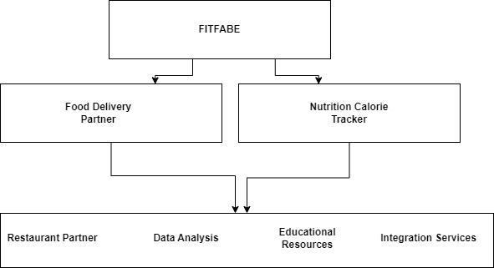

**FIG:3.1:** ARCHITECTURE DIAGRAM OF FITFABE

The architecture diagram illustrates the key components and interactions within the collaboration between food delivery platforms and nutrition/calorie trackers. At the center of the diagram is the User Interface, which serves as the primary point of interaction for users accessing the food delivery platform. This interface enables users to engage with various functionalities, including ordering food, tracking nutritional information, and participating in rewards or incentive programs.

**3.2. SYSTEM FLOW DIAGRAM:**

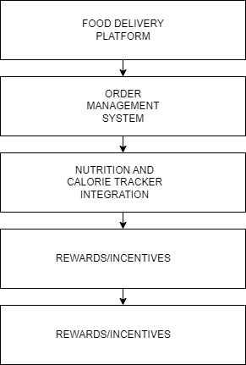

**FIG:3.2:** SYSTEM FLOW DIAGRAM OF FITFABE

The system flow diagram provides a visual representation of the structural components and interactions within the collaboration between food delivery platforms and nutrition/calorie trackers.

**3.3. SEQUENCE DIAGRAM:**

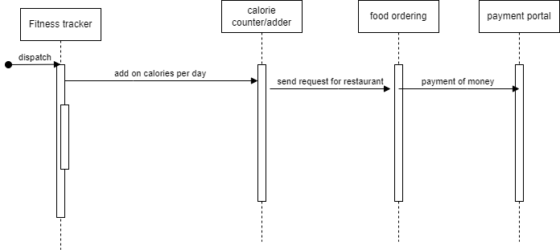

**FIG:3.3:** SEQUENCE FLOW DIAGRAM OF FITFABE

The sequence diagram illustrates the interaction between a user and the FitFabe(Swiggy+HealthifyMe) application, including the process of browsing meal options, placing an order through Swiggy, tracking the order, and retrieving nutritional information through HealthifyMe.

**CHAPTER 4**

**OUTPUT SCREENSHOTS**

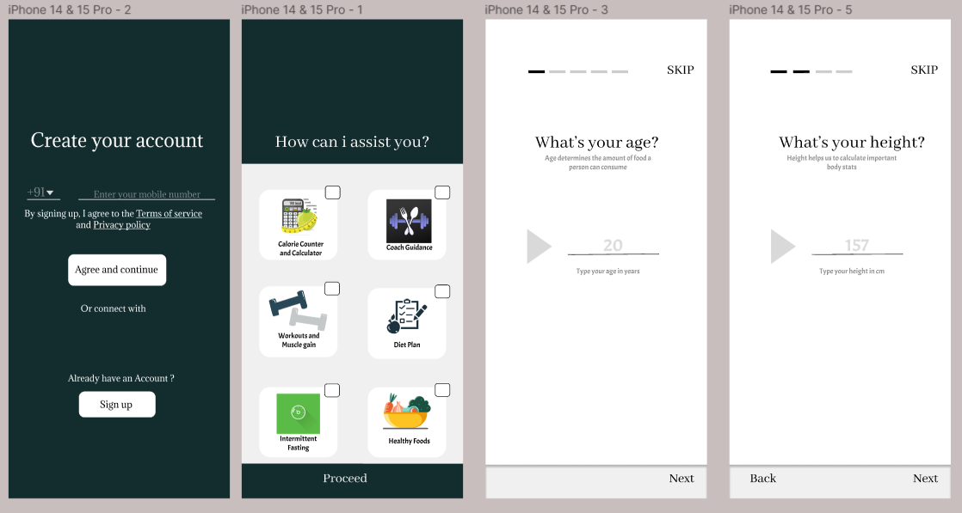

**FIG 4.1:**User interface of initiation of application

This is the initial setup screen where you’re prompted to enter your mobile number and agree to the terms of service and privacy policy. There’s also an option to connect with Google or sign up if you already have an account.

This screen allows you to select from various services the app offers, such as calorie counting, coach guidance, diet plans, workout routines, intermittent fasting, and healthy food suggestions. After making your selections, you would proceed to the next step.

You’re asked to enter your age in years. The app explains that your age will help determine the appropriate amount of food you can consume.

The screen asks for your height in centimeters. The app uses this information to calculate important body statistics.

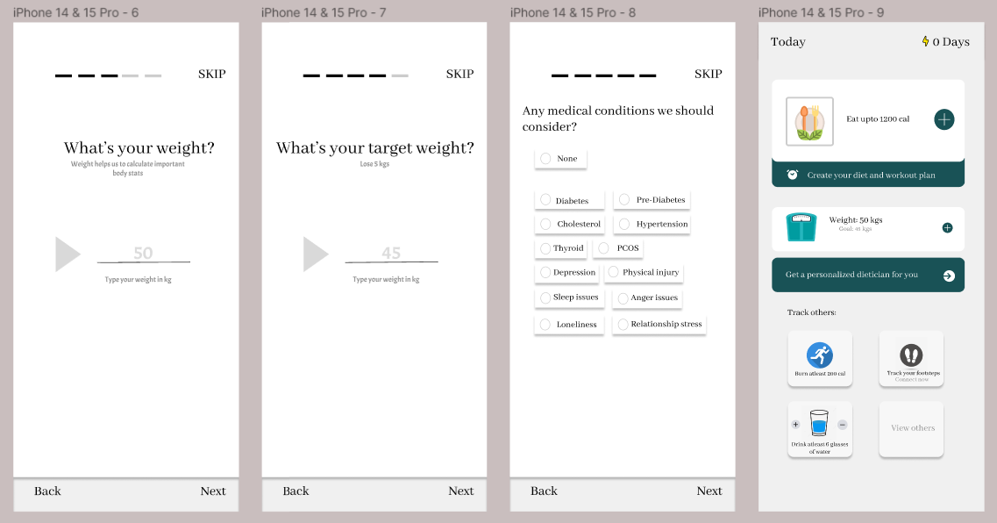

**FIG 4.2:**User interface of fitness tracker

Here, you can set a goal for your weight loss or gain journey by entering your desired target weight in kilograms.Any medical conditions we should consider. This screen allows you to inform the app of any medical conditions that might affect your diet and exercise plan, such as diabetes, cholesterol issues, thyroid conditions, and more.App’s home screen overview: The final screenshot shows the home screen of the app, which features options like setting a calorie limit, creating diet and workout plans, getting personalized dietitian support, tracking progress, and building a social network within the app.

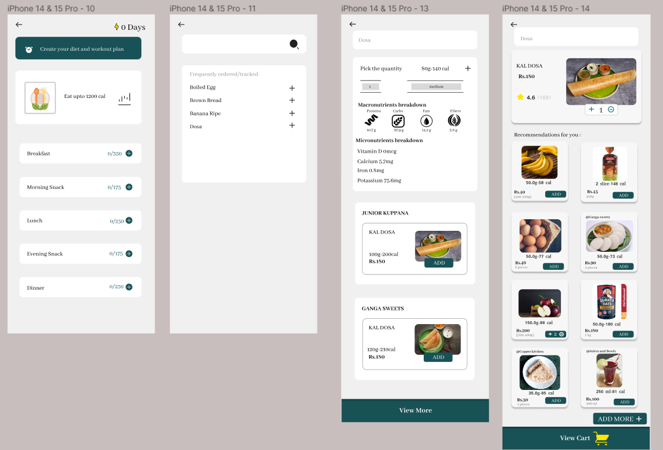

**FIG 4.3:**User interface of food ordering

The first screenshot presents a 10-day meal plan with specific times for meals like breakfast, morning snack, lunch, evening snack, dinner, and a late-night option labeled ‘Knorr’. There’s also a feature to create a custom plan.

The second and third screenshots provide details for selected food items. They offer options to choose the quantity and view nutritional information, such as carbohydrates, protein, fats, and total calories. Icons indicate if the food is vegetarian, gluten-free, or has other attributes.

The fourth screenshot appears to be the shopping cart page, where you can review the items you’ve selected, see their prices, and adjust quantities or remove items.

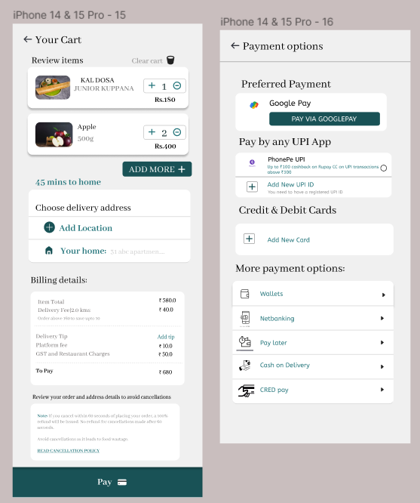

**FIG 4.4:**User interface of food payment

The interface provides a straightforward process for reviewing your order, selecting a delivery address, and choosing a payment method before finalizing the purchase

**CHAPTER 5**

**CONCLUSION**

FitFabe(Swiggy+HealthifyMe) represents a promising integration that harnesses the strengths of food delivery convenience and personalized nutrition guidance to promote holistic well-being in the digital age. By combining Swiggy's expansive restaurant network and delivery infrastructure with HealthifyMe's comprehensive health and wellness features, this integration offers users access to healthier meal options tailored to their dietary preferences and fitness goals.

While FitFabe(Swiggy+HealthifyMe) holds immense potential for promoting healthy eating habits, facilitating behavior change, and fostering a supportive ecosystem for individuals striving to improve their overall health and lifestyle, it also poses challenges regarding data privacy, technological interoperability, and ethical marketing practices. Addressing these challenges will be crucial for ensuring the integrity, trustworthiness, and effectiveness of the integrated platform.

Looking ahead, FitFabe(Swiggy+HealthifyMe) has the potential to reshape the food delivery and health tech industries, paving the way for innovative solutions that prioritize user well-being and contribute to a healthier, more sustainable future. Continued research, collaboration, and user feedback will be essential for optimizing the integration and maximizing its impact on promoting health and wellness in the digital landscape.

**APPENDIX**

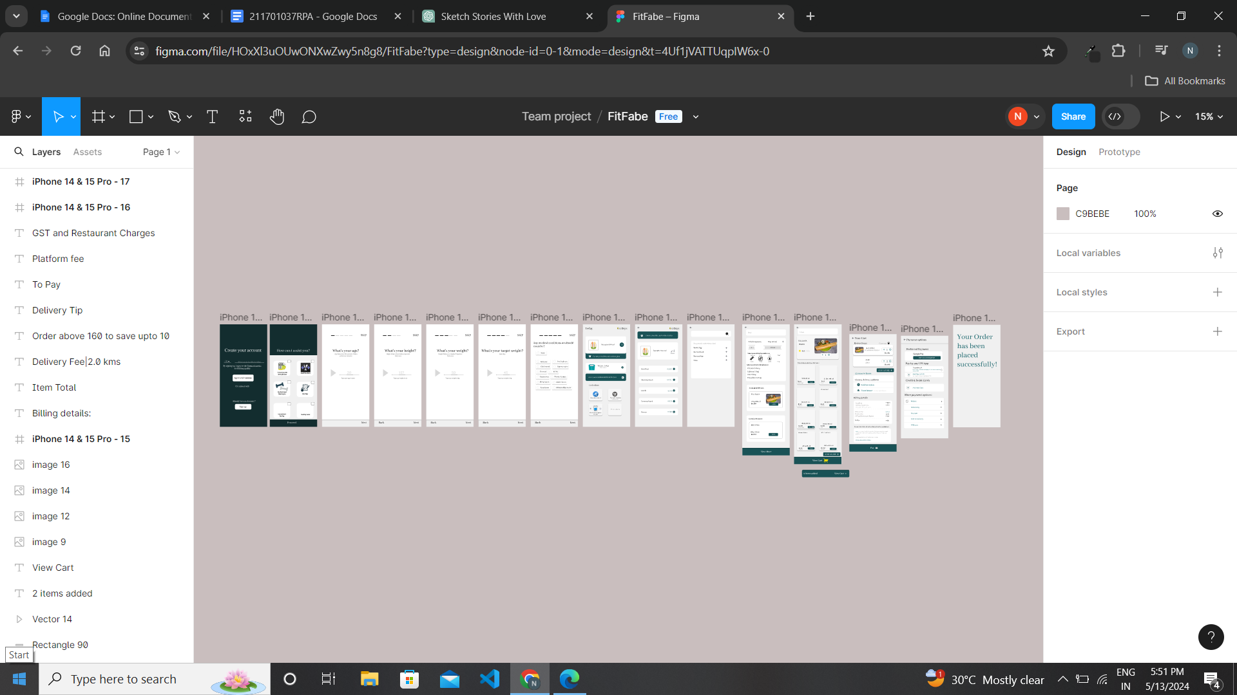

**FIG: 5.2.1Appendix**

**REFERENCES**

[1] “ Literature review on consumer consumption towards online food delivery apps”. Dr. Milind A Marathe, Dr. Parag C Kalkar , Mr. Gaurav Gawade

[2] “Calorie counting smart phone apps: Effectiveness in nutritional awareness, lifestyle modification and weight management among young Indian adults”. Paromita Banerjee, Vishnu Varadhan Rao, Mendu Dhamayanthi Korapathi

[3] “Developing a Calorie Counter Fitness App for Smartphones”

Sanjay Misra, Godwin Olatunde

[4] “A Review of the Usable Food Delivery Apps”

Pathak, Hazif U R Rahman