A

PROJECT REPORT ON

**DigitalNews**

**By**

**Nevil Bavarva (CE-014) (20CEUOD017)**

**Shyam Mendapara (CE-081) (20CEUOD016)**

**B.Tech CE Semester-VI**

**Subject: System Design Practice**

**Guided by:**

Prof. Siddharth p. shah

Assistant Professor

Dept. of Comp. Engg.



**Faculty of Technology**

**Department of Computer Engineering**

**Dharmsinh Desai University**



**Faculty of Technology**

**Department of Computer Engineering**

**Dharmsinh Desai University**

**CERTIFICATE**

This is to certify that the practical / term work carried out in the subject of

**System Design Practice** and recorded in this journal is the

bonafide work of

**Nevil Bavarva (CE-014) (20CEUOD017)**

**Shyam Mendapara (CE-081) (20CEUOD016)**

of B.Tech semester **VI** in the branch of **Computer Engineering**

during the academic year **2021-2022**.

Prof. Siddharth p. shah Dr. C. K. Bhensdadia,

Assistant Professor, Head,

Dept. of Computer Engg., Dept. of Computer Engg.,

Faculty of Technology Faculty of Technology

Dharmsinh Desai University, Nadiad Dharmsinh Desai University, Nadiad

**INDEX**

|  |  |  |
| --- | --- | --- |
| **SR.NO** | **TOPICS** | **PAGE NO.** |
| **1** | **Abstract** | 1 |
| **2** | **Introduction:** | 2 |
|  | * Technology and Tools Used |  |
| **3** | **Software Requirement Specifications:** | 4 |
|  | * Scope |  |
|  | * System Functional Requirements |  |
|  | * Other Non‐Functional Requirements |  |
| **4** | **Design:** | 9 |
|  | * Use Case Diagram |  |
|  | * Sequence Diagram |  |
|  | * Activity Diagram |  |
|  | * ER Diagram |  |
|  | * Data Dictionary |  |
| **5** | **Implementation Details:** | 16 |
|  | * Modules |  |
|  | * Functional prototypes |  |
| **6** | **Screen‐shots of the System** | 21 |
| **7** | **Conclusion** | 27 |
| **8** | **Limitations and Future Extensions of System** | 28 |
| **9** | **Bibliography** | 29 |

**Abstract:**

DigitalNews is a website which provides the user with latest news of all around the world. User is displayed with subcategories on side panel, also news are displayed category wise on home page as well. User gets separate block of a news with thumbnail, title and brief of description. User can view previous old news upto a week on website as well.

**Introduction:**

Now a days there are lots of news website available on the internet, But in busy life nobody has time to keep surfing around various website for different kinds of news.

So, we have developed a website that provides user with latest News possible of almost all kind of news along with current cryptocur.

If user finds a website with good content on certain topic that is not present, they can add them in the website so that other user can have access to more informative and genuine websites. And they can always send suggestions regarding other possible changes from contact page.

* **Technology and Tools Used:**
* **Technology:**
* React
* Nodejs
* Express and REST apis
* JavaScript
* HTML
* CSS
* **Tools:**
* Git
* Visual Studio Code
* Postman

**Software Requirement Specifications:**

* **Scope:**
* This system is designed for getting all types of news under one platform/site.
* There are various sites available on internet but they provide certain news of several categories, But on DigitalNews user can choose from many of the categories.
* **System Functional Requirements:**
* **R1. Manage Information by Admin:**
* R1.1: Adding News

Description: New News are added by admin.

Input: Data of new news.

Output: Display newly added news.

* R1.2: Updating News

Description: Existing News are updated by admin.

Input: Updated data of existing News.

Output: Display updated News.

* R1.3: Delete News

Description: If the existing data is outdated and/or news needs to be deleted for reasons, it can be deleted.

Input: Data to be deleted

Output: Reflection in website.

* R1.4: Adding Category

Description: New Categories are added by admin.

Input: Data of new categories.

Output: Display newly added categories.

* R1.5: Updating Category

Description: Existing categories are updated by admin.

Input: Updated data of existing category.

Output: Display updated category.

* R1.6: Delete Category

Description: If the existing data is outdated and/or not in use at current time, it can be deleted.

Input: Data to be deleted

Output: Reflection in website.

* **System Non-Functional Requirements:**

1. **Performance:**

The system must be interactive and must not involve long delays. Though in case of opening the app components or loading the page the system shows the delays less than 2 seconds.

1. **Safety**

The admin’s data is secure. The system has authorization to avoid any un-authorized access to admin’s data.

1. **Reliability**

As the system has news data, its reliability is the major factor for consideration.

1. **Database**

System requires to access admin submissions, versions, reviews and profile data fast to maintain the performance.

**Design:**

* **Use Case Diagram:**

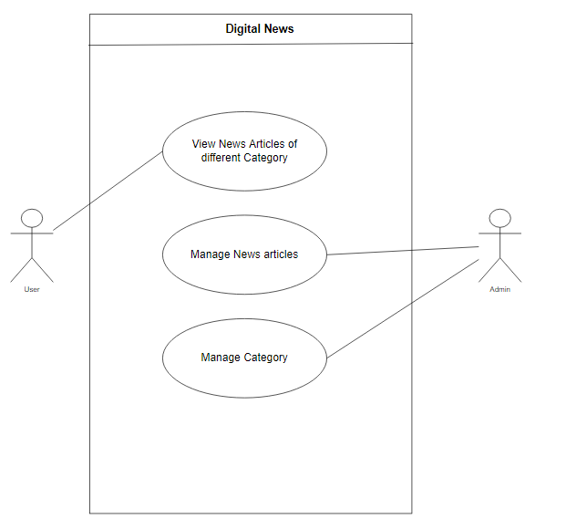

* **Sequence Diagram:**

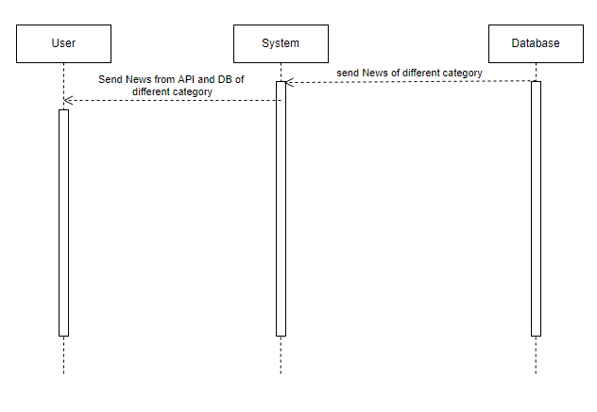

* **Activity Diagram:**

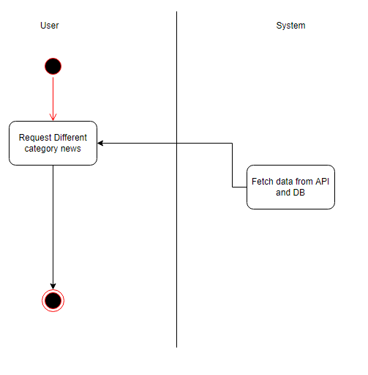

* **DFD Diagram (Level 0):**

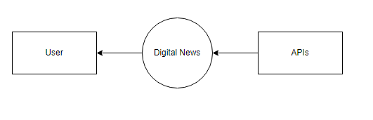

* **DFD Diagram (Level 1):**

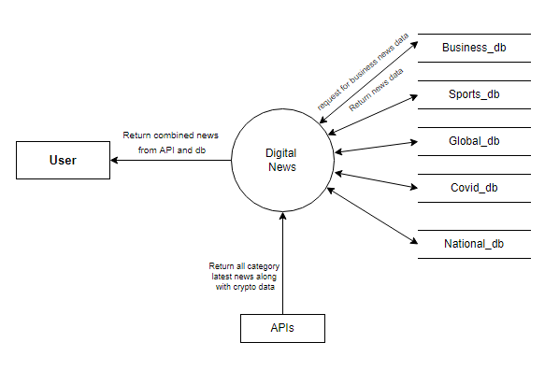

* **Data Dictionary:**

**Business:**

|  |  |  |  |
| --- | --- | --- | --- |
| **Field** | **Datatype** | **Size** | **Constrains** |
| Business_Id | Integer | - | Primary key |
| Type_Of_News | String | - |  |
| Title_Name | String | - | - |
| Redirect_Url | String | - | - |
| Thumbnail_Url | String | - | - |
| Description | String | - | - |
| Date_of_Publication | Date | - | - |

**Covid:**

|  |  |  |  |
| --- | --- | --- | --- |
| **Field** | **Datatype** | **Size** | **Constrains** |
| Covid_Id | Integer | - | Primary key |
| Type_Of_News | String | - |  |
| Title_Name | String | - | - |
| Redirect_Url | String | - | - |
| Thumbnail_Url | String | - | - |
| Description | String | - | - |
| Date_of_Publication | Date | - | - |

**Sports:**

|  |  |  |  |
| --- | --- | --- | --- |
| **Field** | **Datatype** | **Size** | **Constrains** |
| Sports_Id | Integer | - | Primary key |
| Type_Of_News | String | - |  |
| Title_Name | String | - | - |
| Redirect_Url | String | - | - |
| Thumbnail_Url | String | - | - |
| Description | String | - | - |
| Date_of_Publication | Date | - | - |

**National:**

|  |  |  |  |
| --- | --- | --- | --- |
| **Field** | **Datatype** | **Size** | **Constrains** |
| National_News_Id | Integer | - | Primary key |
| Type_Of_News | String | - |  |
| Title_Name | String | - | - |
| Redirect_Url | String | - | - |
| Thumbnail_Url | String | - | - |
| Description | String | - | - |
| Date_of_Publication | Date | - | - |

**Global:**

|  |  |  |  |
| --- | --- | --- | --- |
| **Field** | **Datatype** | **Size** | **Constrains** |
| Global_Id | Integer | - | Primary key |
| Type_Of_News | String | - |  |
| Title_Name | String | - | - |
| Redirect_Url | String | - | - |
| Thumbnail_Url | String | - | - |
| Description | String | - | - |
| Date_of_Publication | Date | - | - |

**Implementation Details:**

**Module:**

1. **Fetching News from API:**

* File NewsApi.jsx has a function called Newsapi which calls the query to fetch news from API.
* This function takes argument from the page it is being called and puts that argument as category of news needed to be fetched using the query.

1. **Fetching News from DB:**

* Each category has its own .jsx file which contains function that fetches data from database.
* It uses- axios.get() to bind data from database to the url of the page mentioned as argument.
* Eg: axios.get(“http://local:9000/news/Enterainment”);

1. **Deleting News after 7 days:**

* Schedulars are used to delete more than 7 Day older news.

**Screen‐shots of the System:**

**Conclusion:**

The functionalities are implemented in system after understanding all the system modules according to the requirements.

Functionalities that are successfully implemented in the system are:

* Latest news from API.
* Old news from Database
* Auto save latest news from api into database for later display
* Auto deletion of news articles from all categories after 7 days.

After the implementation and coding of system , comprehensive testing was performed on the system to determine the errors and possible flaws in the system.

**Limitations and future Extensions of system:**

* Limitations: User cannot like or share or comment on article if he/she want as of now. Also for full article user gets redirect to original source of news.
* Future Extensions: implementation of like, share and comment functionality on every news article also with saving that article facility.

**Bibliography:**

Websites:

* <https://www.stackoverflow.com>
* <https://www.draw.io>
* <https://www.mongodb.com>
* <https://www.youtube.com>