# 

# Smart Inventory Management System (SIMS) - Detailed Idea Document

## 1) Team Name and Members

### Team Name: StockSync

* **Members:** -
  + **Nevil** – Project Manager, AI/ML (Expertise in AI, Python, Flask, and Handles project planning, strategy, and market research)
  + **Parthiv & Dwijesh** – UI/UX Designer & Frontend Developer (Expert in React.js, user experience, and frontend architecture)
  + **Shubh** – Backend Developer (Expertise in database management, system architecture, and API development)

## 2) Problem Statement

### Chosen Problem:

Traditional inventory management systems are prone to errors due to manual tracking, leading to overstocking, stockouts, financial losses, and inefficiencies in restocking. Businesses need an intelligent solution to automate inventory tracking and predict demand accurately.

### Problem Analysis:

### Small and medium-sized enterprises (SMEs), supermarkets, and e-commerce platforms struggle with inventory mismanagement, causing financial losses.

### Manual systems fail to track stock levels in real time, leading to inefficiencies.

### Lack of AI-powered solutions in traditional systems results in poor demand forecasting and delayed restocking.

### 

### Target Audience:

### Retailers & Supermarkets (Efficient stock replenishment and demand forecasting)

### Warehouses & Logistics Companies (Better stock control & movement tracking)

### Manufacturing Units (Raw material and finished product inventory tracking)

## 3) Solution Overview

* **StockSync** is an AI-powered inventory management system that automates stock management, predicts demand, and streamlines restocking.

### Key Features:

### Real-time Inventory Tracking: Monitors stock levels, updates automatically based on sales and stock movement.

### AI-driven Demand Forecasting: Uses machine learning models to predict future stock needs based on past sales data.

### Automated Restocking Suggestions: Notifies managers when to reorder, preventing over/under-stocking.

### Supplier Management: Tracks suppliers, purchase orders, and delivery timelines.

### Smart Dashboard: Displays real-time insights, AI-based predictions, and alerts.

### Stock Movement Analysis: Analyzes stock trends and seasonal fluctuations.

### Excel Import & Manual Entry: Allows bulk stock insertion via Excel files or manual entry.

## 4) Tech Stack & Implementation

### Frameworks & Technologies:

### Backend: Flask/Django (Python API for inventory management and AI integration)

### Frontend: Vue.js/React.js (Dynamic and responsive UI)

### Database: PostgreSQL/MongoDB (Scalable storage for inventory and transaction data)

### AI/ML: scikit-learn (RandomForestRegressor for demand forecasting, ARIMA for time-series analysis)

### Hosting: Railway.app / Firebase / Vercel (Cloud deployment for scalability)

### Reasoning for Tech Choices:

### Python & Flask/Django: Easy integration with AI models, robust API handling.

### React.js/Vue.js: Lightweight, fast UI with better state management.

### PostgreSQL/MongoDB: Reliable storage and retrieval of stock data.

### AI-based Demand Prediction: Helps in reducing stockouts and preventing wastage.

**5) Feasibility & Implementation Plan**

* **Implementation Steps:**

1. **Inventory Management (CRUD Operations)**
   * Users can add, update, delete, and view stock levels.
   * Ensures accurate stock tracking and prevents discrepancies.
   * API endpoints for managing inventory items efficiently.
2. **AI-Based Demand Prediction**
   * Machine learning models (RandomForestRegressor, ARIMA) analyze past sales data.
   * Predicts future demand to avoid overstocking or stockouts.
   * AI continuously updates forecasts based on new data inputs.
3. **Automated Restocking Suggestions**
   * System generates alerts when stock reaches predefined thresholds.
   * Recommends optimal reorder quantities to maintain inventory balance.
   * Admin can approve or modify restocking recommendations before execution.
4. **Supplier & Purchase Order Management**
   * Stores supplier details, purchase orders, and transaction history.
   * Tracks pending, completed, and canceled purchase orders.
   * Ensures timely supplier notifications for restocking.
5. **Dashboard & Reports**
   * Provides real-time insights into stock levels, AI predictions, and transaction history.
   * Graphical representations of inventory trends, seasonal demand patterns.
   * Custom reports for business analysis and decision-making.
6. **Bulk Stock Upload via Excel**
   * Users can upload inventory data in bulk using Excel files.
   * System validates data format before inserting into the database.
   * Supports both manual and automated stock entry.

* **Challenges & Assumptions:**
  + **Challenge: Ensuring real-time stock updates.**
    - **Solution:** Implement WebSockets or Firebase for instant stock synchronization across devices.
  + **Challenge: Handling large datasets for AI predictions efficiently.**
    - Solution: Optimize database queries and leverage cloud-based ML models.
  + **Assumption:** Businesses will provide accurate historical sales data for AI model training.
    - Without quality data, AI predictions may be less effective.

## 6) UI/UX & User Flow

### Key Screens:

* **Login/Register Page** – Secure authentication.
* **Dashboard** – Overview of stock levels, AI predictions, alerts.
* **Stock Management Page** – Add, update, and remove inventory items.
* **Supplier Management** – View supplier details, track purchase orders.
* **AI Predictions Page** – View demand forecasts and restocking suggestions.
* **Excel Upload Page** – Allows bulk stock insertion via Excel.

### User Journey:

1. **User logs in & accesses the dashboard.**
2. **Dashboard displays stock levels, predictions, and alerts.**
3. **Stock Management**:

* Users can **add, update, delete, or view stock**.
* If authorized → **AI demand forecasting is triggered**.

1. **AI Demand Forecasting**:

* The system **analyse past trends** and predicts future demand.

1. **Restocking suggestions** are generated.
2. **Admin reviews AI-generated suggestions.**

* If approved → **Purchase order is created.**
* If rejected → **Manual review is required.**

1. **Supplier receives an order notification.**
2. **Stock is updated once products are received.**
3. **Excel import/manual entry for external data sources.**

## 

## 7) Business Scope & Use Cases

### Use Cases:

* **Retail Chains**: AI predicts demand spikes, ensuring stock availability.
* **E-commerce Warehouses**: Automates tracking and restocking process.
* **Supermarkets**: Prevents product shortages by forecasting demand.

### Market Need:

* **AI in inventory management is growing at 6.5% CAGR.**
* **Businesses lose $1.1 trillion annually due to stock mismanagement** – AI can reduce these losses.

### Revenue Model:

* **Subscription-based (SaaS)** – Monthly/Yearly pricing for cloud-hosted inventory management.
* **Freemium Model** – Basic inventory management free, AI-powered forecasting as a paid upgrade. [Future Requirement]

## 8) System Design & Architecture

### System Architecture:

* **MVC Architecture**: Flask/Django handles the API, React.js/Vue.js handles UI.
* **RESTful APIs**: APIs for stock updates, AI predictions, and supplier management.
* **AI Module**: Runs periodic demand forecasting and restocking analysis.
* **Authentication & Authorization:**
* **User Authentication:** The system will implement secure authentication using **OAuth, JWT (JSON Web Tokens), or Firebase Auth** to ensure safe user access. This will help in session management, token-based authentication, and secure login handling.
* **Role-Based Access Control (RBAC):** Users will be assigned specific roles to control access and permissions:
  + **Admin:** Full access to manage inventory, AI settings, and reports.
  + **Manager:** Can approve restocking requests and manage suppliers.
  + **Employee:** Limited access to view and update stock.
  + **Supplier:** Restricted access to track orders and supply status.

### Database Schema:

* **Products Table**: Stores stock data (ProductID, Quantity, Price, SupplierID).
* **Sales Table**: Tracks transactions for AI forecasting.
* **Supplier Table**: Stores supplier details and order history.
* **Class Diagram :**
  + The Class Diagram represents the structure of the Smart Inventory Management System (SIMS) by defining the main classes, their attributes, and relationships.
* User (Authentication & Role Management)
* **Attributes**: user_id, name, email, password, role
* **Methods**:
* register(): Creates a new user account.
* login(): Handles authentication.
* manageAccount(): Allows users to update their profile settings.
* **Relationships**: Users interact with inventory, purchase orders, and dashboards.

**InventoryItem (Stock Management)**

* **Attributes:** item_id, name, category, quantity, price, supplier_id

**Methods:**

* **addItem():** Adds a new product to inventory**.**
* **updateItem():** Updates product details and stock levels.
* **deleteItem():** Removes an item from the inventory.
* **getStockLevel():** Fetches the available stock for a given item**.**

**Relationships:**

* Linked to Supplier (each item has a supplier).
* AI module (AIModel) processes inventory data to predict demand**.**

**Supplier (Supplier & Purchase Order Management)**

* **Attributes:** supplier_id, name, contact, address

**Methods:**

* **addSupplier**(): Registers a new supplier.
* **updateSupplier():** Updates supplier details.
* **getSupplierDetails():** Fetches supplier information.

**Relationships:**

* Connected to InventoryItem (each inventory item has a supplier).
* Used in PurchaseOrder to track orders**.**

**PurchaseOrder (Order Processing & Restocking)**

* **Attributes:** order_id, item_id, supplier_id, order_date, status

**Methods:**

* **createOrder():** Generates a new purchase order.
* **updateOrder(): Modifies order details.**
* **cancelOrder(): Cancels an order before processing.**
* **trackOrder(): Monitors the order status from supplier to warehouse.**

**Relationships:**

* **Directly associated with InventoryItem and Supplier.**
* **AI module (AIModel) triggers restocking orders when stock is low.**

**AI/Model (Demand Prediction & Forecasting)**

* **Attributes:** model_id, training_data, prediction_results

**Methods:**

* **trainModel():** Trains machine learning models using historical data.
* **predictDemand():**Analyzes past trends and forecasts stock requirements.
* **updateModel():** Continuously improves prediction accuracy.

Relationships:

* **Works with InventoryItem to provide demand forecasts.**
* **Triggers Notification for restocking alerts.**

**Notification (Real-time Alerts & Updates)**

* **Attributes:** notification_id, user_id, message, timestamp

**Methods:**

* **sendNotification():** Sends alerts when stock is low or orders are updated.
* **viewNotifications():** Retrieves past alerts.

**Relationships:**

* **Connected to User (alerts are sent to relevant users).**
* **Works with AIModel (triggers stock shortage notifications).**
* **Linked to PurchaseOrder (notifies about order status updates).**

**ExcelImport (Bulk Stock Entry)**

* **Attributes:** file_id, uploaded_by, timestamp

**Methods:**

* **uploadFile():** Allows users to upload Excel sheets for bulk stock entry.
* **processFile():** Parses Excel data and updates inventory.

**Relationships:**

* **Works with InventoryItem to insert stock records.**

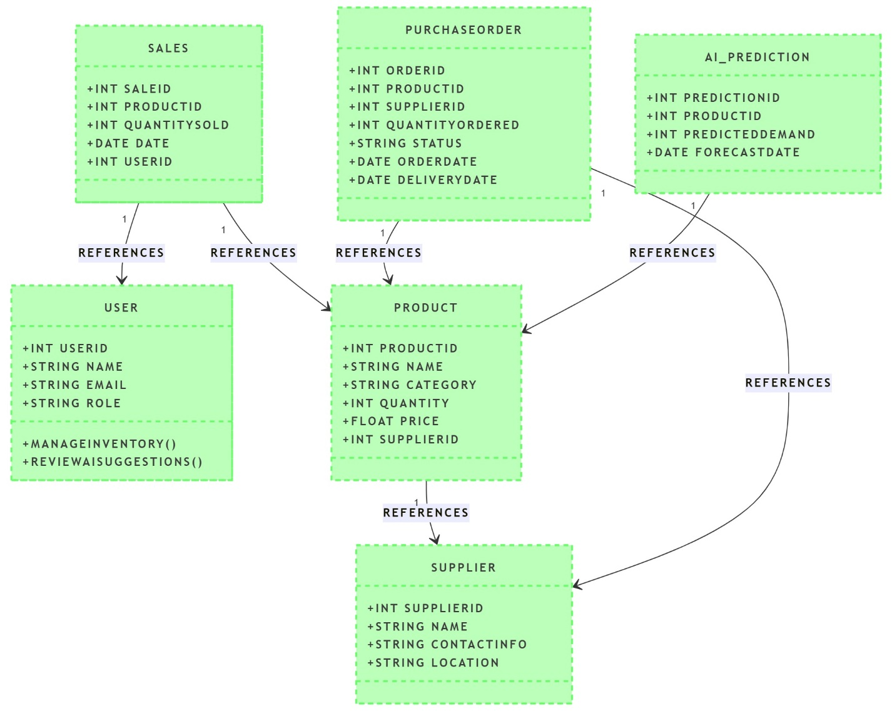

### Flowchart Overview:

1. User interacts with the dashboard, sends requests to backend API.
2. AI processes data and predicts demand, returns stock recommendations.
3. System triggers automated alerts, admin approves restocking order.
4. Supplier gets notified, new stock is added upon arrival.
5. Excel files can be uploaded to insert bulk stock data.

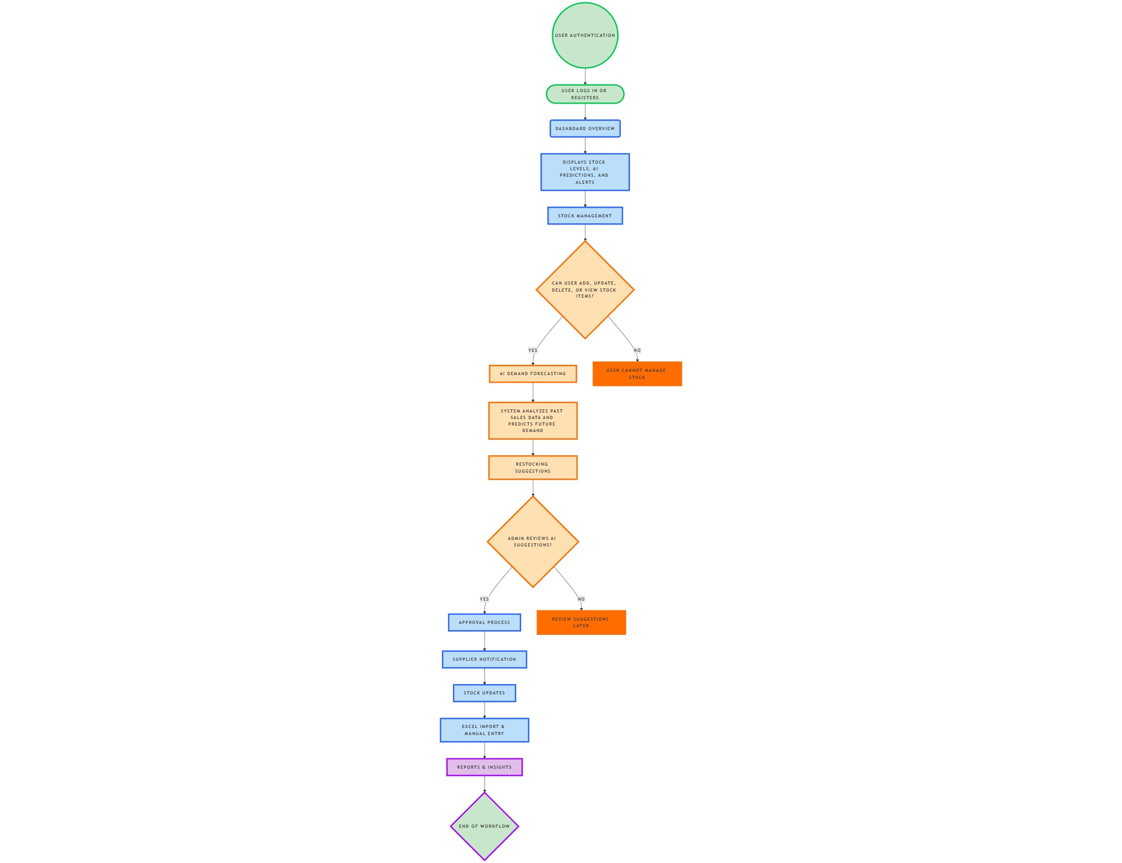

## 9) Development & Coding Strategy

### Development Methodology:

* **Agile with Sprints**: Divide development into short, focused sprints (Inventory CRUD, AI model training, Dashboard UI, API integration, Testing, Deployment).
* **Version Control**: GitHub repository for collaboration.

### Testing Approach:

* **Unit Testing**: PyTest for backend, Jest for frontend.
* **Integration Testing**: End-to-end testing of stock updates and AI predictions.
* **Load Testing**: Ensuring system handles multiple concurrent users.

## 10) Additional Resources

### Market Research:

* Industry reports on AI in inventory management.

### Competitor Analysis:

* **SAP**: SAP SE is a European multinational software company and the world’s largest vendor of enterprise resource planning software.
* **Oracle ERP**: Oracle Cloud ERP is a cloud-based enterprise resource planning software that manages accounting, financials, project management, and procurement.

### References:

* Case studies on AI-based demand forecasting.

**11) Future Enhancements (Version 2.0 & Beyond)**

* **Planned Enhancements:**
* **IoT integration** for automated stock tracking using RFID.
* **AI-powered pricing recommendations** based on demand.
* **Blockchain-based supplier contract management.**

#### **Scalability & Performance Optimization**

* **Handling Large Datasets:** Optimize performance for businesses with **millions of inventory items**.
* **Caching Mechanisms:** Implement **Redis** for **faster query performance**.
* **Database Optimization:** Use **sharding & partitioning** for large-scale data management.