NAME: Neville P
ROLL NO: 241901072

EXPERIMENT 10
EXTRACT EXCHANGEABLE IMAGE FILE FORMAT (EXIF) DATA FROM IMAGE FILES USING EXIFREADER SOFTWARE

AIM
To extract and examine Exchangeable Image File Format (EXIF) data from image files using Exifreader software.
PROCEDURE
- Select an image file from the computer for EXIF data extraction.
- Download and install Exifreader software, if it is not already installed.
- Open the Exifreader application.
- Load or select the image file to be examined.
- Allow the software to read and display the image's EXIF metadata.
- Observe the camera make and model details, if available.
- Examine image properties such as date and time, image dimensions, and file format.
- Check other available metadata fields, such as exposure settings and orientation.
- Record the displayed EXIF information and analyze the metadata obtained from the image.
OBSERVATION
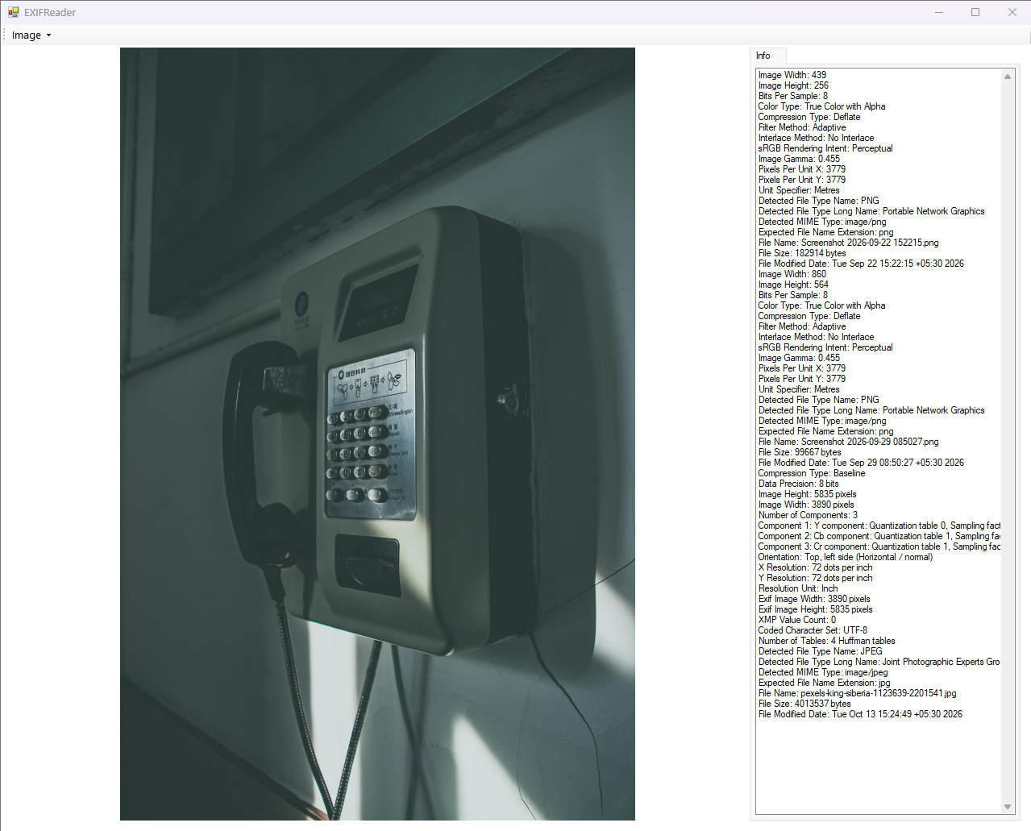

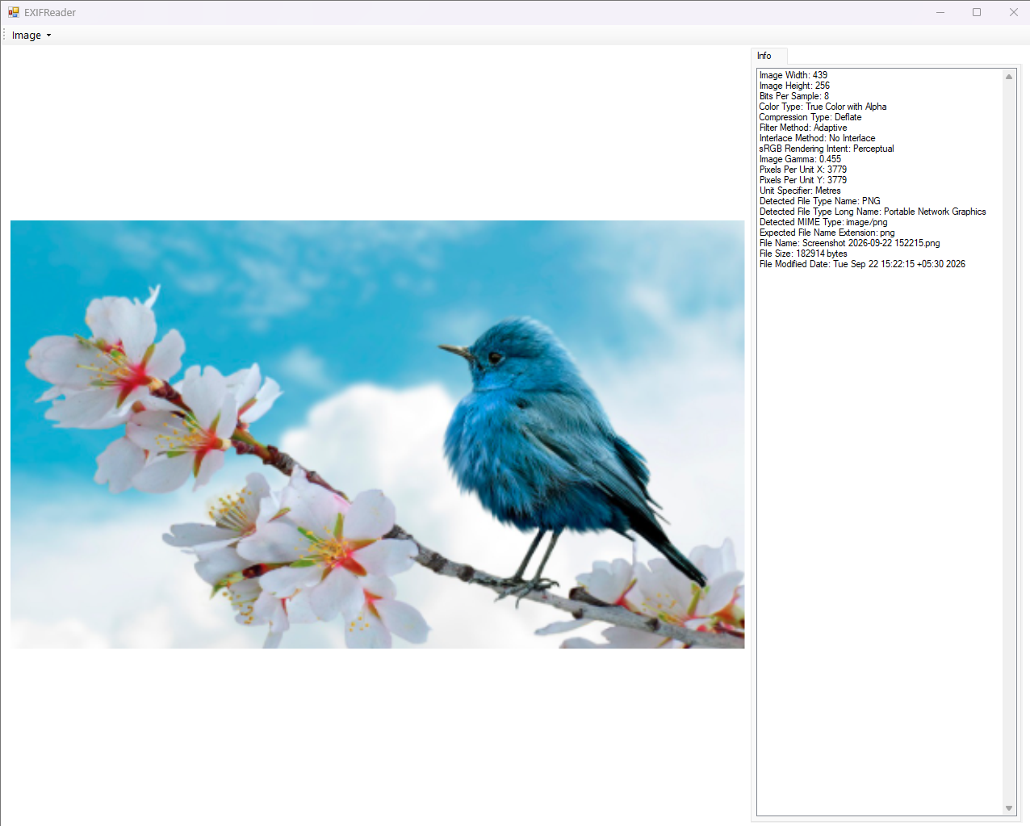

RESULT
EXIF data was extracted and examined from an image file using Exifreader software.

