NAME: Neville P
ROLL NO: 241901072
EXPERIMENT – 2
LIVE FORENSICS CASE INVESTIGATION USING AUTOPSY
AIM
To investigate a live forensic case using Autopsy and analyze digital evidence from a computer system or storage device.
PROCEDURE
- Open Autopsy and click New Case. Enter the case name and base directory.
- Enter the case number and examiner details, then click Finish.
- Select the appropriate data source and browse to the evidence file or device.
- Configure the required Ingest Modules and click Finish to start processing.
- Examine the forensic investigation results after processing is complete.
- View device details, EXIF metadata, installed programs, operating system information, and user accounts.
- Analyze recent documents, web bookmarks, cookies, downloads, browsing history, search history, and email addresses.
- Review the extracted artifacts and document the findings.

OBSERVATION
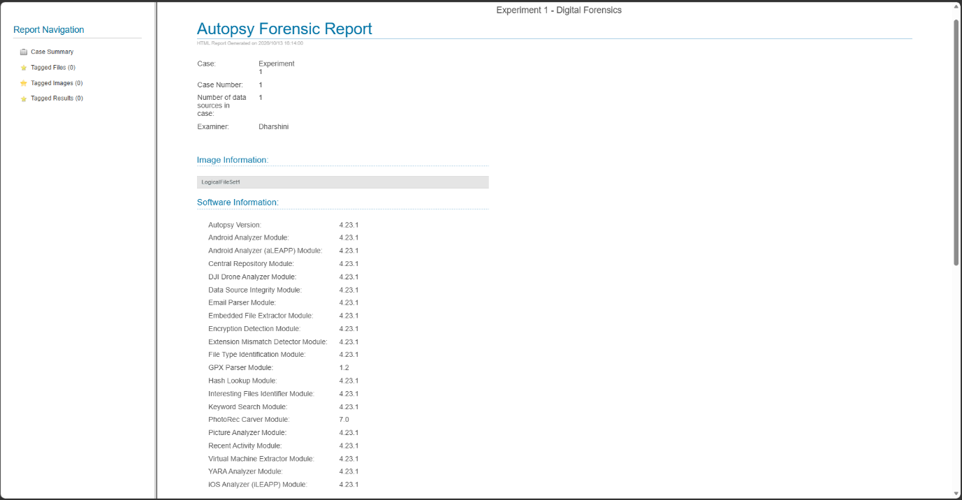
Figure 1.1 Autopsy Forensic Report

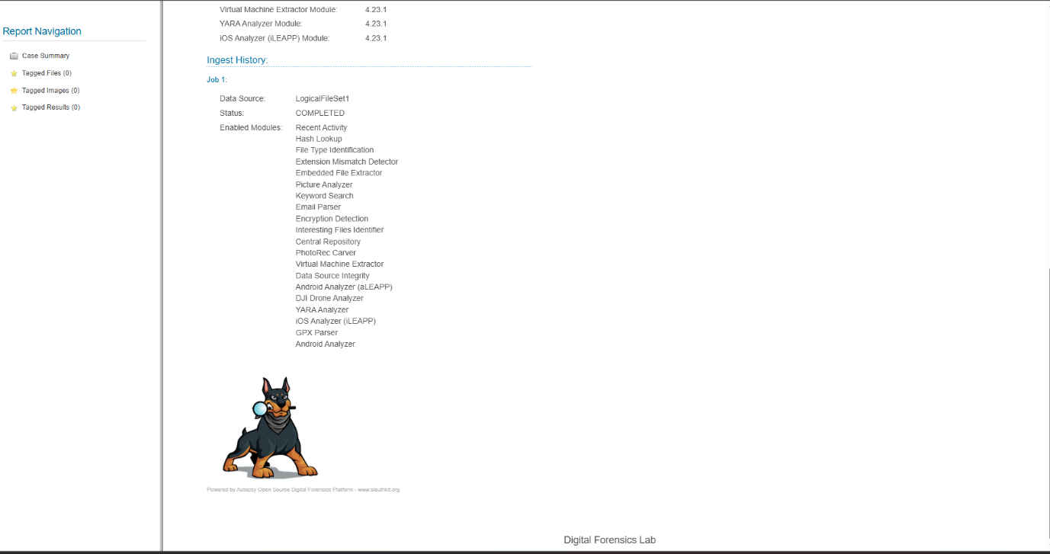
Figure 1.2 Autopsy Forensic Report

RESULT
Thus, Autopsy was used to create a forensic case, process the selected evidence source, and examine digital artifacts for forensic investigation.

