NAME: Neville P
ROLL NO: 241901072
EXPERIMENT – 4
FIND LAST CONNECTED USB ON YOUR SYSTEM (USB FORENSICS)
AIM
To identify the last connected USB device on a system using USB forensics.
PROCEDURE
- Download and run the USBDeview utility on the Windows system.
- Open USBDeview to view the list of USB devices.
- Identify the USB devices currently connected to the computer.
- Examine the list of previously used USB devices.
- Check the device name and description of each USB device.
- Observe the device type and serial number, if available.
- Check the date and time when each USB device was added to the system.
- Examine the Vendor ID and Product ID of the USB devices.
- Compare the available device details and timestamps to identify the most recently connected USB device.

OBSERVATION
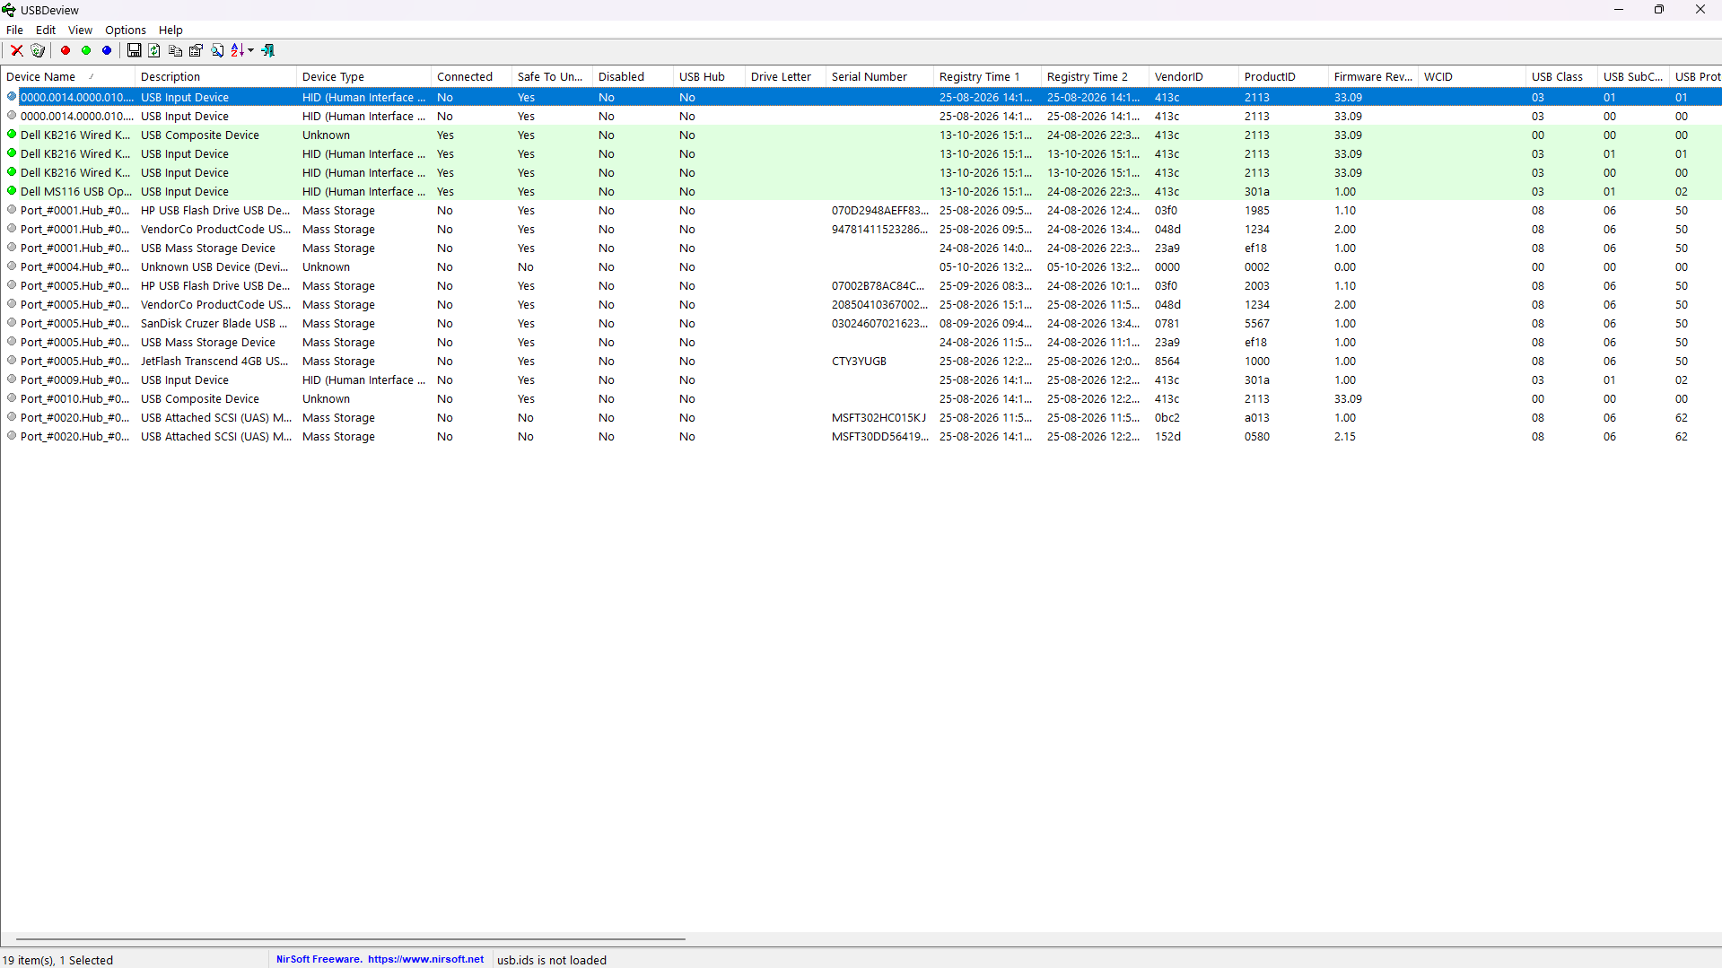

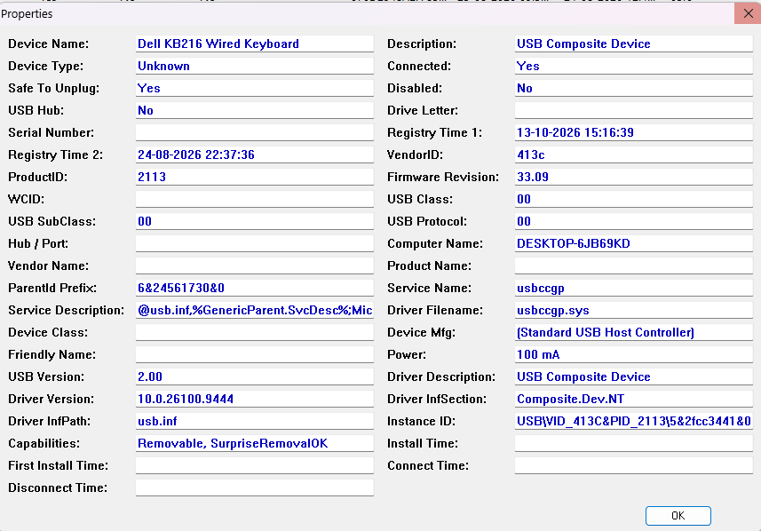

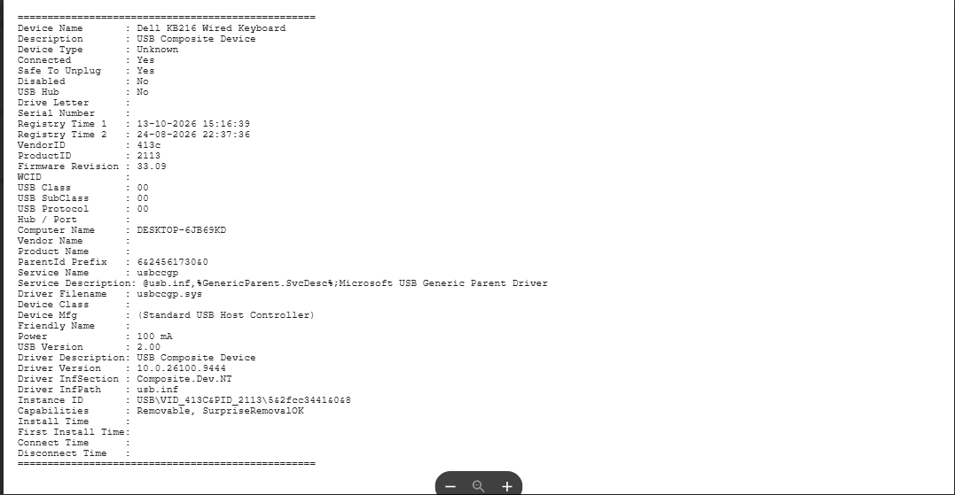

RESULT
Thus, USBDeview was used to examine USB device details and identify the most recently connected USB device on the system.

