NAME: Neville P
ROLL NO: 241901072
EXPERIMENT – 7
COMPARISON OF TWO FILES FOR FORENSICS INVESTIGATION BY COMPARE IT SOFTWARE
AIM
To compare two files for forensic investigation using Compare It software.
PROCEDURE
- Download and install the Compare It software.
- Open the Compare It application.
- Select the option to choose files for comparison.
- Browse and select the first file, then click Open.
- Select the second file and click Open.
- Allow the software to compare the contents of both files.
- Observe the differences highlighted in the comparison window.
- Examine the changes displayed side by side.
- Generate or print a report showing the differences between the two files.

OBSERVATION
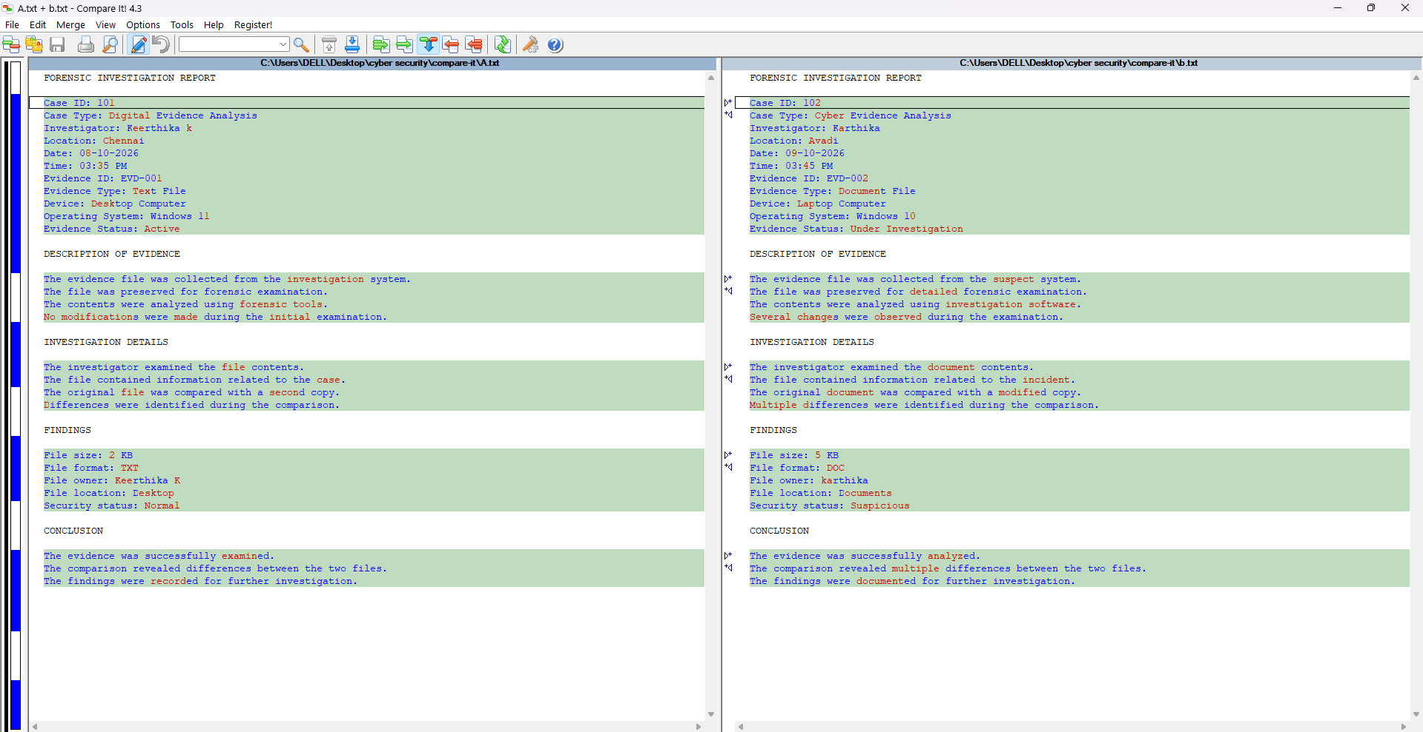

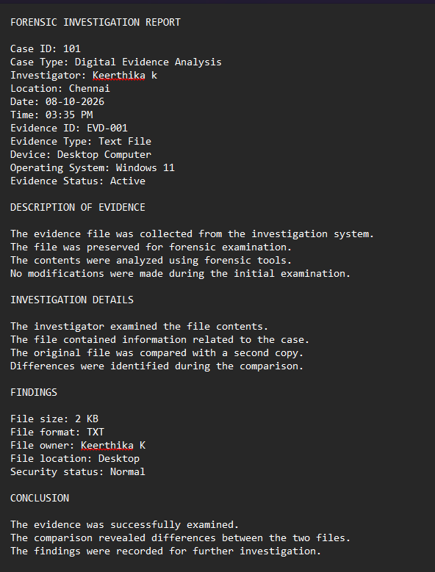
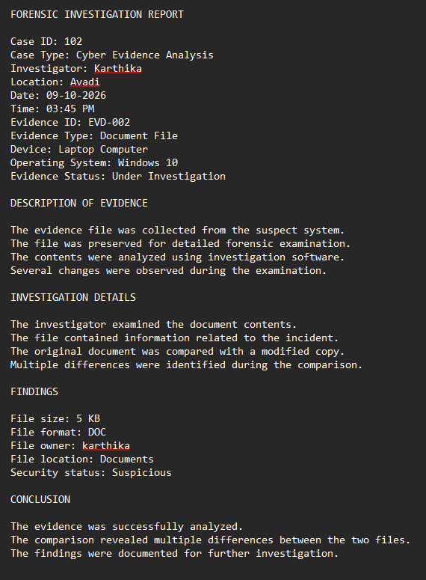

RESULT
Thus, two files were compared successfully using Compare It software, and the differences were identified for forensic investigation.

