NAME: Neville P
ROLL NO: 241901072

EXPERIMENT – 9
STUDY THE STEPS FOR HIDING AND EXTRACTING ANY TEXT FILE BEHIND AN IMAGE FILE/AUDIO FILE USING COMMAND PROMPT.

AIM
To study the steps for hiding and extracting a text file behind an image or audio file using Command Prompt.
PROCEDURE
- Copy the text file (A.txt) and image file (B.jpg) to the Desktop.
- Open the Command Prompt by pressing Win + R, typing cmd, and pressing Enter.
- Navigate to the Desktop using the command cd Desktop.
- Use the command copy /b B.jpg + A.txt C.jpg to combine the image and text file.
- Verify that the output file C.jpg has been created.
- Open the output image file using Notepad.
- Scroll to the end of the file to locate the hidden text content.
- For audio files, place the audio file and the file to be hidden in the same folder.
- Use the binary copy command to combine the files and examine the output using a suitable archive utility.
OBSERVATION
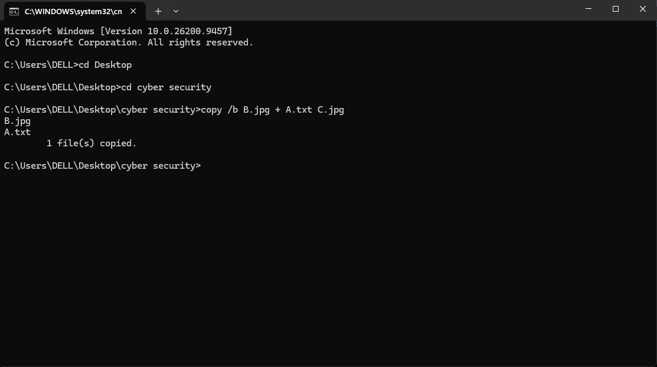

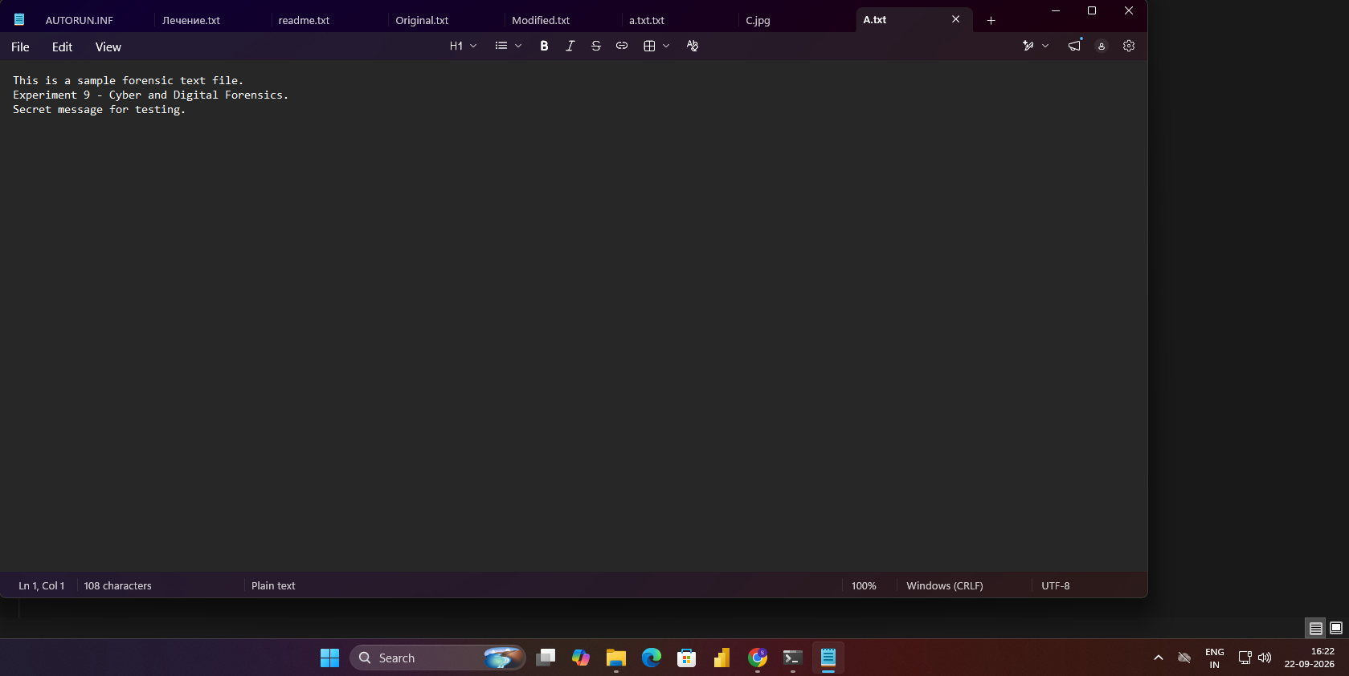

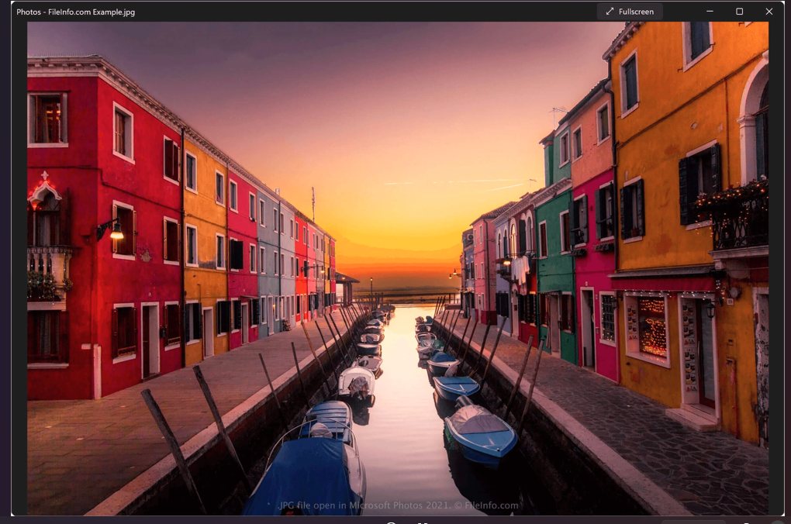

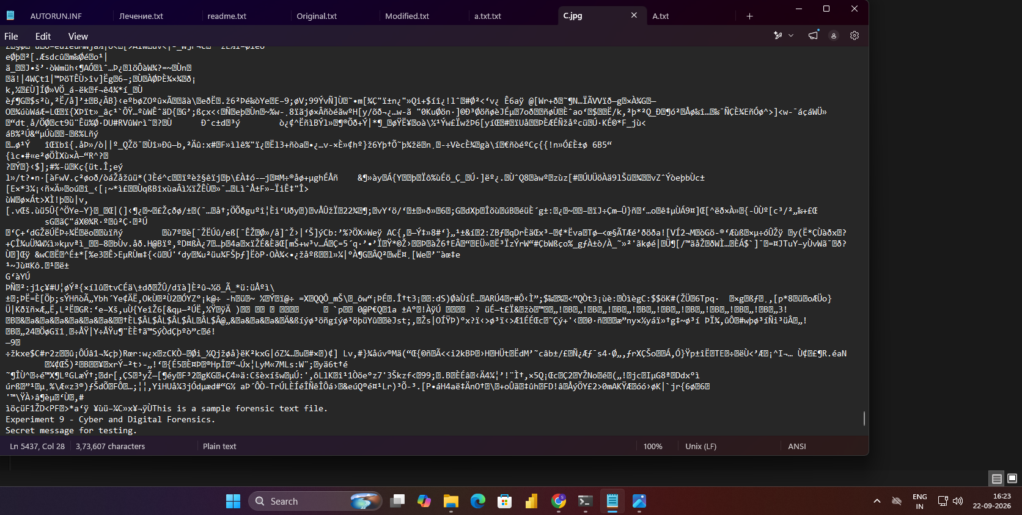

RESULT
Thus, the steps for hiding and extracting text data behind image or audio files using Command Prompt were studied successfully.

