**YouTube Media Player-**

**Implement YouTube Media Player and Play Video**

1. **Task Description**

In this task, you will implement a YouTube Media Player in an Android application using the **Android-YouTube-Player Library**. The application will play a YouTube video when the screen is loaded.

The process includes the following steps:

1. Add the dependency of Android-YouTube-Player.
2. The app will display a YouTube video player on the screen.
3. Upon launching the app, the video will automatically load and start playing from the specified YouTube Video ID.
4. The activity will manage the lifecycle of the YouTube player and release resources when the activity is destroyed.
5. **Task Output Screenshot**

• **Screen 1:**   
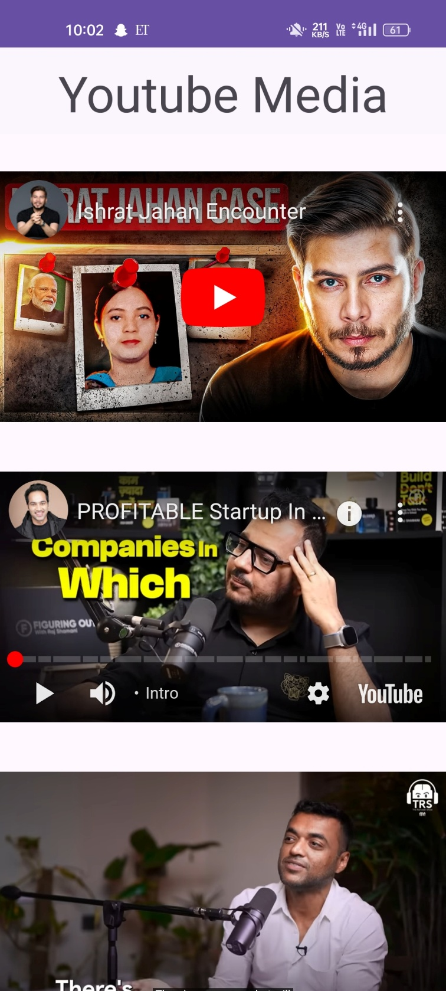

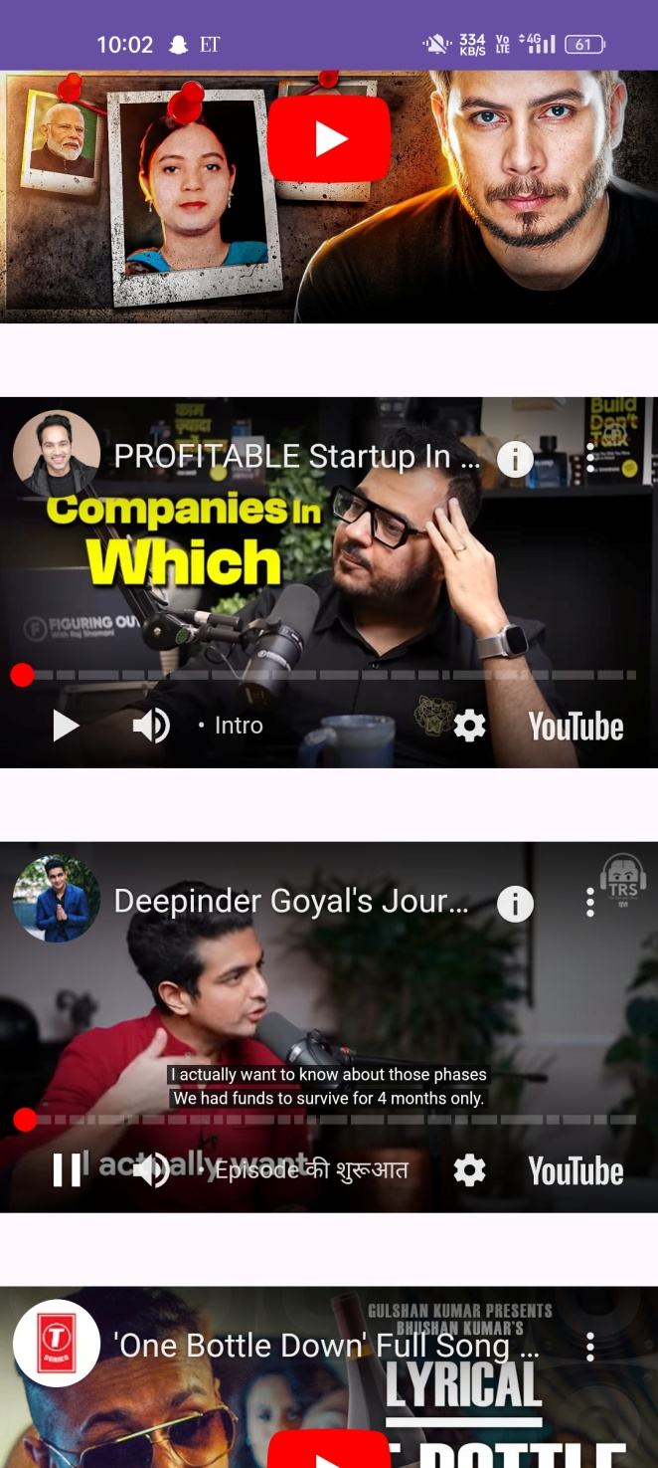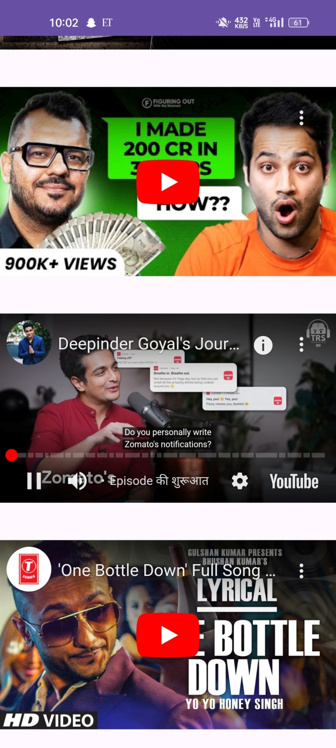

1. **Widget/Algorithm Used In Task**

**Widgets:**

* **YouTubePlayerView**  
  This widget is used to display the YouTube player inside your Android app. It embeds the YouTube video player and allows the app to load and play videos by interacting with the YouTube API.

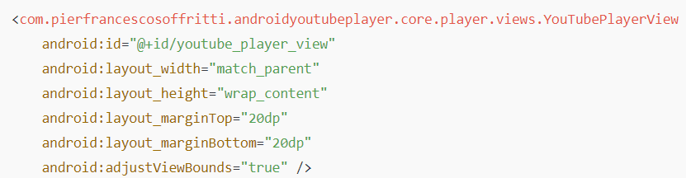

* **ConstraintLayout**  
  The ConstraintLayout is used as the root layout in the XML file, making it easier to arrange the YouTubePlayerView widget and ensuring it adjusts to different screen sizes.

**Permissions:**

* **INTERNET Permission**

The app requires internet access to fetch the video from YouTube. This is achieved by adding the following permission to the AndroidManifest.xml file:



**Dependencies:**

* **YouTube Player API**

The YouTube player functionality is added using the external library provided by **Pierfrancesco Soffritti’s Android YouTube Player API**. You need to add this dependency to your app’s build.gradle file:

