**REPUBLIC OF CAMEROON REPUBLIQUU DU CAMEROUN**

**Peace – Work – Fatherland Paix – Travail - Patrie**

**MINISTER OF HIGHER EDUCATION MINISTERE DE L’ENSEIGNEMENTS**

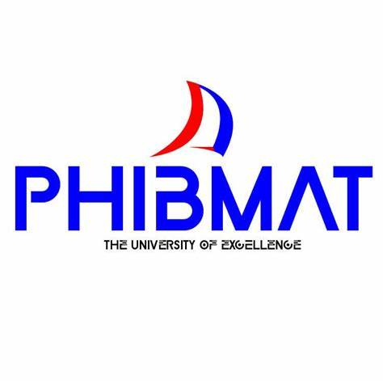 **DEPARTMENT OF BIOMEDICAL SCIENCES**

**OPTION꞉ NURSING**

The University of Excellence

**EXPLORING THE KNOWLEDGE AND ATTITUDE OF PATIENTS TOWARD STUDENT NURSES(TRANSFERENCE IN NURSING)AT THE BONASSAMA DISTRICT HOSPITAL**

Research Report Submitted to the Department Biomedical Sciences, Specialty of

Nursing in Partial Fulfillment of the Requirements for the Award of a Higher

National Diploma (HND) In Nursing Science

**Written and Presented by**

**MBONGWOH GILIANNE NCHANGE**

**23NUR41**

**Supervisor**

**MR. AFESEH ELIAS**

**APRIL 2025**