**Instructions**

* Requirements and Installations

Your computer should have at least 4 GB RAM and intel i3 processor to run the whole web application.

**XAMPP**

1. First go this website: - <https://www.apachefriends.org/download.html> and download the XAMPP in your computer. Install the XAMPP. After installation go to the xampp folder and inside xampp folder, search for xampp-control and after that click on it. See the below picture for better understanding.

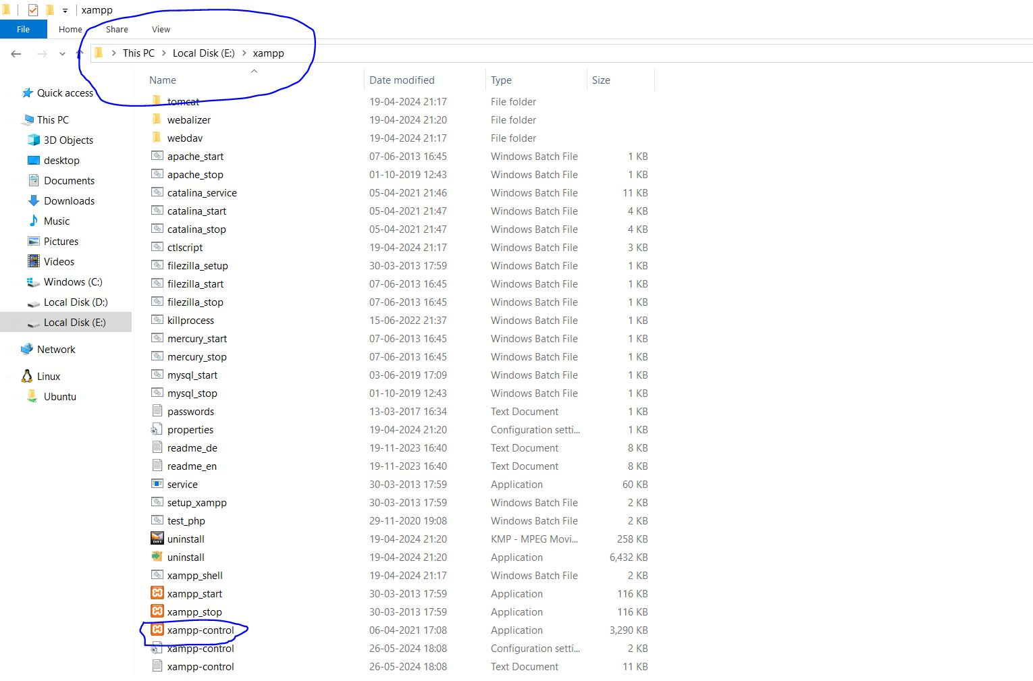

1. After that xampp control panel will be opened. Click on the start buttons of both Apache and MySQL and after that click on the admin button, see the below picture for better understanding.

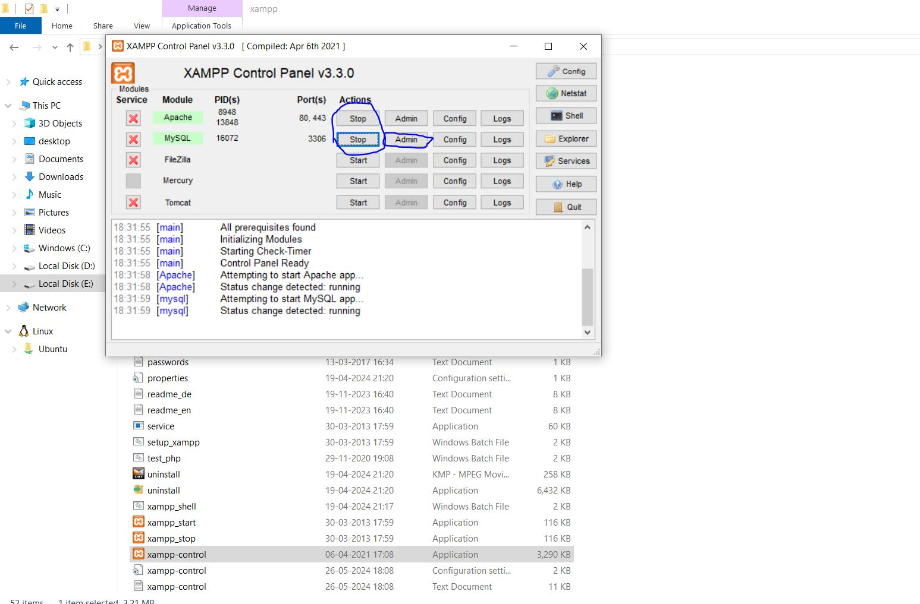

1. Now after that phpMyAdmin will be opened in your web browser. There you will create a database called umbrella-admin. Click on the new button and enter the database name and click on create. See the below picture for better understanding.

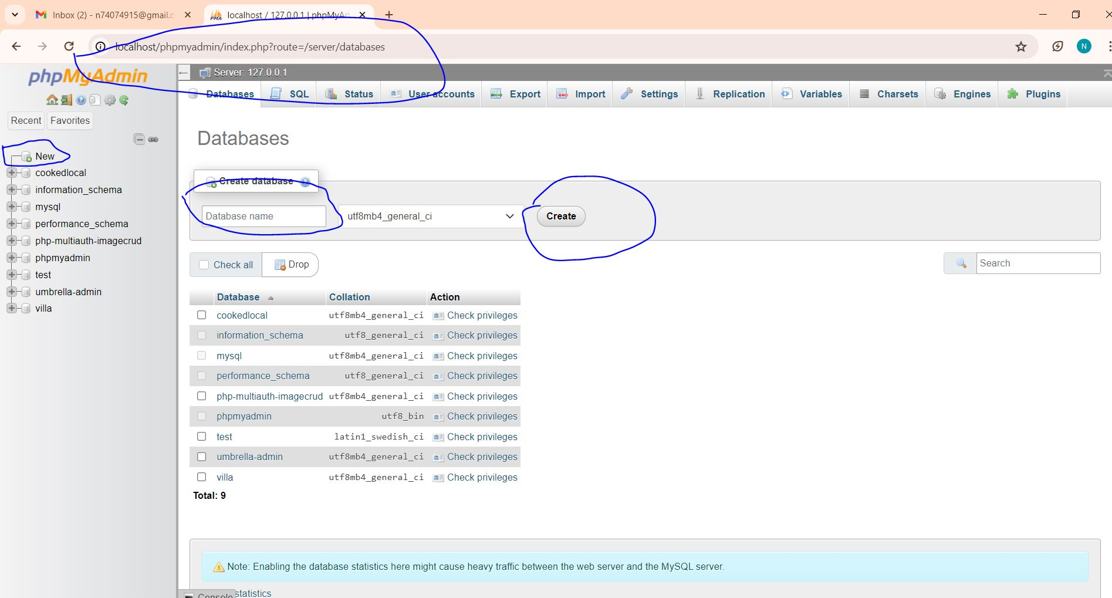

**NODE NPM PACKAGE MANGER**

1. Now go this website: - <https://nodejs.org/en/download/prebuilt-installer>

Download NODE accordingly and install it properly. To check if it is installed. Open command prompt and type node -v command. See the below picture.

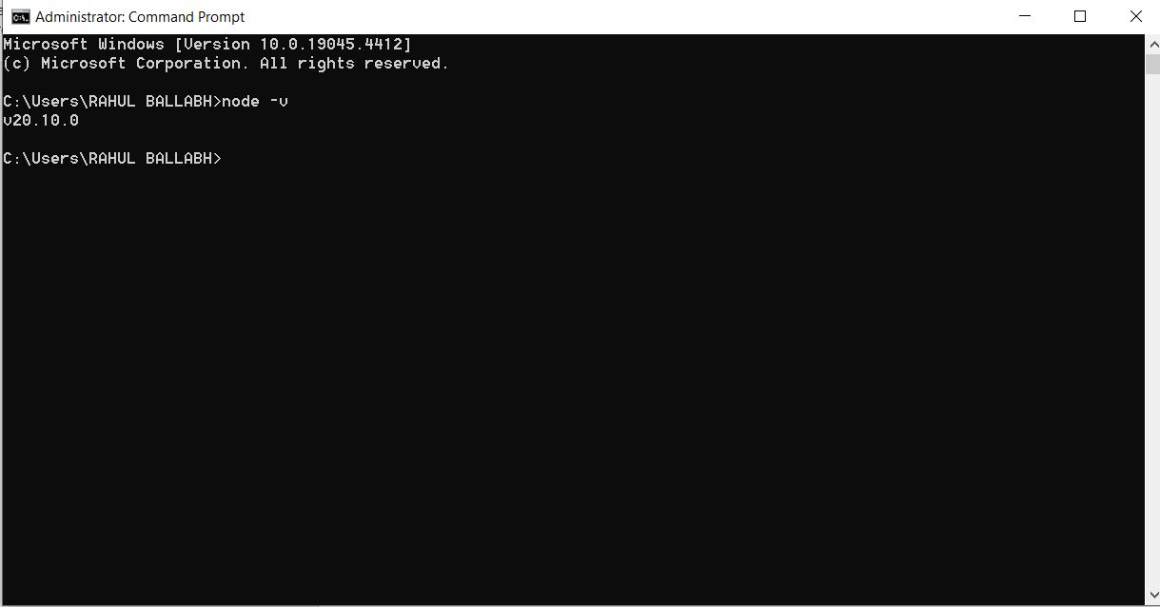

**Code Editor**

1. Go to this website: - <https://code.visualstudio.com/download>

Download the VS Code and install the VS Code for opening or editing or coding JavaScript files.

**Gmail Credentials**

1. Login to Gmail account with following credentials: -

Email: - [n74074915@gmail.com](mailto:n74074915@gmail.com)

Password: - NevileShah@123

**Cloudinary**

1. Go to this website: - <https://console.cloudinary.com/pm/c-54e5337f8e800f05eebb70b29601e4/getting-started>

Login with the above Gmail credentials.

**OpenWeatherMap**

1. Go this website: - <https://home.openweathermap.org/api_keys>

Sign up and Login and get the API key. Open the zip the file we sent it to you. In that file look for backend folder, open that folder with code editor and look for .env file and there, paste the appropriate API keys.

**Mailtrap**

1. Go to this website: - [https://mailtrap.io/home/](https://mailtrap.io/home/%20)

Sign up and Login and Email Testing inbox and get the appropriate keys and paste them in .env file same way as before.

See the below picture.

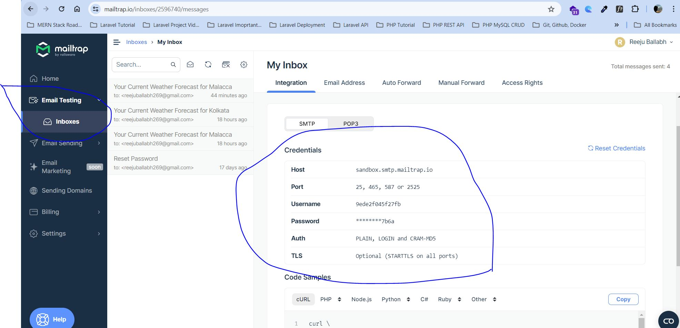

**STRAPI**

1. Remember these credentials and use it, when it is required.

Username or email: - [n74074915@gmail.com](mailto:n74074915@gmail.com)

Password: - Nevile@123

* **How to run the web application?**

Open the zip file and unzip it, if you have not done yet. After that you will see three folders: - Admin, backend, jmbrella. Follow the demonstration video, you will notice, how the three folders are being opened with command prompt. Carefully see that part repeatedly. First open the Admin folder with command prompt and type npm run develop command. Open the backend folder with command terminal and type npm start command. Open the jmbrella folder with command prompt and type npm start command. Wait for few minutes and after of these terminals are working, then go to the web browser and type localhost:3000 to open the web application and open another tab and type localhost:1337/admin to open the Strapi Admin Panel. After that using above mentioned Strapi credentials, login and add, edit, and remove news-article images and titles and descriptions. Watch the demonstration video very carefully to understand. If any error appear in any of these three command prompt, type these two commands: - npm install and npm update.