  


**TECHNOLOGICAL UNIVERSITY OF THE PHILIPPINES**

Ayala Blvd, Ermita, Manila, Metro Manila

**College of Science**

PyPoint: Simple One-Point Iteration Calculation & Visualization Program

An Undergraduate Project Requirement for the Degree

of

BACHELOR OF SCIENCE IN COMPUTER SCIENCE

CSF2 – Free Elective

SUBMITTED BY:

Aquino, Kyle Shaun

Estopace, Robert G.

Revillas, Harvey

SUBMITTED TO:

Prof. Ernita Calayag

MARCH 2018

1. **Introduction**
   * 1. *Overview of the Development and Operation of the Program*
2. **Objectives**
3. **Scope and Limitation**
4. **The Program**

*Programming Lan*g*uage*

The developers utilized Python 3 as the programming language in the creation of the program.

*Software Used*

The developers used PyCharm IDE as their programming platform during the development of the system.

*Design and Development*

The developers of the project used PyLab as a platform that allows the system to plot functions.

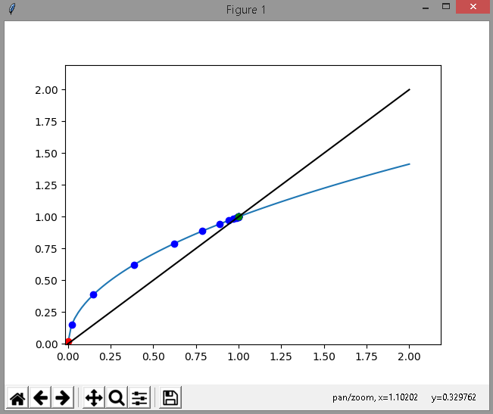

*Sample Plot*

*Operation*

Step 1: Input Mathematical Function

Step 2: Input Starting Point

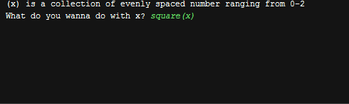

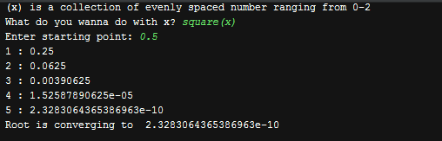

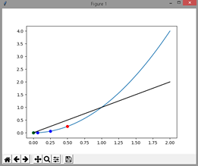

1. **Applications**
   * 1. *Sample Problems (at least five)*
     2. *Discussion of Results of the Solution Obtained*
     3. *Exercise Problems with answer*
2. Evaluation and Recommendation