Building AI Application Challenge 2026
Builder Progress Log & Submission Workbook
Days 2–8 (Environment → Build → Evaluate → Deploy → Submit)

Use this document as a living workbook. Update it daily with links to your repo, demos, screenshots, and decisions.

0) Participant & Project Metadata
Participant Name | Nevin Pinto
Email | Not provided
Timezone | GST (Dubai)
Start Date | 9 November 2026 (local working date; confirm if challenge start date differs)
Path (select one) | ☐ Model Building ☒ LLM/API Integration ☐ No-Code/Low-Code
Team Members (if any) | Individual project
Mentor / Reviewer (if any) | Not provided
Project Repo URL (GitHub) | Not created/published yet
Demo / App URL (if available) | Local prototype: http://localhost:3000 (only accessible on the user's computer)

Quick links (keep updated):
- ☐ GitHub repo (public link)
- ☐ Deployment link (Hugging Face / Streamlit / other)
- ☐ Demo video link (Loom/YouTube)
- ☐ LinkedIn progress post URL
- ☐ Tweet/X progress post URL (if applicable)

1) Day 1 Idea Summary (from your Day 1 template)
Fill this section by copying your Day 1 submission. Keep it crisp but specific.
Project Title | Nevin Chemistry Chatbot
Concept Summary | An AI-powered Chemistry learning assistant that helps students understand Chemistry concepts and solve problems through clear, step-by-step explanations.
Target Audience | School and college students learning introductory Chemistry and practising numerical or conceptual questions.
Key Features (top 3–5) | 1) Explains Chemistry concepts in simple language. 2) Shows step-by-step calculations with units. 3) Helps with balancing equations and stoichiometry. 4) Checks significant figures and chemical plausibility. 5) Encourages learning with a short understanding check when useful.
Technical Approach (high-level) | Browser-based HTML/CSS/JavaScript interface; Node.js and Express backend; Groq-hosted language model accessed through the OpenAI-compatible JavaScript SDK; local environment variables for secrets.
Expected Challenges | API quotas and model availability; Chemistry answer accuracy; safe handling of API keys; clear error handling; avoiding unsupported claims.
Expected Outcome (by Day 8) | A working, documented Chemistry tutoring prototype with tested example questions, a clean GitHub repository, screenshots and (if time permits) a deployed demo.
Additional Notes | Day 2 environment and first Groq API integration completed locally. Further evaluation, GitHub publication and deployment remain outstanding.

2) Architecture Snapshot (living design)
Update this whenever your design changes.
One-line problem statement | Students need accessible, step-by-step Chemistry support, not only final answers.
Primary user story / flow | Student enters a Chemistry question in the browser → frontend sends conversation to Express endpoint → server adds Chemistry tutor instructions → Groq API generates response → server returns answer to browser.
Inputs | Student's text question and recent conversation messages (limited by backend validation).
Outputs | Chemistry explanation or worked solution displayed in the chat interface.
Key components (UI, backend, storage, etc.) | Frontend: HTML, CSS, browser JavaScript. Backend: Node.js + Express. Model provider: Groq API. Configuration: local .env. No database or RAG pipeline in the current prototype.
Data flow diagram (link/image) | Not created yet. A simple flow is described in the user story above.
Non-functional requirements (latency, cost, privacy, uptime) | Cost: use Groq free-tier quotas subject to current limits. Privacy: API key remains server-side in .env. Latency/uptime: dependent on local machine, internet and provider availability. Prototype is local, not deployed.

3) Data / Knowledge Sources Inventory
Day 2 focus: list your data sources clearly. This becomes critical for quality, evaluation, and judging.
Source | Type | Owner / License | Format | Size | Update freq | Access method | Preprocessing needed | PII/Sensitive? | Status
Student questions | User-provided input | End user | Text | Per request | Live | Chat interface | Backend validates role/content and limits message length | May contain personal data; advise users not to enter sensitive details | Implemented
Chemistry tutor instructions | Prompt / application instructions | Project author | Text in server.js | One system prompt | Updated with code | Server-side | Maintained in source code | No personal data intended | Implemented
Groq language model | Hosted model/API | Groq; model subject to provider terms | API request/response | Per API call | Provider-managed | HTTPS API | Request messages and model response | Review provider data policy; do not submit sensitive data | Connected; first answer confirmed
If you are doing RAG / search:
☐ Corpus assembled (what content?)
☐ Chunking strategy defined (size/overlap)
☐ Embedding model selected
☐ Vector store selected (or file-based retrieval)
☐ Citation strategy (how will you show sources?)
☐ Data safety: remove secrets/PII and respect copyright

4) LLM / Model Selection & Experiments
Capture what you tried, what worked, and why you chose your final stack.
Candidate | Provider | Why considered | Prompting approach | Quality notes | Latency notes | Cost notes | Decision
Groq `openai/gpt-oss-20b` | Groq API | Free-tier hosted inference; OpenAI-compatible endpoint | Chemistry system prompt + conversation messages | One live question returned an answer; not yet independently graded | Not measured | Free-tier quotas/rate limits apply; confirm current console limits | Selected for prototype; further evaluation pending
OpenAI API | OpenAI | Initial implementation path | Same Chemistry tutor instructions | Blocked by no remaining API credits in user's account | Not measured | Requires paid API balance | Not selected for current prototype
Prompt versions (for LLM/API or No‑Code tools):
Prompt ID | Goal | System constraints | Few-shot examples? | Tools/Actions used | Notes / Results
Chemistry tutor system prompt | Application-level prompt | Consistent step-by-step teaching behavior | Role, calculation steps, units, safety and uncertainty constraints | First basic response confirmed; quality evaluation pending | Not measured
Included in API input tokens | Keep and evaluate
Model-building path only (if applicable):
Framework | e.g., PyTorch / TensorFlow / scikit-learn
Model family | e.g., classifier / regressor / transformer / CNN / etc.
Baseline approach
Training data
Validation strategy
Key metrics

5) Day 2 — Environment Setup & Initial Development
Deliverable for Day 2: no full project submission today—prepare your environment + tech stack/tooling + initial work evidence.
Environment setup checklist (tick what applies):
- ☐ Repository created and initial commit pushed — not yet done
- ☒ README created (project goal + how to run)
- ☒ .gitignore configured (no secrets)
- ☐ Python environment / no-code workspace — not applicable (Node.js project)
- ☒ Dependencies installed (npm install; lockfile not yet added)
- ☒ API key stored safely in local .env (never include it in GitHub)
- ☒ Local application launched successfully
- ☒ Basic Groq API call tested; first Chemistry answer confirmed by participant
- ☒ Project folder structure created (public/, docs/, server.js)
- ☒ First prototype screen and chat flow created
Evidence (links):
GitHub repo URL | Not yet created. Add the public GitHub URL after repository publication.
Commit hash / tag | Not yet created.
Screenshot(s) link | Screenshots still need to be captured and added. See docs/screenshots/ in the project package.
Notes on setup decisions | Used Node.js/Express for a simple local web app; retained the existing interface; switched from OpenAI API to Groq after the OpenAI account returned a no-credit error; stored the Groq key in .env.
Initial development log (what you built today):
• Installed VS Code and Node.js; verified Node.js and npm from the terminal.
• Installed project dependencies and configured the local .env file.
• Updated the backend to use Groq's OpenAI-compatible API and confirmed a first Chemistry answer in the browser.
Blockers / issues encountered (and how you resolved them):
• PowerShell blocked npm.ps1; resolved by using npm.cmd without changing execution policy.
• OpenAI API account had no remaining credits; switched the prototype to Groq. GitHub repository and screenshots are still pending.

Day 3 — Building the Brain of Your App
Checklist:
- ☐ Core logic implemented (model/prompt/workflow)
- ☐ Data ingestion or API integration expanded beyond hello world
- ☐ 10–20 test questions/examples drafted (start your 'exam set')
- ☐ First measurable baseline created (even if rough)
- ☐ README updated with run instructions
Artifacts / notes:
What is the 'brain' of your app (1–2 sentences)? | Planned brain: Chemistry system instructions plus Groq-hosted model. It is designed to explain concepts and show worked steps, units and checks.
Link to key code/workflow | Local code: server.js (publish repository first, then add GitHub link).
Baseline results (short) | One successful live smoke test confirmed by participant; no scored baseline or independent accuracy evaluation yet.
What you will improve next | Run 10–20 test questions, check calculation accuracy, improve error handling and document limitations.
Decisions made today (why):
•
•
Blockers / help needed:
•

Day 4 — Optimizing Integration & Application Evaluation
Checklist:
- ☐ Evaluation approach defined (metrics + test set)
- ☐ Error handling + retries added (API) OR validation rules added (no-code)
- ☐ Prompt/model iteration based on failures
- ☐ Latency/cost notes captured
- ☐ Safety/guardrails considered (content, PII, injection)
Artifacts / notes:
Evaluation dataset link / location | docs/testing-checklist.md (initial test set; additional cases pending)
Metrics used (accuracy, faithfulness, etc.) | Planned: factual correctness, calculation accuracy, equation balance, units, clarification behavior, API availability. No aggregate score yet.
Top failure modes found | Initial OpenAI API call blocked by zero credits; Groq connection now returns a response. Chemistry correctness not yet comprehensively evaluated.
Fixes applied | Changed API provider to Groq and updated environment variables/client configuration. Further error handling and regression tests pending.
Decisions made today (why):
•
•
Blockers / help needed:
•

Day 5 — Integration of Model/API with Interface
Checklist:
- ☐ User flow designed (screens + inputs/outputs)
- ☐ Interface connected to backend/logic
- ☐ UX basics: loading, error states, reset/clear
- ☐ Logging of inputs/outputs enabled (safe logging)
- ☐ Demo link created (even if rough)
Artifacts / notes:
Interface tech (Gradio/Streamlit/React/No-code UI) | HTML, CSS and browser JavaScript; Node.js + Express backend.
Demo link | Local only: http://localhost:3000 (not a public demo URL).
Screenshots link | Capture actual screenshots locally; none embedded in this workbook yet.
Known UX issues to fix | Need additional UX testing, loading/error-state review and screenshots.
Decisions made today (why):
•
•
Blockers / help needed:
•

Day 6 — Final Enhancements, Security & Debugging
Checklist:
- ☐ Input validation + sanitization
- ☐ Secrets handling reviewed (no keys in repo)
- ☐ Rate limits / caching considered
- ☐ Bug list triaged and reduced
- ☐ README + architecture notes cleaned up
Artifacts / notes:
Security checklist notes | .env used for GROQ_API_KEY; .gitignore excludes .env and node_modules. Never commit provider keys.
Top bugs fixed | Resolved npm PowerShell script restriction using npm.cmd; switched provider after OpenAI balance error.
Remaining risks | Provider quotas/model availability; unverified Chemistry answer accuracy; repository not yet published; local-only app.
Decisions made today (why):
•
•
Blockers / help needed:
•

Day 7 — Final Review & Deployment
Checklist:
- ☐ Deployment target chosen and deployed
- ☐ Environment variables set in deployment platform
- ☐ Smoke tests run on deployed version
- ☐ Performance checked (latency/cost)
- ☐ Submission package checklist started
Artifacts / notes:
Deployment platform | Not selected yet.
Deployment URL | Not deployed.
Smoke test results | Local smoke test passed (one response returned); deployed smoke test not applicable.
Fallback plan if deployment breaks | Keep local project and .env backup; redeploy after resolving configuration if hosting fails.
Decisions made today (why):
•
•
Blockers / help needed:
•

Day 8 — Final Submission & LinkedIn Sharing
Checklist:
- ☐ Final app link working
- ☐ Final repo is clean + documented
- ☐ Demo video recorded
- ☐ Final submission form completed
- ☐ LinkedIn post published + link shared
Artifacts / notes:
Final app URL | Not deployed.
Final repo URL | Not published yet.
Demo video URL | Not recorded.
LinkedIn post URL | Not recorded.
Tweet/X URL (if applicable) | Not applicable / not recorded.
Reflection: what you learned | Learned local Node.js setup, npm dependency installation, environment-variable handling and connecting an OpenAI-compatible client to Groq. Need further testing before judging Chemistry accuracy.
Decisions made today (why):
•
•
Blockers / help needed:
•

10) Community Sharing Tracker (bonus points)
Use this to track your social proof and claim points.
Date | Platform | Post URL | What you shared | Tagged DDS? | Points claimed

11) Reference Resources (from the challenge)
Core challenge walkthrough video: https://www.youtube.com/watch?v=X4PitcxNDjE
Python environment setup: https://www.youtube.com/watch?v=D5XyQ96EgiM&t=759s
GitHub basics: https://youtu.be/bV_9mr5O5bg?si=0oiiT9BZutcKCjnL
OpenAI API key setup: https://www.youtube.com/watch?v=CVnTzj-qhCU&t=8s
Model/LLM selection blogs:
• https://decodingdatascience.com/choosing-the-right-gemini-model-for-your-ai-project-a-beginner-friendly-guide/
• https://decodingdatascience.com/openai-guide-to-use-which-model-for-tasks/
• https://decodingdatascience.com/how-to-choose-the-right-openai-model-gpt-5-complete-guide/
AI Explorer RSVP: https://nas.io/artificialintelligence/events/ai-explorer-ai-demos-ai-use-cases-and-q-a-1767887350300

12) Reviewer / Mentor Notes (optional)
Use this section if an instructor/mentor is reviewing your progress.
Strengths observed:
•
Areas to improve next:
•
Action items:
•

Appendix: Project Screenshots and Testing Evidence
The following screenshots were captured from the Nevin Chemistry Chatbot prototype. They document the interface and example chemistry questions tested during the Day 2 build.

Screenshot 1. Chemistry chatbot home screen and first atom-versus-molecule question.
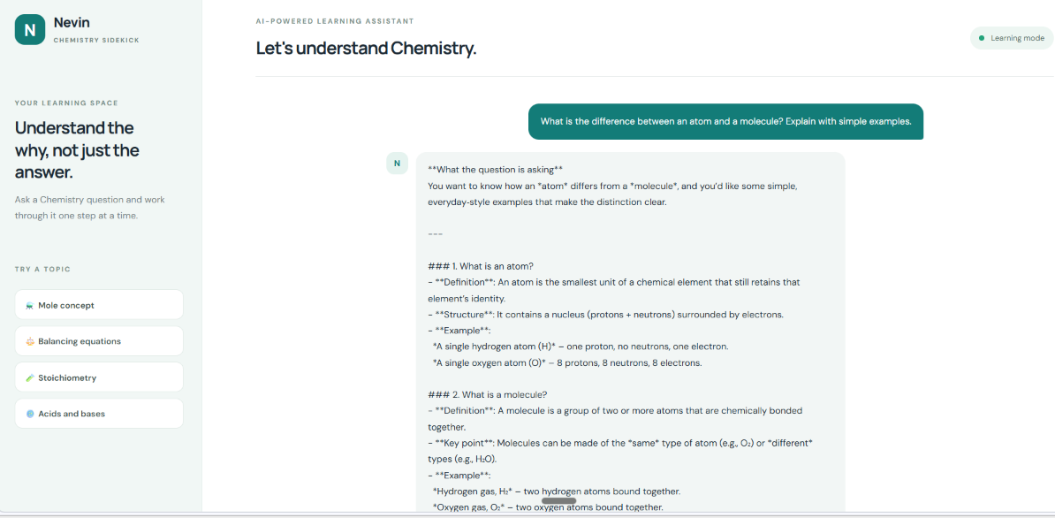

Screenshot 2. Continuation of the atom-versus-molecule explanation.
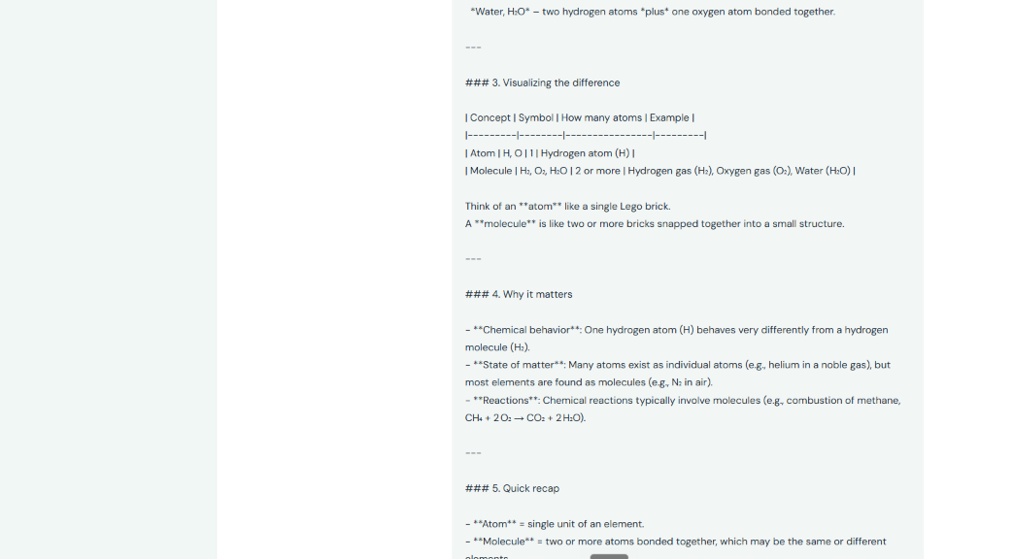

Screenshot 3. Explanation of the structure of an atom.
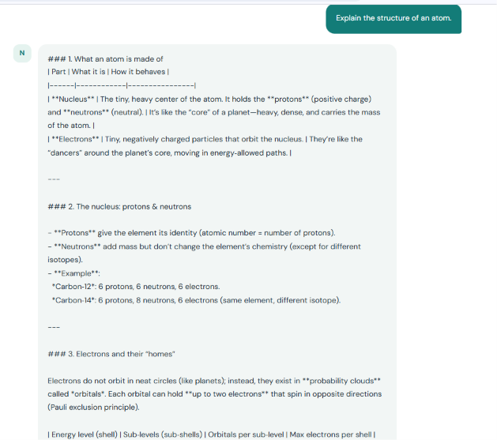

Screenshot 4. Electron shells, subshells, and electron configuration details.
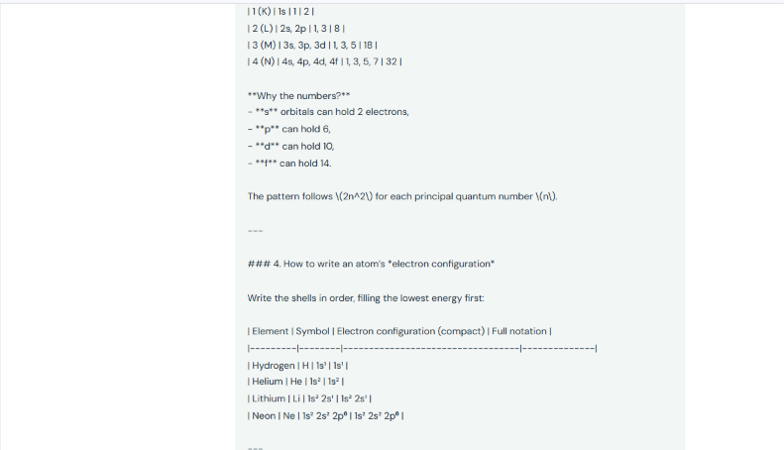

Screenshot 5. Atom structure visual aid and quick recap.
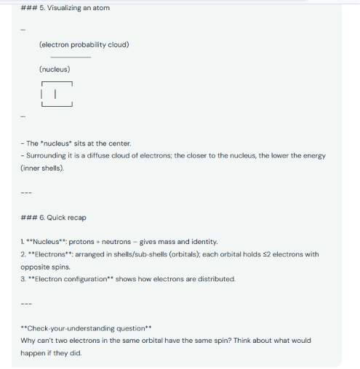

Screenshot 6. Step-by-step balancing of the equation H₂ + O₂ → H₂O.
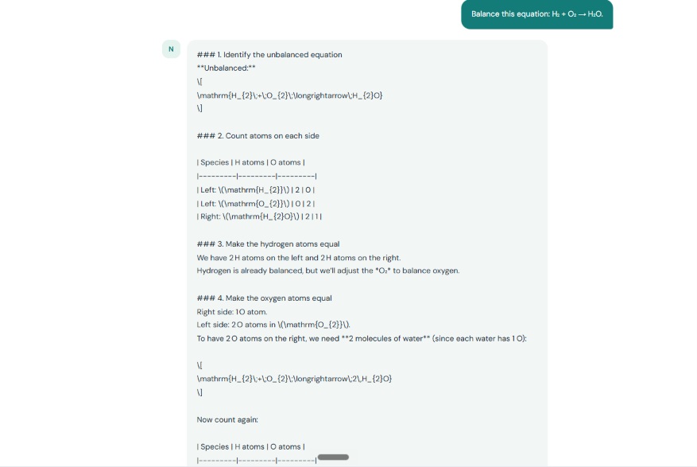

Screenshot 7. Balancing check and final balanced equation.
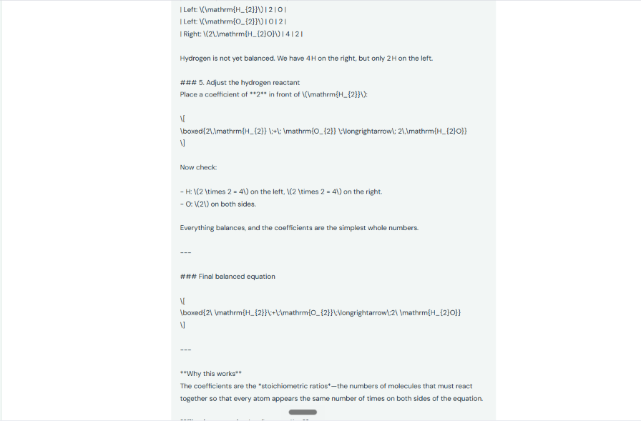

Screenshot 8. Molar-mass calculation for H₂SO₄.
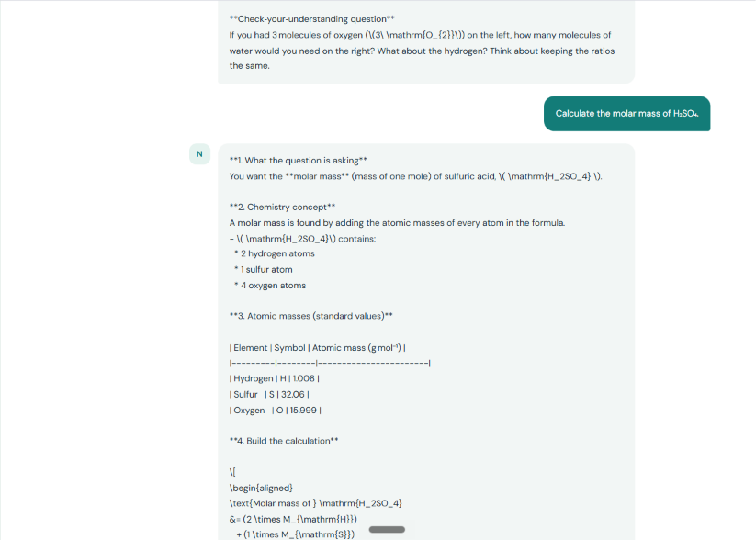

Screenshot 9. Molar-mass calculation and final result.
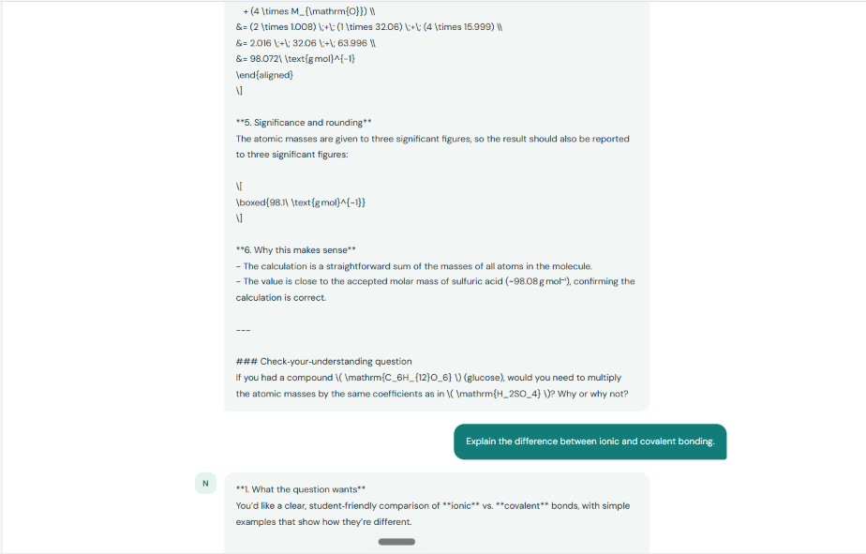

Screenshot 10. Explanation of ionic and covalent bonding.
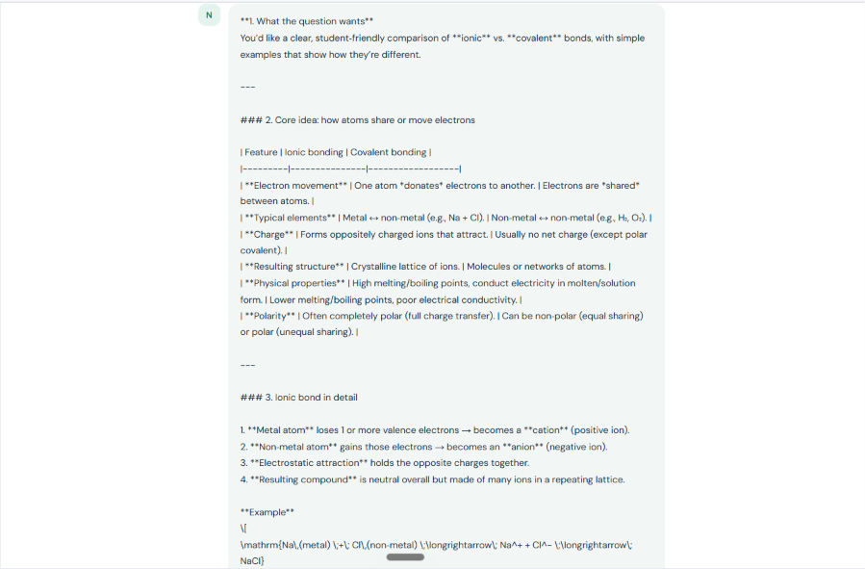

Screenshot 11. Ionic bonding explanation and sodium chloride example.
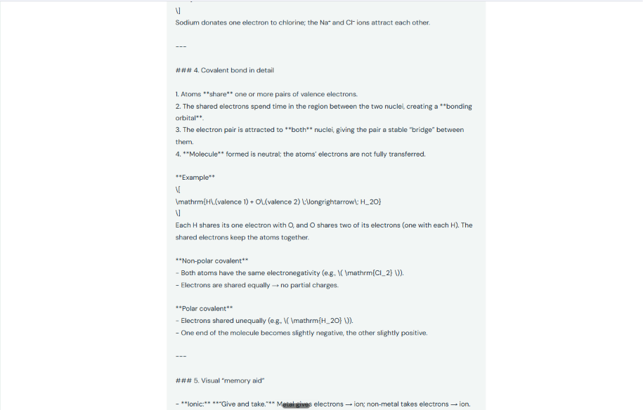

Screenshot 12. Covalent bonding explanation and comparison.
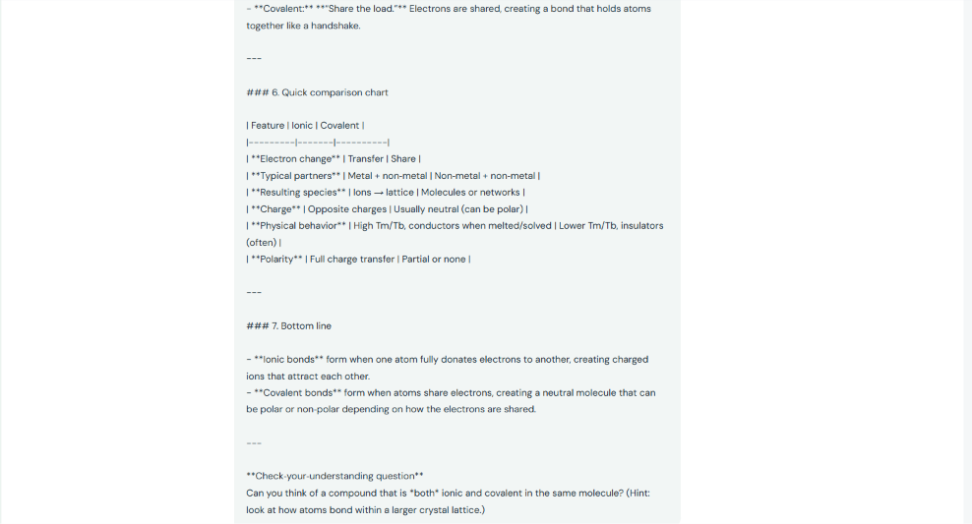

Screenshot 13. Summary comparison of ionic and covalent bonds.
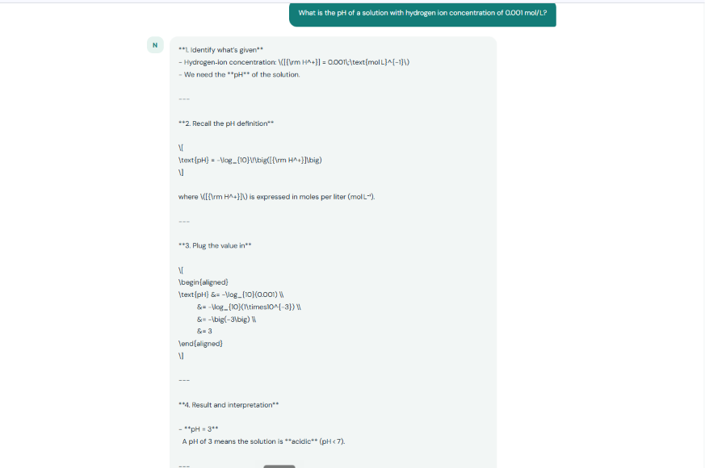

Screenshot 14. pH calculation for a hydrogen-ion concentration of 0.001 mol/L.
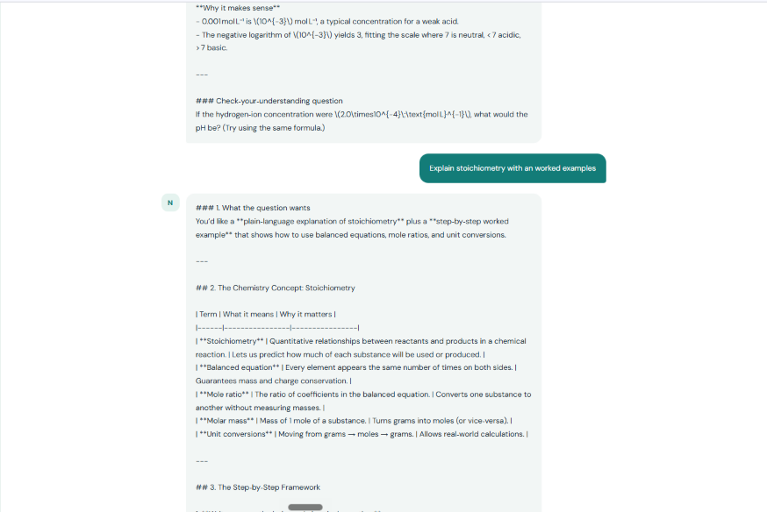

Screenshot 15. Stoichiometry concept and step-by-step framework.
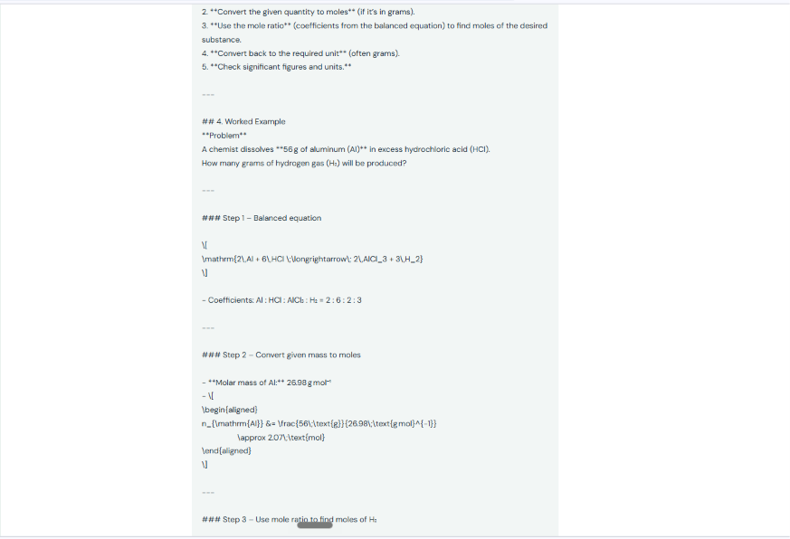

Screenshot 16. Worked stoichiometry example using aluminium and hydrochloric acid.
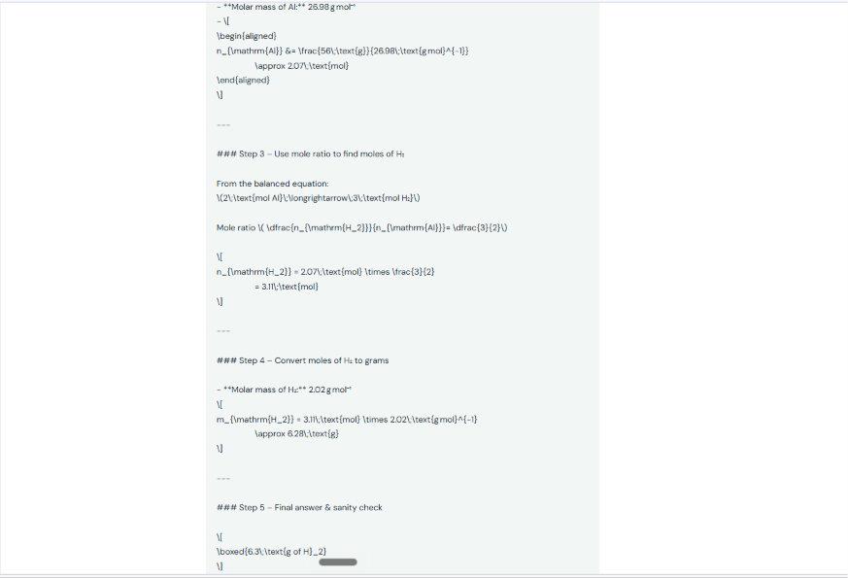

Screenshot 17. Final stoichiometry result and quick summary.
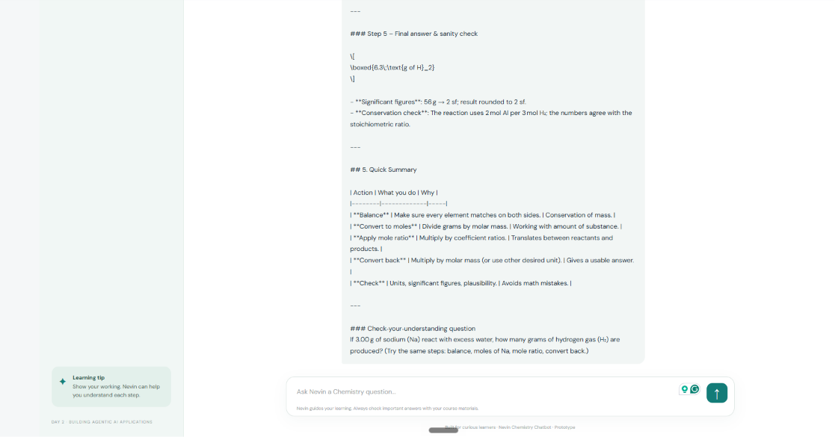

DAY 3 PROGRESS REPORT
DDS Agentic AI Application Challenge | LLM/API Integration Path
Project | Nevin Chemistry Chatbot
Developer | Nevin Pinto
Technology stack | JavaScript, Node.js, Express, Groq API, OpenAI-compatible SDK, HTML, CSS

1. Day 3 objective
Day 3 focuses on advancing the application's core functionality through stronger API integration, multi-turn interactions, error handling, performance considerations, and integration between the API and the user interface. This project follows the LLM/API Integration Path.

2. Work completed and verified in the project code
Area | Implementation verified
API-to-UI connection | The browser interface sends chat requests to the Express backend through POST /api/chat. The backend sends the conversation to the Groq API and returns the generated answer.
Multi-turn conversation context | The frontend keeps conversation history and sends the most recent messages (up to 20) with each request. The backend validates the conversation message array.
Input and payload validation | The backend accepts between 1 and 20 messages, checks message roles and content types, limits each message to 5,000 characters, and limits JSON request bodies to 32 KB.
Error handling | The backend catches API/server errors, logs a concise message, and returns a user-safe error response. The frontend displays a readable error message and re-enables the send button.
Chemistry-focused instructions | The system prompt directs the assistant to explain concepts, show formulas and working, retain units, check chemical plausibility, ask for clarification when information is missing, and avoid unsafe Chemistry instructions.
Health endpoint | A GET /api/health endpoint is available to check whether the local service is responding.
UI interaction | The interface supports typed questions and suggested prompt buttons, displays a thinking indicator, and prevents another submission while a request is in progress.

3. API integration and conversation flow
The current request flow is: (1) a student enters a Chemistry question in the browser; (2) the frontend adds the question to conversation history; (3) the frontend sends recent messages to the local Express endpoint; (4) the backend validates the request and calls the Groq chat-completions API; (5) the backend returns the answer; and (6) the frontend displays the answer and stores it in conversation history.
The API key is read from a server environment variable and is not placed in browser code. The .env file is intended to remain local and excluded from Git through .gitignore. The .env.example file documents required configuration without exposing the secret.

4. Testing status and findings carried forward from Day 2
The five formally recorded Chemistry topic checks from Day 2 remain the available manual test evidence: atoms versus molecules, balancing chemical equations, molar mass, acids/bases and pH, and stoichiometry. Results were mostly successful, but raw Markdown syntax appeared in some chatbot answers, and one pH 9 explanation contained an inconsistent numerical ratio. These findings are not represented as fixed.
• Multi-turn context — Implemented in code; fresh end-to-end retest still required.
• Invalid/missing input — Basic validation exists; edge-case testing remains pending.
• API outage / rate limit — General error handling exists; dedicated timeout, rate-limit, and invalid-key tests remain pending.
• Markdown rendering — Known UI improvement required; current frontend displays answer text without Markdown formatting.
• Feedback controls — Thumbs-up/down or comment feedback is a suggested enhancement, not implemented.
• Caching / batching — Not implemented; possible future optimizations, not completed Day 3 work.

5. Challenges and how they were addressed
• API provider configuration: The project moved from an unavailable OpenAI-credit setup to the Groq-compatible API endpoint. The API key is configured through a local environment variable rather than hard-coded in source files.
• Conversation context: The frontend stores user and assistant messages and sends bounded recent history with each request. The backend enforces a maximum message count and content length.
• Failed requests: The frontend catches request failures and presents a user-facing message; the backend catches exceptions and returns a safe response.
• Generated-answer presentation: Testing showed raw Markdown markers in the chat window. This remains a documented UI issue for a later improvement.

6. Day 3 current project status
The application has a local web interface connected to an Express backend and Groq's chat-completions API. The codebase includes conversation-history handling, request validation, a health endpoint, and basic error handling. The existing GitHub repository is https://github.com/Nevin-CS/nevin-chemistry-chatbot. The project is at a functional prototype stage; it is not yet a fully validated production application.

7. Remaining work and next steps
1. Run fresh end-to-end tests for multi-turn follow-up questions and confirm earlier context is used correctly.
2. Test blank input, malformed requests, long messages, API rate limits, timeouts, and invalid API configuration.
3. Improve Markdown rendering so headings, lists, tables, and chemical notation are easier to read.
4. Retest the pH 9 explanation and record the exact prompt, output, result, and screenshot.
5. Consider a simple thumbs-up/down feedback control.
6. Review the interface for accessibility, clear loading states, and readable error messages.
7. Update the README and testing checklist when new tests or code changes are actually completed, then commit and push those changes to GitHub.

8. Day 3 submission checklist
• ☐ Updated progress report with Day 3 work, challenges, status, and next steps.
• ☐ GitHub repository link included: https://github.com/Nevin-CS/nevin-chemistry-chatbot
• ☐ Screenshot evidence of the application and/or code included where available.
• ☐ LinkedIn progress post is optional; if published, include the public post URL in the challenge submission form.
• ☐ Submit a screenshot/image of actual project work through the challenge platform.

9. Evidence note
The screenshots supplied with the Day 3 instructions show challenge guidance slides, not proof that those tasks were completed. The implementation statements in this report are based on inspection of the project's server.js and public/app.js files in the existing submission package. Earlier Day 2 application-testing screenshots remain in the report appendix as prior testing evidence.

10. Suggested short submission description
For Day 3, I continued developing Nevin Chemistry Chatbot on the LLM/API Integration Path. The application connects its web interface to an Express backend and the Groq API. The current code supports multi-turn conversation history, request validation, a health-check endpoint, and basic error handling. I reviewed issues found during Day 2 testing, especially Markdown display and one inconsistent pH explanation. These remain documented for further improvement and retesting. The project is a functional prototype, and additional edge-case testing and UI refinement are planned.

Appendix: Day 3 implementation evidence
This earlier project screenshot shows the server-side API setup and project structure. It is supporting evidence of the API integration work, not a new screenshot captured on the Day 3 date.
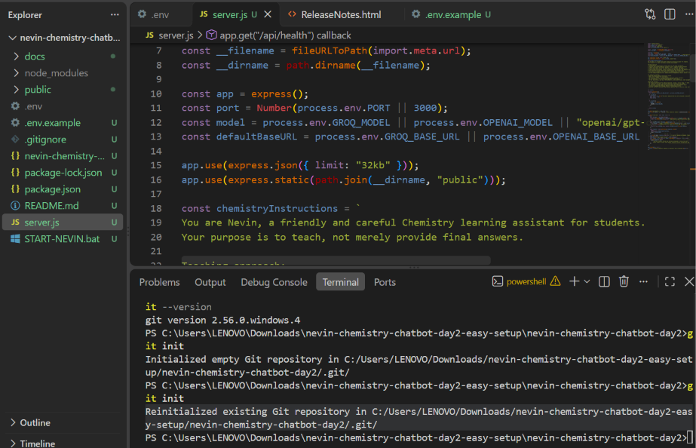
Figure D3-1. VS Code view of the Express server and project files.
The Day 3 instruction-slide images supplied separately were not inserted as project evidence because they describe required activities rather than showing the chatbot implementation.

Appendix B: Day 3 working application screenshots
The following screenshots were supplied on 10 November 2026 and show the Nevin Chemistry Chatbot running in the browser. They document the visible application interface and examples of Chemistry questions and responses. The screenshots provide evidence of the working prototype and its demonstrated topic coverage; they do not, by themselves, verify every backend validation, error-handling, or performance feature described in the report.
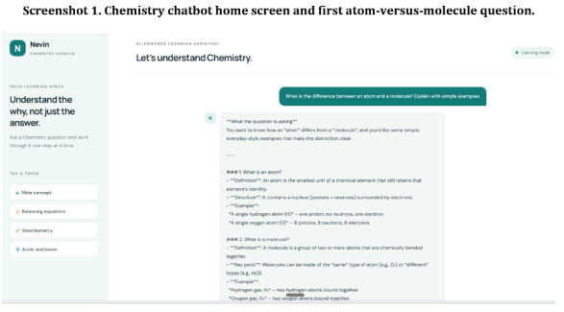
Screenshot 1. Chemistry chatbot home screen and first atom-versus-molecule question.
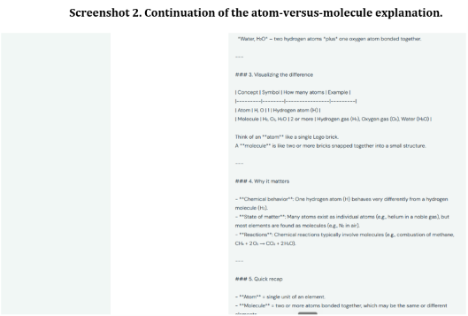
Screenshot 2. Continuation of the atom-versus-molecule explanation.

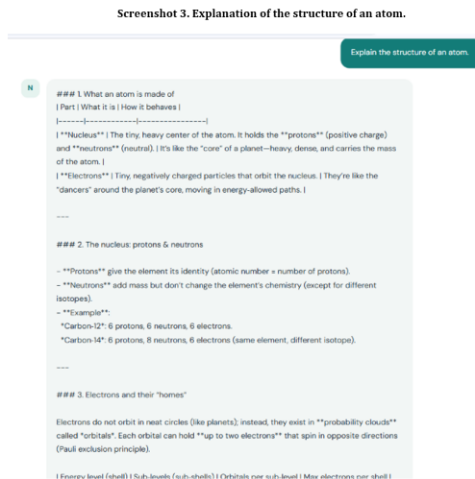
Screenshot 3. Explanation of the structure of an atom.
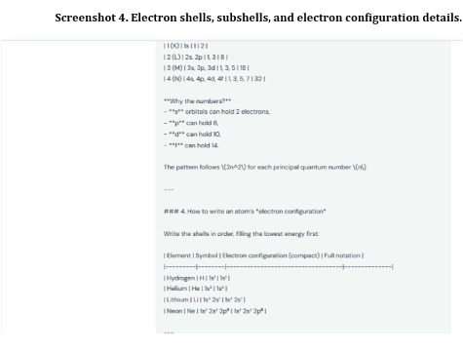
Screenshot 4. Electron shells, subshells, and electron configuration details.

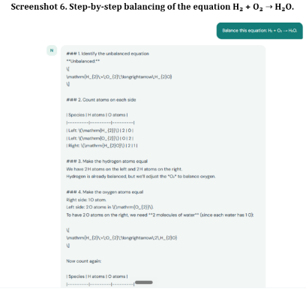
Screenshot 6. Step-by-step balancing of the equation H₂ + O₂ → H₂O.
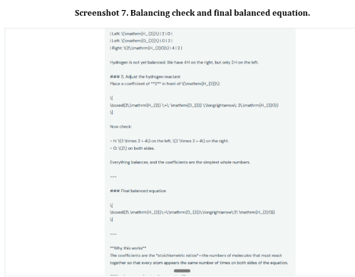
Screenshot 7. Balancing check and final balanced equation.

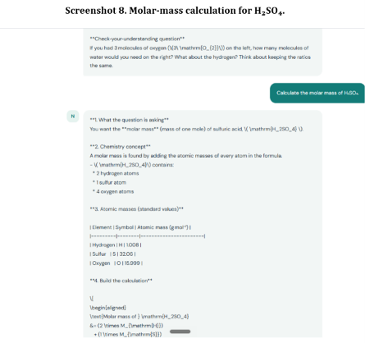
Screenshot 8. Molar-mass calculation for H₂SO₄.
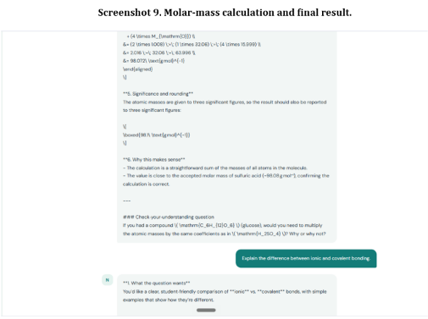
Screenshot 9. Molar-mass calculation and final result.

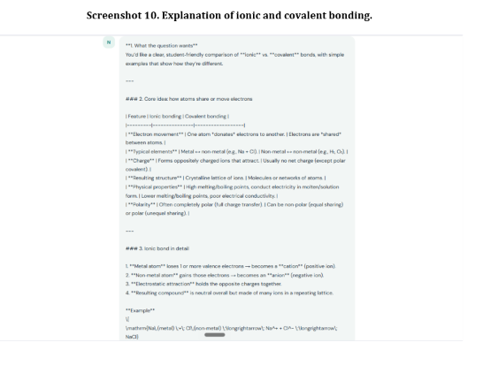
Screenshot 10. Explanation of ionic and covalent bonding.
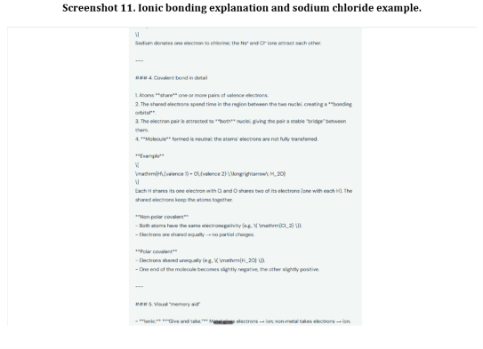
Screenshot 11. Ionic bonding explanation and sodium chloride example.

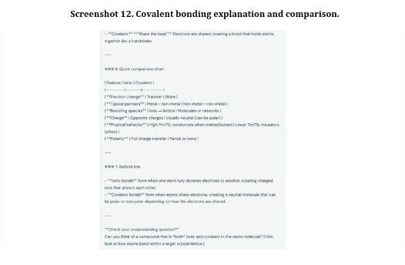
Screenshot 12. Covalent bonding explanation and comparison.
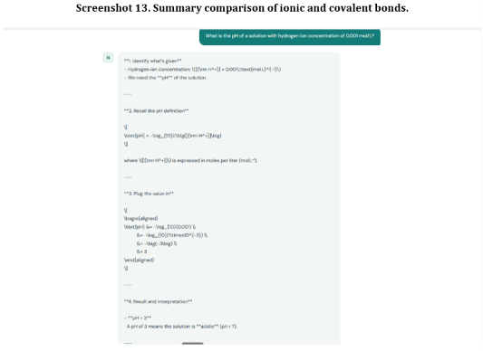
Screenshot 13. Summary comparison of ionic and covalent bonds.

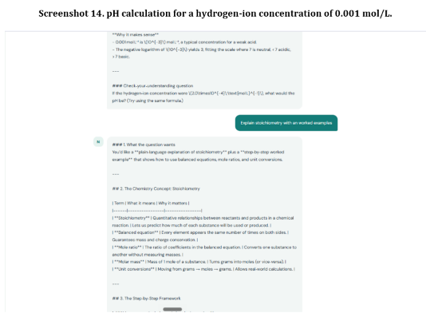
Screenshot 14. pH calculation for a hydrogen-ion concentration of 0.001 mol/L.
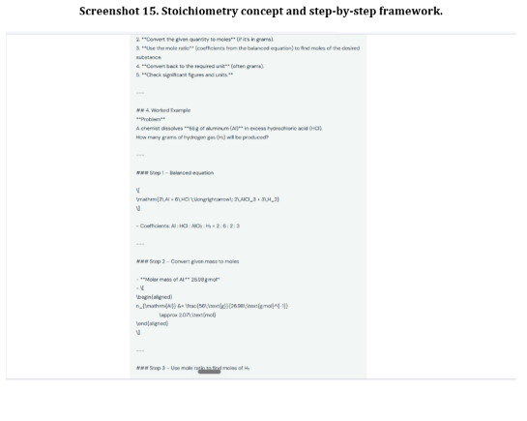
Screenshot 15. Stoichiometry concept and step-by-step framework.

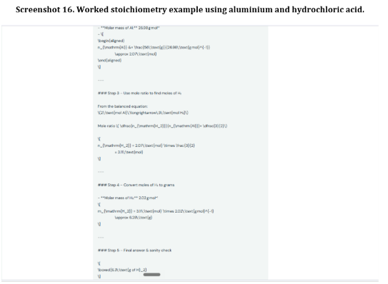
Screenshot 16. Worked stoichiometry example using aluminium and hydrochloric acid.
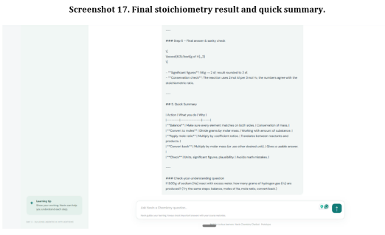
Screenshot 17. Final stoichiometry result and quick summary.

Day 4 Progress Report – API Integration, Testing and Optimization
Project: Nevin Chemistry Chatbot | LLM/API Integration Path
Prepared by: Nevin Pinto

1. Day 4 objective
The Day 4 checkpoint focuses on refining prompt engineering, improving API and UI interaction, handling input and output data, testing end-to-end functionality and edge cases, reviewing performance, and maintaining security and privacy. This section records the current implementation and the evidence available when this report was prepared.

2. Application and technology stack
• Application: Nevin Chemistry Chatbot – an AI-powered Chemistry Learning Assistant.
• Frontend: HTML, CSS and JavaScript.
• Backend: Node.js with Express.
• LLM/API: Groq chat-completions API using an OpenAI-compatible request format.
• Configuration: API credentials are read from an environment variable; the .env file is excluded from Git.
• GitHub repository: https://github.com/Nevin-CS/nevin-chemistry-chatbot

3. Prompt engineering and response quality
The application uses Chemistry-focused system instructions intended to guide the assistant to explain concepts clearly, show calculations step by step, include formulas and units, check chemical plausibility, ask for clarification when information is missing, and respond safely. Earlier test examples cover atomic structure, balancing chemical equations, molar mass, ionic and covalent bonding, pH, and stoichiometry.
The available evidence shows that the application was exercised with Chemistry prompts. It does not establish that a systematic prompt-variant experiment or a formal benchmark was completed during Day 4. Further prompt comparisons should record the prompt version, input, expected result, actual result, and pass/fail decision.

4. API integration, data handling and UI interaction
The frontend sends chat messages to the Express POST /api/chat endpoint. The backend validates the message history and sends the request to the Groq API. The frontend includes recent conversation history (up to 20 messages), supporting multi-turn context. The backend validation in the existing implementation checks message count, role/content fields, message length and request body size.
The UI includes a message input, suggested prompts, a waiting indicator, and error display. The frontend disables sending while a request is in progress and re-enables it after completion or an error. A GET /api/health endpoint is also present. These are implementation details from the existing project; this report does not claim that new API features were added or pushed during Day 4.

5. Testing process and evidence
The existing Day 2/Day 3 manual test record contains five formal Chemistry test cases. Recorded results include correct balancing of H₂ + O₂ → H₂O, an H₂SO₄ molar mass of approximately 98.08 g/mol, a follow-up oxygen-atom mole calculation, and stoichiometry examples. One pH explanation contained an internal inconsistency: the OH⁻/H⁺ ratio was calculated as 10,000 but later described as 100. That case requires correction and retesting.
The 16 application screenshots in Appendix A are previous screenshots of the working chatbot and Chemistry interactions. They are useful visual evidence that the interface and example workflows were exercised. They are not represented as newly executed Day 4 tests. The images in Appendix B are challenge-instruction slides supplied by the participant; they document checkpoint requirements and are not application-test evidence.
Not yet evidenced as completed: a full edge-case test suite (empty input, ambiguous/incomplete input, very long input and invalid API key), measured API response times, BLEU or other formal quality metrics, a formal user-satisfaction survey, and a repeated pH verification after correcting the inconsistency.

6. Performance, security and privacy
No measured latency dataset or formal performance benchmark was supplied for this report. Therefore, no numerical response-time or performance improvement is claimed. The next evaluation should record response time over multiple requests and note slow, failed and successful requests.
The API key is configured through an environment variables and the .env file is excluded from version control. This reduces the risk of committing credentials. The current evidence does not establish that transport encryption, PII redaction, log scrubbing, rate limiting or a dedicated request timeout have been independently tested; these should be reviewed before public deployment.

7. Fine-tuning and dataset
Fine-tuning has not been performed. The project currently uses prompt instructions with a hosted LLM API. A curated Chemistry question-and-answer dataset could be prepared later for evaluation or, if supported and justified, fine-tuning. Any dataset should be checked for accuracy, licensing, privacy and consistent formatting before use.

8. Challenges and limitations
• A prior pH response included an inconsistent numerical explanation and needs retesting.
• The interface has previously displayed raw Markdown markers rather than fully rendered formatting.
• Edge-case, invalid-key and long-input tests are not yet documented as completed.
• Response-time measurements and formal output-quality metrics have not been collected.
• No fine-tuning dataset or fine-tuned model is currently part of the implementation.

9. Day 4 next steps
1. Retest the pH example and verify the numerical explanation from beginning to end.
2. Run and record tests for empty, ambiguous, incomplete and long inputs, plus API failure/invalid-key handling.
3. Record response times for a repeatable set of prompts and summarize average and slowest response.
4. Improve Markdown rendering so equations, lists and bold text appear clearly in the UI.
5. Review timeout, rate-limit, logging and privacy protections before deployment.
6. Commit and push any actual code changes with a clear commit message; the report alone does not mean code was updated.

10. Day 4 status summary
The core LLM/API chatbot implementation and multi-turn workflow are present, and earlier Chemistry interaction screenshots are available as supporting application evidence. The supplied Day 4 slides have been included as checkpoint-reference material. Additional Day 4 edge-case testing, performance measurement and any resulting code changes remain to be completed and documented. This report separates verified implementation and earlier test evidence from work that is still pending.

Appendix A – Application screenshots (previous testing evidence)
These screenshots were supplied earlier and show the Nevin Chemistry Chatbot interface and Chemistry question/answer interactions. They support the existence and prior exercise of the application; they are not claimed to be new Day 4 test executions.
Application screenshot 01
Application screenshot 02
Application screenshot 03
Application screenshot 04
Application screenshot 05
Application screenshot 06
Application screenshot 07
Application screenshot 08
Application screenshot 09
Application screenshot 10
Application screenshot 11
Application screenshot 12
Application screenshot 13
Application screenshot 14
Application screenshot 15
Application screenshot 16

Appendix B – Day 4 challenge instruction slides
The following images are checkpoint instruction slides provided for reference. They show the criteria used to structure this progress report; they are not screenshots of the chatbot.
Challenge instruction image 01
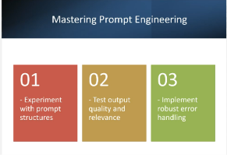
Challenge instruction image 02
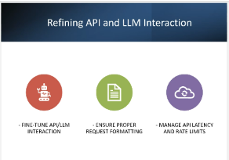
Challenge instruction image 03
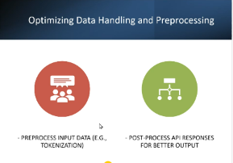
Challenge instruction image 04
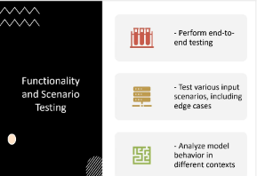
Challenge instruction image 05
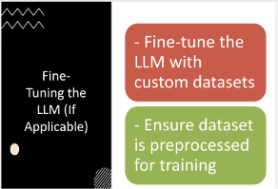
Challenge instruction image 06
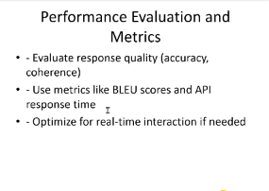
Challenge instruction image 07
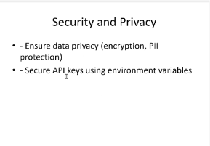
Challenge instruction image 08
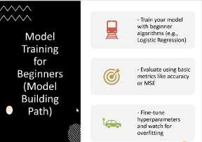
Challenge instruction image 09
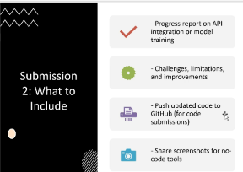
Challenge instruction image 10
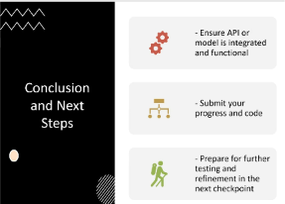
Challenge instruction image 11
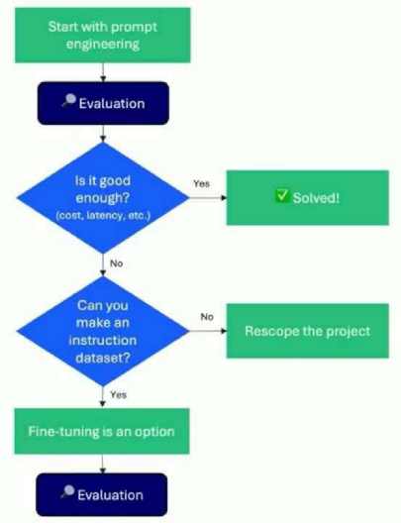

Day 4 Testing Update – Test 3: API Connection Error Handling
Test objective: verify that the chatbot interface responds appropriately when the backend server is unavailable and the browser cannot complete the API request.
Procedure: the Node.js server was stopped from the VS Code/PowerShell terminal. The user then submitted the prompt, “Explain the difference between ionic and covalent bonding.”
Observed result: the chatbot displayed the message, “I couldn't connect just now. Failed to fetch”. The terminal screenshot also shows the server process was terminated and the PowerShell prompt returned.
Result: PASS for displaying a user-facing connection error when the API request cannot reach the backend. The evidence does not yet confirm recovery after restarting the server, so the recovery check remains pending.
Evidence 1 – Backend server stopped:
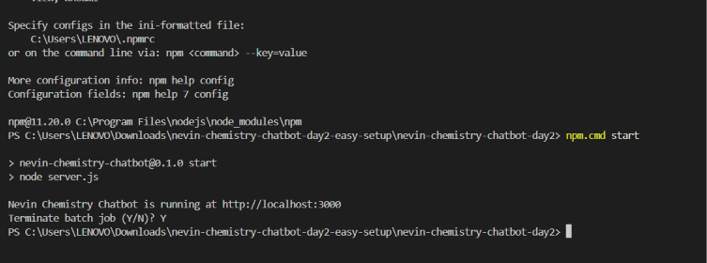
Evidence 2 – Chatbot displays connection error:
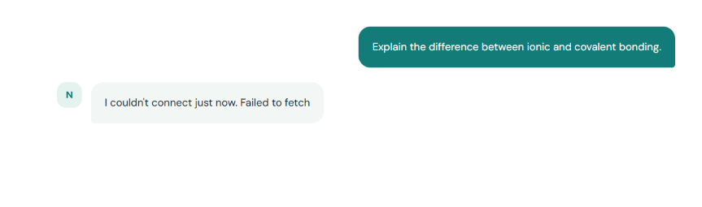

Updated Day 4 test summary
• Test 1 – Incomplete question: PASS. The chatbot asked the user to specify the missing chemical compound.
• Test 2 – Follow-up question: PASS. The chatbot resolved “it” to H₂SO₄ and calculated 1.00 mol of oxygen atoms from 0.25 mol of H₂SO₄.
• Test 3 – Connection error: PASS for error display. The chatbot displayed “I couldn't connect just now. Failed to fetch” when the backend was stopped.
• Pending: restart the backend, refresh or retry in the browser, and capture a successful response to document recovery.

Day 4 Testing Update – Backend Recovery Verification
After the connection-error test, the Node.js server was started again and the chatbot page was refreshed. The user submitted the question, “What is the difference between an atom and a molecule?”
Observed result: the chatbot returned a Chemistry explanation in the webpage. The two supplied screenshots show the question and the response across its continuation. This provides visual evidence that the application could successfully process a new request after the backend was restarted.
Result: PASS for the recovery check based on the supplied screenshots. Together with the earlier server-stop and “I couldn't connect just now. Failed to fetch” screenshots, the evidence documents both error display and successful operation after restarting the server.
Recovery evidence – response, first part:
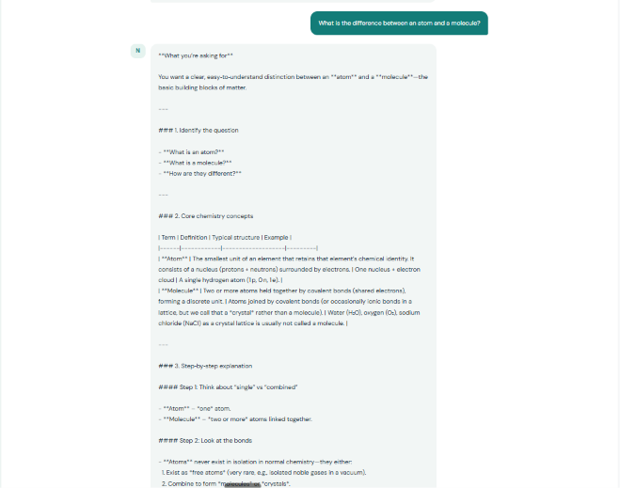
Recovery evidence – response, continuation:
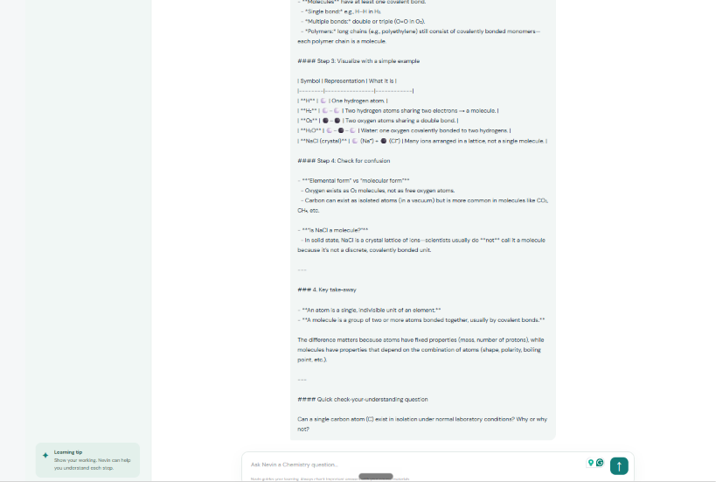

Final Day 4 testing results
• Test 1 – Incomplete question: PASS. The chatbot asked which chemical compound the user meant instead of guessing.
• Test 2 – Follow-up question: PASS. The chatbot used the H₂SO₄ context and calculated 1.00 mol of oxygen atoms from 0.25 mol of H₂SO₄.
• Test 3 – Connection error display: PASS. With the backend stopped, the chatbot displayed “I couldn't connect just now. Failed to fetch”.
• Test 3 – Recovery after restart: PASS. After restarting the server and refreshing the webpage, the chatbot successfully answered a new atom-versus-molecule question.
Evidence limitation: these screenshots verify the tested browser workflow. They do not constitute a broad load test, latency benchmark, security audit, or proof that every possible API failure is handled.

