PREDICTING CUSTOMER CHURN
A DATA-DRIVEN ANALYSIS OF SUBSCRIPTION CUSTOMER BEHAVIOUR USING MACHINE LEARNING

Project Report Submitted in fulfillment of the Requirements for the Data Science & AI Training Program by IDRA

Data Science and AI
By:
Name: [Student Name]
Institute: [Institute Name]
Institute Roll No.: [Roll Number]
Enrollment No.: IDRA-[Enrollment Number]
Under the Supervision of
Dr. Shaheena Salam
Through the platform:
India Data Research Academy

DECLARATION
I declare that this project report presents the analysis and modelling work completed as part of the IDRA Data Science & AI training program. The computational work and interpretations are documented in the accompanying notebook, and external sources used in preparing the report are acknowledged.

ACKNOWLEDGEMENT
I sincerely acknowledge the India Data Research Academy and the Data Science & AI training program for providing the learning framework, project guidance and dataset resources required for this capstone. I also acknowledge the project supervisor and all instructors whose training supported the completion of this work.

ABSTRACT
This study investigates customer churn in a telecommunications subscription dataset containing 7,043 customer records and 21 variables. The objective is to identify customer characteristics associated with churn and develop a classification model capable of identifying customers at risk of leaving. Data preparation included converting TotalCharges from text to numeric format, resolving 11 blank charge records using a zero value consistent with their zero-month tenure, verifying that no duplicate records were present, and excluding the customer identifier from modelling. Exploratory analysis examined churn by contract type, internet service and payment method, while statistical analysis compared tenure, monthly charges and total charges across churn outcomes. Logistic Regression was used as a baseline and Random Forest as the final model. On a stratified 80/20 test split, the Random Forest achieved 0.763 accuracy, 0.537 precision, 0.783 recall and 0.637 F1-score, with ROC-AUC of 0.842. Contract type, tenure, service-related variables and payment method were among the strongest predictive inputs. The findings support targeted retention strategies focused particularly on month-to-month customers and early-tenure customers, while emphasizing that observed relationships are not causal evidence.
Keywords: Customer Churn; Exploratory Data Analysis; Classification; Random Forest; Predictive Analytics; Customer Retention

TABLE OF CONTENTS
1. Introduction
2. Problem Statement and Motivation
3. Objectives
4. Research Questions
5. Dataset Description and Data Understanding
6. Data Cleaning
7. Data Preprocessing
8. Exploratory Data Analysis
9. Statistical Analysis
10. Feature Engineering
11. Model Development
12. Model Evaluation
13. Results and Findings
14. Discussion
15. Limitations
16. Conclusion
17. Recommendations and Future Work
18. References
Appendix A. Code
Appendix B. Additional Figures and Tables

1. INTRODUCTION

1.1 Background
Customer churn refers to customers ending a subscription relationship. For subscription businesses, understanding churn is important because retention efforts can be directed toward customers showing characteristics associated with higher departure risk.

1.2 Context of the Problem
The dataset represents telecommunications customers with demographic, service, contract, payment and billing variables. The practical stakeholder is a customer-retention team that wants evidence about which segments experience higher churn and a model that can prioritize potential churners.

1.3 Scope of the Study
The study covers data quality assessment, preprocessing, EDA, descriptive statistics, classification modelling and interpretation. It does not claim causal effects, customer-level intervention outcomes, or production deployment performance.

2. PROBLEM STATEMENT AND MOTIVATION
The central problem is: **Which customer characteristics are associated with churn, and how effectively can machine learning predict whether a customer will churn?** A reliable screening model can help retention teams allocate attention more efficiently.

3. OBJECTIVES
• Understand and validate the structure and quality of the LMS-provided churn dataset.
• Identify patterns and customer groups associated with churn.
• Prepare features using leakage-safe preprocessing.
• Build and compare classification models for churn prediction.
• Evaluate the final model using accuracy, precision, recall, F1-score and a confusion matrix.
• Translate analytical and modelling results into practical retention recommendations.

4. RESEARCH QUESTIONS
1. What are the major characteristics and quality issues in the dataset?
2. Which customer attributes and service groups are most strongly associated with churn?
3. How do tenure and monthly charges differ between churned and retained customers?
4. Which features contribute most to predictive performance?
5. How accurately can churn be predicted on unseen test data?

5. DATASET DESCRIPTION AND DATA UNDERSTANDING

5.1 Data Source
The dataset used for this capstone is the Project 4 Customer Churn CSV supplied in the IDRA LMS Study Material. The file is used as provided; the analysis documents transformations applied during cleaning.

5.2 Dataset Size and Structure
The raw dataset contains 7,043 observations and 21 columns. The target variable is Churn, with values Yes/No. The modelling task is binary classification.
Measure | Value
Rows | 7,043
Columns | 21
Target | Churn
Target classes | No / Yes
Churned customers | 1,869
Overall churn rate | 26.54%

5.3 Data Dictionary
Variable | Meaning | Type | Role
customerID | Unique customer identifier | Categorical | Identifier / excluded
SeniorCitizen | Senior-citizen indicator | Binary numeric | Feature
Partner / Dependents | Household characteristics | Categorical | Features
tenure | Months with the service | Numeric | Feature
PhoneService / MultipleLines | Phone-service details | Categorical | Features
InternetService | Internet service type | Categorical | Feature
OnlineSecurity / OnlineBackup / DeviceProtection | Optional service indicators | Categorical | Features
TechSupport / StreamingTV / StreamingMovies | Support and entertainment services | Categorical | Features
Contract | Contract term | Categorical | Feature
PaperlessBilling / PaymentMethod | Billing and payment characteristics | Categorical | Features
MonthlyCharges | Current monthly charge | Numeric | Feature
TotalCharges | Accumulated charges | Numeric | Feature
Churn | Whether customer left | Categorical | Target

6. DATA CLEANING

6.1 Missing Values
The raw file has no formal CSV null values, but TotalCharges contains 11 blank strings. After conversion to numeric, these become missing. All 11 affected records have tenure equal to 0, so TotalCharges was filled with 0 to represent no accumulated charge at the start of service.

6.2 Duplicate Records
No duplicate rows were found in the raw dataset (duplicate count = 0). Therefore, no observations were removed for duplication.

6.3 Data Types and Inconsistent Values
TotalCharges was converted from object/text to numeric. Other categorical labels were inspected and were consistent in spelling and capitalization. Churn was mapped to a binary modelling target only after the raw categorical values were preserved for interpretation.

6.4 Outlier Handling
The IQR method was used to inspect tenure, MonthlyCharges and TotalCharges. No observations fell outside the 1.5×IQR fences for these variables, so no numeric observations were removed as outliers.
Variable | Q1 | Q3 | IQR | Lower Fence | Upper Fence | Outliers
tenure | 9.00 | 55.00 | 46.00 | -60.00 | 124.00 | 0
MonthlyCharges | 35.50 | 89.85 | 54.35 | -46.02 | 171.38 | 0
TotalCharges | 398.55 | 3786.60 | 3388.05 | -4683.52 | 8868.67 | 0

6.5 Before vs After Cleaning
Quality Item | Before | After | Treatment
TotalCharges type | object | float | Numeric conversion
Blank TotalCharges | 11 | 0 | Filled with 0
Duplicate rows | 0 | 0 | No removal required
Rows | 7043 | 7043 | No row loss

7. DATA PREPROCESSING

7.1 Categorical Encoding
Categorical predictors are one-hot encoded with handle_unknown='ignore', allowing unseen test categories to be handled safely.

7.2 Feature Scaling and Transformation
Numerical predictors are median-imputed and standardized for the Logistic Regression baseline. The same preprocessing pipeline is used for Random Forest for a consistent comparison; scaling does not drive tree splits but keeps the workflow uniform.

7.3 Train-Test Split
The dataset is divided into 80% training and 20% testing data using random_state=42 and stratification by the churn target. Preprocessing is fitted inside the pipeline on training data only, preventing information leakage from the test set.

7.4 Final Feature Set
The final predictors include demographic, service, contract, billing and payment variables. customerID is excluded because it is an identifier without a meaningful behavioural interpretation. Churn is the target.

8. EXPLORATORY DATA ANALYSIS

8.1 Univariate Analysis
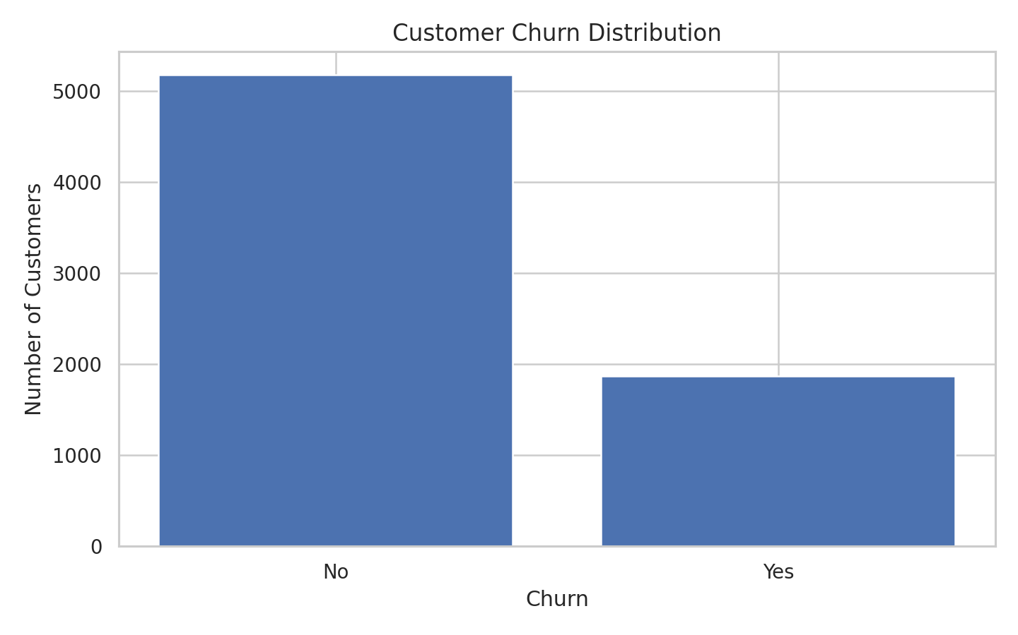
Figure 1. Distribution of customer churn outcomes.
Churn represents 26.54% of the sample, while 73.46% of customers are retained. This class imbalance makes recall, precision and F1-score important alongside accuracy.

8.2 Categorical Analysis
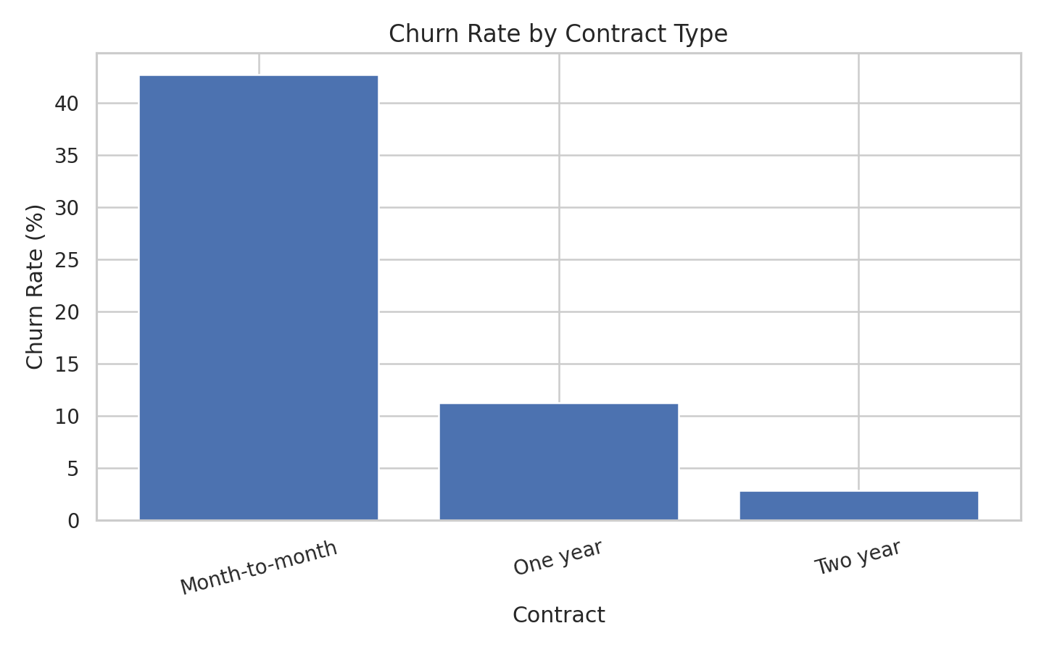
Figure 2. Observed churn rate across contract types.
Month-to-month customers show an observed churn rate of 42.71%, compared with 11.27% for one-year contracts and 2.83% for two-year contracts. Contract type is therefore a major segmentation variable.
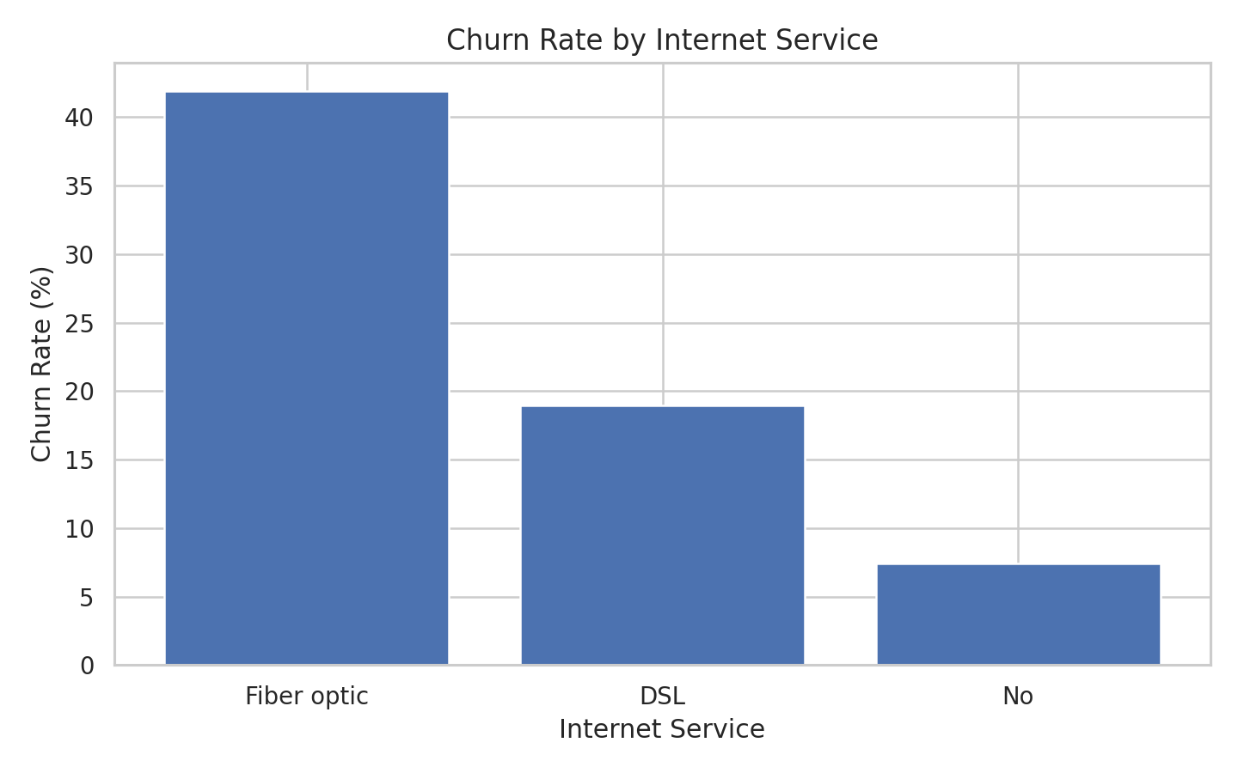
Figure 3. Observed churn rate across internet service types.
Fiber optic customers have an observed churn rate of 41.89%, while DSL customers show 18.96% and customers without internet service show 7.40%.

8.3 Bivariate / Relationship Analysis
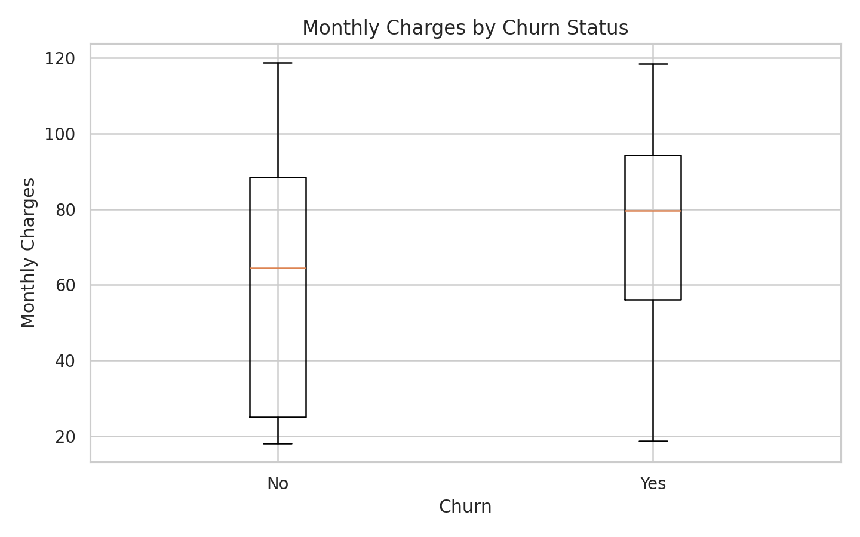
Figure 4. Monthly charges by churn outcome.
Average monthly charges are 74.44 for churned customers versus 61.27 for retained customers. This is an observed association and should not be interpreted as proof that charges cause churn.
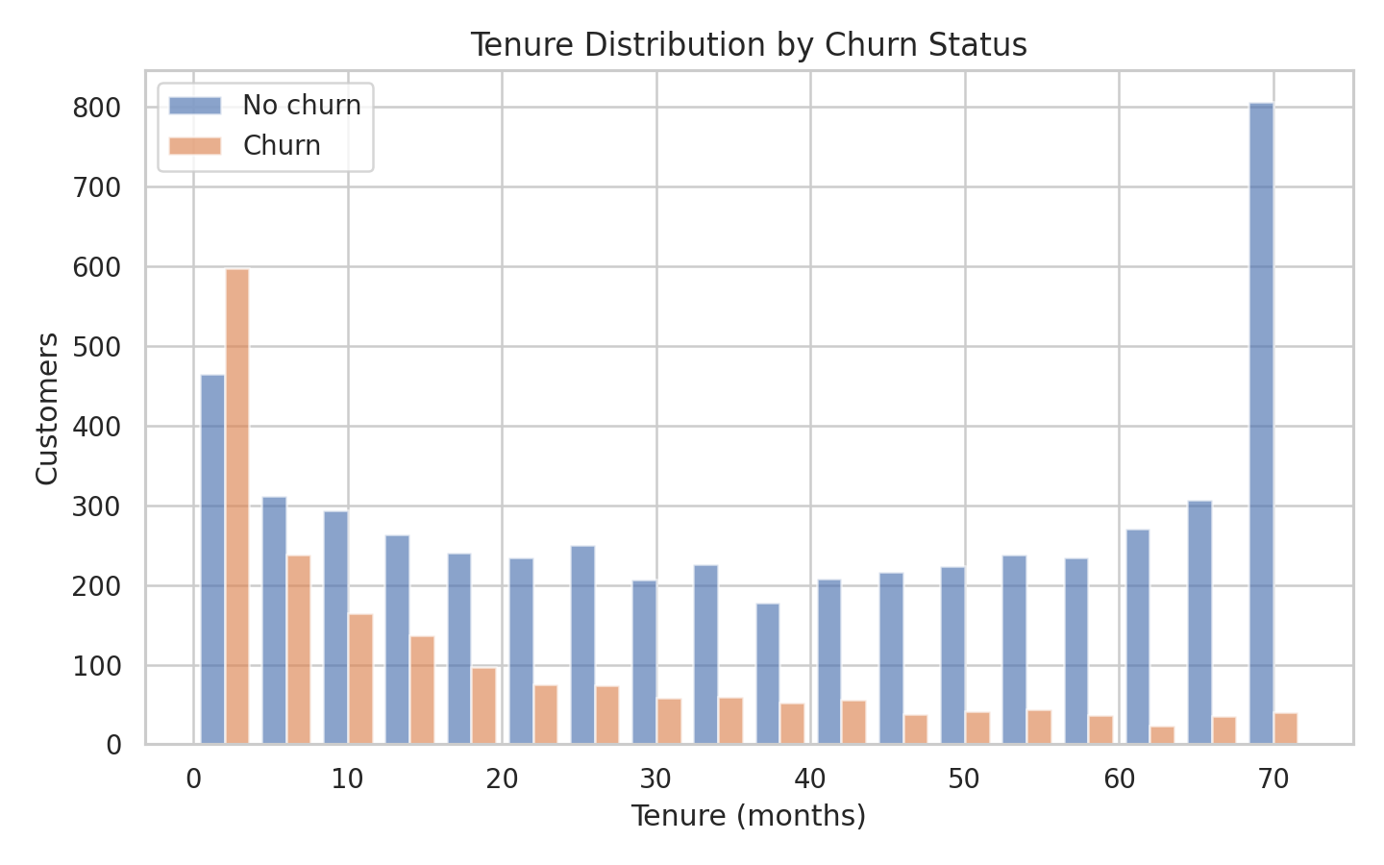
Figure 5. Tenure distributions by churn outcome.
Average tenure is 17.98 months for churned customers and 37.57 months for retained customers, showing a substantial lifecycle difference.

8.4 Correlation Analysis
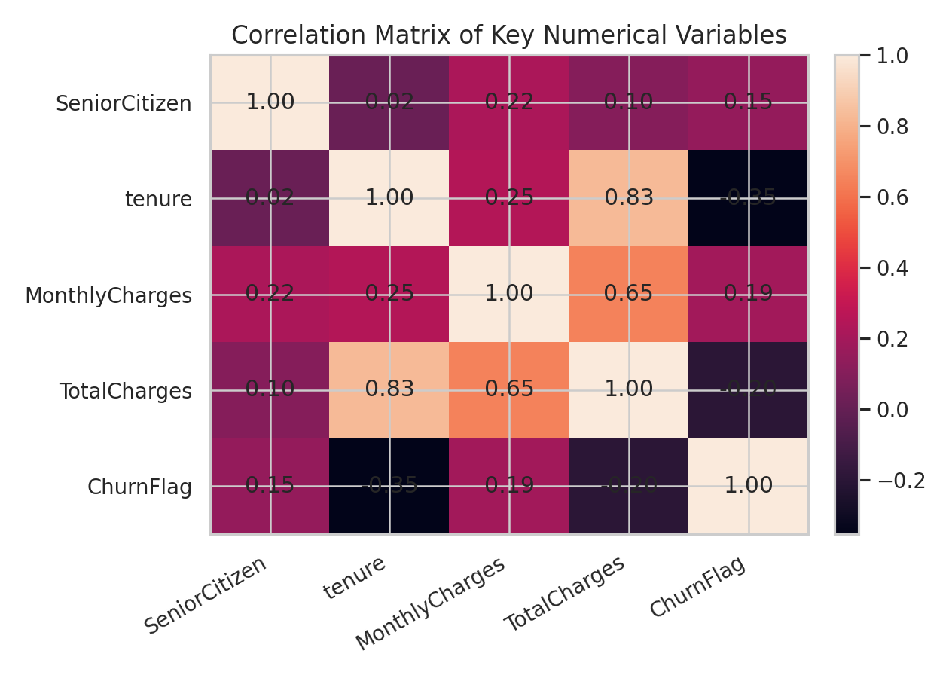
Figure 6. Correlation matrix of selected numerical variables and the churn indicator.
Tenure and TotalCharges are strongly related because accumulated charges grow with time in service. Churn has a negative relationship with tenure and positive relationships with several billing-related variables. Correlation supports feature understanding but does not establish causation.

8.5 Other Figures
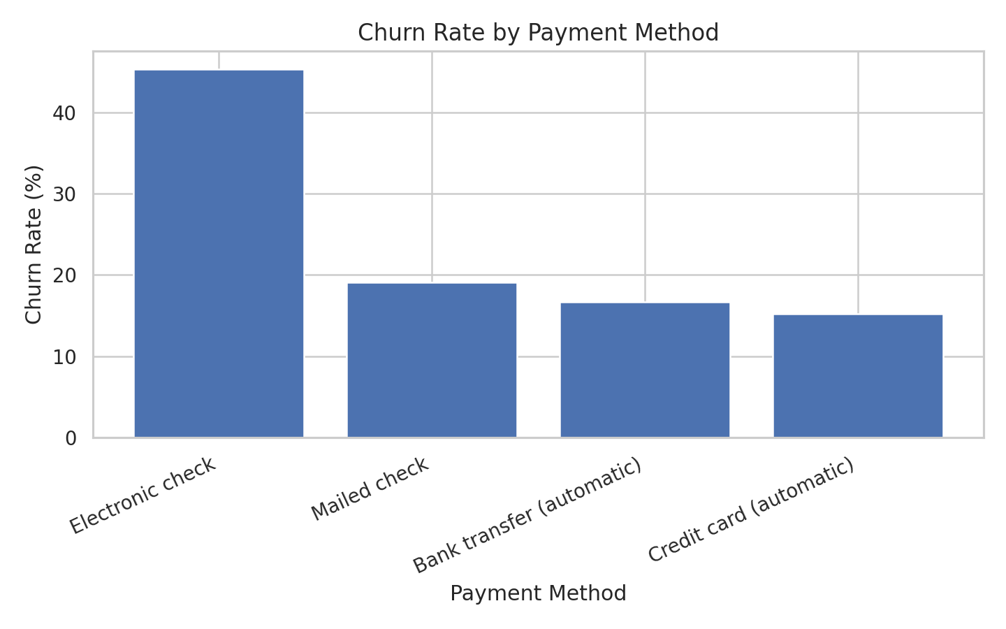
Figure 7. Observed churn rate by payment method.
Electronic check has the highest observed churn rate among payment methods at 45.29%. This may be useful for retention segmentation and payment-experience investigation.

9. STATISTICAL ANALYSIS
Variable | Mean | Median | Std Dev | Min | Max
Tenure | 32.37 | 29.00 | 24.56 | 0 | 72
MonthlyCharges | 64.76 | 70.35 | 30.09 | 18.25 | 118.75
TotalCharges | 2279.73 | 1394.55 | 2266.79 | 0.00 | 8684.80
Group-wise statistics show that churned customers tend to have shorter tenure and higher monthly charges. The distribution of TotalCharges is naturally linked to tenure, so it should not be interpreted independently of service duration.

10. FEATURE ENGINEERING
The main engineered modelling feature is the binary ChurnFlag target (No=0, Yes=1). No artificial composite features were introduced because the original variables already capture contract, service and billing dimensions. Keeping the feature set interpretable supports the capstone's research-style emphasis.

11. MODEL DEVELOPMENT

11.1 Problem Formulation
This is a binary classification problem. The target is Churn, and predictors are customer demographics, tenure, service subscriptions, contract, billing and payment variables.

11.2 Model Selection
Logistic Regression is used as an interpretable baseline. Random Forest is used as the final nonlinear model because churn relationships may involve interactions among contract, tenure, services and billing characteristics.

11.3 Training the Model
Both models use the same leakage-safe preprocessing pipeline and an 80/20 stratified split. Random Forest uses 300 trees, maximum depth 8, minimum leaf size 3, class balancing and random_state 42.

12. MODEL EVALUATION

12.1 Classification Evaluation
Model | Accuracy | Precision | Recall | F1-score | ROC-AUC
Logistic Regression | 0.806 | 0.657 | 0.559 | 0.604 | 0.842
Random Forest | 0.763 | 0.537 | 0.783 | 0.637 | 0.842
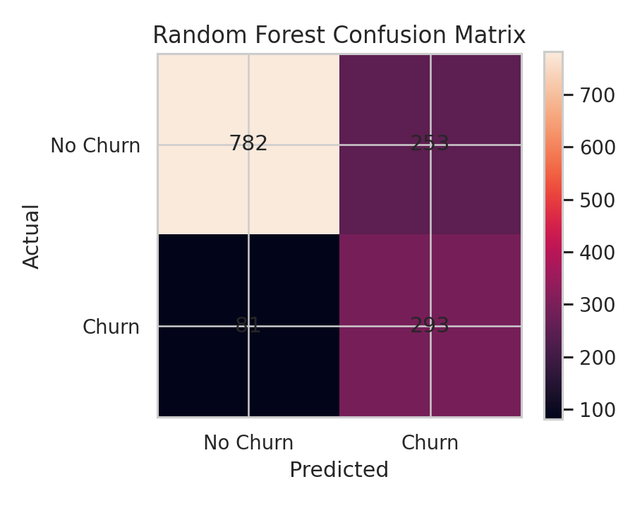
Figure 8. Random Forest confusion matrix on the 20% test set.
The Random Forest correctly identifies 293 churners and misses 81 churners in the test set. Its recall of 78.34% indicates that it identifies a larger share of actual churners than the Logistic Regression baseline.

12.2 Overfitting and Underfitting
Random Forest training accuracy is 0.797, compared with test accuracy of 0.763. The gap is 0.034, suggesting no severe accuracy overfitting under this configuration. Evaluation on unseen test data remains the primary evidence of generalization.

13. RESULTS AND FINDINGS
1. Overall churn rate is 26.54%, making churn a meaningful but minority outcome.
2. Month-to-month customers have the highest observed churn rate (42.71%), far above one-year and two-year contracts.
3. Churned customers have shorter average tenure (17.98 months) than retained customers (37.57 months).
4. Average monthly charges are higher among churned customers (74.44) than retained customers (61.27).
5. The Random Forest achieves 76.30% accuracy and 63.70% F1-score, with recall of 78.34%, making it a useful baseline for churn-risk screening.

14. DISCUSSION
The EDA and model results point to customer lifecycle and relationship structure as central themes. Contract commitment is strongly associated with observed churn, while shorter tenure marks a higher-risk stage. Higher monthly charges and particular service/payment configurations also distinguish churn outcomes. The Random Forest captures nonlinear patterns and provides higher recall and F1-score than the logistic baseline, which is valuable when the business wants to avoid overlooking potential churners. These findings are predictive associations, not causal effects.

15. LIMITATIONS
• The dataset is observational and cannot establish causality.
• Important churn drivers such as competitor offers, satisfaction changes, service incidents or customer complaints may be absent.
• Historical model performance may not generalize unchanged to future customer populations.
• Random Forest feature importance indicates predictive contribution rather than causal importance.
• Business-specific misclassification costs were not supplied, so the classification threshold was not optimized for a particular financial objective.

16. CONCLUSION
This capstone completed an end-to-end churn analysis on 7,043 telecommunications customer records. The analysis found substantial differences across contract types, tenure, monthly charges, internet service and payment methods. A Random Forest classifier provided the strongest balance of recall and F1-score among the tested models and can serve as a practical screening baseline. The evidence supports targeted retention, particularly for month-to-month and early-tenure customers, while emphasizing human review and ongoing model validation.

17. RECOMMENDATIONS AND FUTURE WORK

17.1 Recommendations
• Prioritize proactive retention outreach for month-to-month customers because this segment has the highest observed churn rate.
• Strengthen onboarding and early-lifecycle engagement because churned customers have substantially shorter tenure.
• Review pricing and value communication for higher-charge customers, while testing retention offers rather than assuming price is causal.
• Investigate payment-method experience, especially electronic-check customers, where observed churn is highest.
• Use the Random Forest as a risk-screening tool and combine its predictions with customer-service context before taking action.

17.2 Future Work
Future work could include probability-threshold tuning based on the cost of missed churners versus unnecessary outreach, temporal validation, calibrated probabilities, additional customer-interaction variables, and controlled retention experiments to measure whether interventions actually reduce churn.

18. REFERENCES
India Data Research Academy. (2026). Capstone Project Guide 2026. Data Science & AI Training Program.
India Data Research Academy. (2026). Capstone Project Template Sample. Data Science & AI Training Program.
Pandas documentation. Data manipulation and analysis in Python.
Scikit-learn documentation. Classification, preprocessing, pipelines and model evaluation.

APPENDIX A. CODE
The complete reproducible code is provided in `Customer_Churn_Capstone_Analysis.ipynb`. It contains data loading, cleaning, IQR analysis, EDA, statistical analysis, preprocessing, model training, evaluation and interpretation.

A.1 Data Loading and Inspection
The notebook loads the LMS CSV, displays the first rows, shape, data types, missing values and duplicates.

A.2 Data Cleaning
TotalCharges is converted to numeric and its 11 blank values are resolved using the documented tenure-based treatment.

A.3 Preprocessing
Categorical one-hot encoding, numerical imputation/scaling and the stratified train-test split are implemented using a scikit-learn Pipeline.

A.4 EDA and Visualization
The notebook generates churn distribution, contract, internet-service, monthly-charge, tenure, payment-method, correlation and feature-importance figures.

A.5 Model Training and Evaluation
Logistic Regression and Random Forest are trained and compared using accuracy, precision, recall, F1-score and ROC-AUC, with a confusion matrix for the final model.

APPENDIX B. ADDITIONAL FIGURES AND TABLES
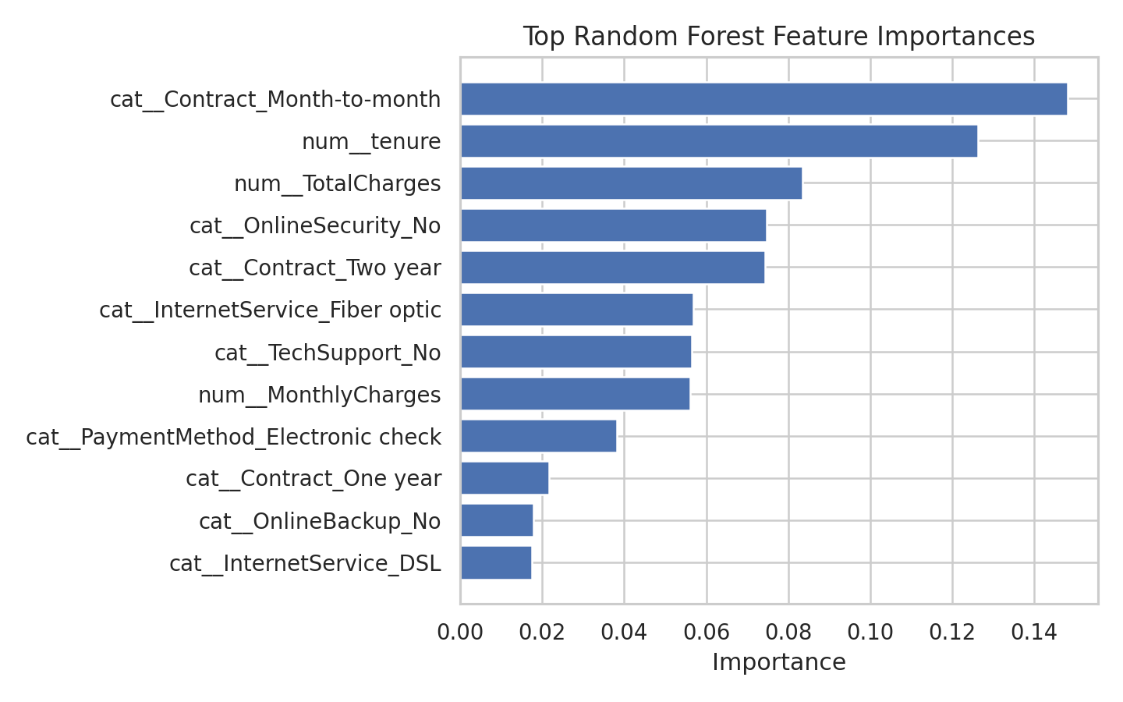
Figure 9. Top Random Forest feature importances.
The feature-importance chart highlights contract, tenure, security/support, internet service, payment method and billing variables among the strongest predictive inputs.

APPENDIX A — KEY CODE EXCERPTS (REPRODUCIBILITY)
The complete executable code remains in the Jupyter notebook. The excerpts below document the most important analytical and modelling decisions, consistent with the IDRA guidance.
A.1 Data Loading and Inspection
# Data loading and inspection
df = pd.read_csv("P_4_WA_Fn-UseC_-Telco-Customer-Churn.csv")
print(df.shape)
display(df.head())
display(df.dtypes.to_frame("dtype"))
A.2 Data Cleaning
# Cleaning TotalCharges
df["TotalCharges"] = pd.to_numeric(df["TotalCharges"], errors="coerce")
print(df["TotalCharges"].isna().sum()) # 11 blank records
df["TotalCharges"] = df["TotalCharges"].fillna(0)
A.3 Preprocessing
# Leakage-safe preprocessing and split
X = df.drop(columns=["Churn", "customerID", "ChurnFlag"])
y = df["ChurnFlag"]
X_train, X_test, y_train, y_test = train_test_split(
X, y, test_size=0.20, random_state=42, stratify=y
)
A.4 Model Training and Evaluation
# Model training and evaluation
pipe = Pipeline([("preprocessor", preprocessor), ("model", model)])
pipe.fit(X_train, y_train)
pred = pipe.predict(X_test)
prob = pipe.predict_proba(X_test)[:, 1]
f1 = f1_score(y_test, pred)
recall = recall_score(y_test, pred)
roc_auc = roc_auc_score(y_test, prob)
A.5 Classification Evaluation
# Confusion matrix
cm = confusion_matrix(y_test, pred)
print(cm)

REFERENCE NOTE
Primary dataset: India Data Research Academy (IDRA), Project 4 — Telco Customer Churn dataset, supplied through the LMS Study Material.
Methodology references: pandas documentation; scikit-learn documentation for preprocessing pipelines, classification models and evaluation metrics.
The report intentionally does not cite external churn studies for empirical claims that were calculated directly from the supplied dataset.

