WEEK 2

PENETRATION TESTING &
NETWORK RECONNAISSANCE REPORT
W2-PM1: Footprinting with Six Kali Tools (Elective)
W2-PM5: Zenmap-Based Network Scanning (Essential)
Prepared by: Nevin K Jolly
Date: 13 November 2026
Platform: Kali Linux on Oracle VirtualBox

Modules covered
W2-PM1 – Footprinting with Six Kali Tools (Elective)
W2-PM5 – Zenmap-Based Network Scanning (Essential)

Report Contents
1. Executive Summary
2. Objectives
3. Scope, Environment and Methodology
4. W2-PM1 – Footprinting with Six Kali Tools (Elective)
4.3 nslookup – DNS Resolution
4.4 curl -I – HTTP Response Header Inspection
4.5 wafw00f – Web Application Firewall Fingerprinting
4.6 dnsrecon – DNS Record Enumeration
5. W2-PM5 – Zenmap-Based Network Scanning (Essential)
6. Supplementary Activity – Traceroute
7. Consolidated Findings
8. Security Observations and Recommendations
9. Limitations
10. Conclusion
Appendix A – Commands Used
Appendix B – Evidence Register

1. Executive Summary
This report documents two completed Week 2 project modules: W2-PM1, the elective module on footprinting with six Kali Linux tools, and W2-PM5, the essential module on Zenmap-based network scanning. The exercises used the training target networkwalks.com for passive/limited web and DNS reconnaissance, and the local lab subnet 192.168.1.0/24 for host discovery.
The footprinting work used WHOIS, WhatWeb, nslookup, curl -I, wafw00f and dnsrecon. The results identified domain-registration information, the resolved web-server IP address, visible web technologies, HTTP response headers, a ModSecurity (SpiderLabs) web application firewall fingerprint, and DNS records including A, NS, MX, TXT and SRV records.
The Zenmap ping scan discovered six responsive hosts in the 192.168.1.0/24 subnet. The scan completed against 256 IP addresses in approximately 8.59 seconds. Because the selected Zenmap profile was Ping scan (nmap -sn), the exercise was host discovery only; it did not establish which TCP/UDP ports or services were open.
An additional traceroute exercise was also performed and is documented as supplementary evidence. It is not counted among the six required W2-PM1 tools.

2. Objectives
- Perform domain and website footprinting using six Kali Linux tools.
- Collect publicly observable registration, DNS, HTTP and web-technology information.
- Identify the target website’s apparent web application firewall using wafw00f.
- Enumerate DNS records using dnsrecon.
- Discover active devices on the local lab subnet using Zenmap/Nmap.
- Interpret the findings, identify limitations, and document the results with evidence.

3. Scope, Environment and Methodology
Target for W2-PM1: https://networkwalks.com/ (domain: networkwalks.com; resolved address observed during the exercise: 192.232.216.135).
Target for W2-PM5: local lab subnet 192.168.1.0/24, scanned from the Kali Linux virtual machine using Zenmap. The subnet scan is separate from the public website footprinting exercise.
Environment: Kali Linux running in Oracle VirtualBox; Zenmap with Nmap 7.98; WhatWeb 0.6.4; WAFW00F 2.4.2; DNSRecon 1.6.0. Tool output and screenshots supplied for this report are treated as the evidence record.
Methodology: (1) collect domain registration data with WHOIS; (2) fingerprint the website with WhatWeb; (3) resolve the domain with nslookup; (4) inspect HTTP response headers with curl -I; (5) fingerprint the WAF with wafw00f; (6) enumerate DNS records with dnsrecon; and (7) perform a Zenmap ping scan of the local subnet. Commands were run with the target values shown below.

4. W2-PM1 – Footprinting with Six Kali Tools (Elective)
4.1 WHOIS – Domain Registration Lookup
Command: whois networkwalks.com
Purpose: WHOIS queries the domain-registration database and returns registrar, registration dates, status, name-server and registrant-contact information where publicly available.
Observed results: Domain name NETWORKWALKS.COM; registrar GoDaddy.com, LLC; creation date 2019-11-06; registry/registrar expiry date 2027-11-06; updated date shown as 2025-11-12 in the captured output; registrar WHOIS server whois.godaddy.com; and registrar URL https://www.godaddy.com. The registrant and technical contact details were privacy-protected through Domains By Proxy, LLC. The output listed nameservers including NS6135.HOSTGATOR.COM and NS6136.HOSTGATOR.COM; a later WHOIS response also listed NS29.DOMAINCONTROL.COM and NS30.DOMAINCONTROL.COM. DNSSEC was reported as unsigned.
Interpretation: The domain is registered through GoDaddy and uses hosting/name-server infrastructure associated with HostGator and DomainControl. Registrant privacy protection limits the personal information exposed by the WHOIS record. The displayed expiry date is the registry/registrar record date and may not necessarily be the final customer-facing renewal date.
4.2 WhatWeb – Website Technology Fingerprinting
Command: whatweb -v https://networkwalks.com/
Purpose: WhatWeb inspects a website’s responses and page content to identify technologies, content-management systems, libraries, cookies and server indicators.
Observed results: HTTP status 200 OK; page title “Networkwalks Academy”; IP address 192.232.216.135; server identified as Apache; WordPress detected with version 7.1.4; WordPress Download Manager 3.3.76; jQuery 3.7.1; Google Tag Manager; HTML5; Open Graph metadata; frames/iframes; and cookie __wpdm_client marked HttpOnly. WhatWeb also displayed Bootstrap[7.1.4]. This Bootstrap version is recorded as reported by the tool and should be independently verified before being treated as a confirmed framework version.
Interpretation: The site appears to use WordPress and the WordPress Download Manager plugin, with Apache identified in the HTTP server header. The technology fingerprint is useful for asset inventory and for prioritising patch/version verification; it does not by itself prove that any component is vulnerable.
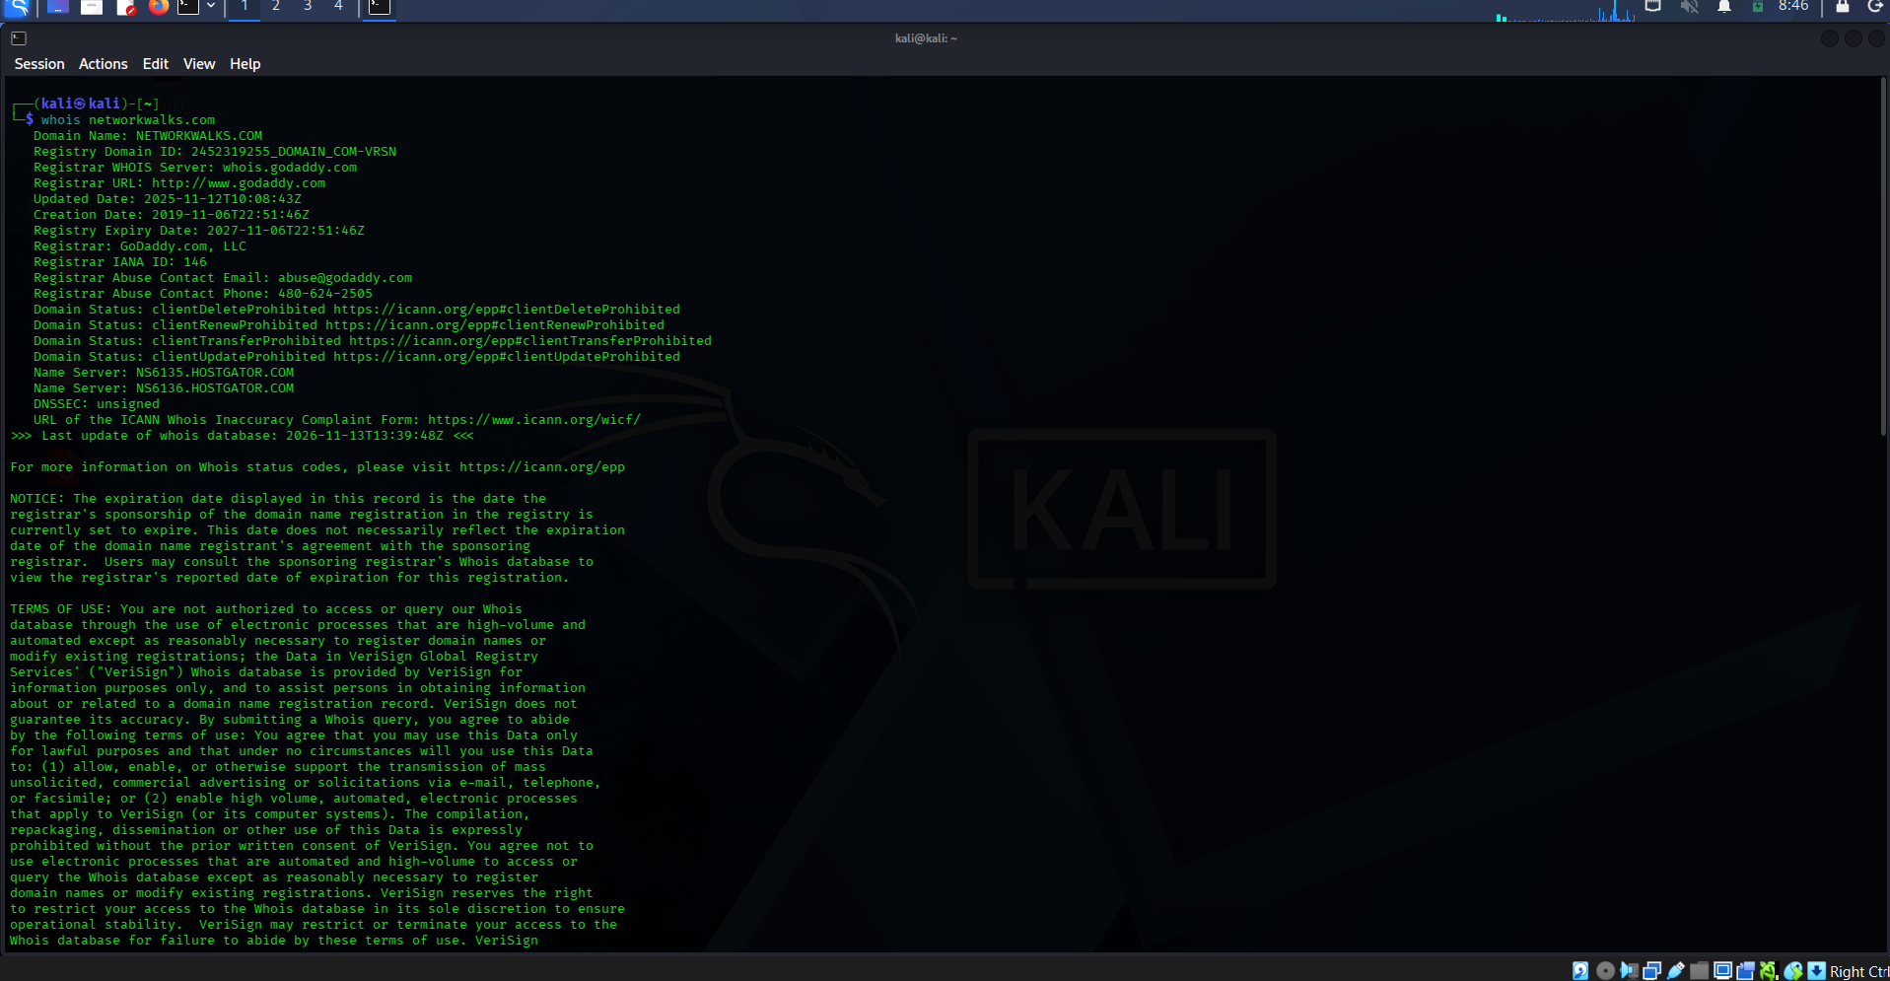
Figure 1. WHOIS registration and registrar information.
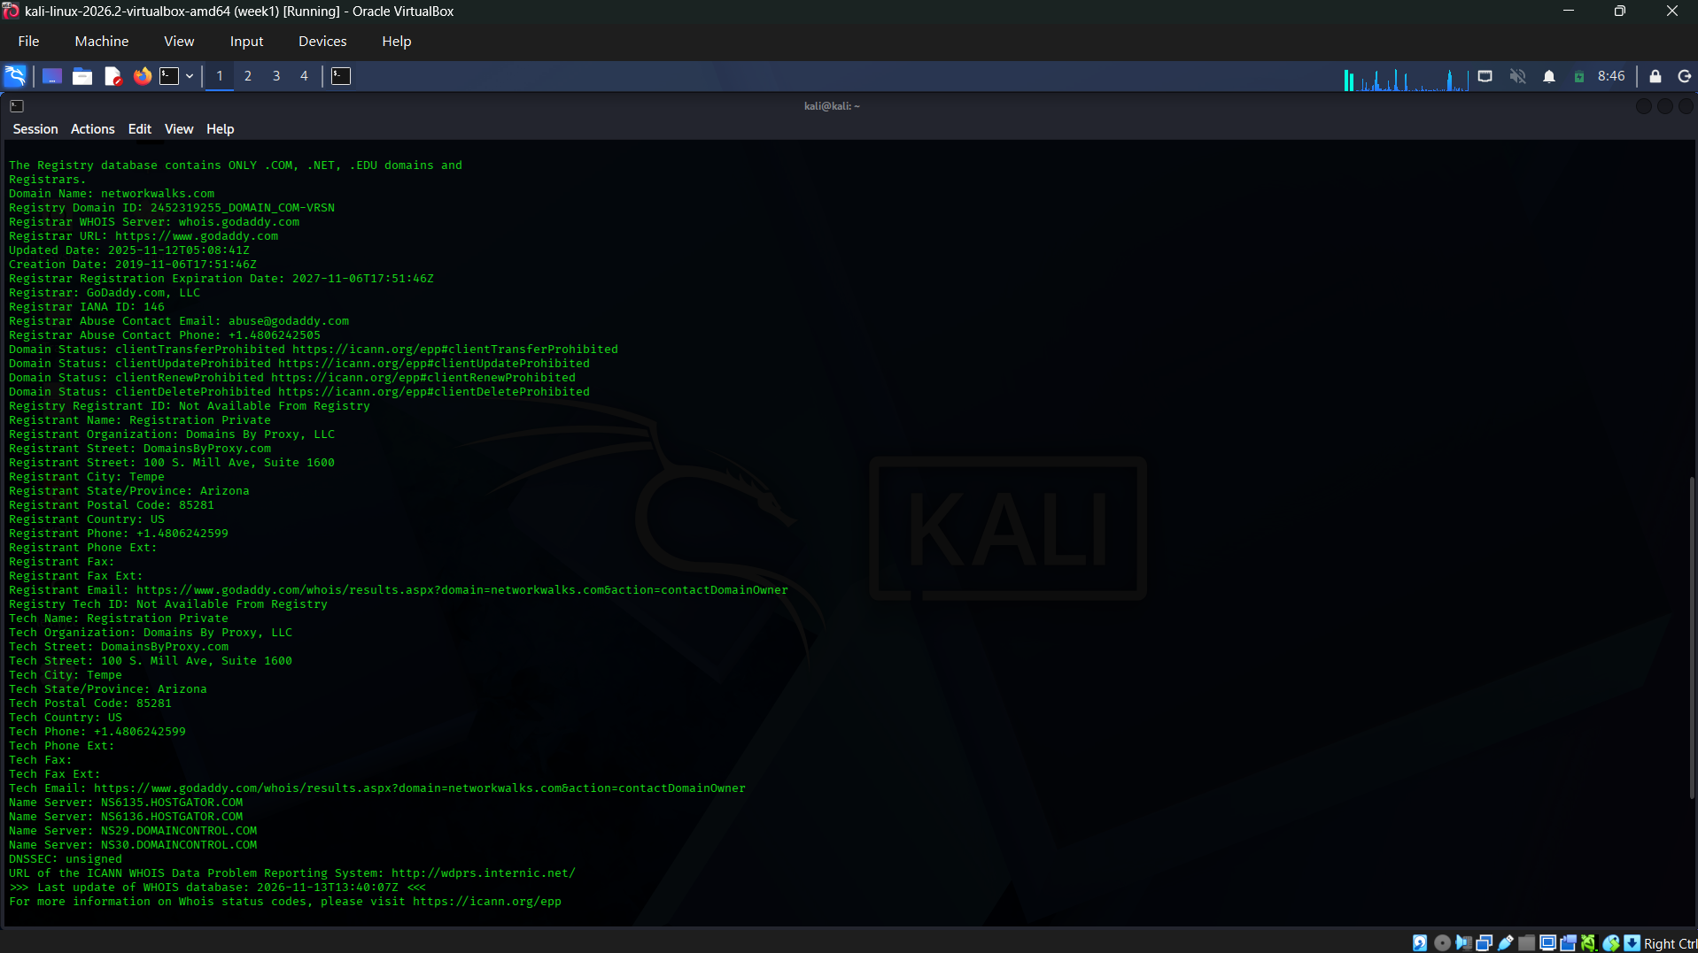
Figure 2. WHOIS registrant privacy, technical contact and nameserver details.
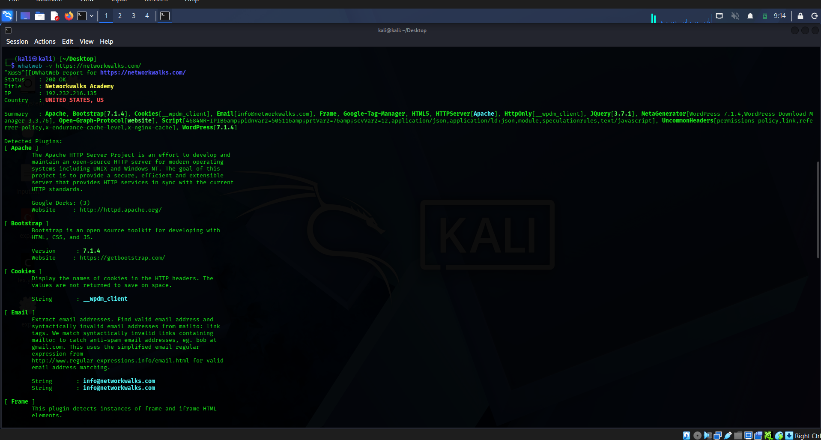
Figure 3. WhatWeb technology fingerprinting output.
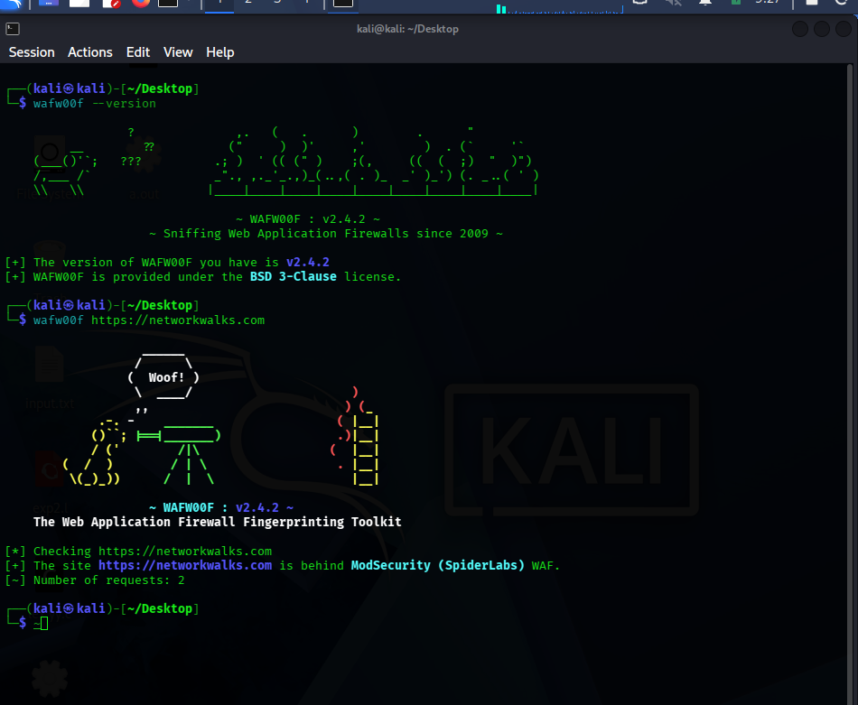
Figure 4. WAFW00F identifies ModSecurity (SpiderLabs).
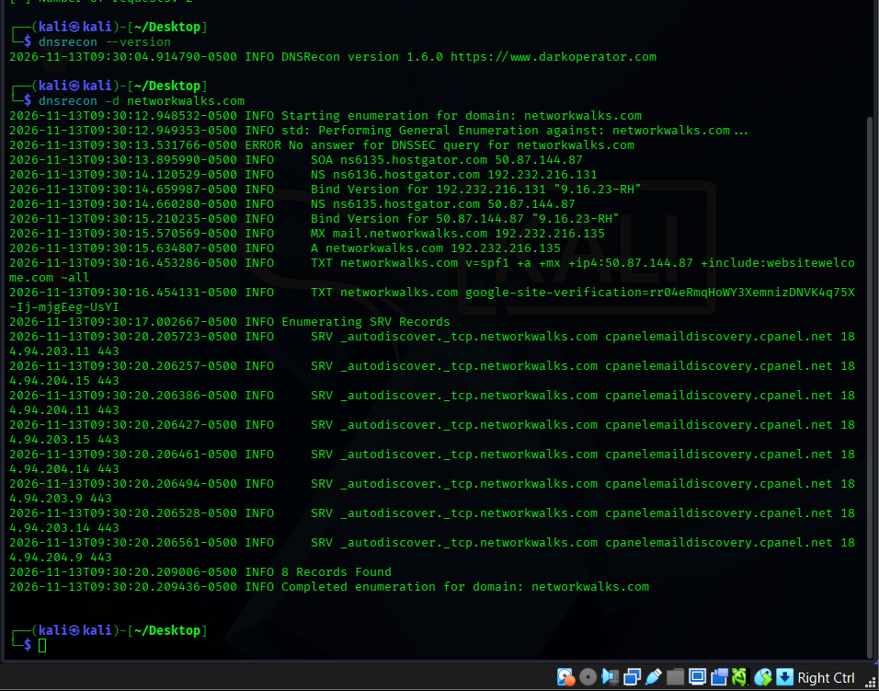
Figure 5. DNSRecon enumerates DNS records.

4.3 nslookup – DNS Resolution
Command: nslookup networkwalks.com
Purpose: nslookup asks a DNS resolver to return DNS information for a hostname.
Observed results: Resolver 8.8.8.8 (Google Public DNS); domain networkwalks.com; returned IPv4 address 192.232.216.135.
Interpretation: The domain resolved successfully to 192.232.216.135 at the time of testing. DNS answers can change due to hosting, CDN, load-balancing or DNS configuration changes, so the result is time-specific.

4.4 curl -I – HTTP Response Header Inspection
Command: curl -I https://networkwalks.com
Purpose: The -I option requests the response headers without downloading the complete page body. It helps identify server responses, cookies, content type and security-related header configuration.
Observed results from the captured terminal output: HTTP/1.1 200 OK; Date header Fri, 13 Nov 2026 14:00:23 GMT; Server: Apache; Content-Type: text/html; charset=UTF-8; Set-Cookie for __wpdm_client with Secure and HttpOnly attributes; Referrer-Policy: no-referrer-when-downgrade; Permissions-Policy present; and WordPress-related Link headers exposing the REST API relation and page endpoint. The response also included X-Endurance-Cache-Level and X-nginx-cache: WordPress.
Interpretation: The server returned a successful response and exposed several implementation details in its headers. The observed cookie has Secure and HttpOnly attributes, which are useful protections for that cookie. The presence of a security header does not establish that its policy is optimal; the actual directives and application context would need review.

4.5 wafw00f – Web Application Firewall Fingerprinting
Command: wafw00f https://networkwalks.com
Purpose: WAFW00F sends a small set of HTTP requests and compares responses with known WAF fingerprints to identify a possible web application firewall.
Observed results: WAFW00F version 2.4.2; the tool reported that https://networkwalks.com is behind ModSecurity (SpiderLabs) WAF; number of requests: 2.
Interpretation: The response pattern matched the ModSecurity (SpiderLabs) fingerprint in WAFW00F’s detection database. This is a fingerprinting result, not a full validation of the WAF’s rules, coverage or effectiveness. A WAF may also be configured in detection-only or blocking mode; this test did not establish which mode is active.

4.6 dnsrecon – DNS Record Enumeration
Command: dnsrecon -d networkwalks.com
Purpose: DNSRecon queries DNS records and performs standard enumeration checks to identify infrastructure and mail/service configuration.
Observed results: DNSRecon 1.6.0 completed general enumeration and reported 8 records. The output included SOA information for ns6135.hostgator.com; NS records ns6135.hostgator.com and ns6136.hostgator.com; A record networkwalks.com → 192.232.216.135; MX record networkwalks.com → 192.232.216.135; TXT SPF record beginning “v=spf1 +a +mx +ip4:50.87.144.87 +include:websitewelcome.com ~all”; a Google site-verification TXT value; and SRV records for _autodiscover._tcp.networkwalks.com pointing to cpanelemaildiscovery.cpanel.net on port 443. Multiple SRV responses with associated addresses were displayed. The tool also logged “No answer for DNSSEC query” for the DNSSEC check.
Interpretation: The DNS data indicates web and mail-related records and exposes service-discovery information associated with the hosting environment. The SPF record authorises the mechanisms listed in that record for sending mail. The DNSSEC message means the query did not return an answer in this run; it should not be interpreted as a complete DNSSEC audit without checking the authoritative zone and parent delegation.

5. W2-PM5 – Zenmap-Based Network Scanning (Essential)
5.1 Scan Configuration
Application: Zenmap (Nmap 7.98). Target: 192.168.1.0/24. Profile: Ping scan. Command generated by Zenmap: nmap -sn 192.168.1.0/24.
Purpose: A ping scan performs host discovery to determine which IP addresses respond. The -sn option disables the port scan stage. It is appropriate for identifying active hosts on a local network before any separately authorised service enumeration.
5.2 Results
Zenmap reported 256 IP addresses scanned and 6 hosts up in approximately 8.59 seconds. The six responsive addresses shown were 192.168.1.1, 192.168.1.3, 192.168.1.5, 192.168.1.7, 192.168.1.8 and 192.168.1.10.
Observed MAC/vendor details: 192.168.1.1 – 14:A7:2B:31:19:CA (currentoptronics Pvt. Ltd.); 192.168.1.3 – B8:AB:62:A5:90:CE (Hui Zhou Gaoshengda Technology); 192.168.1.5 – 3C:B0:ED:73:E3:0C (Nothing Technology Limited); 192.168.1.7 – 02:A3:11:EB:BF:F8 (vendor shown as Unknown); 192.168.1.10 – 4A:76:0D:9B:7D:1A (vendor shown as Unknown). A MAC address was not visible in the supplied output for 192.168.1.8.
5.3 Interpretation
The scan confirms that six devices responded to host discovery within the selected /24 subnet at the time of the scan. The address 192.168.1.1 is commonly used as a gateway address, but the screenshot alone does not confirm the device’s role. MAC vendor identification is based on the address prefix and may be absent, inaccurate or obscured by virtualisation, randomised MAC addresses or network boundaries.
Important limitation: Because the selected profile was Ping scan (nmap -sn), the output does not show open, closed or filtered ports and does not identify running services or operating systems. A separate, explicitly authorised port/service scan would be required for those results.
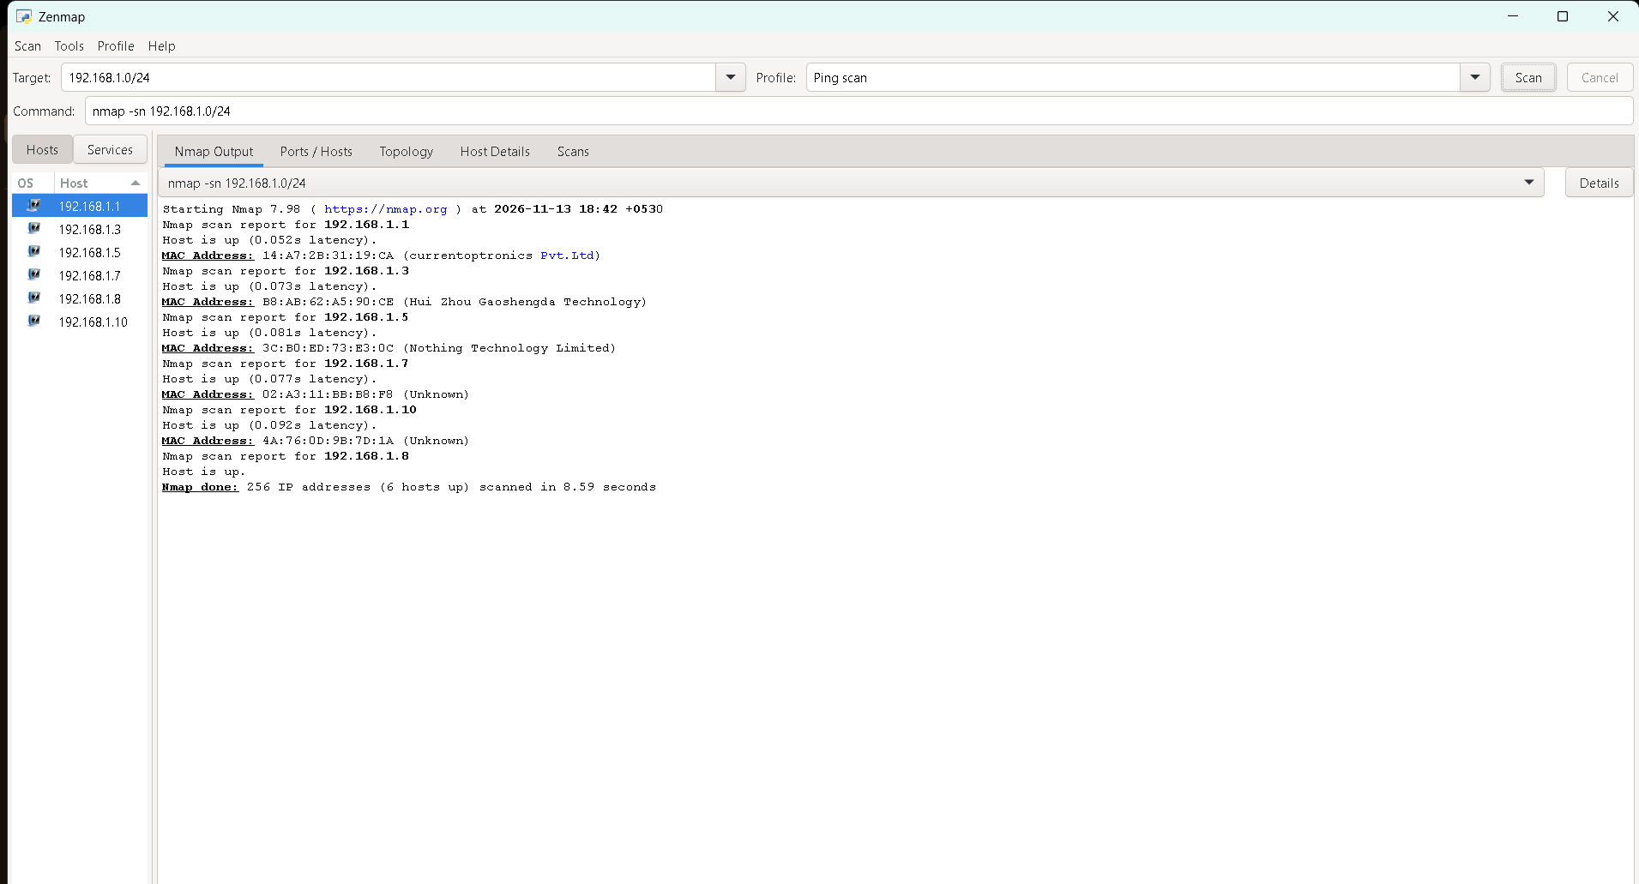
Figure 6. Zenmap ping scan: six hosts up on 192.168.1.0/24.
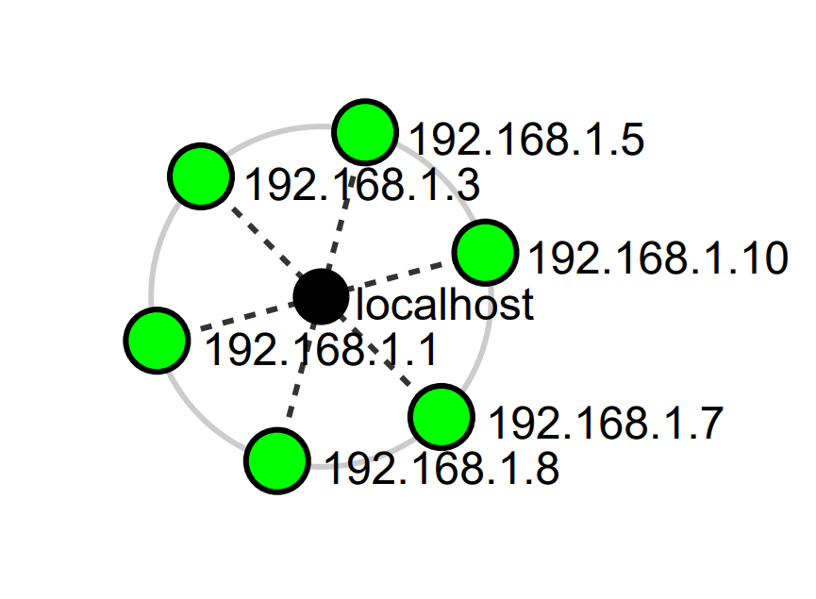
Figure 7. Topology diagram of localhost and the six discovered hosts.

6. Supplementary Activity – Traceroute
Commands shown: traceroute -I networkwalks.com and sudo traceroute -T -p 443 networkwalks.com.
Observed results: The destination resolved to 192.232.216.135. The ICMP-based trace showed the first hop as 10.0.2.2, several intermediate hops that did not return probe responses (shown as * * *), and the destination at hop 15 as 192-232-216-135.unifiedlayer.com (192.232.216.135), with round-trip measurements around 282–283 ms in the displayed run. The TCP trace to destination port 443 reached the destination in one reported hop, with measurements around 264–270 ms.
Interpretation: The first hop 10.0.2.2 is consistent with a virtual/NAT gateway in the lab environment. Asterisks indicate that probes did not receive a response before the timeout; they do not prove that routers are offline. Firewalls and router policies commonly suppress traceroute responses. This traceroute activity is supplementary and is not counted as one of the six W2-PM1 tools.
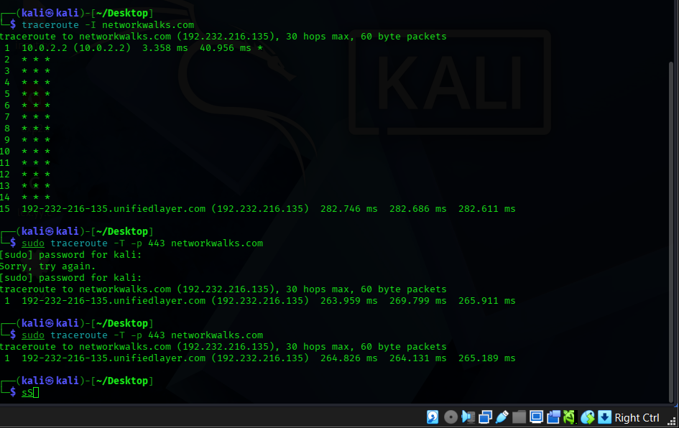
Figure 8. Supplementary ICMP and TCP traceroute output.

7. Consolidated Findings
- Domain registration: GoDaddy.com, LLC; creation date 2019-11-06; expiry date shown as 2027-11-06; registrant privacy protection enabled; DNSSEC reported unsigned in WHOIS.
- DNS resolution: networkwalks.com resolved to 192.232.216.135 using resolver 8.8.8.8.
- Web technologies: Apache and WordPress were detected; WordPress Download Manager 3.3.76 and jQuery 3.7.1 were also reported.
- HTTP response: 200 OK; Apache server header; __wpdm_client cookie included Secure and HttpOnly; WordPress-related response links were exposed.
- WAF fingerprint: WAFW00F identified ModSecurity (SpiderLabs), based on two requests.
- DNS enumeration: 8 records were reported, including A, NS, MX, TXT and SRV data.
- Local network discovery: 6 active hosts found in 192.168.1.0/24 out of 256 scanned addresses.
- Traceroute: destination reached; intermediate routers did not respond to every probe.

8. Security Observations and Recommendations
- Verify and maintain software versions: Confirm the actual WordPress core, WordPress Download Manager and JavaScript library versions from the server/application inventory, then apply supported security updates.
- Review exposed metadata: Consider whether WordPress REST API discovery links, generator metadata and other response details need to be publicly exposed. Do not disable required functionality without testing.
- Review HTTP security headers: Validate the exact Content-Security-Policy, Strict-Transport-Security, X-Content-Type-Options, Referrer-Policy and Permissions-Policy configuration. The captured output did not establish that all recommended headers are present.
- Review cookie settings: The observed __wpdm_client cookie had Secure and HttpOnly attributes. Confirm whether SameSite is appropriate and whether all session/authentication cookies use suitable flags.
- Review DNS configuration: Confirm that DNSSEC is intentionally configured or document why it is not used. Review SPF, DKIM and DMARC together; the exercise only captured an SPF TXT record and did not test mail authentication end-to-end.
- Review WAF operation: Confirm that ModSecurity is enabled, maintained and operating with appropriate rules in blocking mode where suitable. WAFW00F fingerprinting alone cannot verify rule quality or effectiveness.
- Protect internal network assets: Maintain an inventory of the six discovered hosts, identify unknown devices, and ensure router, endpoint and IoT firmware are updated. Restrict management interfaces to trusted networks.
- Perform further testing only with written authorisation: Any port scan, vulnerability scan, exploitation attempt or authenticated testing should be separately scoped and approved.

9. Limitations
The findings are a point-in-time record from the supplied screenshots and terminal output. DNS records, IP addresses, software versions and response headers can change.
WhatWeb and WAFW00F rely on detectable response patterns; their results may be incomplete or inaccurate. A detected technology does not automatically indicate a vulnerability.
The DNSRecon DNSSEC message is not a full DNSSEC validation. No DKIM or DMARC verification was supplied.
The Zenmap exercise used host discovery only. No port-state, service-version or operating-system results were collected.
The screenshots do not include a separate screenshot for every command (notably nslookup and curl -I); their outputs are documented from the terminal results shared in the conversation.

10. Conclusion
The Week 2 elective W2-PM1 was completed using six Kali Linux footprinting tools: WHOIS, WhatWeb, nslookup, curl -I, wafw00f and dnsrecon. The exercise gathered domain-registration details, DNS information, web technology indicators, HTTP headers and a WAF fingerprint for networkwalks.com.
The essential W2-PM5 was completed using Zenmap’s Ping scan profile against 192.168.1.0/24. Six responsive hosts were discovered from 256 scanned addresses. The scan provided a useful view of active devices but did not inspect ports or services because it used nmap -sn.
Together, the modules demonstrate how reconnaissance and host discovery support the early stages of a security assessment. All results should be treated as observations rather than proof of vulnerabilities, and any further testing should remain within a clearly authorised scope.

Appendix A – Commands Used
whois networkwalks.com
whatweb -v https://networkwalks.com/
nslookup networkwalks.com
curl -I https://networkwalks.com
wafw00f https://networkwalks.com
dnsrecon -d networkwalks.com
Zenmap target: 192.168.1.0/24
Zenmap profile: Ping scan
Generated command: nmap -sn 192.168.1.0/24
Supplementary traceroute commands:
traceroute -I networkwalks.com
sudo traceroute -T -p 443 networkwalks.com

Appendix B – Evidence Register
Figure 1. WHOIS domain registration output (first portion).
Figure 2. WHOIS additional registrant, technical contact and nameserver output.
Figure 3. WhatWeb website technology fingerprint.
Figure 4. WAFW00F output identifying ModSecurity (SpiderLabs).
Figure 5. DNSRecon enumeration output showing 8 records.
Figure 6. Zenmap ping scan output showing 6 active hosts.
Figure 7. Network topology diagram representing localhost and the six discovered hosts.
Figure 8. Supplementary traceroute output.

