|  |  |
| --- | --- |
| **Ex. No. 4** | **RESPONSIVE WEB DESIGN USING BOOTSTRAP UI** |
| **Date of Exercise** | **18/07/2022** |
| **Web Host Link** |  |
| **Youtube Link** |  |

**Aim**

To create a responsive web design using Bootstrap UI framework.

**Description**

* Bootstrap is a free front-end framework for faster and easier web

development

* Bootstrap includes HTML and CSS based design templates for typography, forms, buttons, tables, navigation, modals, image carousels and many other, as well as optional JavaScript plugins
* Bootstrap also gives you the ability to easily create responsive designs

**What is Responsi*v*e Web Design**?

Responsive web design is about creating web sites which automatically adjust themselves to look good on all devices, from small phones to large desktops.

**Setting the Viewport**

To create a responsive website, add the following <meta> tag to all your web pages:

<meta name="viewport" content="width=device-width, initial-scale=1">

**Where to Get Bootstrap 5**

Include the following tag in order to integrate Bootstrap 5 Framework in your web design.

<!-- Latest compiled and minified CSS --> <link href="https*://c*dn.jsdelivr.net*/*npm*/*bootstrap@5.1.3*/*dis*t/*css*/*bootstrap. min.css" rel="stylesheet">

<!-- Latest compiled JavaScript --> <script src="https*://c*dn.jsdelivr.net*/npm/*bootstrap@5.1.*3/*dist*/j*s*/*bootstrap.b undle.min.js"><*/*script>

**Bootstrap 5 Containers**

Containers are used to pad the content inside of them, and there are two container classes available:

The .container class provides a responsive fixed width container

<div class="container">

<h1>My First Bootstrap Page<*/*h1>

<p>This is some text.</p>

<*/*div>

The .container-fluid class provides a full width container, spanning the entire width of the viewport

<div class="container-fluid">

<h1>My First Bootstrap Page<*/*h1>

<p>This is some text.<*/*p>

<*/*div>

**Bootstrap Spacing - Padding and Margin**

The classes are named using the format

{property}{sides}-{size}

Where property is one of:

* m - for classes that set margin
* p - for classes that set padding

Where sides is one of:

* t - for classes that set margin-top or padding-top
* b - for classes that set margin-bottom or padding-bottom
* s - for classes that set margin-left or padding-left
* e- for classes that set margin-right or padding-right
* x - for classes that set both *-left and *-right
* y - for classes that set both *-top and *-bottom blank - for classes that set a margin or padding on all 4 sides of the
* element

Example

<body>

<div class="container bg-primary text-white p-5 my-4">

<h1>Welcome to My Web</h1>

<p>This is some text.</p> <*/d*iv> *</*body>

<body>

<div class="container border border-primary rounded text-black pl-3 pt-3 mt-5">

<h1>Welcome to My Web</h1>

<p>This is some text.<*/*p> </div> </body>

**Program**

<!DOCTYPE html>

<html><head>  
  <meta name="viewport" content="width=device-width, initial-scale=1">  
  <link href="<https://cdn.jsdelivr.net/npm/bootstrap@5.1.3/dist/css/bootstrap>. min.css" rel="stylesheet">  
  <script src="<https://cdn.jsdelivr.net/npm/bootstrap@5.1.3/dist/js/bootstrap.b> undle.min.js"></script>  
  <meta charset="utf-8">  
  <meta name="viewport" content="width=device-width, initial-scale=1">  
  <link rel="stylesheet" href="<https://cdn.jsdelivr.net/npm/bootstrap@4.6.1/dist/css/bootstrap.min.css>">  
  <script src="<https://cdn.jsdelivr.net/npm/jquery@3.6.0/dist/jquery.slim.min.js>"></script>  
  <script src="<https://cdn.jsdelivr.net/npm/popper.js@1.16.1/dist/umd/popper.min.js>"></script>  
  <script src="<https://cdn.jsdelivr.net/npm/bootstrap@4.6.1/dist/js/bootstrap.bundle.min.js>"></script>  
  <style>  
   ul li {  
        display: inline-block;  
        word-spacing: 30px;  
        padding-left: 400px;  
  
         
      }  
      .carousel-inner img {  
    width: 100%;  
    height: 500px;  
  }  
   .reg{  
    border:2px solid blue;  
    /* width: 50%;  
    padding: 10px;  */  
  }  
    /* .table{  
    width:50%;  
    height: 50%px;  
    float:right;  
    margin-bottom: 600px;  
  }  */  
   
   
   
  </style>  
</head>  
<body>  
    <img src="<https://encrypted-tbn0.gstatic.com/images?q=tbn:ANd9GcSeuXftADuVvua0OF8j6cLO-edmDAPzO4Q2OA&amp;usqp=CAU>" width="250px" height="50px" style="float: left;">  
  <nav>  
  
<nav>  
  <div class="a">  
    <ul>  
        <li style="color:blue;">Home Services Clients ContactUs Login/SignUp <input type="text" placeholder="Search.."><input type="Submit" value="submit" style="background-color:rgb(0, 183, 255) ;color:aliceblue;"></li>  
        </ul>  
  </div>  
</nav>  
<div id="demo" class="carousel slide" data-ride="carousel">  
  
    <!-- Indicators -->  
    <ul class="carousel-indicators">  
      <li data-target="#demo" data-slide-to="0" class="" width="5%;"></li>  
      <li data-target="#demo" data-slide-to="1" width="5px;" class=""></li>  
      <li data-target="#demo" data-slide-to="2" width="5px;" class="active"></li>  
    </ul>  
   
    <!-- The slideshow -->  
    <div class="carousel-inner">  
      <div class="carousel-item">  
        <img src="<https://encrypted-tbn0.gstatic.com/images?q=tbn:ANd9GcSALYpHmzEtIHFVHZsgxADlssmLT5UO301M3A&amp;usqp=CAU>">  
      </div>  
      <div class="carousel-item active carousel-item-left">  
        <img src="<https://encrypted-tbn0.gstatic.com/images?q=tbn:ANd9GcSGOeMZqrXDogHX4OURAVpwZFNf1VqyXkBb3w&amp;usqp=CAU>" alt="Chicago">  
      </div>  
      <div class="carousel-item carousel-item-next carousel-item-left">  
        <img src="<https://encrypted-tbn0.gstatic.com/images?q=tbn:ANd9GcQLSRYL3WQWHyH7pmaEq84b32y9WclbaDG0Yw&amp;usqp=CAU>" alt="New York">  
      </div>  
    </div>  
   
    <!-- Left and right controls -->  
    <a class="carousel-control-prev" href="#demo" data-slide="prev">  
      <span class="carousel-control-prev-icon"></span>  
    </a>  
    <a class="carousel-control-next" href="#demo" data-slide="next">  
      <span class="carousel-control-next-icon"></span>  
    </a>  
  </div>  
   
  <section id="services" class="form-table">  
    <div class="container-fluid">  
      <div class="row">  
        <div class="col-md-6">  
          <form class="row g-3 form">  
            <div class="col-md-6">  
               
              <label for="inputEmail4" class="form-label">Email</label>  
              <input type="email" class="form-control" id="inputEmail4">  
            </div>  
            <div class="col-md-6">  
              <label for="inputPassword4" class="form-label">Password</label>  
              <input type="password" class="form-control" id="inputPassword4">  
            </div>  
            <div class="col-12">  
              <label for="inputAddress" class="form-label">Address</label>  
              <input type="text" class="form-control" id="inputAddress" placeholder="Write address here">  
            </div>  
            <div class="col-12">  
              <label for="inputAddress2" class="form-label">Address 2</label>  
              <input type="text" class="form-control" id="inputAddress2" placeholder="Apartment, studio, or floor">  
            </div>  
            <div class="col-md-6">  
              <label for="inputCity" class="form-label">City</label>  
              <input type="text" class="form-control" id="inputCity">  
            </div>  
            <div class="col-md-4">  
              <label for="inputState" class="form-label">State</label>  
              <select id="inputState" class="form-select">  
                <option selected="">Choose...</option>  
                <option>...</option>  
              </select>  
            </div>  
            <div class="col-md-2">  
              <label for="inputZip" class="form-label">Zip</label>  
              <input type="text" class="form-control" id="inputZip">  
            </div>  
            <div class="col-12">  
              <div class="form-check">  
                <input class="form-check-input" type="checkbox" id="gridCheck">  
                <label class="form-check-label" for="gridCheck">  
                  Check me out  
                </label>  
              </div>  
            </div>  
            <div class="col-12">  
              <button type="submit" class="btn btn-primary">Sign in</button>  
            </div>  
          </form></div>  
           
           
         
        <div class="col-md-6">  
          <table class="table table-bordered">  
            <thead class="bg-primary" style="color: white">  
              <tr>  
                <th scope="col">S.No</th>  
                <th scope="col">Reg.No</th>  
                <th scope="col">Name of the Participant</th>  
                <th scope="col">Collaborative activity</th>  
                <th scope="col">Collaborating Agency</th>  
              </tr>  
            </thead>  
            <tbody>  
              <tr>  
                <th scope="row">1</th>  
                <td>URK20CS2043</td>  
                <td>BENSTON DANIEL</td>  
                <td>WEB DESIGN</td>  
                <td>SATA Centre</td>  
              </tr>  
              <tr>  
                <th scope="row">2</th>  
                <td>URK20CS2053</td>  
                <td>SITARAMAN</td>  
                <td>Product Design and Analysis</td>  
                <td>CADD Centre</td>  
              </tr>  
              <tr>  
                <th scope="row">3</th>  
                <td>URK23456</td>  
                <td>ERIK SHUAN</td>  
                <td>Product Design and Analysis</td>  
                <td>CADD Centre</td>  
              </tr>  
              <tr>  
                <th scope="row">4</th>  
                <td>URK69CS4205</td>  
                <td>BUG DWIK</td>  
                <td>Product Design and Analysis</td>  
                <td>CADD Centre</td>  
              </tr>  
              <tr>  
                <th scope="row">5</th>  
                <td>URK23AE08</td>  
                <td>BUSII K J</td>  
                <td>Product Design and Analysis</td>  
                <td>CADD Centre</td>  
              </tr>  
              <tr>  
                <th scope="row">6</th>  
                <td>URK16AE1220</td>  
                <td>KOOKIEKUL</td>  
                <td>Product Design and Analysis</td>  
                <td>CADD Centre</td>  
              </tr>  
              <tr>  
                <th scope="row">7</th>  
                <td>URK16AE021</td>  
                <td>JEROME</td>  
                <td>Product Design and Analysis</td>  
                <td>CADD Centre</td>  
              </tr>  
              <tr>  
                <th scope="row">8</th>  
                <td>URK16AE022</td>  
                <td>AFNAN M. ARIEF</td>  
                <td>Product Design and Analysis</td>  
                <td>CADD Centre</td>  
              </tr>  
            </tbody>  
          </table>  
        </div>  
      </div>  
    </div>  
  </section>  
  
  <!-- Popper JS -->  
  <script src="<https://cdn.jsdelivr.net/npm/@popperjs/core@2.11.5/dist/umd/popper.min.js>" integrity="sha384-Xe+8cL9oJa6tN/veChSP7q+mnSPaj5Bcu9mPX5F5xIGE0DVittaqT5lorf0EI7Vk" crossorigin="anonymous"></script>  
  
  <!-- Bootstrap JS -->  
  <script src="<https://cdn.jsdelivr.net/npm/bootstrap@5.2.0/dist/js/bootstrap.min.js>" integrity="sha384-ODmDIVzN+pFdexxHEHFBQH3/9/vQ9uori45z4JjnFsRydbmQbmL5t1tQ0culUzyK" crossorigin="anonymous"></script>  
  <!-- <div class="bottom">  
  
  <div class="reg">  
    <div class="container-fluid">  
      <h5 style=" color:rgba(0, 255, 255, 0.774); text-align:center">Registration Form</h5>  
      <form class="form-inline">  
        <label class="mb-6 p-2">Email</label>  
        <input type="email" class="form-control mb-2">  
        <label class="mb-6 p-2">password</label>  
        <input type="password" class="form-control mb-2">  
      </div>  
          <label class="mb-2">Adress</label>  
          <input type="text" class="form-control mb-2" placeholder="Enter your Address">  
          <label class="mb-2">Adress 2</label>  
          <input type="text" class="form-control mb-2" placeholder="Enter your Address">  
          <div class="form-inline">  
            <label class="mb-3 p-2">city</label>  
            <input type="text" >  
            <label class="mb-2 p-3">Zip</label>  
            <input type="number">  
          </div>  
          <input type="checkbox">Check me out</input><br><br>  
          <input type="submit" class="btn btn-primary mb-2" value="submit">  
        </form>  
       
       
        </div>  
        <table class="table table-bordered">  
          <th>  
            <tr class ="bg-primary text-white">  
              <th>S.no</th>  
              <th>Reg.no</th>  
              <th>Name of the participant</th>  
              <th>Collabarative activity</th>  
              <th>Collaborating Agency</th>  
            </tr>  
          </th>  
          <tr>  
            <td>1</td>  
            <td>UR16AE001</td>  
            <td>ANIT ANU JOHN</td>  
            <td>Product design and analysit</td>  
            <td>CABB Center</td>  
          </tr>  
          <tr>  
            <td>2</td>  
            <td>UR16AE011</td>  
            <td>VASANTHA</td>  
            <td>Product design and analysit</td>  
            <td>CABB Center</td>  
          </tr>  
          <tr>  
            <td>3</td>  
            <td>UR16AE003</td>  
            <td>ABIJITH</td>  
            <td>Product design and analysit</td>  
            <td>CABB Center</td>  
          </tr>  
          <tr>  
            <td>4</td>  
            <td>UR16AE005</td>  
            <td>JEBIN JOHN</td>  
            <td>Product design and analysit</td>  
            <td>CABB Center</td>  
          </tr>  
          <tr>  
            <td>5</td>  
            <td>UR16AE012</td>  
            <td>JOSHI K</td>  
            <td>Product design and analysit</td>  
            <td>CABB Center</td>  
          </tr>  
          <tr>  
            <td>6</td>  
            <td>UR16AE021</td>  
            <td>J B GOKUL</td>  
            <td>Product design and analysit</td>  
            <td>CABB Center</td>  
          </tr>  
          <tr>  
            <td>7</td>  
            <td>UR16AE051</td>  
            <td>JEROME</td>  
            <td>Product design and analysit</td>  
            <td>CABB Center</td>  
          </tr>  
          <tr>  
            <td>8</td>  
            <td>UR16AE056</td>  
            <td>AFNAN M. ARIEF</td>  
            <td>Product design and analysit</td>  
            <td>CABB Center</td>  
          </tr>  
  
        </table>  
         
     
  </div>  
   
                   
                   
   -->  
   
  
</nav></body></html>

**Output**

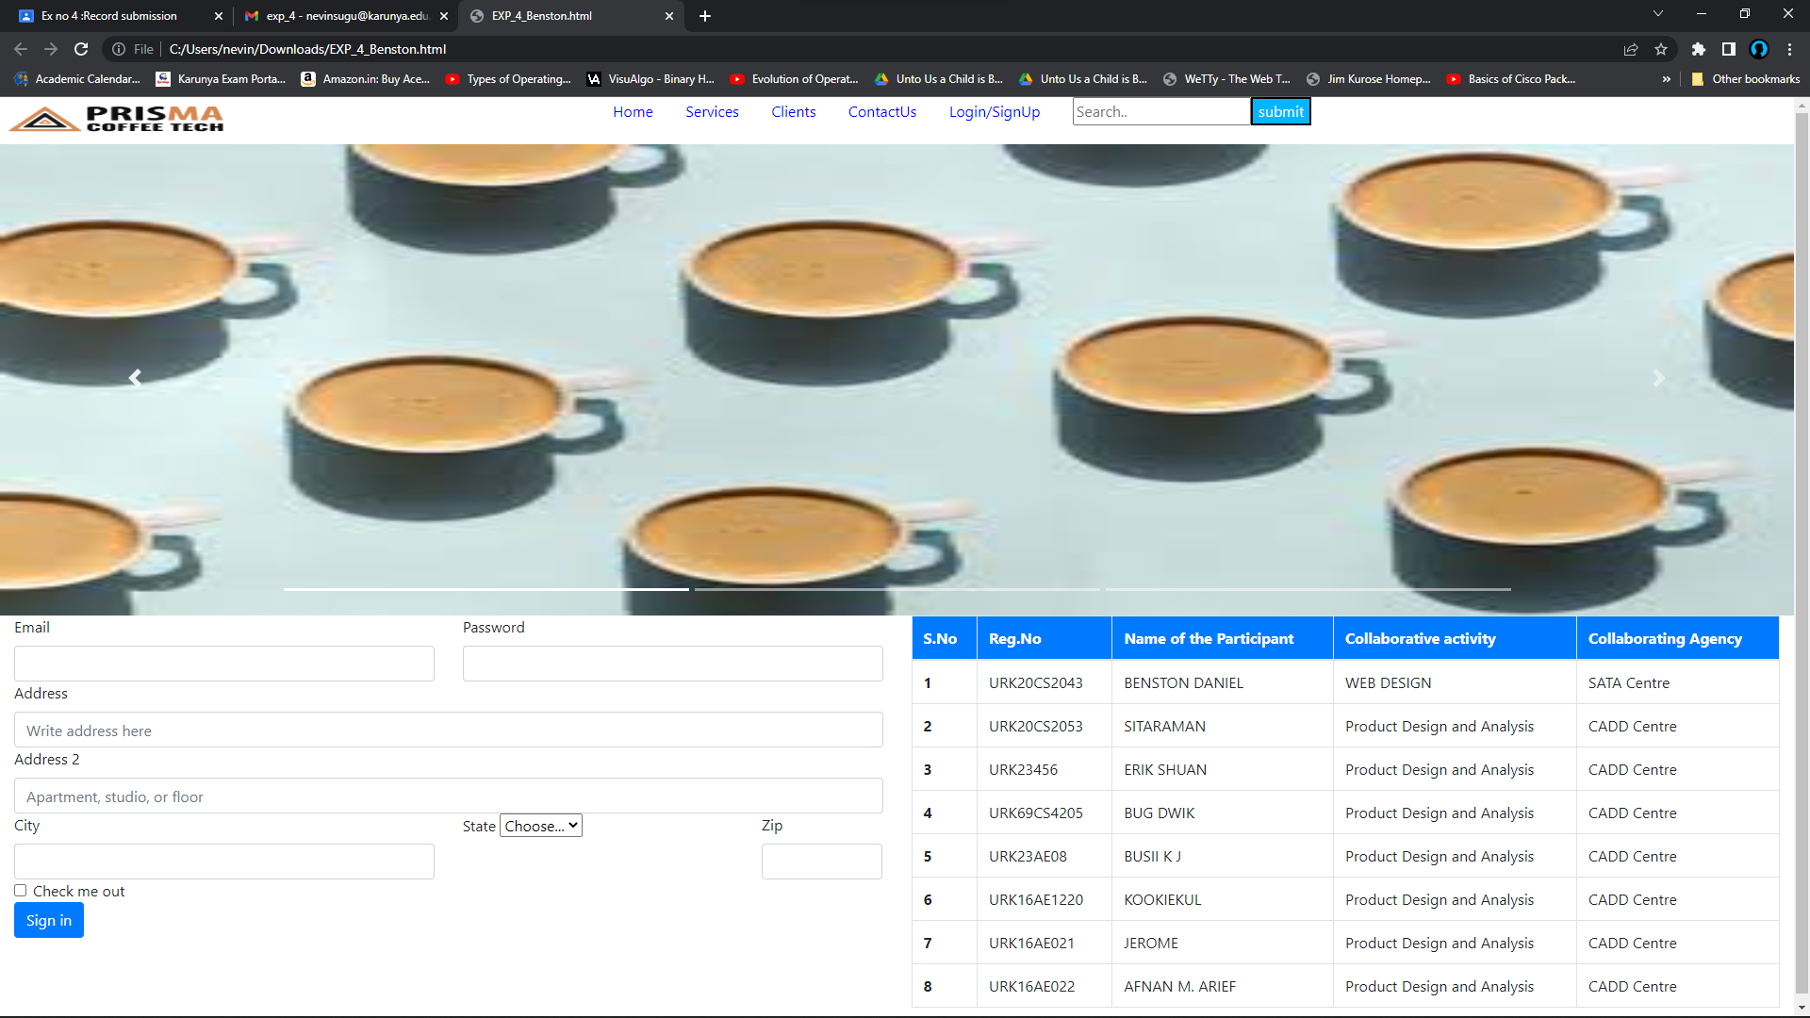

**Result**

The code is compiled successfully and gave the desired output.