NLP Task

Nevin Mathews Kuruvilla

15th July 2022

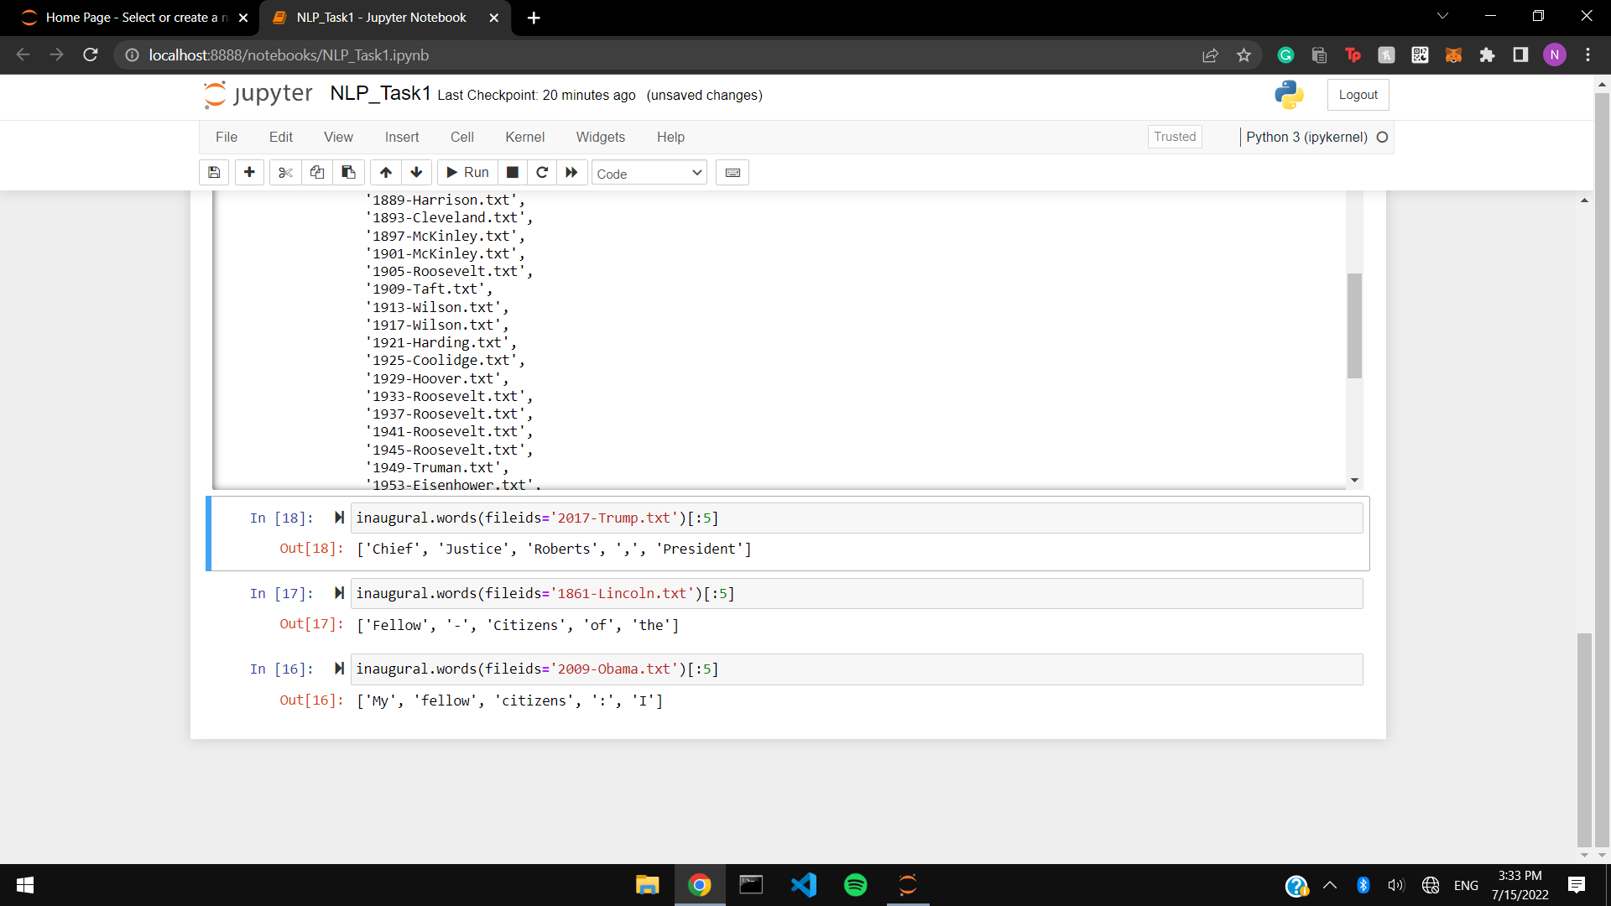

The styles of Abraham Lincoln and Barack Obama closely resemble each other as they first address the citizens, meanwhile Trump addresses the important personals in the congregation. We can also conclude that Lincoln and Obama follow a script or a patterned speech whereas Trump seem to be doing his own thing.