md++ Word Export Fixture
A DOCX test document for Word-to-md++ exporters
Purpose: explain the md++ language profile while exercising clean mappings, lossy mappings, sidecar metadata, and unsupported Office features.

Fixture map
This file is intentionally both documentation and a test fixture. The exporter should produce readable md++ plus diagnostics where fidelity cannot be preserved.
- Spec overview and expected md++ directives
- Word styles mapped to md++ classes
- Markdown-compatible body features
- Simple and complex tables
- Images, captions, links, bookmarks, and assets
- Headers, footers, page numbers, sections, and layout
- Comments, review metadata, and unsupported objects
- Exporter acceptance checklist

1. md++ spec overview
md++ keeps ordinary Markdown as the host language and adds directives, resources, capabilities, layouts, models, plugins, and output conventions. A plain Markdown renderer should still show useful content; a full md++ processor adds interpretation.
A Word style named Executive Summary should export as an author-facing class, for example {.word-style-executive-summary}, not as a hidden Word-only object.
COMMENT_TARGET_STYLE_CLASS: This warning callout tests a named paragraph style that should map to {.callout-warning}. Unknown classes should remain in the Markdown source.
Representative md++ document directives:
[md:profile]: md++
[md:profile-version]: 0.14
[md:title]: <md++ Word Export Fixture>
[md:status]: draft
[md:require]: include
[md:require]: layout.grid
[md:require]: diagram.mermaid
[md:require]: model.dot
[md:theme]: ./themes/company.theme.md
[md:layout]: ./layouts/report.layout.md
[md:stylesheet]: ./styles/local-overrides.css

2. Word-to-md++ mapping matrix
Word source feature | Expected md++ target | Exporter assertion | Diagnostic expectation
Document title/properties | [md:title], metadata | Preserve title and status when available | none
Heading 1-4 | # through #### | Preserve hierarchy and generated anchors | duplicate anchors are errors
Named styles | attribute-list classes | Map safe names to {.word-style-name} | unknown classes normally kept
Body paragraphs | Markdown paragraphs | No Word-only style objects in body | none
Simple table | GFM table | Header row and cells preserved | none
Merged/complex table | component block or fallback HTML/asset | Do not flatten silently | MDPP0700-range when degraded
Images | ![alt](asset) | Extract asset and preserve alt text/caption | warning if missing asset
Header/footer/page number | theme page-furniture | Map slots and page-number tokens | MDPP0418 if page count unavailable
Comments | sidecar YAML/JSON | Anchor comments to block id/range | MDPP0700-range for degraded anchors
Freeform text box/shape | asset, placeholder, omission, or diagnostic | Do not treat as normal body flow | MDPP0700-range

3. Markdown-compatible body features
Inline formatting: strong text, emphasized text, inline code model=system-graph, and an external link to a placeholder exporter URL.
Nested list test:
- First bullet should remain an unordered Markdown item.
- Nested bullets should preserve indentation.
- Numbered sequence should become an ordered Markdown list.
- Second ordered item checks numbering continuity.
Block quote test: md++ should preserve ordinary Markdown block quote semantics before applying theme or layout interpretation.
Fenced code block test:
```typescript
interface MdExportResult {
markdown: string;
diagnostics: MdDiagnostic[];
sidecars: MdSidecar[];
}
```
Inline math target: $E = mc^2$ should remain Markdown-compatible text if no equation converter is available.
Word equation object: $E = mc²$
Exporter note: if Word equation OMML can be converted to LaTeX, emit md++ math. Otherwise emit source text, placeholder, or a diagnostic.

4. Tables
Simple table expected to export as a GFM table:
Construct | md++ meaning | Expected output
[md:require] | Capability requirement | directive line
```dot model=NAME``` | Model registration | absorbed model block
### Left {.left} | Area binding | heading with class
![alt](asset.png) | Image asset | Markdown image
COMMENT_TARGET_TABLE: The next table deliberately uses merged cells and nested-looking content. It should not be forced into a plain GFM table if structure would be lost.
Complex Word table: merged title row plus mixed content
Vertical group  (merged cells) | Case | Expected md++ target | Reason
 | nested list-like content | component block | GFM cannot preserve merged geometry
 | manual line breaks | fallback HTML or diagnostic | structure is richer than simple Markdown

5. Images, captions, links, and anchors
Image test: exporter should extract this PNG as an asset, preserve alt text, and keep the caption nearby.
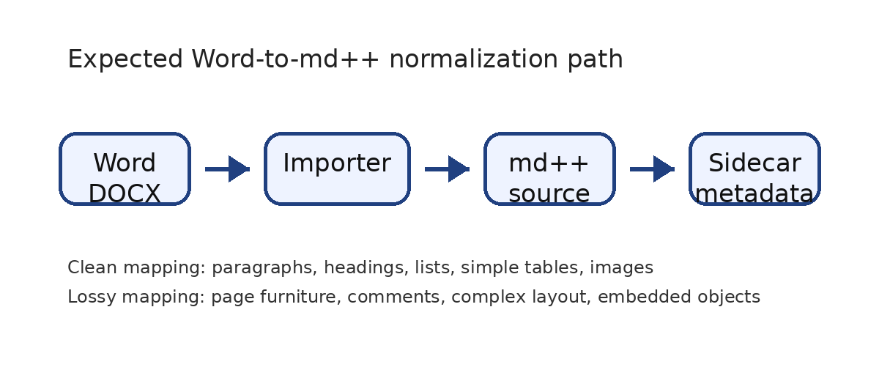
Figure 1. md++ Word-to-md++ asset pipeline; expected Markdown image with alt text and caption.
Internal anchor test: this sentence refers to Figure 1 by a named bookmark. Exporters may convert bookmarks to explicit anchors such as {#fig-mdpp-pipeline}.

6. Page furniture and layout
This document has a different first-page header, a running header, and a footer with PAGE and NUMPAGES fields. The md++ target should prefer theme page-furniture definitions instead of duplicating repeated header/footer text in body flow.
## page-furniture report
header-left: {document.title}
header-right: {page.number}
footer-center: Confidential fixture
number-format: {page.number} / {page.count}
Section and page-break test: the next page is landscape to test layout/page model normalization. A simple exporter may emit a layout resource, a page attribute, or a diagnostic if it cannot preserve orientation.

7. Landscape layout and unsupported Office objects
This landscape section checks page geometry, section breaks, freeform objects, and degraded visual constructs.
 | 1fr | 1fr | 1fr
auto | title | title | title
1fr | left | center | right
The table above is content that explains layout resources. It is not a Word layout engine. It should export as a simple Markdown table.
Unsupported freeform layout object below:
Freeform text box
Expected: static asset, placeholder, omission, or MDPP0700-range diagnostic.
COMMENT_TARGET_UNSUPPORTED: The text box above is an unsupported freeform object test. Exporter should emit a static asset, placeholder, omission, or MDPP0700-range diagnostic.
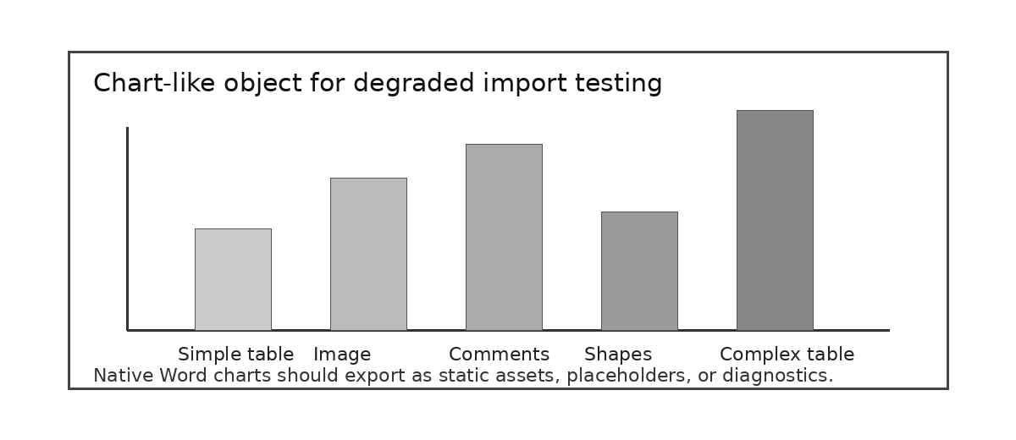
Figure 2. Chart-like visual: native Word charts should degrade to asset, placeholder, or diagnostic; this fixture includes a static image analogue.

8. Comments and review metadata
This section includes real Word comments added after document creation. The expected md++ export is a sidecar file such as root.md.comments.yaml, with anchors to headings, paragraphs, or generated block identifiers.
Tracked change seed sentence: This sentence intentionally contains the phrase tracked-new-mdpp-term for review metadata testing.
If tracked changes are unsupported by the exporter, emit review metadata to a sidecar or produce a diagnostic rather than silently accepting or discarding the change.

9. Exporter acceptance checklist
Check | Expected result | Pass criterion
Metadata | [md:profile], [md:title], [md:status] | Document identity captured
Styles | {.word-style-*}, {.lead}, {.callout-warning} | Safe classes preserved
Core Markdown | headings, paragraphs, lists, links, code, math | Readable plain Markdown fallback
Resources | images extracted and referenced | Alt text and captions preserved
Tables | GFM for simple, diagnostic/fallback for complex | No silent structural loss
Page furniture | theme/layout page-furniture | Headers, footers, page fields not duplicated as body
Sidecars | comments/review notes externalized | Comment text and anchor references preserved
Diagnostics | MDPP0700 range for unsupported Office constructs | Each lossy decision is reported
The output should be useful as md++ even when not every Word visual feature is preserved exactly.

