REG NUMBER: SCT221-0230/2021
1.Data as he object of study
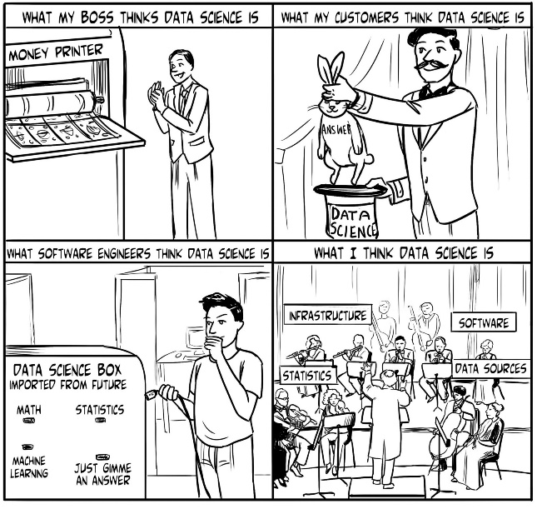
In recent years, there has been a seemingly never-ending discussion about whether the field of data science is merely a reincarnation or an offshoot—in the Big Data Age—of any of a number of older fields that combines software engineering and data analysis: operations research ,decision science ,analytic ,data mining, mathematical modeling, or applied statistics, for example. As with any trendy term or topic, the discussion over its definition and concept will cease only when the popularity of the term dies down. I don’t think I can define data science any better than many of those who have done so before me, so let a definition from Wikipedia, paraphrased and suffice:
2. Data science is The Extraction of Knowledge from Data.
Simple enough, but that description doesn’t distinguish data science from the many other similar terms, except perhaps to claim that data science is an umbrella for the whole lot.
Once the other hand, this era of data science has a property that no previous era had, And it is, to me, a fairly compelling reason to apply a new term to the types of things That data scientists do that previous applied statisticians and the data-oriented Software engineers did not.
The users of computer and the internet became data generators.
Throughout recent history, computers have made incredible advances in:
- Computational power,
- Storage, and
- General capacity to accomplish previously unheard-of tasks.
Tab stops
Name : Name1
Name2: Name2

