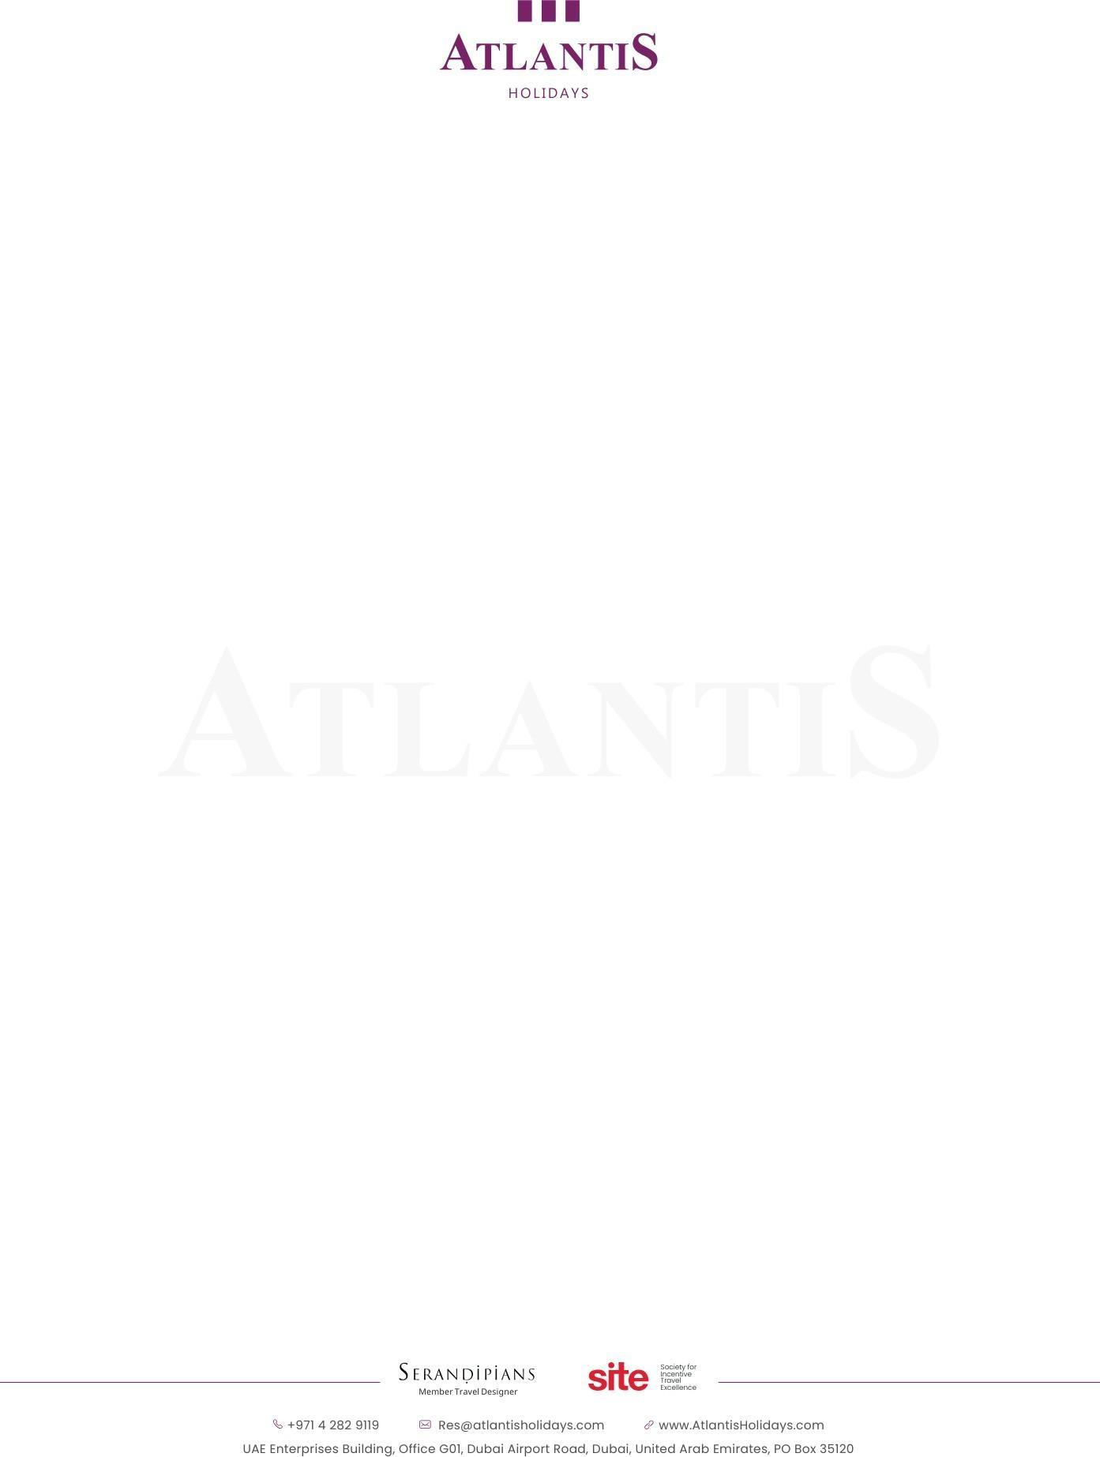
Atlantis EADV Congress
Nov. 23 – Nov. 26
Dubai, 18 guests
ESTIMATED CALCULATION
Service | Quantity | Unit (nights) | Rate | Total in AED
HOTEL OPTIONS
NH Collection Dubai the Palm
NH Collection Dubai The Palm is a modern beachfront hotel located on Palm West Beach in Palm Jumeirah, Dubai. It features 227 rooms and suites alongside 299 serviced apartments, a rooftop infinity pool, direct beach access, multiple dining venues, and a gym.
Standard room Nov. 23 – Nov. 26 (3 nights) | 18 | 3 | 680 AED | 36,720.00 AED
Tax: The room rates include: Breakfast, Applicable taxes and Tourism Dirhams
Room rates are in AED per night, and include the following amenities:
Option date: shared option first come first served Availability of rooms and rates are limited and subject to change any time, rates are valid till: Aug. 8, 2026
Transportation with 35-seater Luxury Coach
Airport transfer airport - hotel with meet & greet | 1 | 1 | 675 AED | 675 AED
Half day (Dubai – 5 hours) | 1 | 1 | 750 AED | 750 AED
Airport Departure | 1 | 1 | 450 AED | 450 AED


Tours
Bohemia Beach Club: All Inclusive. Without transfer. Per person | 1 | 1 | 350 AED
Buggy Experience.  Private 4x4 pickup with dedicated safari guide  Dune bashing, followed by guided dune buggy adventure, sandboarding, and a scenic photo point  Private desert dinner with live BBQ and bonfire under the stars Return transfer by 4x4 car. Max. 6 pax in each car – total 3 cars | 1760 AED | 18 | 31680 AED
Talise Ottoman Spa. Per person Royal Ottoman - Talise Signature 60 min  Turkish Elegance: Relax in the elegance of the hammam as the heat and delicate aromas prepare you for the traditional ‘Kese’ mitt body polish and foam massage. Savor the warm glow from the marble as your hair is shampooed and your scalp is massaged, followed by a moisturizing conditioner. Your body is then enveloped in a honey mask to revitalize and hydrate your complexion.  Remarks  Please note that the Hammam follows a strict gender policy: male therapists attend to male guests, and female therapists attend to female guests. The Hammam area is a shared space with other guests, featuring a common marble platform in a warm environment. | 1065 AED | 1 | 1065 AED
Points to note
This proposal is based on the requested period, length of stay, program, and number of rooms. In case of any changes, the conditions are subject to change.
As this is an exceptionally busy period, we are unfortunately unable to guarantee the quoted prices.
Our proposal was prepared exclusively for you.
Disclosure of this proposal or its parts to a third party other than your final client is strictly prohibited
References from our clients can be provided upon request. Rates are subject to change at the time of final confirmation.

