Nathalie Bertrams and Ingrid Gercama

Main page

Smoke and Mirrors
- Intro video element https://drive.google.com/open?id=0B62LlPkQP0SueXI0cjJsdm9ua0U
- Text (below)

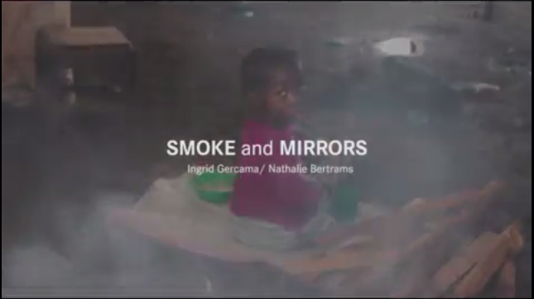

Smoke is the silent killer in the kitchen: every 8 seconds, a person dies of cooking fumes.

Every year, indoor pollution claims the lives of over 4.3 million people all over the world – more than malaria, tuberculosis and HIV/AIDS combined.

Almost half of the world population uses firewood, charcoal or dung to cook. Women and children risk contracting deadly lung and heart diseases, as they breathe in thick smoke for hours while preparing meals. ‘Unclean’ cooking causes a global health crisis – with huge environmental consequences.

Malawi is one of the 20 most affected countries on the world – can a solution be found for its burning problem?

Balancing the burden
- Photo & text
- Link to 1. Subpage
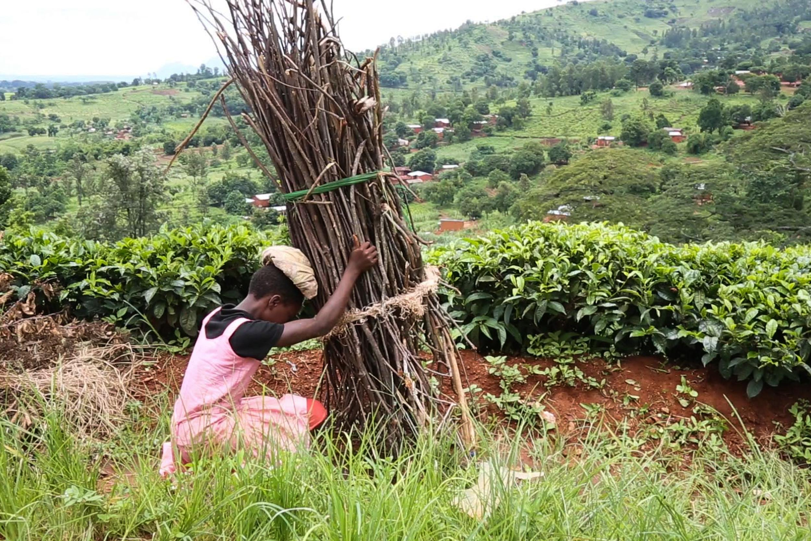
Rhoda mounting her load of firewood

Charity Gogoda, 21, and Merida and Rhoda, her teenage girlfriends, are on their way back from a three-hour trek into the forest on the slopes of Mount Mulanje. Charity points to the 20kg bundles of firewood perched on each of their heads. ‘It’s heavy’, she says.

Every three days they make the journey from their village, Mulema – a little hamlet surrounded by tea plantations in the south of Malawi – to collect wood. ‘We need it for cooking nsima,’ the country’s staple maize porridge.

In Malawi, 98 per cent of the population relies on biomass woodfuels to cook – mostly charcoal in the cities and firewood in rural areas. But together with health risks, using woodfuels imposes a massive burden on women and on the environment.

Deforestation and the related degradation of ecosystems threaten food security. In 2016, Malawi’s President Peter Mutharika declared a state of national emergency over food shortages caused by severe drought. In February last year the price of maize had already increased by 60 per cent.

Cooking kills
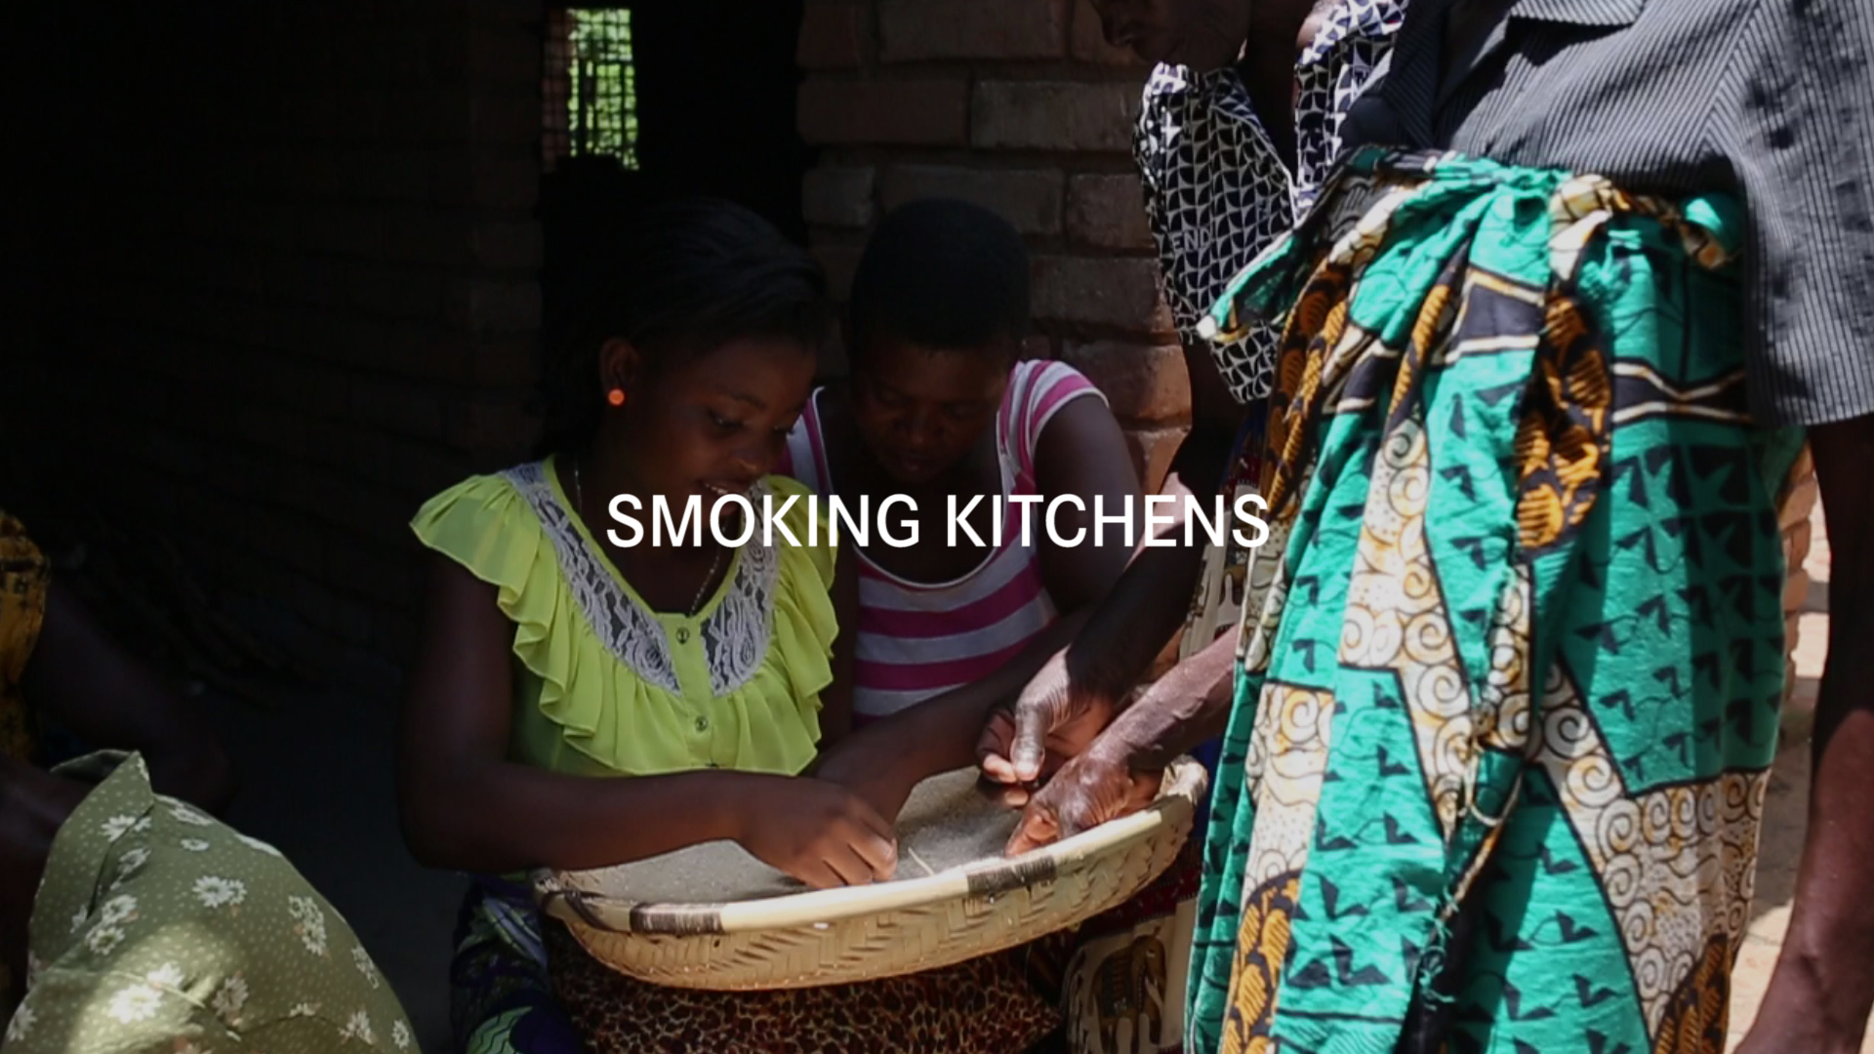

- Video element of women cooking: https://drive.google.com/open?id=0B62LlPkQP0SuamJoQVdvTDRXWjQ
- Link to 2. Subpage
- Text:

Women and children are the most exposed to the health risks of cooking fumes – as they spend the longest time in kitchens and around fires. In Malawi, nearly one in 10 deaths are attributed to cooking fumes. The World Health Organization (WHO) has called exposure to smoke produced by burning biomass fuels a major public health risk.

In Malawi’s badly ventilated homes, toxic smoke can carry more than 100 times the acceptable level of fine soot particles, which penetrate deep into the lungs – destroying cells beyond repair. Just one hour indoors has been likened to smoking 400 cigarettes.

Cooking over open fires can cause respiratory infections, lung cancer, heart disease and blindness as well as short term suffering such as coughing, burning eyes, chest pain and headaches.

Tina Chirwa, from Pitala village in Nkhata-Bay district, is having to constantly duck in and out of the kitchen. ‘When there is too much smoke I have to go for air and then come back,’ she says. Her sister Vanessa adds: ‘the smoke is giving me headaches and I get tears in my eyes while cooking. It makes me cough.’

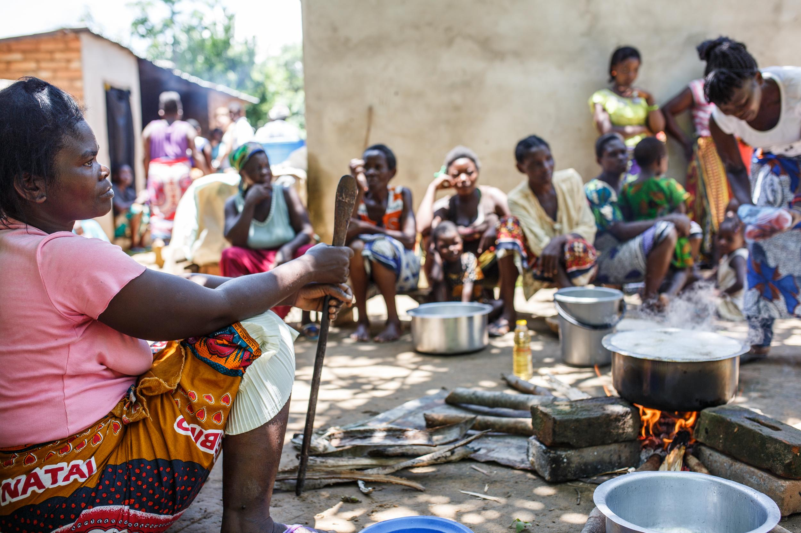
Women in Pitala village cooking over open fire

Doctor Wezzie Mumba, Senior Medical Officer at Bwaila Hospital in Lilongwe, – the capital, recognizes that: ‘Women keep complaining of a cough.’ How does she recognize the cause might be unclean cooking? ‘The hairs on their arms are all gone because of the open fire.’

A group of women of Pitala say that extension workers from the Ministry of Health have told them that cigarettes are bad for them, but did not mention the ill effects of cooking smoke. Only a fraction (0.4 per cent) of Malawian women smoke cigarettes, but all of them have to prepare meals.

Playing children and people with epilepsy are also heavily exposed to the risks of open fires. Boniface, a 16-year-old suffering from epilepsy, fell in the fire when his mother was boiling water.

The clean cooking solution?
- Link to 3. Subpage
- Text:

Improved cookstoves have been identified by the ‘Global Alliance for Clean Stoves’ as a key tool in the fight against smoke exposure, deforestation, climate change and as an enabler for women empowerment. So-called improved or ‘cleaner’ cookstoves have more energy efficient fuel combustion systems, and also produce less smoke.

In Malawi, the affiliated ‘National Cookstove Steering Committee’ hopes for two million homes to adopt clean and efficient stoves and fuels by 2020. To this day, a range of NGOs and businesses have provided half a million households with cookstoves.

Women who cook on improved cookstoves report that they save fuel and time. Florence Togama from Mulumbe village in the South of Malawi says, ‘I don’t have to walk so long to collect firewood.’ Flora Kandodo from Nessa village agrees and adds that ‘it also doesn’t smoke so much.’

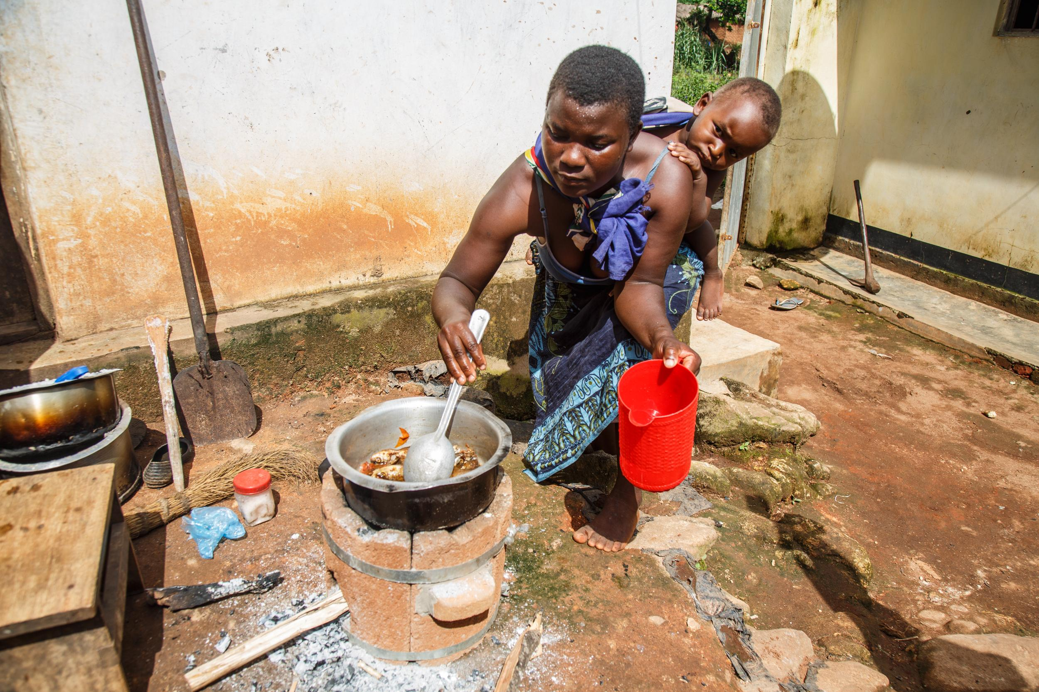
Flora Kandodo from Nessa near Mulanje cooking a relish on an improved Aleva model.

But even if NGOs and donors are convinced of the modified stoves, not all researchers are sold on their positive health effects. Clinical Lecturer in Respiratory Medicine, Kevin Mortimer, for example, found that the modified cook stove he tested in Malawi did not necessarily prevent pneumonia.

Others are even more critical about the ‘solution for all’. Uptake of the stoves, after almost 30 years of NGO presence, is still low. ‘Perhaps we just need better stoves’, says Cornwell Chisale, Energy Officer at the Alternative and Renewable Section of the Department of Energy. ‘These clay things are just too indigenous – they just don’t pass the test of the sophisticated society of today.’

Stove economics
- (link to 4. Subpage)
- Text.

Local stoves may not yet be the consensus solution, but they do provide a source of income. Women groups make some money by manufacturing and selling stoves. Astina from Nessa village relates the successes of her Aleva production group: ‘We sold almost 220 stoves since 2011. Almost everyone in this village has a stove now.’

That too poses challenges, though. Heather Campbell, Country Director for United Purpose, a Britain-based charity, is aware of the complications of a rural economy.

‘There comes a time when the market reaches its saturation point – when these women have sold stoves to everyone in their catchment area,’ she says. Small production groups find their local markets saturate quickly, with no solid distribution plan available. To overcome this, the charity tried to connect rural groups with urban consumers by encouraging the women to sell their stoves at gas stations.

Yet after 30 years of NGO work – the cookstove market is only really profitable for a lucky few – those who have managed to strike a deal with charities and development agencies able to guarantee regular purchase of products.

Malawi’s black gold
- (link to 5. Subpage)
- Text:

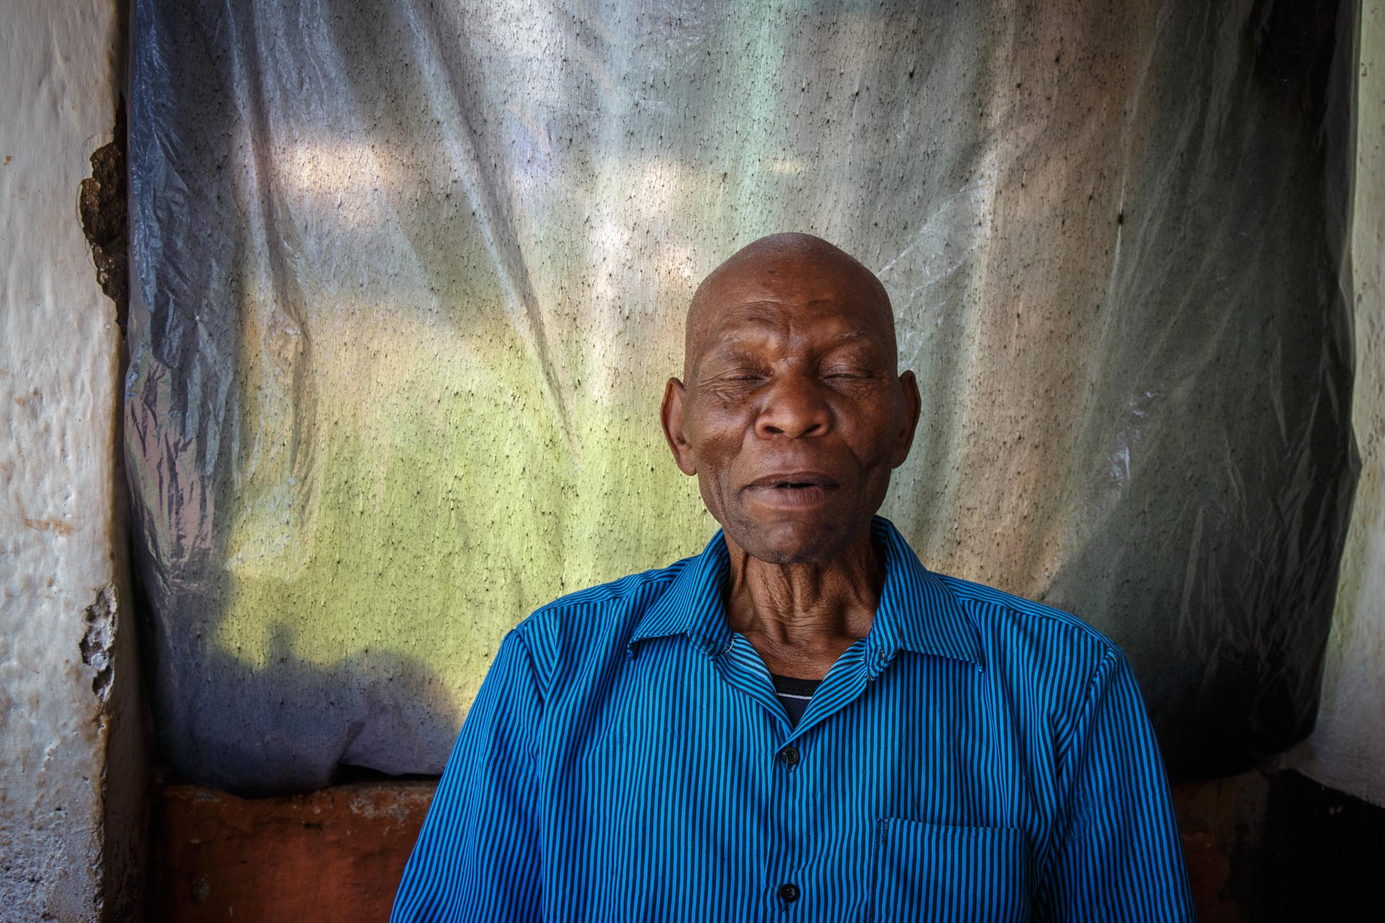
Chief Paulo Douglas of Mulumbe village says he dreams of trees for his grandchildren.

If the cookstove business is slumping, another business, meanwhile, is booming: charcoal. Malawi’s charcoal trade is currently the country’s third largest industry, after tobacco and tea. Charcoal is the choice cooking fuel of the urban poor, and its production the main driver of deforestation.

As a result, Malawi’s forest reserves are dwindling: An estimated 50,000 hectares are lost every year. Drastic measures need to be taken to turn the tide: ‘If we don’t act now, in five years the forests will be gone’ says Mr. Kabichi, Assistant Plantation Manager at Dzalanyama Forest Reserve.

1. Subpage - A woman's burden
- Video element: https://drive.google.com/open?id=0B62LlPkQP0SueklFNndXNE1JTkU

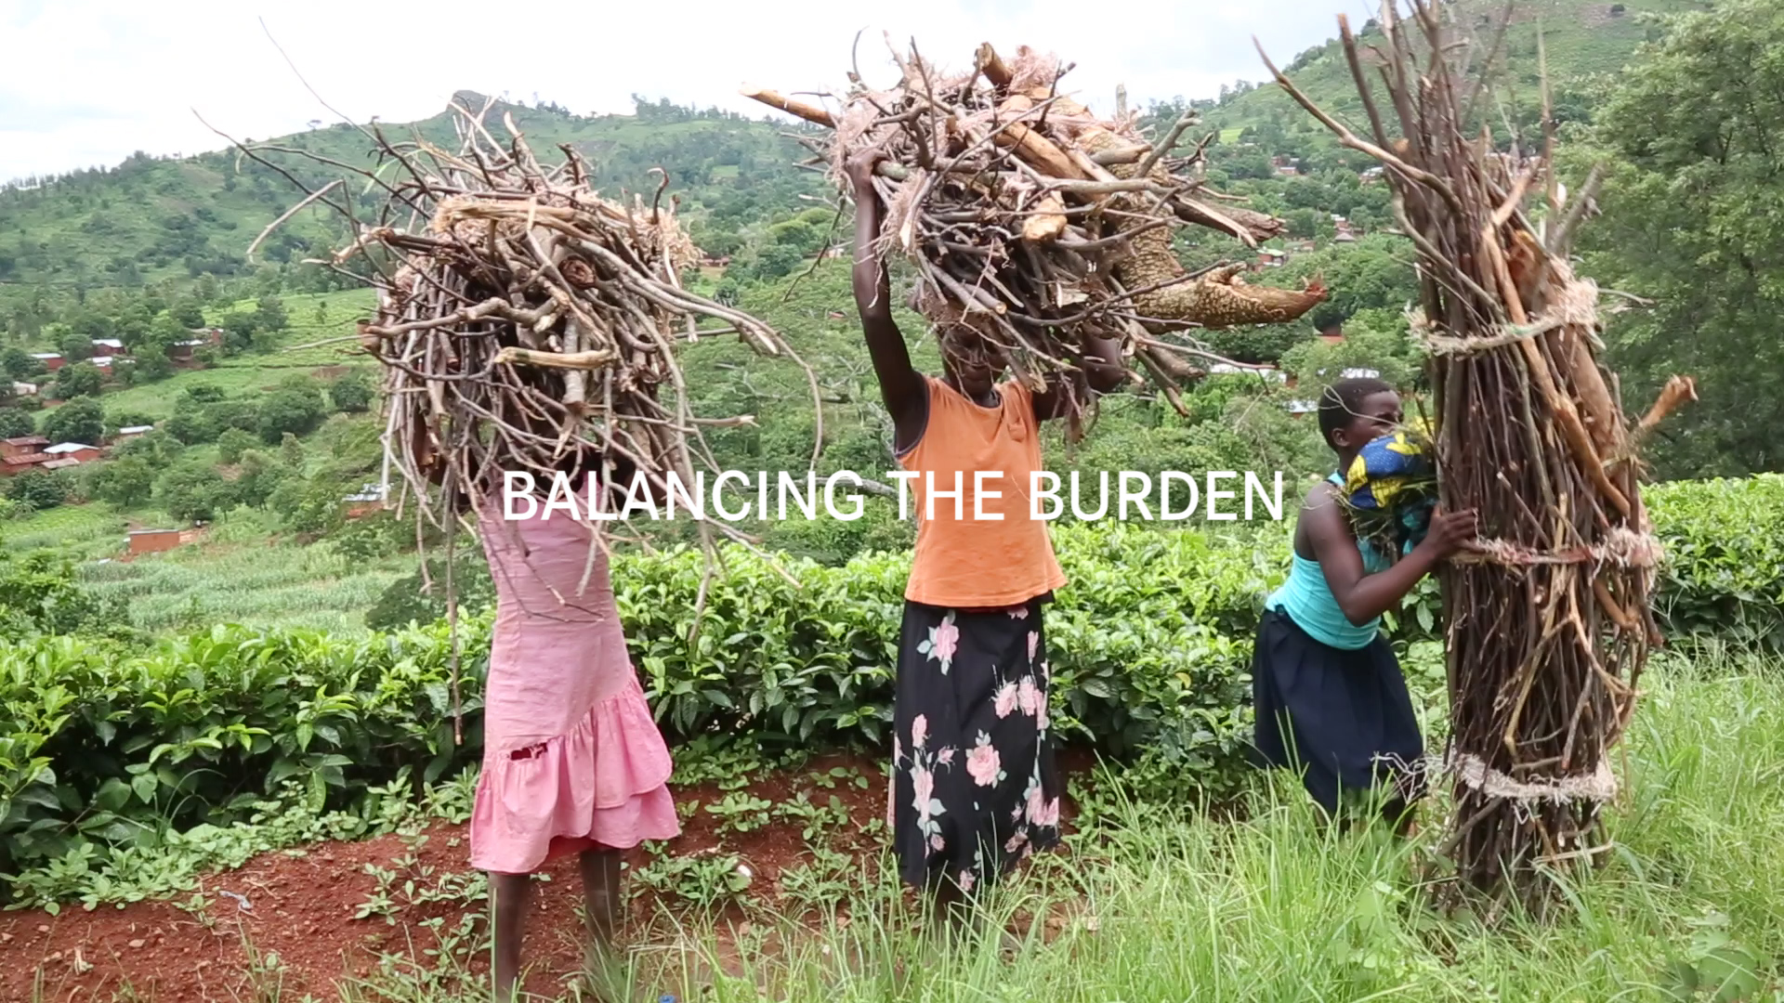

Chief Peterson Weston from Nessa Village is concerned: ‘the men of this village complain to me because the women spend more time on the mountain than before’. They are not at home to cook anymore, he says, and this is causing conflict between husband and wife.

Firewood collection for cooking is a burden that falls on women, and keeps them away for hours each time they go out.

‘Whether you like it or not – you have to make sure that food is available for your husband’, says Vanessa Chirwa, from Pitala village in Nkhata-Bay district. Like millions other women in the Malawi, Vanessa cooks for her family on the traditional three-stone fire.

Rose Kagaso, her daughter Maggie and the other women from Chikwawa are out collecting firewood for two hours each day. ‘Down by the river’, they say, ‘it is dangerous, the crocodiles are on the hunt there’. By ‘crocodile’ they refer not only to the amphibious species, but also to human predators. Due to stigma those who come home bleeding talk about the crocodile.

Sometimes, even 10-year-old girls become responsible for households energy needs – a full time job that needs to be balanced with education, and often child care of siblings. Collecting the wood, hauling water, growing food and cooking it takes all their time. Each meal of the day must be freshly cooked – a whole lot of work with no electricity available.

While firewood becomes scarcer and scarcer, the burden of wood collection has even increased. Charity Gogoda from a village close to the Lujeri Tea Plantation in Mulanje confirms: ‘A bundle of firewood lasts only a few days, and then we have to go out again’. And every year Charity and her friends have to walk further and further.

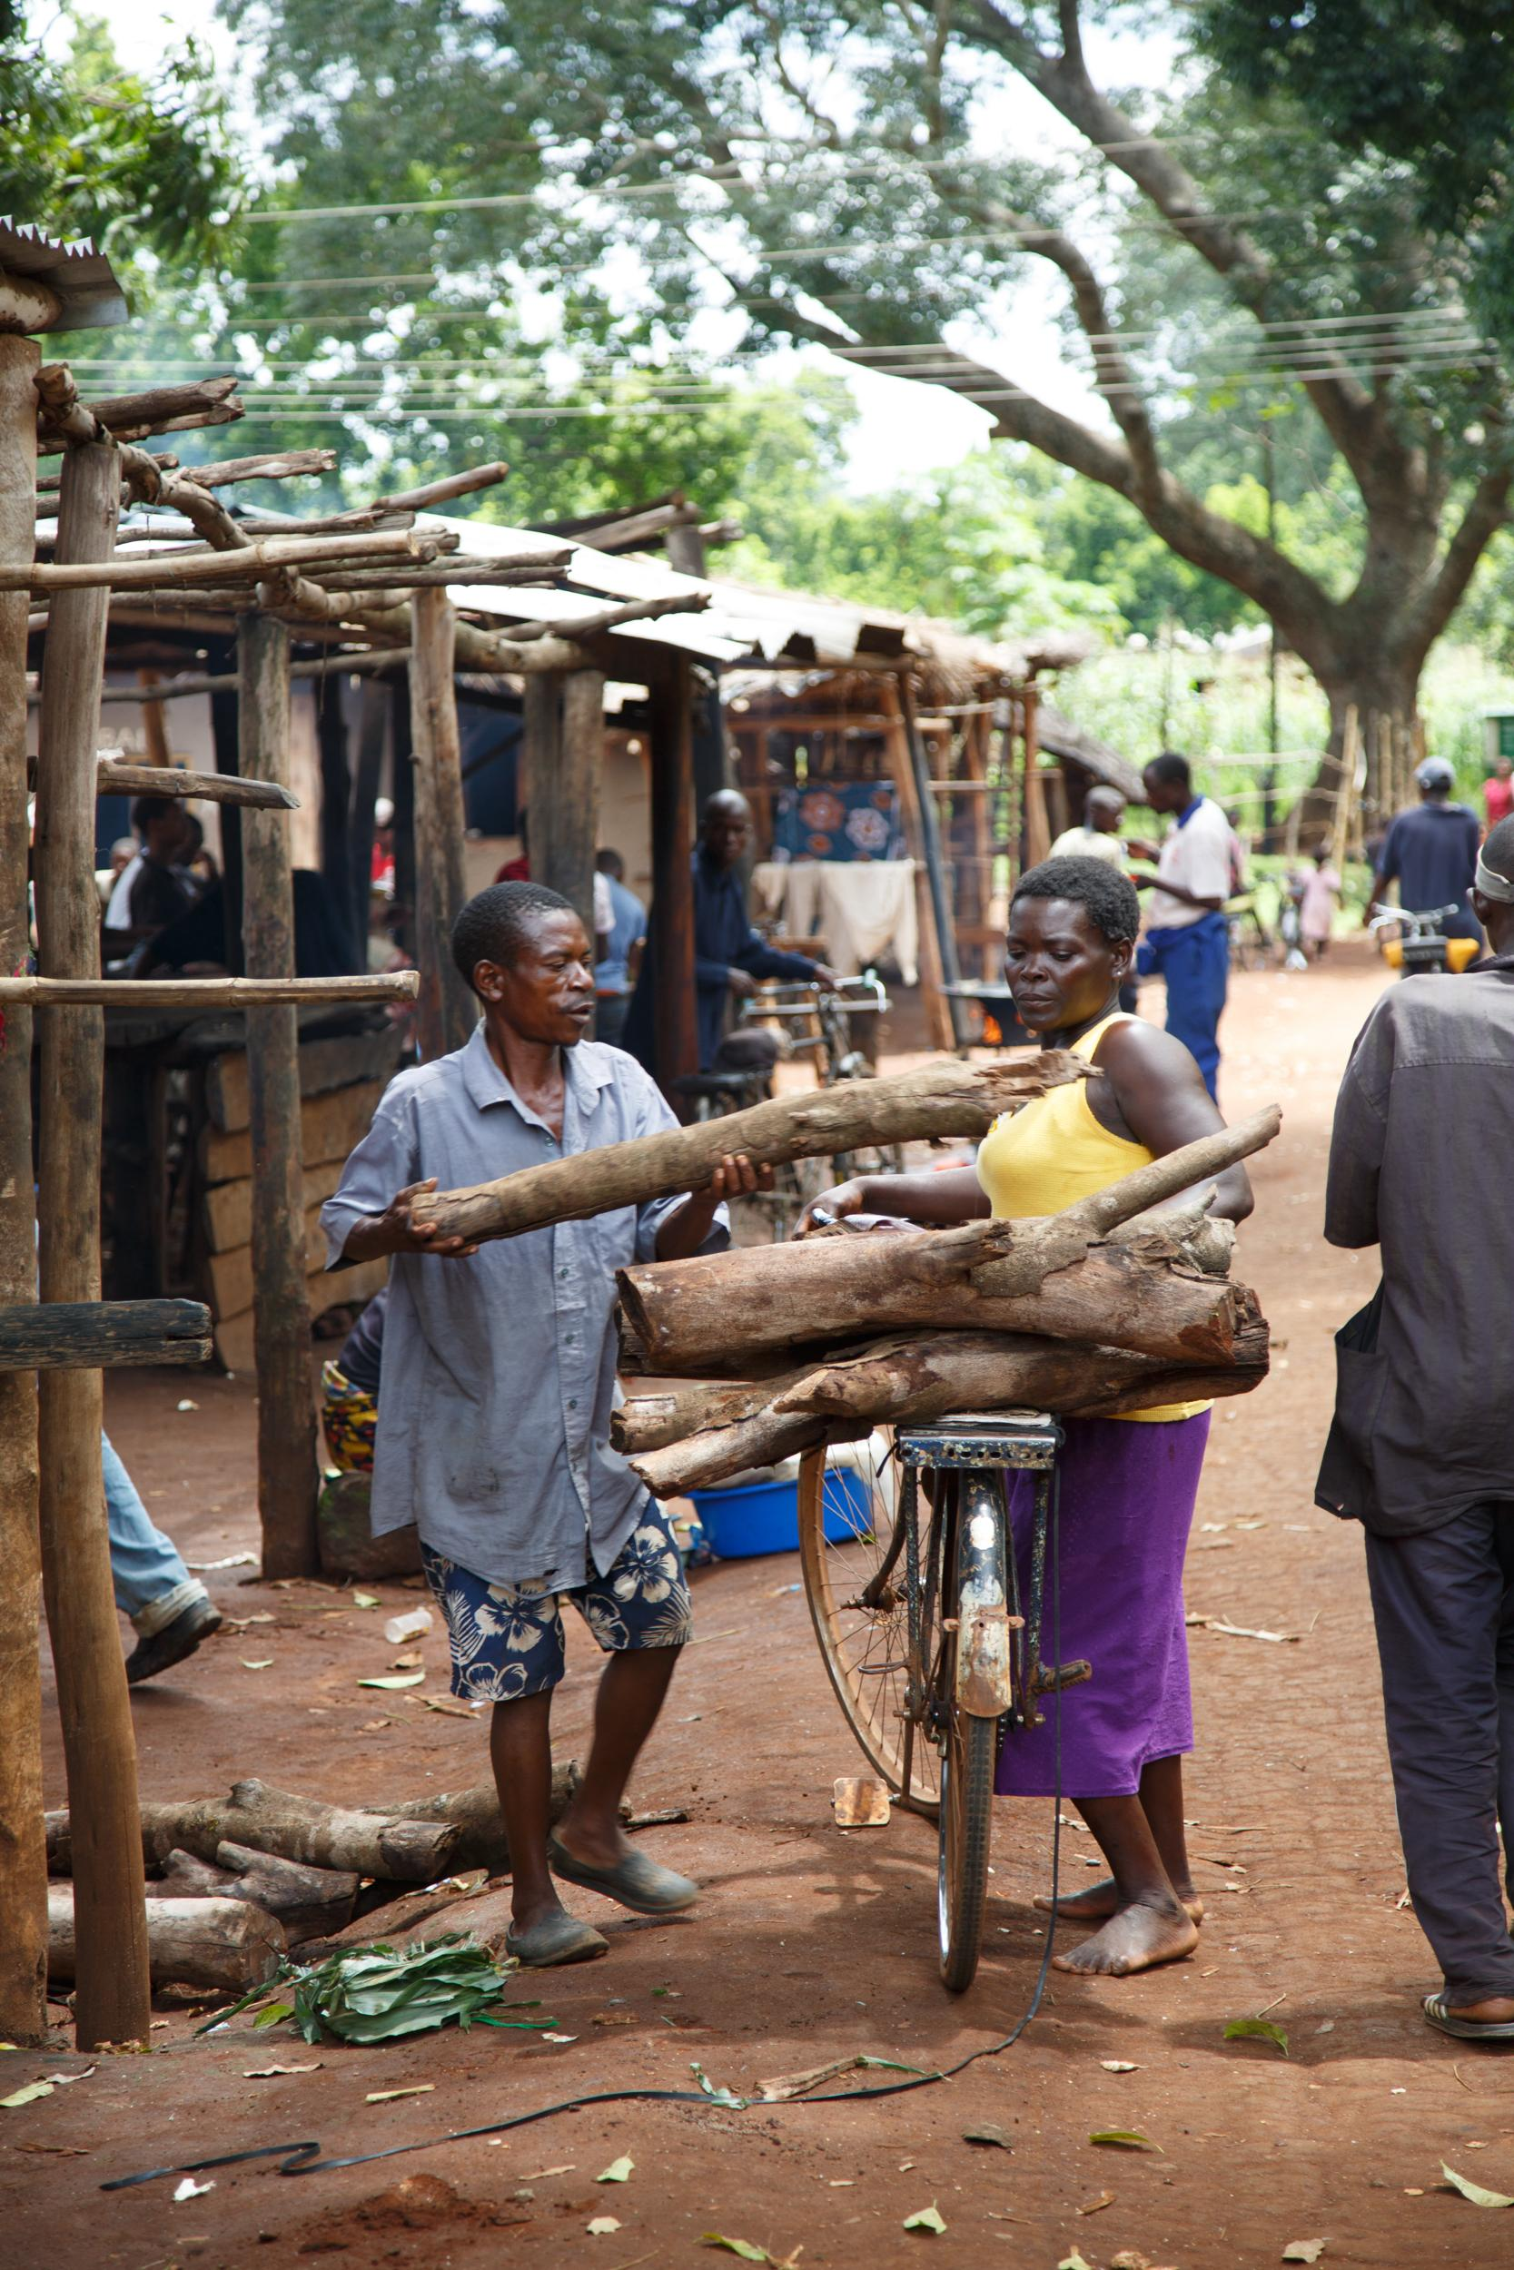
Firewood is also sold in urban centres, like here around Mulanje

2. Subpage: The killer in the kitchen

- Photo gallery burn victims - https://drive.google.com/open?id=0B62LlPkQP0SuLVVlUThlVXd0alE
- Text

Globally, cooking smoke causes 45 times the number of the global annual deaths from natural disasters, and more than twice the number of people dying of HIV/AIDS (1.5 million in 2013).

Reliance on solid fuels is one of the 10 most important threats to public health globally. It might as well be the most unreported of the world’s big problems. A shift towards cleaner and more efficient modern fuels and cookstoves, could help eliminate this health risk.

According to the World Health Organization, more than half of premature deaths among children under the age of five are due to pneumonia caused by breathing this smoke, and there is evidence of a link with low birth weight. On average, babies exposed to household air pollution in the womb are born 90 grams lighter at birth than babies that have not been exposed to household air pollution.

Open cooking fires are also a health and safety risk to children playing around the fire. In Malawi, many children and women suffer with burn injuries from cooking over open fires: they might trap over a log knocking over a pot with boiling water, or fall into the flames.

More serious burns require immediate emergency medical care to prevent complications and death. With a lack of surgical facilities, medicines and even doctors and nurses – rural hospitals can’t meet the demand. Patients are referred to Kamuzu Central Hospital in the capital, Lilongwe, where they are treated by a small group of nurses, led by head nurse Chrissy Nyirenda.

Her ward mainly treats women and children ‘because they spend more time in the kitchen’, she says. Most children that come through her ward were burned with hot liquid; most adults suffer from epilepsy – open fire poses a significant risk to them. She also treats men, who mainly come in with burns obtained at the workplace, but ‘there are many less of them’.

Photogallery

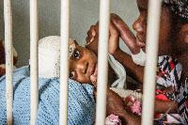

Jacqueline (2,5 years old) has just come out of the operating theatre. She suffered severe burns and had to have her second surgery in Kamuru Central Hospital in Malawi’s capital Lilongwe.

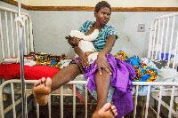

Loveness lies in her mother’s arms – around 80 per cent of her body was burned when boiling water fell on her. Unes, her mother, is eighteen years old and cringes when Loveness yelps. Her wounds hurt her and she has difficulty sleeping.

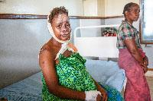
Mary suffers from epilepsy. Her face and her hair burned when she fell in the fire - she remembers only pain. Now she is getting treatment on the Kamuzu hospital's burn ward, she is on the mend.

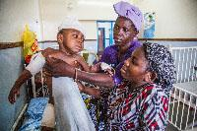

Jacqueline’s mother Eliza and grandmother Aida holding the baby - still dizzy from surgery.

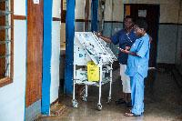

Head nurse Chrissy Nyirenda inspects the medicine cabinet of her colleague.

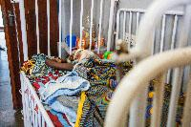

Jonah is 16 years old and suffers from epilepsy. He has been in the hospital for several months now. His mother Gloria explains that he fell in the fire when he got a fit.

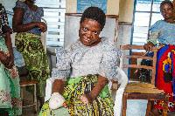

Many burn victims suffer from epilepsy. Open fires are a dangerous trap for them.

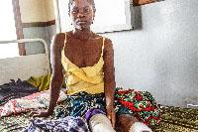

Regina Phirie (24) had a pot with burning fluid fall over her legs. Both legs are burned to the third degree. Regina’s mother keeps her company in the hospital and reads her from the Bible.

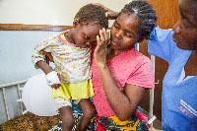

‘When I was cooking he fell in the fire’, says Aida, the mother of this two year old boy. Her son Chisommo’s lower back has been burned to a third degree. Nurse Chrissy laughs when she sees the boy: ‘when he came in he was so bad, but he is getting better now.’

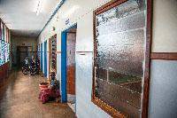

Floor in Kamuzu Central Hospital in Lilongwe, Malawi’s capital. The hospital has a special burns ward. The patients are mainly women and children who were injured in accidents with open fires.

3. Subpage - The cookstove community
- Stakeholder map - https://drive.google.com/open?id=1yBVkogBe9qltg2OwFuirbS5HPKM&usp=sharing
- Photo gallery: https://drive.google.com/open?id=0B62LlPkQP0Sub1ZnWGR2VEhhTVE
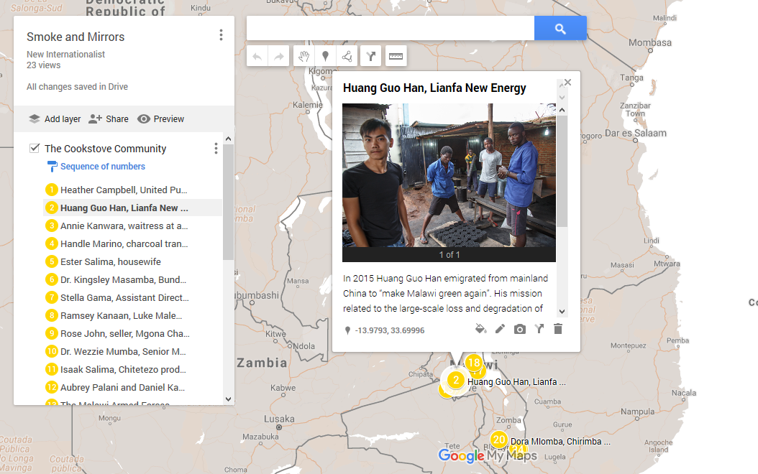

According to the National Cook Stove Steering Committee, 500.000 households in Malawi now use ‘clean and efficient’ cook stoves. The government has set a target of two million households using cleaner cookstoves for for 2020. Malawians on the countryside mainly use firewood, whereas in urban areas charcoal is becoming more and more popular, with over 60 per cent cooking on it already.

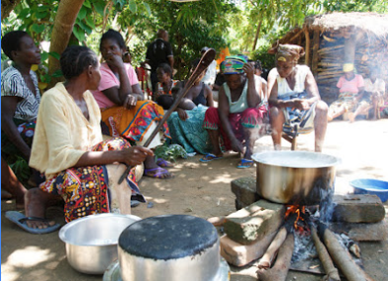

Photo: A three stone fire

A group of women in Pitala village in the Nkata-Bay area cook rice about a traditional three stone fire. The fire smokes a lot which makes the women cough and their eyes turn red.

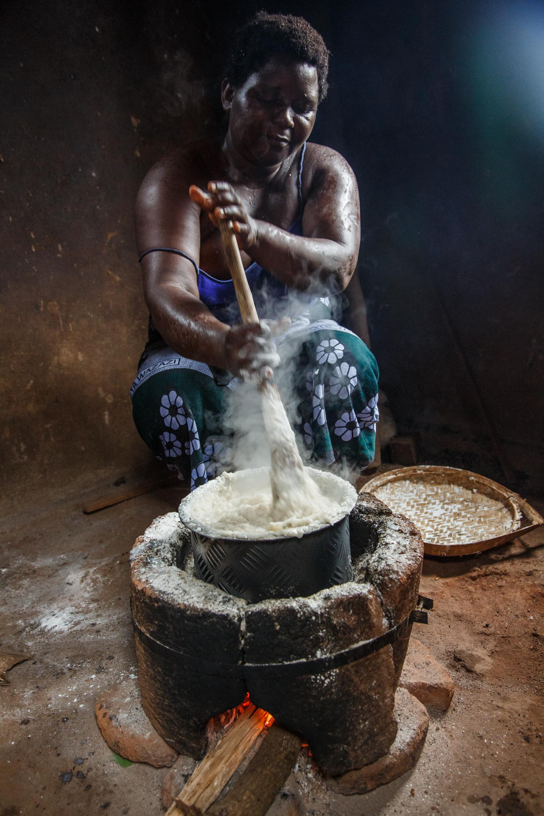

Photo: Rose Kandodo cooking nsima

Rose is happy with her Aleva stove: ‘The food tastes just as good’ on her cook stove compared to when she cooked on the three stone fire. ‘Also the nsima is not grey from the smoke any more’. The new stove also helps her save time – she now has to walk less when she collects the firewood: ‘The women of my village that don’t have the stove have to walk from 7 to 10 am in the morning to collect firewood.’

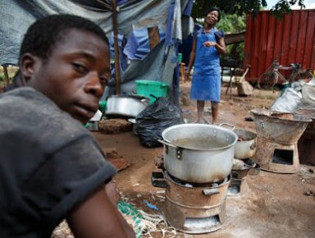

Photo: ‘No smoke for my customers’

Waitress Annie (mid) and her colleague (left) cook a meat stew on a charcoal fire. They sell the stew to customers road-side restaurant strategically located near to the Ministry of Information in down-town Lilongwe: a red container transformed into a bar. Annie laughs about the question why she does not cook on firewood: ‘my customers don’t like the smoke.’

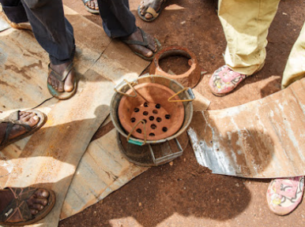
Photo: The Charcoal Stove

Ronald Njiera and his colleagues sell charcoal stoves to customers. They make the iron from zinc that customers bring – often ripped from their houses. The ceramic inner pot makes the stove popular with customers from South Africa and Mozambique – the clay is only readily available in Malawi. On a good day Nijera sells over 200 stoves to foreign entrepreneurs.

According to Njiera his type of stove is prefered over the Chitetezo Mbaula, an improved cookstove widely available in Malawi. ‘This one is more durable’, he says, and ‘when pieces break they can easily be replaced’. Because of it’s portability, cost and availability – this model is most popular in urban areas in Malawi.

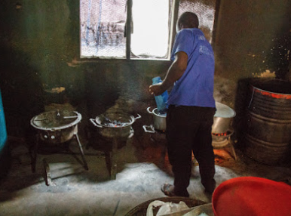

Photo: Cooking breakfast

Heating water for customers can take up a lot of charcoal, which burns slowly. The large pan of water needs to be brought to a boiling point whilst impatient customers haggle the waiter to hurry up. In this roadside restaurant in Salima, customers don’t stop for long – Lilongwe awaits.

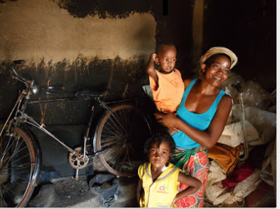

Photo: Florence’s stoves

Florence Togama and her two children live in Mulema village close to Mulanje Mountain is the south of Malawi. She is the proud owner of around five improved cookstoves and one traditional three stone fire. Two of the stoves have been built in this room. She does not use these anymore - the room will soon be transformed into a bedroom for her and the children.

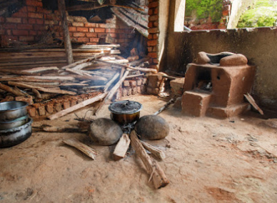

Photo: The Cookstove Museum

Florence has an improved cookstove (right) and a three stone fire (mid) in her collection of around five different models. She doesn’t have a faviouritefavorite - she uses them for different purposes. When we visit her, she uses the three stone fire – wet wood does not burn as easily in a closed combustion chamber.

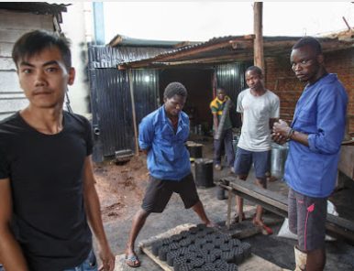

Photo: Making Malawi green again

Huang Guo Han (26 years old) is the founder of Lianfa New Energy, a company that wants to ‘make Malawi green again’. His motivation: ‘from the air you can see that Malawi doesn’t have many trees left. It is getting worse year after year. That’s Malawi’s big problem: no trees, no rain. How can they harvest anything?’

Huang hopes to revolutionize the cook stove market with a technique that has been used in China for over 60 years, he says. ‘In China, we have these stoves; why not make them in Malawi?’ He has introduced a locally produced stove and compatible non-biomass briquettes, modified for use in Africa.

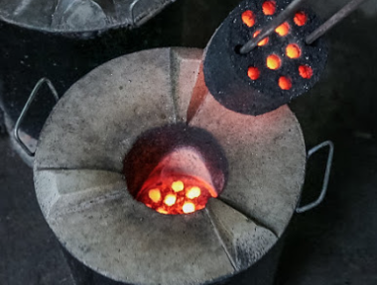

Photo: Huang’s Honeycomb solution

The ‘honeycomb’ made out of soil coal dust and water burns for four hours at high temperature in ceramic stove with metal protective casing. Huang says the stove emits very low levels of smoke, and is more efficient than using charcoal.

On the premises of his uncle’s mattress factory in Njerwa, Lilongwe, Huang and his eight Malawian colleagues assemble the appliances, preparing the raw materials and operating the Chinese machinery. Since production started in March 2016, his 20 agents on the ground sell 90 stoves per day in three urban distribution centres.

Customers who can afford the relatively high upfront cost of the stove (MVK7,000, or US $9.65) seem to appreciate the efficiently burning briquettes, so Huang hopes to increase production to 30,000 briquettes per week. The young entrepreneur finds Malawians are open to the new technology. ‘They have a clean mind,’ he says.

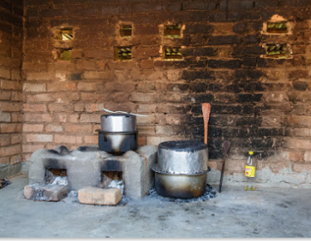
Photo: An improved cookstove...

In their catchment area Ripple Africa, a charity based in Nkhata-Bay close to lake Malawi, in the north-east of the country, promotes the use of the Changu Changu Moto. The design of the cookstove makes that the stove is more energy efficient that the open stone fire. The NGO also claims that the stove improves health outcomes because the fire emits less smoke and is safer to have in the house than an open fire.

The women from Pitala village in Nkhata-Bay are pleased with the technology: ‘the stove uses less firewood’, they say. The chief of the village explains that this is a good thing: ‘now the women don’t spend so much time in the forest.’

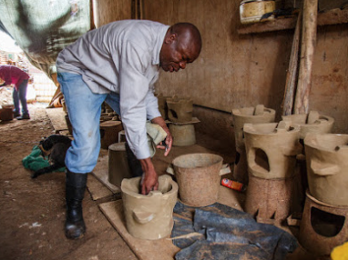

Photo: Isaac Salima, Cook stove Producer

Isaac Salima is the owner of Phukaphuka, a company specialized in the production of Chitetezo stoves. The name of his company ‘means to sprout because I thought I would sprout in this business’, Salima says. With NGOs like Maeve buying the model for distribution in the rural areas or as a way to empower women groups selling the stoves - business is good.

Even if the National Cookstove Steering Committee is proud to be ‘technology-neutral’, the Chitetezo model is, in their eyes, the most appropriate model for Malawi. The stove costs around 1,000 – 1,500 Kwacha (roughly US $1.38 – 2.05) -– affordable for the majority of the population.

A common critique of the model is that it isn’t very durable – the clay pot breaks easily. Salima recognizes the critique and would love to make an improved model, but, he says, ‘the cost is very high. You would have to import steel from South Africa or Mozambique’

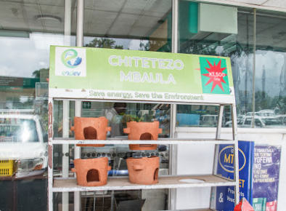

Photo: The Chitetezo Mbaula

The Chitetezo Mbaula is the most commoncook stove model in Malawi – available at gas stations throughout the country. The stove is made out of clay and is more energy efficient than open fire.

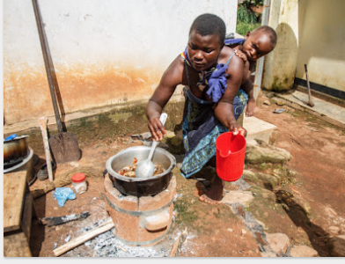

Photo: Flora’s fish stew

Flora cooks a fish stew on her mother Rose Kandodo’s improved Aleva stove. Rose and Flora are very satisfied with the stove. ‘It save time,’ they say. They spend less time collecting firewood now.

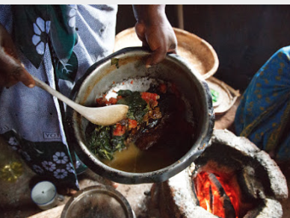

Photo: Dishing out cocoyam stew

Rose Kandodo dishes out a fish stew made of dried chambo, cocoyam leaves and tomato, which her daughter Flora cooked on her energy efficient Aleva stove. The cooking method has changed – but the taste is the same.

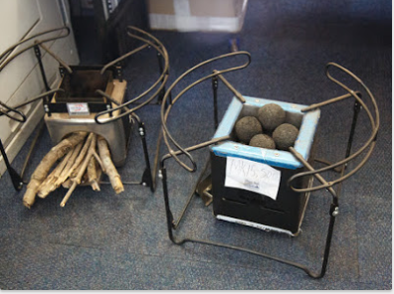

Photo: The ‘sexy’ stoves

In the office of the secretary of the director of the Department of Forestry, two stoves are hidden under a bureau. A donor brought them to the department, but the secretary loved them so much she wanted to keep them for herself. These ‘second generation cleaner cook stoves’ are very popular with women in Lilongwe – but still unaffordable to the masses. They areproduced by the social enterprise Envirofit – a company based in the US. A local retailer has now imported around 4,000 of them to Malawi.

4. Subpage - Cookstove millionaire
- Text:

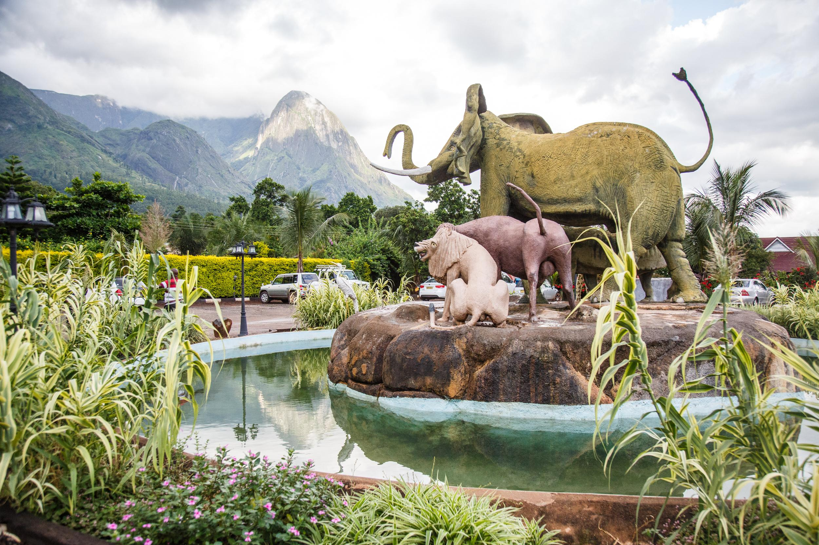

Ken’s big business: Making millions selling stoves

At the foot of Mulanje Mountain, a statue of Africa’s Big Five (lion, African elephant, Cape buffalo, leopard, and rhino) towers in front of the ‘Hapuwani Village Lodge’, a luxurious resort in the south of Malawi. The hotel was built by Ken Chilewe, Mulanje’s very own ‘cookstove millionaire’.

Cookstoves paid for Ken’s luxury village. He is the only entrepreneur in Malawi to have made millions with this household appliance. Selling ‘institutional’ cookstoves to international donors like UNICEF, the World Food Programme and the international charity Mary’s Meals made him what he calls ‘big bucks’. Ken started with one improved cookstove and now sells in bulk to UN agencies in Mozambique, Zambia and Uganda. His ‘institutional’ stoves can be used to prepare food for big groups - schools, weddings, funerals.

He remembers well how his business started. Ken benefitted from a training scheme organised by the German Society for International Co-operation (Deutsche Gesellschaft für Internationale Zusammenarbeit, GIZ) with 24 other young entrepreneurs. They were taught how to make cleaner cookstoves that use less firewood.

Initially, his friends scoffed at him. ‘Who wants to buy this? Why are you involved in women’s business’? But Ken was the only trainee to be persistent enough to set up a business after the training. And today he is the sole ruler of a what looks like Malawi’s cookstove monopoly. His friends had already stopped laughing when Ken sold his first 400 stoves to WFP.

He has advice for other aspiring business women and men ‘There is big money in this,’ he says. ‘Go to the donors.’

Ken sells his stoves for around 10 to 220 Pounds depending on the size of pot the stove can hold. The biggest stove his company produces can hold up to 200 litres. He makesaround 15 per cent profit on each stove.

Why didn’t copycats replicate his model? ‘They cannot afford the big upfront instalment,’ Ken says. ‘The market is there, but people can’t afford it’. And what does the future of the cookstove business look like in Malawi? ‘If NGOs and UN agencies leave, that will be the end.’.He shrugs. ‘That would be so bad for me’. Until then, the business is his.

Photo 1: Ken’s stoves

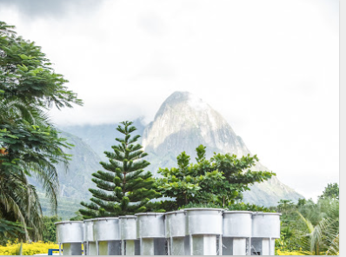

Ken Chilewe sells ‘institutional stoves’: stoves that can hold large pans – with liquid up to 200 litre. His stoves are used in schools, hospitals and at funerals all over the country.

Photo 2: Ken’s rocket stove
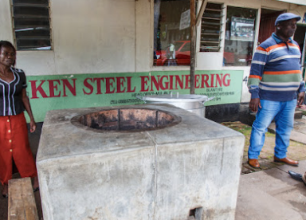
Ken Chilewe (right) is the most successful man in Mulanje – his business ‘Ken Steel Engineering’ makes millions of dollars selling cookstoves. In front of his shop he built a Rocket stove he makes for serious cooks: the stove can hold a large pot for water – enough for the whole family.

5. Subpage - Black gold
- Video Charcoal: https://drive.google.com/open?id=0B62LlPkQP0SubEVxX3NnTHJybVk
- Text:

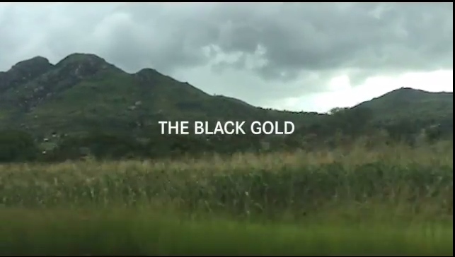

Black gold in Malawi

Almost daily large trucks loaded with big bags of illegal charcoal are confiscated on the road from Dzalanyama forest to Lilongwe. The Forestry Department, authorized under the 1997 National Forestry Act to crack down on illegal charcoal, is ever more despairing.

‘We are losing so much forests’, says Mr Kabichi, Assistant Plantation Manager of Dzalanyama forest reserve, part of the Department of Forestry. Illegal charcoal production is a major factor driving the country’s 2,8 per cent annual deforestation rate – leaving the small south-eastern African country vulnerable to environmental degradation and climate change.

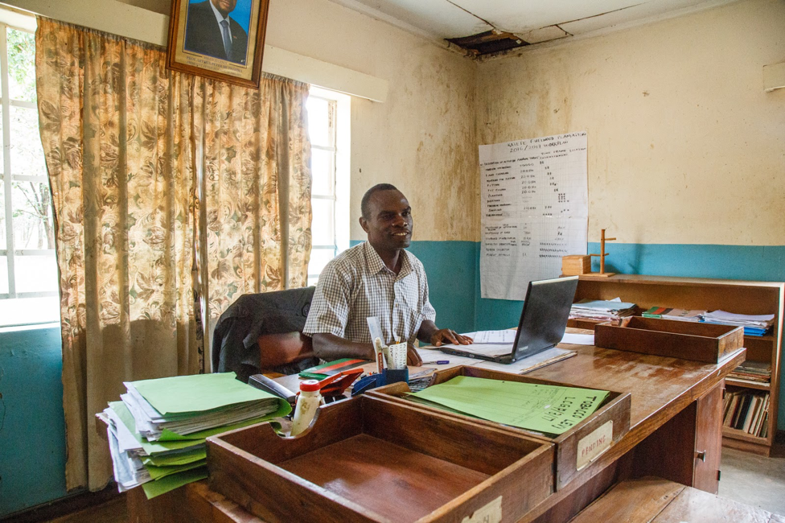

Mr Aubrey Palani, Plantation Manager at Katate Plantation close to Dzalanyama, warns that ‘in five years, there could be no more trees left’, referring to the fast pace of ongoing deforestation in Malawi

Since 2016, the Department of Forestry partners with the Malawi Defence Forces (MDF) – deployed in the most important forest reserves in the country to shut down illegal charcoal production. It is an almost impossible task for the army – they have to protect a forest that spans over almost 1,000 square km – with around 30 soldiers.

Fighting poverty or criminality?

In one of the poorest countries in the world, people ‘see the forest as their primary source of income. So they just go and steal – it is a free resource to them’ explains Stella Gama, Assistant Director at the Department of Forestry. Mr Kabichi agrees: ‘the problem is that charcoal burning is creating a sort of business.’
Cities like Mzuzu, Blantyre and Lilongwe depend on the forest for their energy needs, and are increasing demand. In urban areas over 60 per cent of the population now cooks on charcoal – the national grid is not providing reliable electricity, ethanol and Liquefied Petroleum Gas (LPG) are too expensive, and firewood is perceived as ‘dirty’ and a step down on the energy ladder.

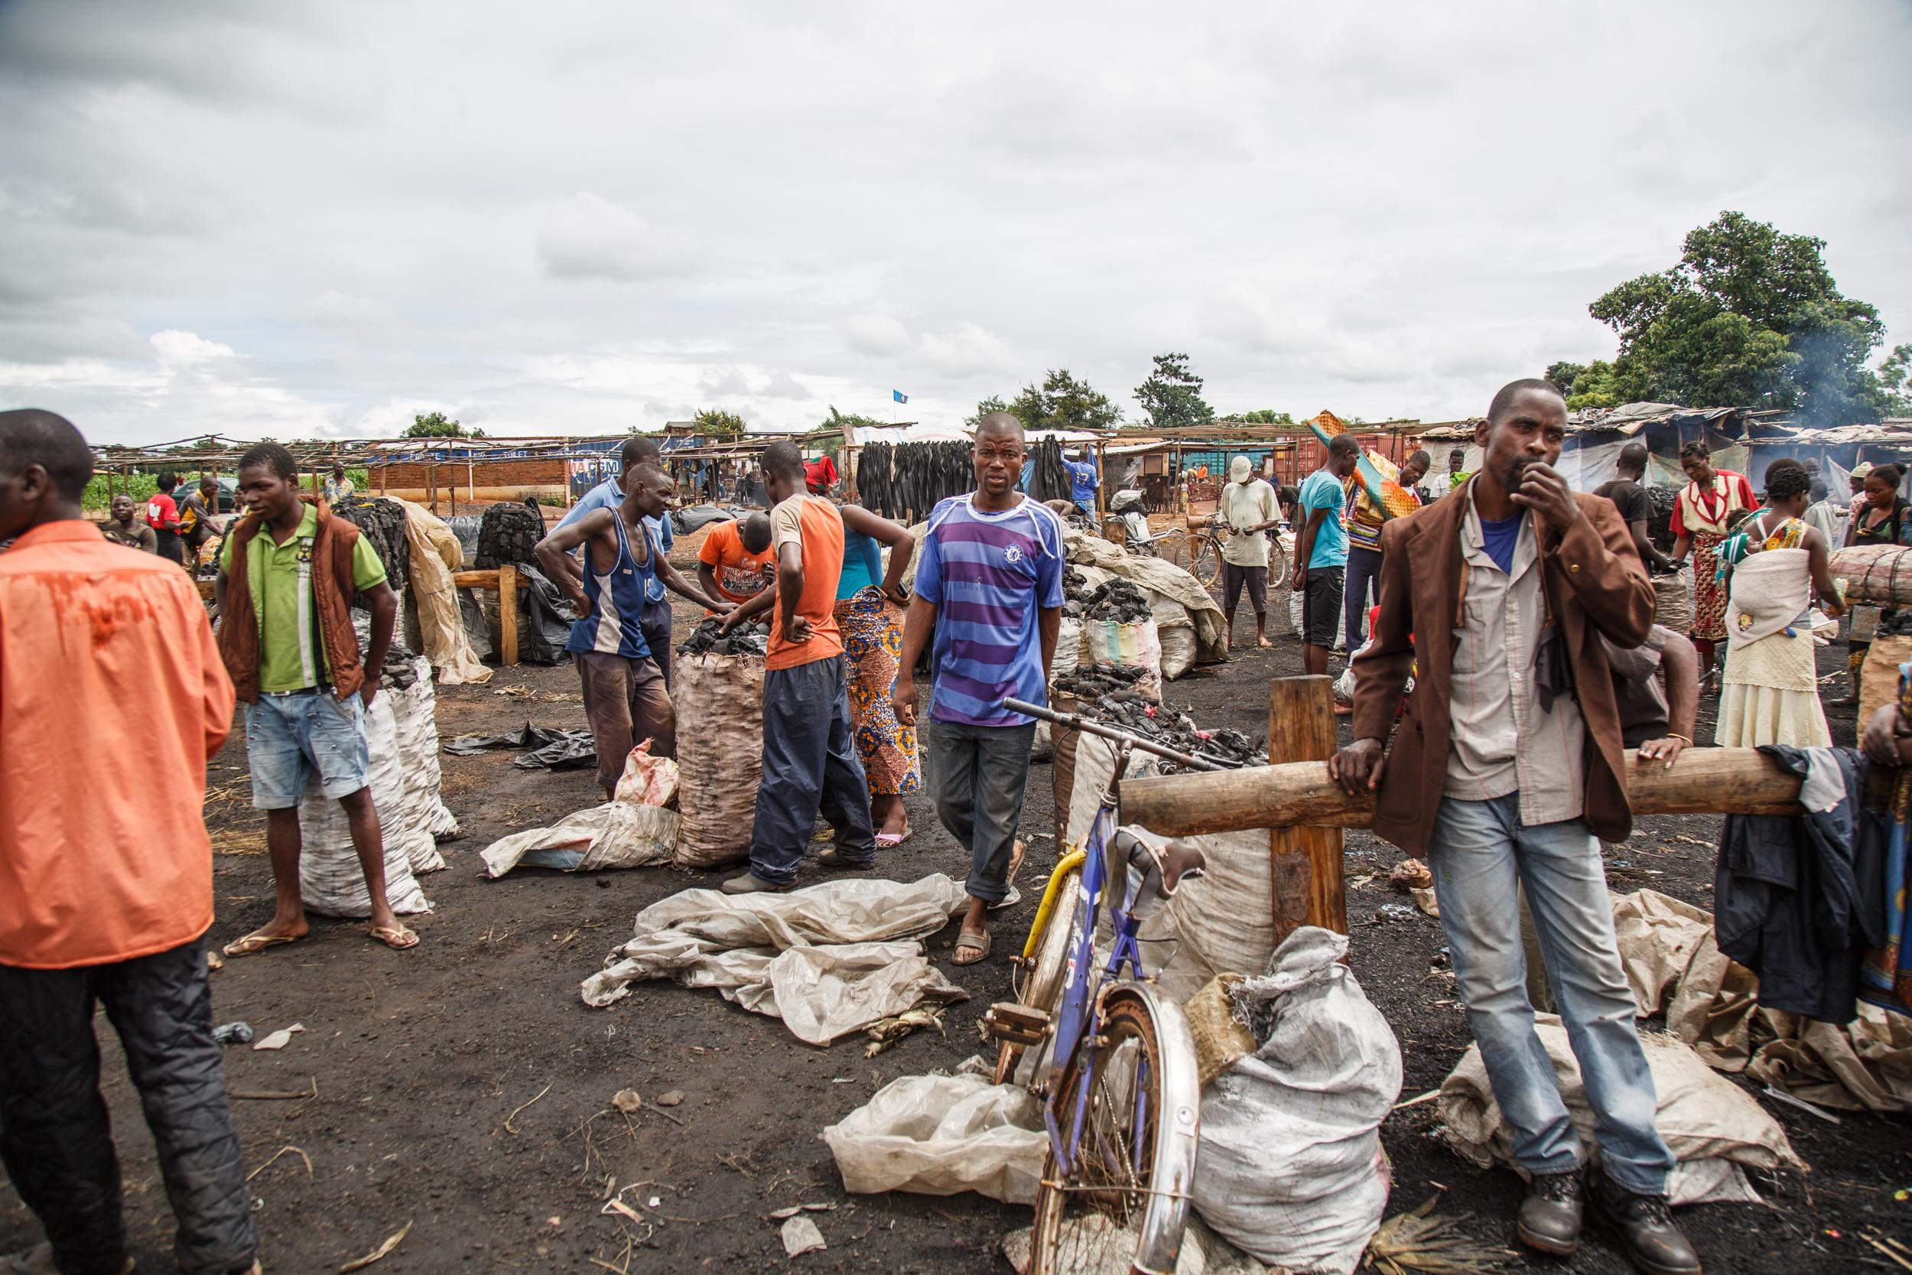
Mgona charcoal market in Lilongwe

In the cities, charcoal means money. Rose John, a charcoal seller at the Ngoma charcoal market in Lilongwe tells her story: ‘I was selling soda before, but I was not making good profits so I ventured into this business. I started seeing that people would come and buy large quantities especially when there is no electricity – then people buy a lot.’

Harold Nuyndo, chairman of an illegal charcoal market in Lilongwe, clarifies why he opted to get involved in the profitable yet illegal business: ‘When I graduated from school – there was no job available’. Rose John, one of his colleagues agrees: ‘it is because we are poor.’

A governance issue

Around 60 per cent of all charcoal comes from national parks and forest reserves. ‘No one will chop down a tree that belongs to themselves’, says District Forestry Officer Teresa Mvula.

But with the change of government – from a one-party state to a democracy – the situation got worse. According to Kabichi, in the past ‘people feared even to pass by the forest’.

An army commander deployed in Dzalanyama forest shows us the scale of the illegal networks that are operating now. ‘Those are organised businessmen, and they use the forest as their source of income. They are acting like they are the government themselves. It is very profitable for them because forest resources are expensive.’

The players of the game

Illegal charcoal is produced mostly in the forest – usually at night. Immediately after felling the tree, the wet wood is carbonised in traditional kilns made of earth. A highly inefficient process: ‘It takes 6-9 kg of wood to get 1 kg of charcoal,’ illustrates Isaac Salima, the director of Phukaphuka, a small sustainable cook stove production company.

Only about 15 per cent of the felled tree is finally transformed into charcoal. Illegal charcoal producers travel within the forest reserves – hoping to leave no trace for the police or army.

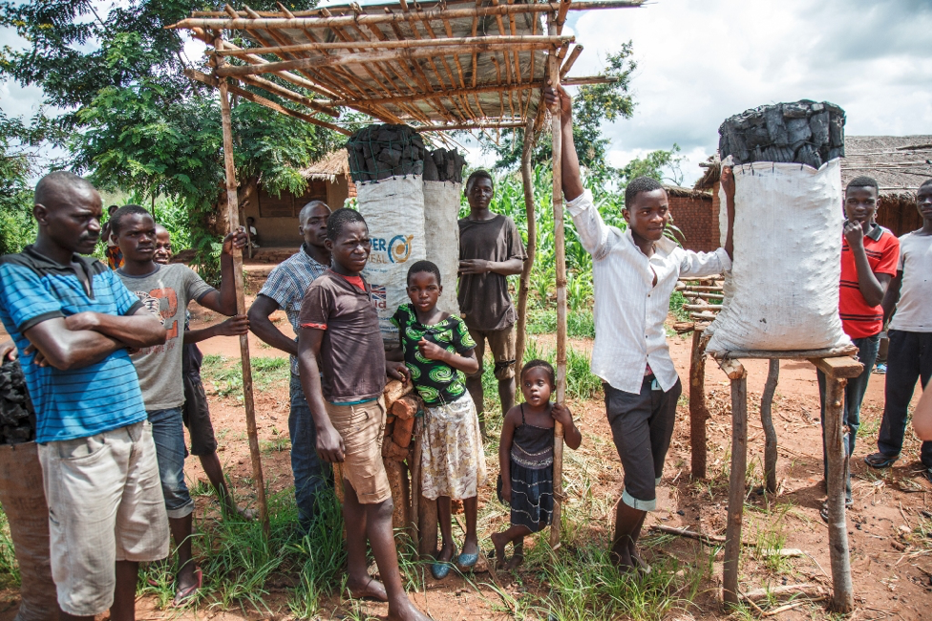
Local charcoal vendors on the main road to Lilongwe

Bags on the rack

From the forest, charcoal producers move to villages where they strike a deal with transporters who can carry the bags to illegal markets in urban centres - or sell their goods on the road to the big cities of Blantyre and Lilongwe.

Carrying a load of 150 kilos of charcoal on his bicycle, transporter Handle Marino, for example, pedals to reach Malawi’s capital Lilongwe early morning to meet his clients. On the road from his village to the city, he runs the risk of getting caught by police, arrested and abused and worst case scenario – his load confiscated. After selling his load to his buyer, Handle makes his way back to his village with a profit of 3000 Kwacha in pocket [US $4.14].

On illegal charcoal markets wholesale sellers like Rose sell their goods to city women or others that repackage the charcoal in smaller bags. She makes around 2500 Kwacha [around US $3,45] profit – but not without risk: ‘the police make a lot of problems.’

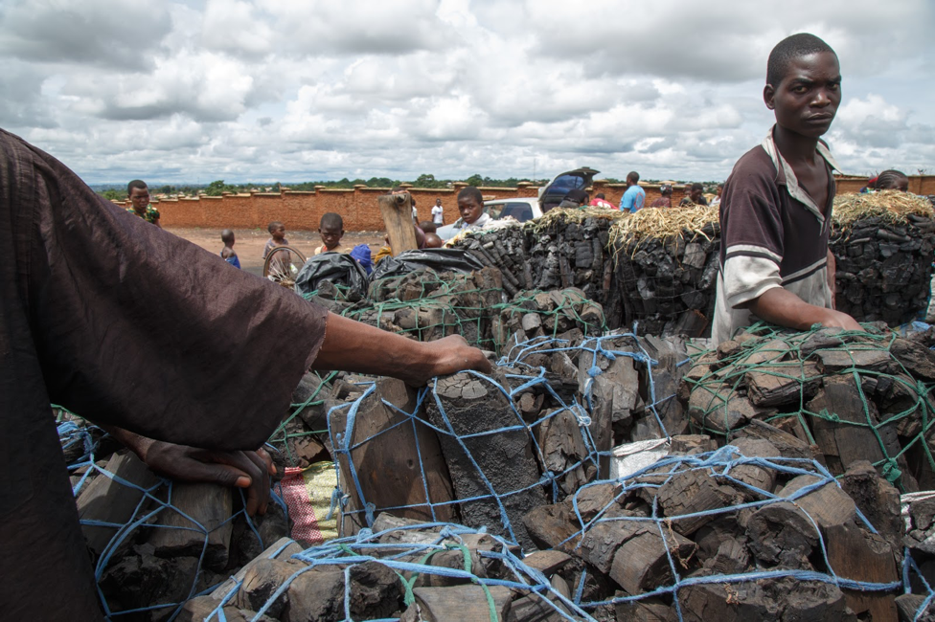
On the illegal charcoal market

Will the future sort itself?

Harold Nyundo, Vice-chairman of the Mgona community charcoal market in Lilongwe is one of the many that squeeze a living out of the black gold. He and his colleague Steven have just come back from the police station where two of his colleagues were held for selling illegal charcoal.

He fails to see the seriousness of their colleague’s crime. ‘In South Africa, they have gold and they are also destroying the environment,’ he says. ‘Here, we don’t have gold – we have the forest. In the future? We will see how the future will sort itself.’

‘Charcoal is here to stay’, agrees Ramzy Kanaan, Chief of Party of PERFORM, an initiative working on reducing emissions from deforestation and forest degradation (REDD). That’s why the only option is to promote ‘the efficiency, consumption and management of resources’ in Malawi.

As for Mr Kabichi, the plantation manager at Dzalanyama forest, he also believes the answer can be efficient forest management: ‘we encourage people to plant more trees’. The way forward, according to him is by getting the community behind the policies through intensive community engagement and education.

FINAL REMARKS

OVERALL ISSUES
- Make everything super clear and digestible for readers! (geography and cookstove models, description of cooking methods first of all. Make the readers feel as though they were there)
- There seems to be a lack of higher-level background: the issue worldwide, why is it unreported. In a nutshell, how the overarching worldwide problem interacts with the situation in Malawi. See comments for more detail
- Try and make stronger the first aim of this report where you can. When people go away from the articles, what is the one thing we want them to take away with them? At the moment, it’s not too clear
- That it’s under-reported?
- That there’s a specific culprit?
- That it’s a crisis costing thousands and thousands of lives? But we don’t talk about deaths very much in the article
- What steps should the world/Malawi?NGOs/Communities take? Are there any solutions or ways the country should explore? If nothing sure, please highlight this anyway!
- 5. Subpage needs a clear sentence/paragraph linking cookstove, charcoal, organised crime and deforestation: how do they relate to one another? What’s the solution to the deforestation side of the issue?

PROPOSED DATAVIZ
- Comparison of causes of death worldwide
Indoor air pollution – car accidents – aids – natural disasters – terrorism
- ranking of top 20 countries with the issue – we need data countries. Maybe http://cleancookstoves.org/country-profiles/all.html ? Or do you have an easier source?
- Maybe an infographic showing which diseases are linked to indoor air pollution?

Let us know if you have any other suggestion!

SOCIAL MEDIA
- Pulitzer Centre for Crisis Reporting
- Carousel
- Social media announcements? Through videos and pictures
- Newsletter
- Maybe social media banner?

OTHER DETAILS
- Video specs to hammer out
- Logos on videos?
- Video fonts

