Exercise 5
Bước 1: Tạo project Maven: Exercise5
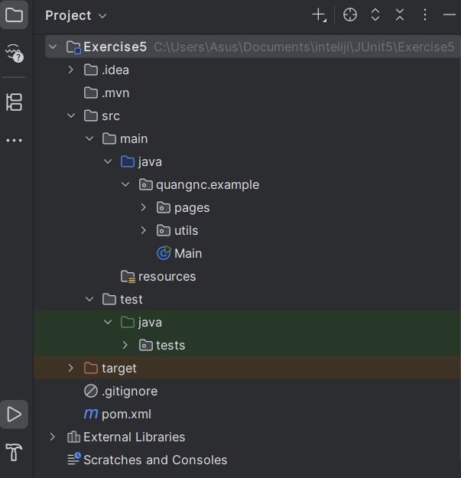

Bước 2 – Cài đặt Maven dependencies

<?xml version="1.0" encoding="UTF-8"?>
<project xmlns="http://maven.apache.org/POM/4.0.0"
xmlns:xsi="http://www.w3.org/2001/XMLSchema-instance"
xsi:schemaLocation="http://maven.apache.org/POM/4.0.0 http://maven.apache.org/xsd/maven-4.0.0.xsd">
<modelVersion>4.0.0</modelVersion>
<groupId>quangnc.example</groupId>
<artifactId>Exercise1_SeleniumBasic</artifactId>
<version>1.0-SNAPSHOT</version>
<properties>
<maven.compiler.source>17</maven.compiler.source>
<maven.compiler.target>17</maven.compiler.target>
<project.build.sourceEncoding>UTF-8</project.build.sourceEncoding>
</properties>
<dependencies>
<!-- Selenium Java -->
<dependency>
<groupId>org.seleniumhq.selenium</groupId>
<artifactId>selenium-java</artifactId>
<version>4.21.0</version>
</dependency>
<!-- JUnit 5 -->
<dependency>
<groupId>org.junit.jupiter</groupId>
<artifactId>junit-jupiter-engine</artifactId>
<version>5.9.3</version>
<scope>test</scope>
</dependency>
<!-- WebDriverManager -->
<dependency>
<groupId>io.github.bonigarcia</groupId>
<artifactId>webdrivermanager</artifactId>
<version>5.9.3</version>
</dependency>
</dependencies>
</project>

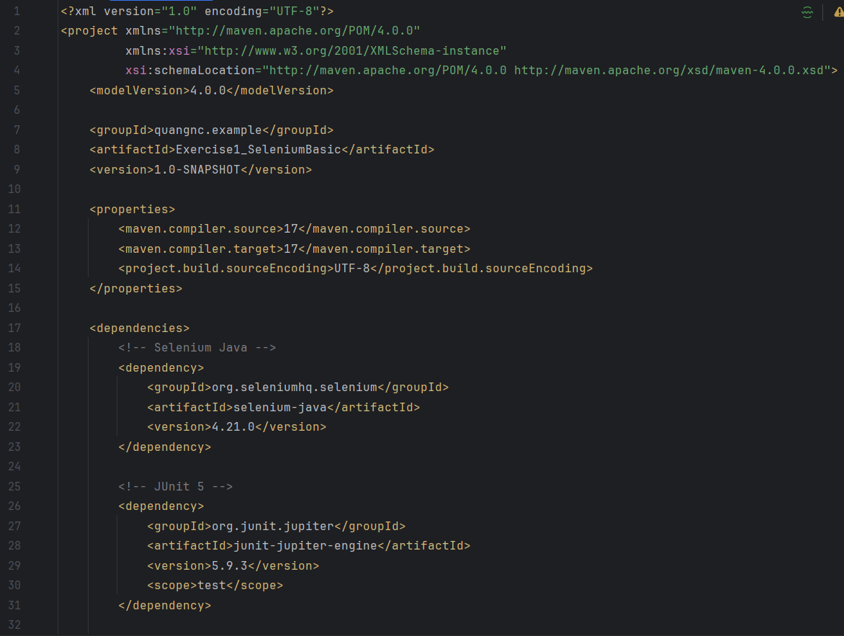
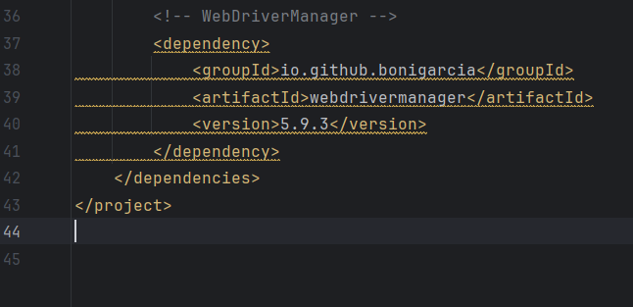

Bước 3 – Tạo lớp DriverFactory.java ở package utils
package quangnc.example.utils;
import io.github.bonigarcia.wdm.WebDriverManager;
import org.openqa.selenium.WebDriver;
import org.openqa.selenium.chrome.ChromeDriver;
public class DriverFactory {
public static WebDriver createDriver() {
WebDriverManager.chromedriver().setup();
return new ChromeDriver();
}
}

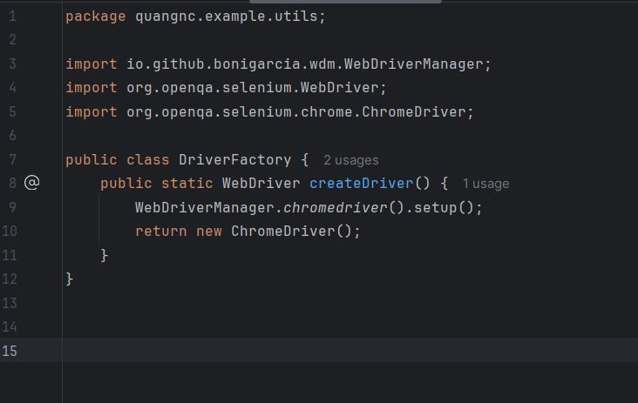

Bước 4 – Tạo lớp BasePage.java nằm trong package pages
Tái sử dụng các thao tác chờ, click, nhập dữ liệu...
package quangnc.example.pages;
import org.openqa.selenium.*;
import org.openqa.selenium.support.ui.*;
import java.time.Duration;
public class BasePage {
protected WebDriver driver;
protected WebDriverWait wait;
public BasePage(WebDriver driver) {
this.driver = driver;
this.wait = new WebDriverWait(driver, Duration.ofSeconds(10));
}
protected WebElement waitForVisibility(By locator) {
return wait.until(ExpectedConditions.visibilityOfElementLocated(locator));
}
protected void type(By locator, String text) {
WebElement element = waitForVisibility(locator);
element.clear();
element.sendKeys(text);
}
protected void click(By locator) {
waitForVisibility(locator).click();
}
protected void scrollIntoView(By locator) {
((JavascriptExecutor) driver).executeScript("arguments[0].scrollIntoView(true);", driver.findElement(locator));
}
}
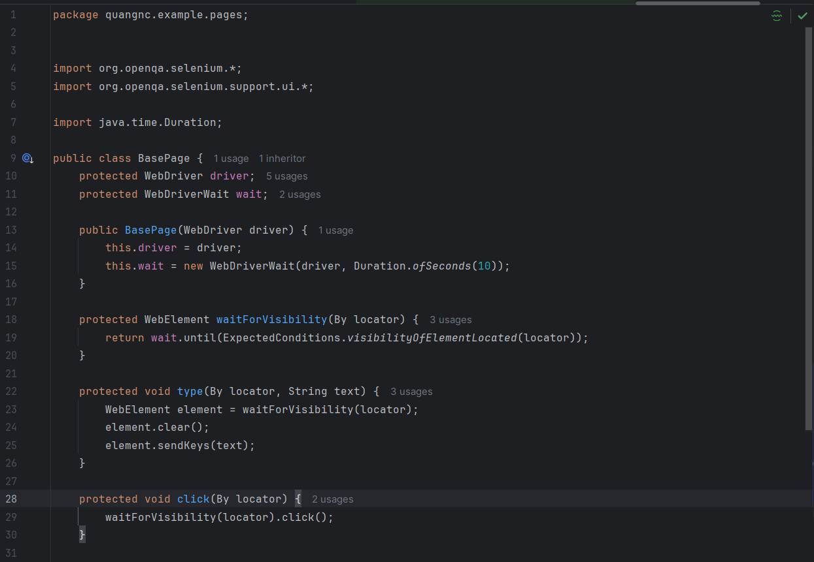
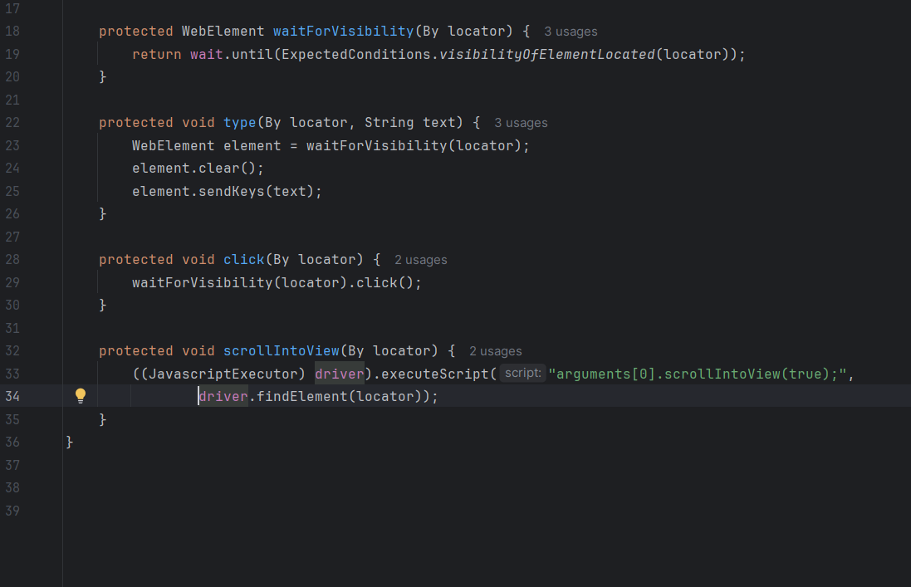
Bước 5 – Tạo lớp RegistrationPage.java trong package pages
Đại diện cho form trên trang demoqa.com
Định nghĩa các locator và method thao tác

package quangnc.example.pages;
import org.openqa.selenium.By;
import org.openqa.selenium.JavascriptExecutor;
import org.openqa.selenium.WebDriver;
public class RegistrationPage extends BasePage {
public RegistrationPage(WebDriver driver) {
super(driver);
}
private By firstName = By.id("firstName");
private By lastName = By.id("lastName");
private By genderMale = By.xpath("//label[text()='Male']");
private By userNumber = By.id("userNumber");
private By submitBtn = By.id("submit");
private By modalTitle = By.id("example-modal-sizes-title-lg");
public void navigate() {
driver.get("https://demoqa.com/automation-practice-form");
// Chờ 1-2 giây để iframe quảng cáo xuất hiện
try {
Thread.sleep(1500); // Chờ 1.5s để iframe load
} catch (InterruptedException e) {
e.printStackTrace();
}
// Xóa tất cả iframe nếu có
JavascriptExecutor js = (JavascriptExecutor) driver;
js.executeScript(
"document.querySelectorAll('iframe').forEach(frame => frame.remove());" +
"let ad = document.getElementById('google_ads_iframe_/21849154601,22343295815/Ad.Plus-Anchor_0');" +
"if(ad) ad.remove();"
);
}
public void fillForm(String fname, String lname, String number) {
type(firstName, fname);
type(lastName, lname);
scrollIntoView(genderMale); // đảm bảo nhìn thấy
try {
Thread.sleep(500); // chờ DOM ổn định
} catch (InterruptedException e) {}
click(genderMale);
type(userNumber, number);
}
public void submit() {
scrollIntoView(submitBtn);
click(submitBtn);
}
public String getModalTitle() {
return waitForVisibility(modalTitle).getText();
}
}
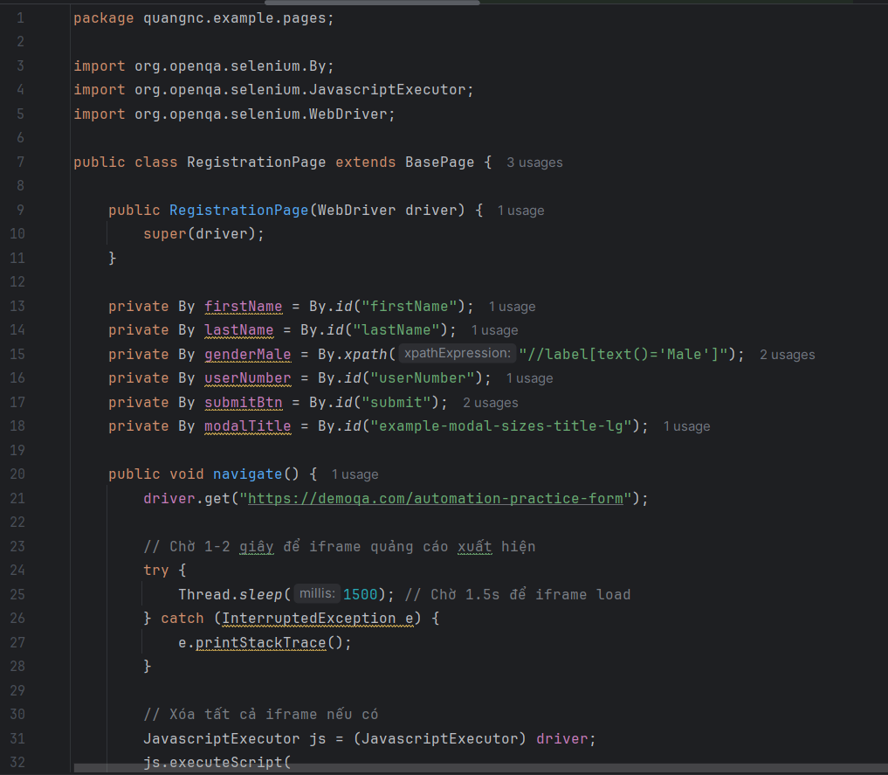
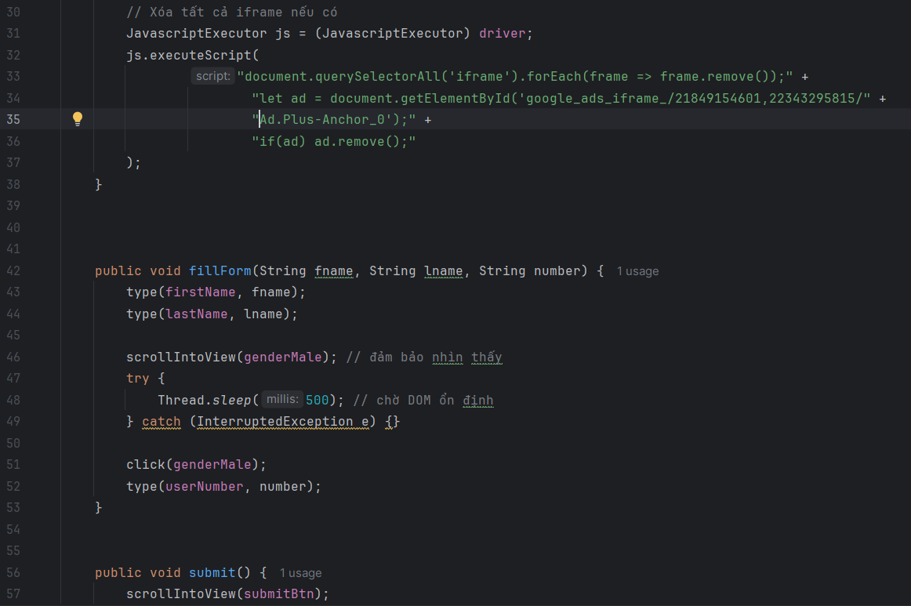
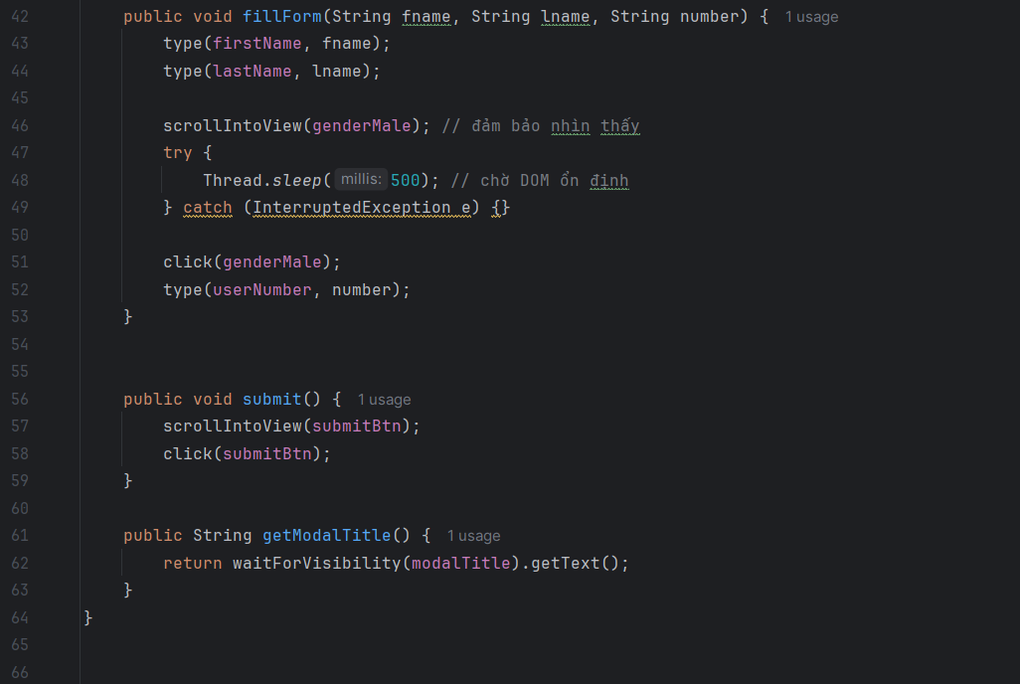
Bước 6 – Viết lớp test RegistrationTest.java

package tests;
import org.junit.jupiter.api.*;
import quangnc.example.pages.RegistrationPage;
import static org.junit.jupiter.api.Assertions.assertEquals;
@TestMethodOrder(MethodOrderer.OrderAnnotation.class)
public class RegistrationTest extends BaseTest {
static RegistrationPage regPage;
@BeforeAll
public static void init() {
regPage = new RegistrationPage(driver);
}
@Test
@DisplayName("Should submit registration form successfully")
public void testFormSubmission() {
regPage.navigate();
regPage.fillForm("John", "Doe", "0999999999");
regPage.submit();
assertEquals("Thanks for submitting the form", regPage.getModalTitle());
}
}
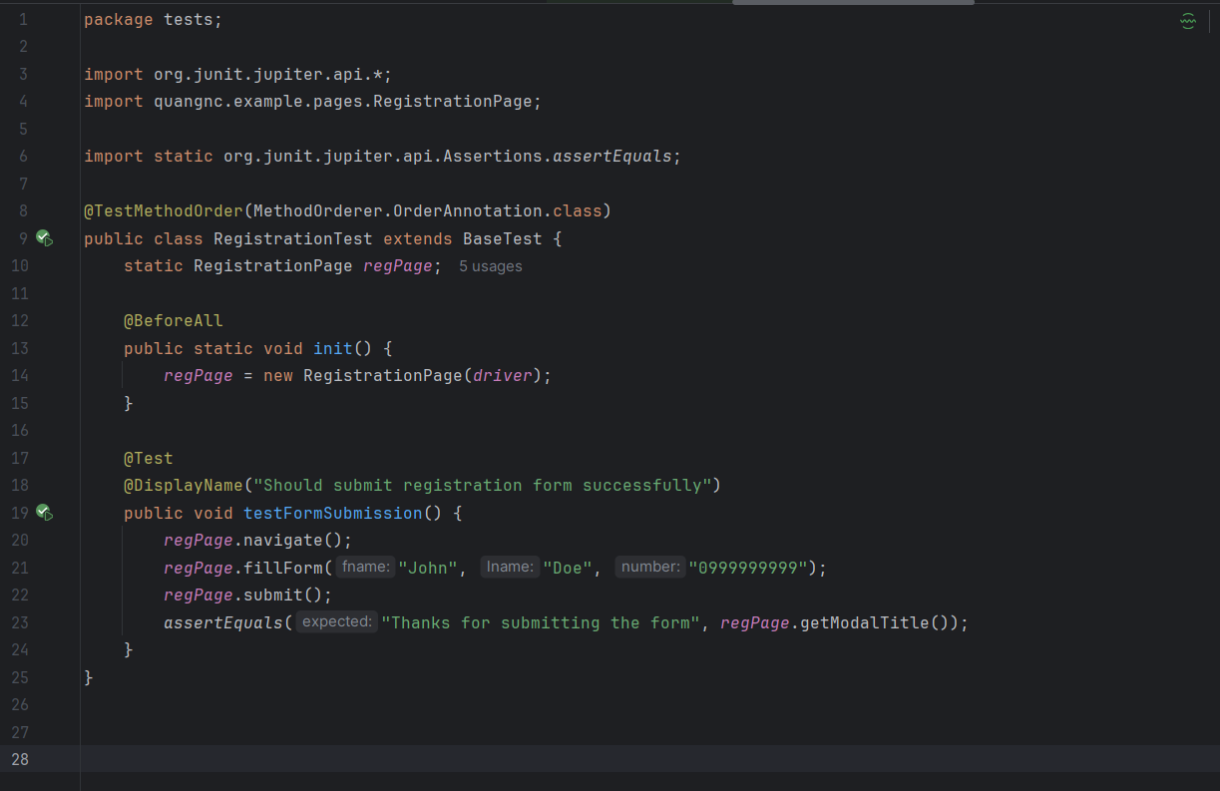
Bước 7 – Chạy test
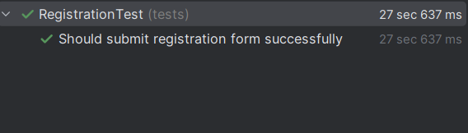

Bước 8 – Chụp kết quả trình duyệt
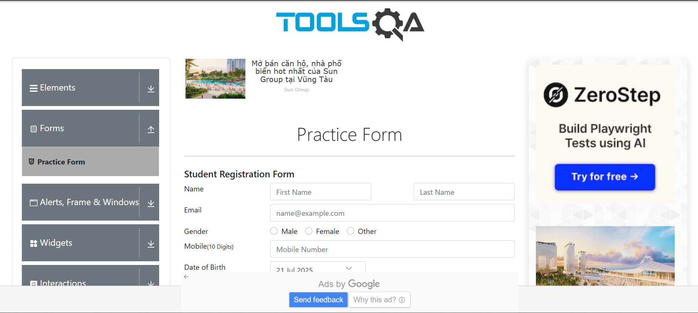

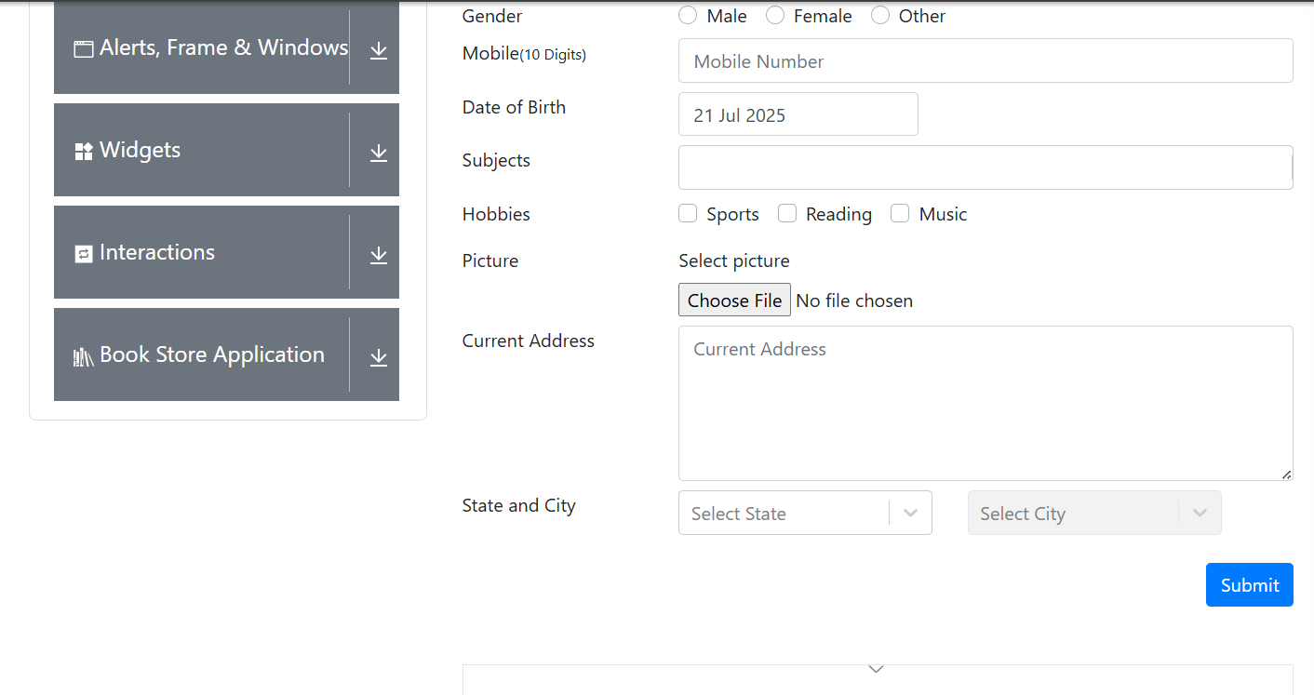

Exercise6:
I. Login:
Bước 1: Tạo giao diện login.html
<!DOCTYPE html>
<html lang="en">
<head>
<meta charset="UTF-8">
<title>Login Page</title>
<style>
body { font-family: Arial, sans-serif; margin: 40px; }
form { max-width: 300px; margin: auto; }
.error-message { color: red; margin-top: 10px; }
</style>
</head>
<body>
<h2>Login</h2>
<form id="loginForm" onsubmit="return handleLogin(event)">
<label for="email">Email:</label><br>
<input type="text" id="email" name="email"><br><br>

<label for="password">Password:</label><br>
<input type="password" id="password" name="password"><br><br>

<button type="submit" id="loginButton">Login</button>
<div class="error-message" id="errorMessage"></div>
</form>

<script>
function handleLogin(event) {
event.preventDefault();

const email = document.getElementById("email").value;
const password = document.getElementById("password").value;
const errorMessage = document.getElementById("errorMessage");

if (email === "user@example.com" && password === "password123") {
alert("Login successful!"); // thông báo popup thay vì chuyển trang
} else {
errorMessage.textContent = "Invalid email or password";
}
}
</script>
</body>
</html>

Bước 2: Tạo Lớp LoginPage.java
package quangnc.example.pages;

import org.openqa.selenium.By;
import org.openqa.selenium.WebDriver;

public class LoginPage extends BasePage {

public LoginPage(WebDriver driver) {
super(driver);
}

private By emailInput = By.id("email");
private By passwordInput = By.id("password");
private By loginButton = By.id("loginButton");
private By errorMessage = By.id("errorMessage");

public void navigateToLoginPage() {
driver.get("file:///C:/path/to/login.html"); // Cập nhật đường dẫn thực tế
}

public void enterCredentials(String email, String password) {
type(emailInput, email);
type(passwordInput, password);
}

public void submitLogin() {
click(loginButton);
}

public String getErrorMessage() {
return getText(errorMessage);
}
}
Bước 3: Tạo lớp kiểm thử LoginTest.java
package tests;

import org.junit.jupiter.api.*;
import quangnc.example.pages.LoginPage;

@TestMethodOrder(MethodOrderer.OrderAnnotation.class)
public class LoginTest extends BaseTest {

LoginPage loginPage;

@BeforeEach
public void setupTest() {
loginPage = new LoginPage(driver);
loginPage.navigateToLoginPage();
}

@Test
@Order(1)
@DisplayName("Login with valid credentials")
public void testLoginSuccess() throws InterruptedException {
loginPage.enterCredentials("user@example.com", "password123");
loginPage.submitLogin();
Thread.sleep(3000); // Để quan sát điều hướng
// Với test thành công, không có message lỗi nên không cần assert
}

@Test
@Order(2)
@DisplayName("Login with invalid credentials")
public void testLoginInvalid() throws InterruptedException {
loginPage.enterCredentials("wrong@example.com", "wrongpass");
loginPage.submitLogin();
Thread.sleep(3000);

Assertions.assertEquals("Invalid email or password", loginPage.getErrorMessage());
}

@Test
@Order(3)
@DisplayName("Login with empty credentials")
public void testLoginEmpty() throws InterruptedException {
loginPage.enterCredentials("", "");
loginPage.submitLogin();
Thread.sleep(3000);

Assertions.assertEquals("Invalid email or password", loginPage.getErrorMessage());
}
}
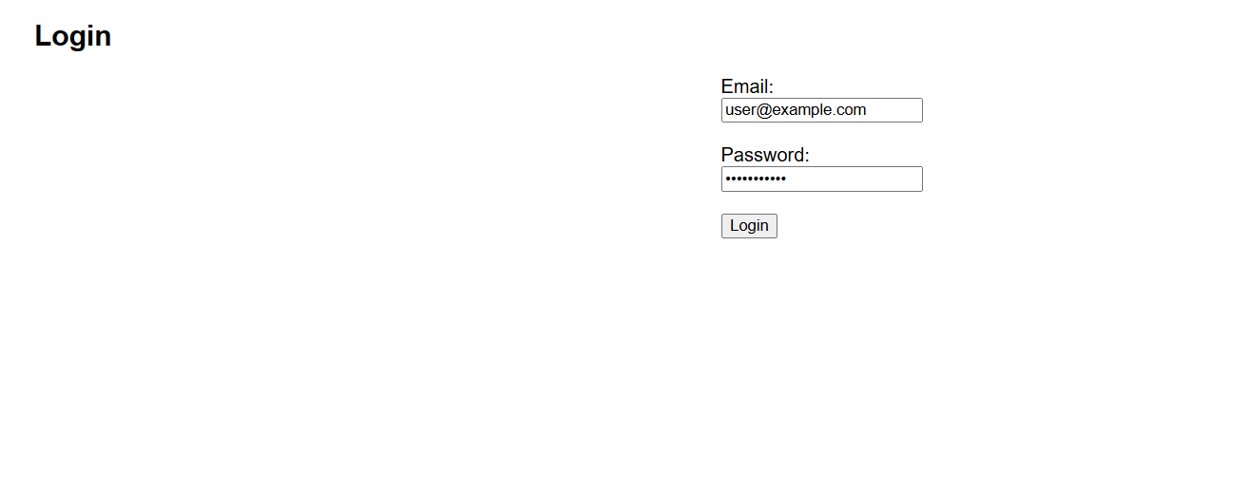

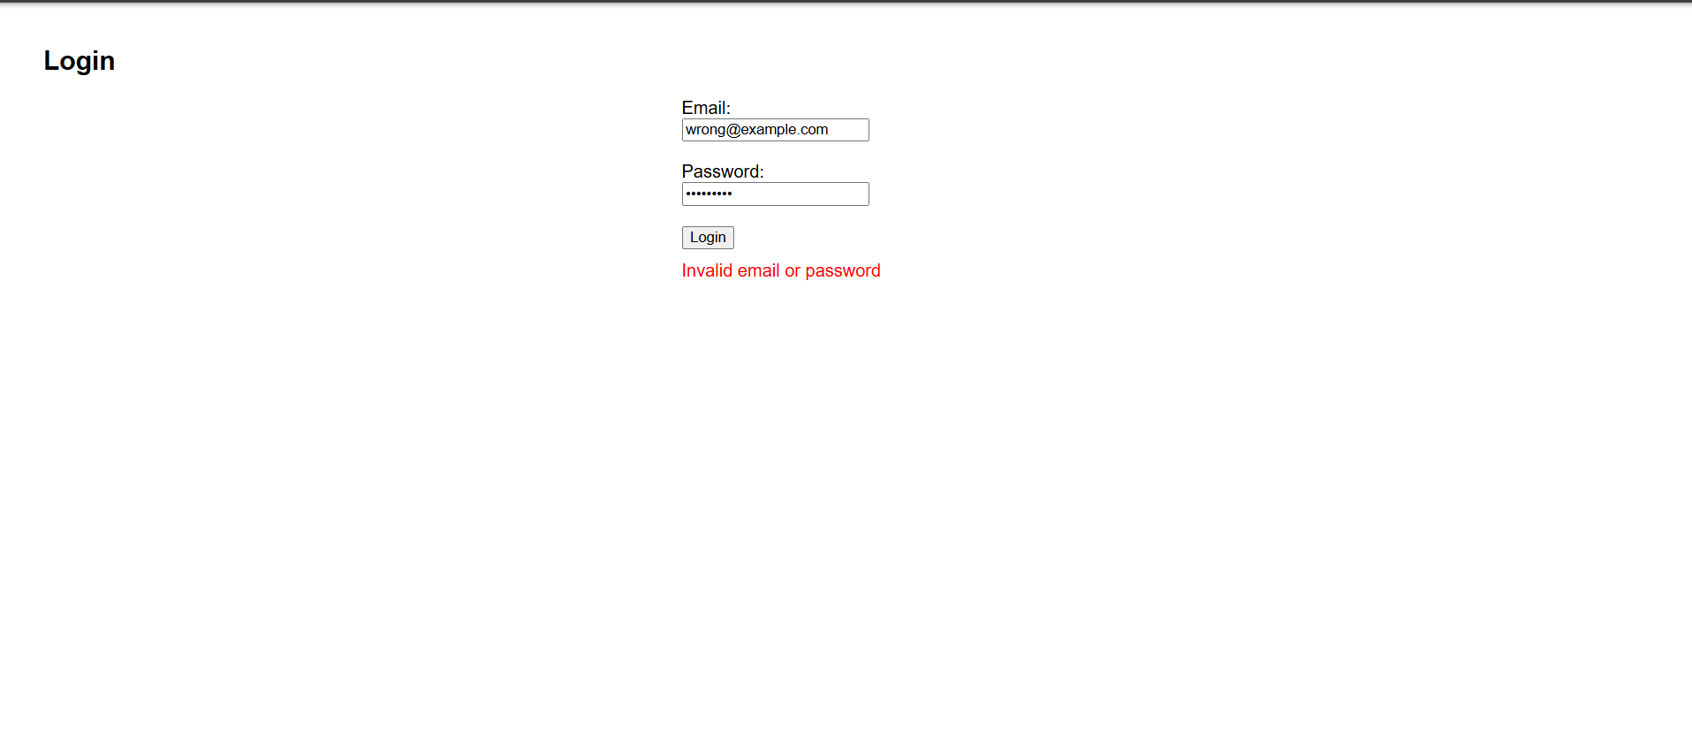

II Registration:
Bước 1: Tạo giao diện HTML cho Register
<!DOCTYPE html>
<html lang="en">
<head>
<meta charset="UTF-8">
<title>Registration</title>
<style>
body { font-family: Arial; margin: 40px; }
form { max-width: 400px; margin: auto; }
.error { color: red; margin-top: 10px; }
.success { color: green; margin-top: 10px; }
</style>
</head>
<body>
<h2>Register</h2>
<form id="regForm" onsubmit="return handleRegister(event)">
<label>Full Name:</label><br>
<input type="text" id="name"><br><br>

<label>Email:</label><br>
<input type="text" id="email"><br><br>

<label>Password:</label><br>
<input type="password" id="password"><br><br>

<label>Confirm Password:</label><br>
<input type="password" id="confirm"><br><br>

<button type="submit">Register</button>
<div class="error" id="errorMsg"></div>
<div class="success" id="successMsg"></div>
</form>

<script>
function handleRegister(event) {
event.preventDefault();
const name = document.getElementById("name").value.trim();
const email = document.getElementById("email").value.trim();
const pass = document.getElementById("password").value;
const confirm = document.getElementById("confirm").value;
const err = document.getElementById("errorMsg");
const success = document.getElementById("successMsg");

err.textContent = "";
success.textContent = "";

if (!name || !email || !pass || !confirm) {
err.textContent = "Please fill in all fields.";
return;
}

if (pass !== confirm) {
err.textContent = "Passwords do not match.";
return;
}

success.textContent = "Registration successful!";
}
</script>
</body>
</html>

Bước 2: Tạo lớp RegisterPage.java trong package quangnc.example.pages
package quangnc.example.pages;

import org.openqa.selenium.By;
import org.openqa.selenium.WebDriver;

public class RegisterPage extends BasePage {

public RegisterPage(WebDriver driver) {
super(driver);
}

private By emailInput = By.id("email");
private By passwordInput = By.id("password");
private By confirmPasswordInput = By.id("confirmPassword");
private By registerButton = By.id("registerButton");
private By message = By.id("message");

public void navigateToRegisterPage() {
driver.get("file:///C:/path/to/register.html"); // cập nhật đường dẫn thật
}

public void enterRegistrationInfo(String email, String password, String confirmPassword) {
type(emailInput, email);
type(passwordInput, password);
type(confirmPasswordInput, confirmPassword);
}

public void submitRegistration() {
click(registerButton);
}

public String getMessage() {
return getText(message);
}
}
Bước 3: Tạo lớp kiểm thử RegisterTest.java trong package tests
package tests;

import org.junit.jupiter.api.*;
import quangnc.example.pages.RegisterPage;

@TestMethodOrder(MethodOrderer.OrderAnnotation.class)
public class RegisterTest extends BaseTest {

RegisterPage registerPage;

@BeforeEach
public void setupTest() {
registerPage = new RegisterPage(driver);
registerPage.navigateToRegisterPage();
}

@Test
@Order(1)
@DisplayName("Register with valid info")
public void testValidRegistration() throws InterruptedException {
registerPage.enterRegistrationInfo("test@example.com", "123456", "123456");
registerPage.submitRegistration();
Thread.sleep(3000);

Assertions.assertTrue(registerPage.getMessage().contains("successful"));
}

@Test
@Order(2)
@DisplayName("Register with mismatched passwords")
public void testMismatchedPasswords() throws InterruptedException {
registerPage.enterRegistrationInfo("test@example.com", "123456", "654321");
registerPage.submitRegistration();
Thread.sleep(3000);

Assertions.assertTrue(registerPage.getMessage().contains("do not match"));
}

@Test
@Order(3)
@DisplayName("Register with missing fields")
public void testMissingFields() throws InterruptedException {
registerPage.enterRegistrationInfo("", "", "");
registerPage.submitRegistration();
Thread.sleep(3000);

Assertions.assertTrue(registerPage.getMessage().contains("fill in all fields"));
}
}

