Tobias Kundig

Unix/Linux and cpp survival skills

CSCI 460

Fall 2013

1. Execute cat command

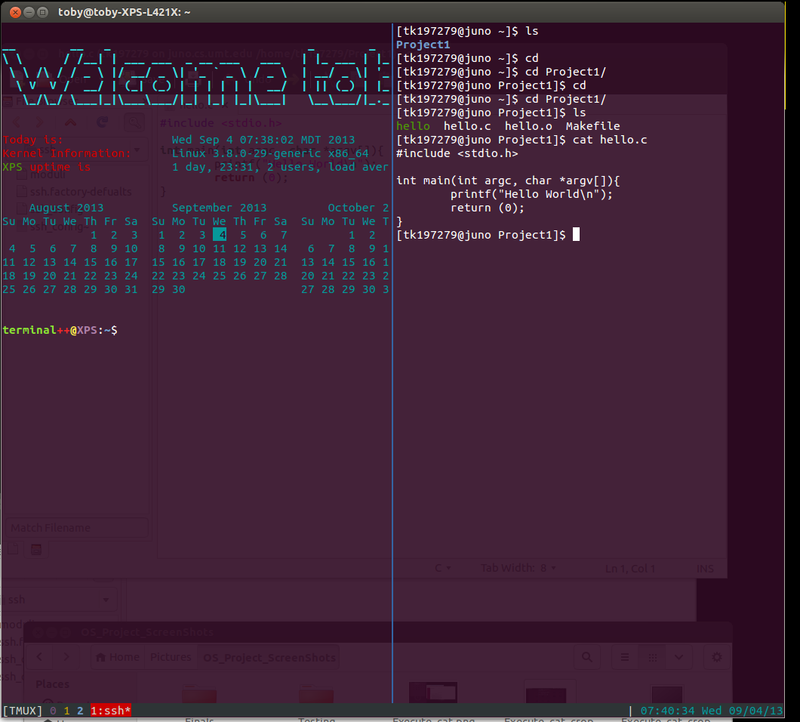

2. Execute ls command

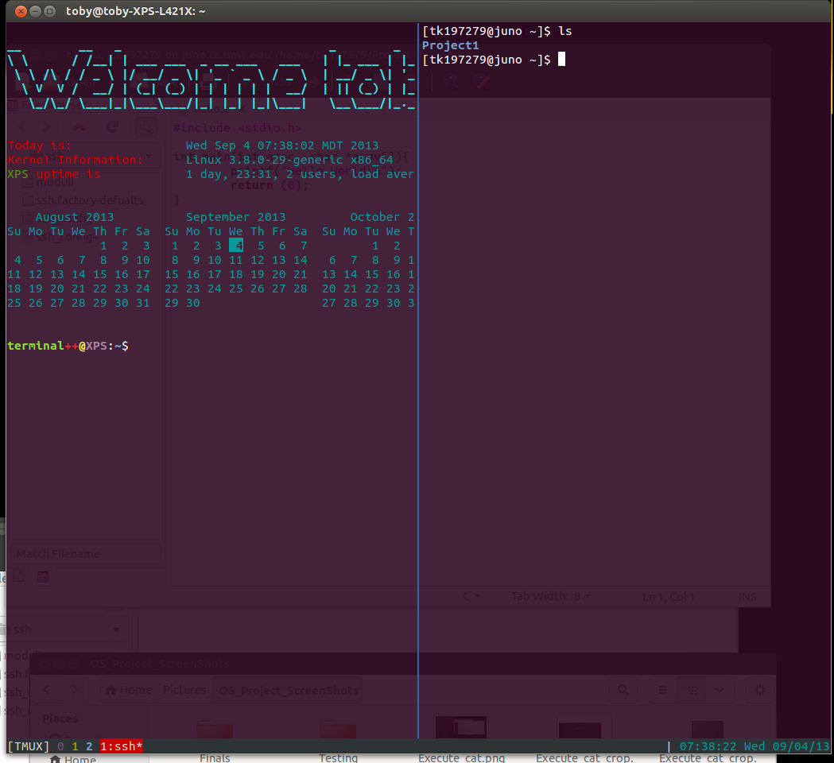

3. Execute cd command

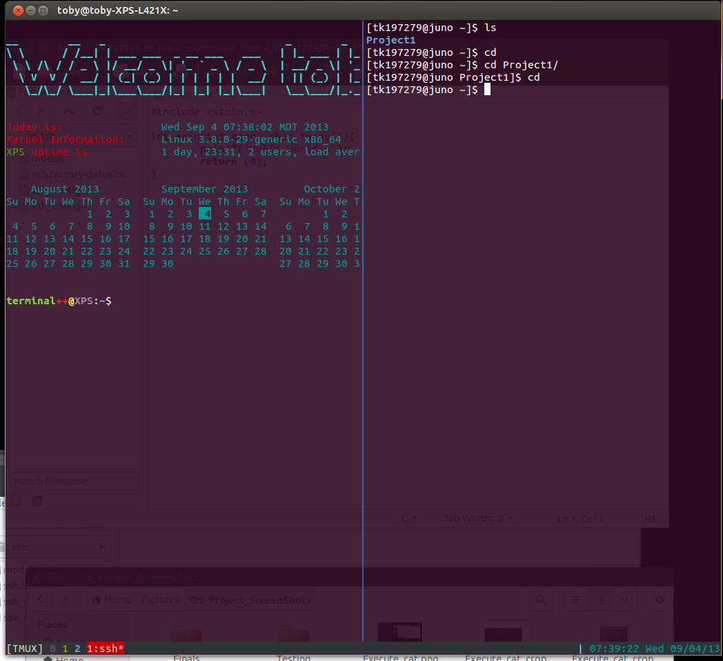

4. Execute make

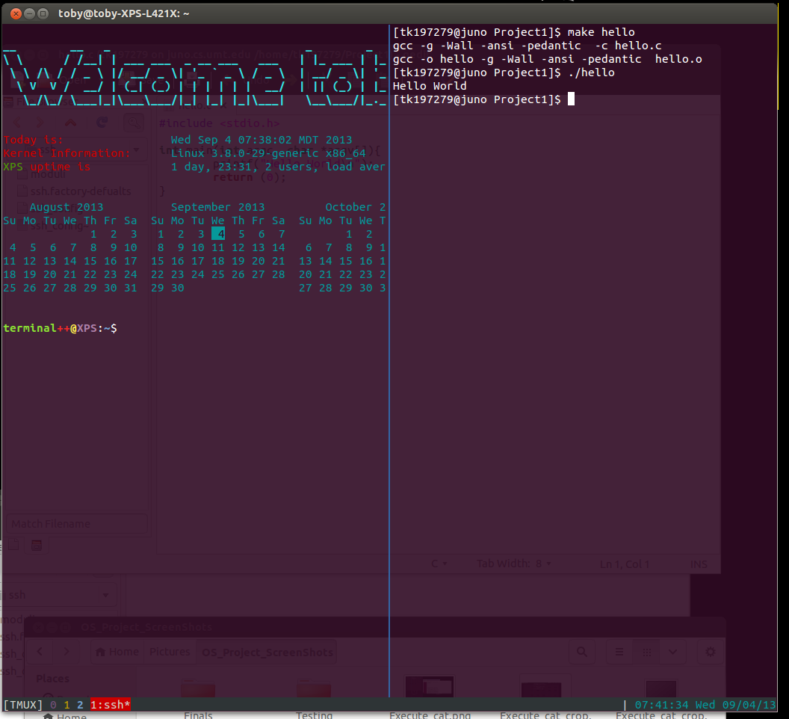

5. Hybrid. Nautilus file manager is logged on with gedit editing.

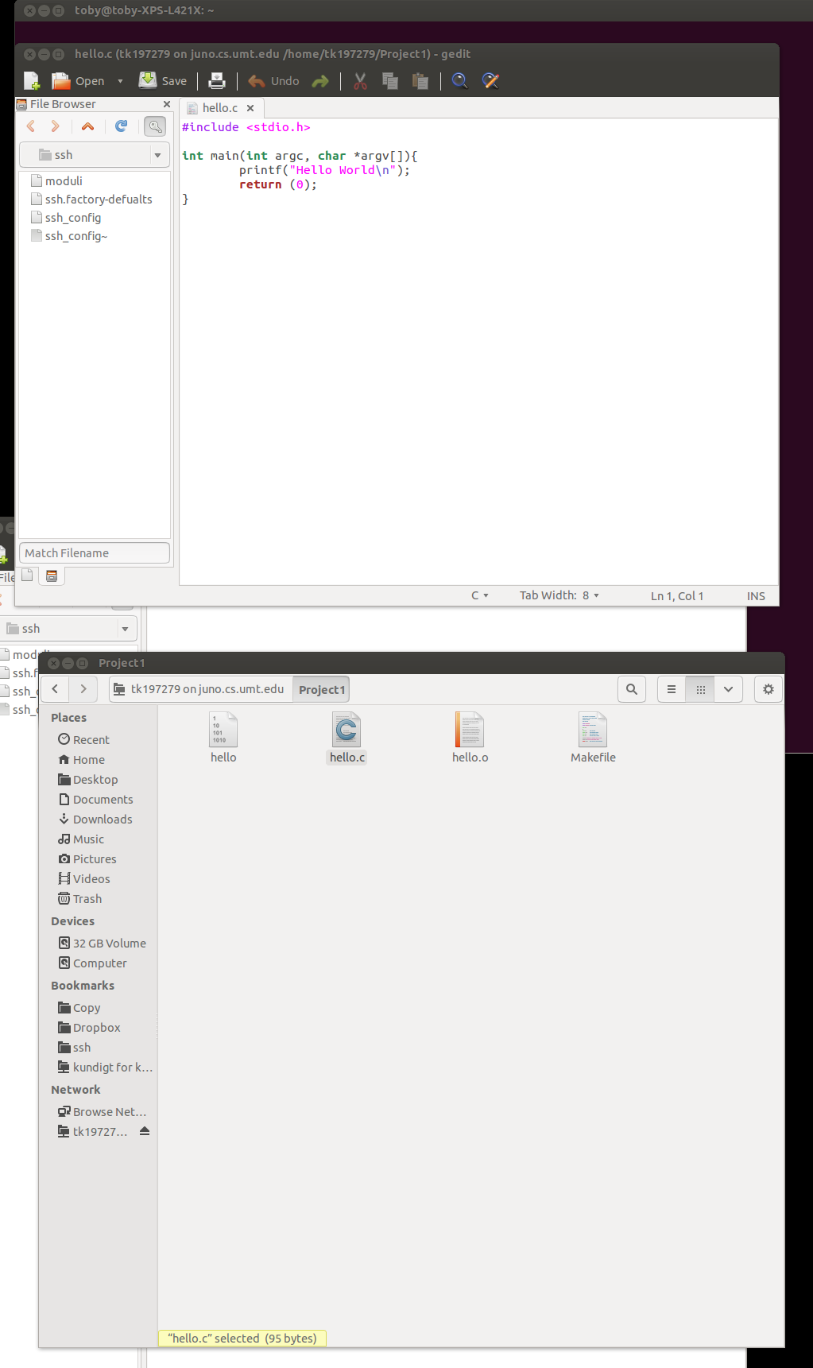

6. Filezilla

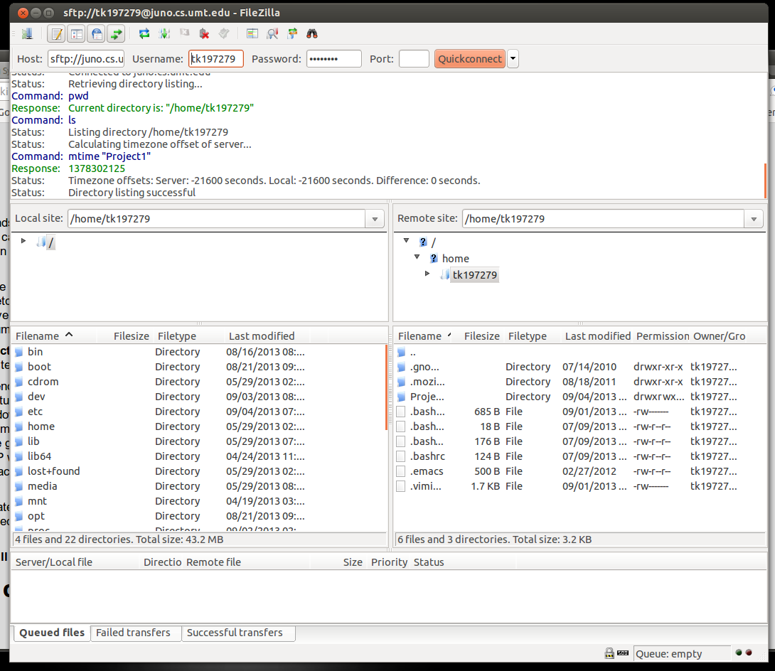

7. Using vim

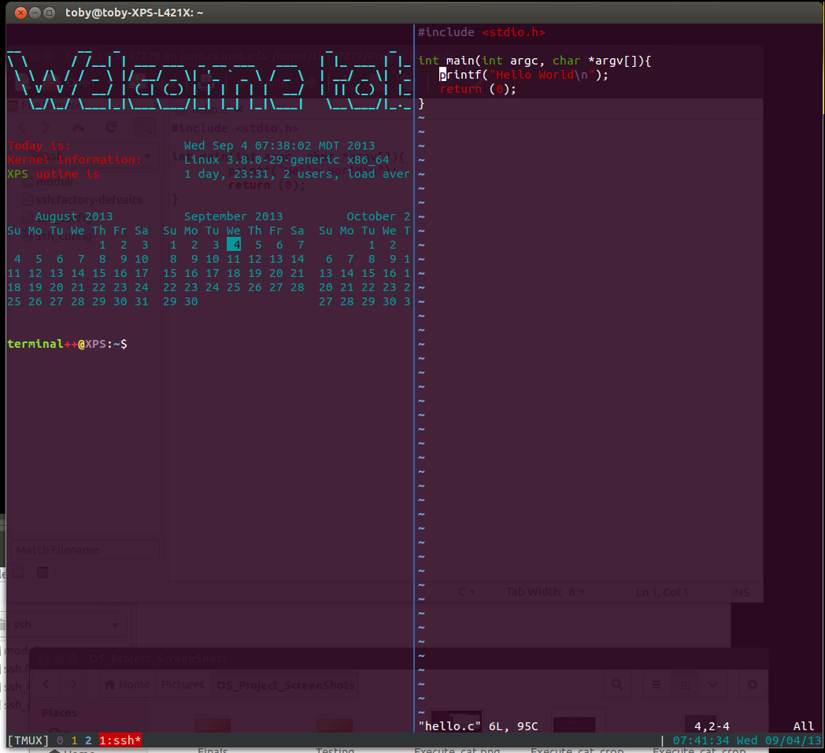

8. Gedit running remotely

