Tobias Kundig

Project 2

Fall ‘13

Douglas Raiford Ph.D.

CSCI 460 Operating Systems

September 10, 2013

Execute adder.c

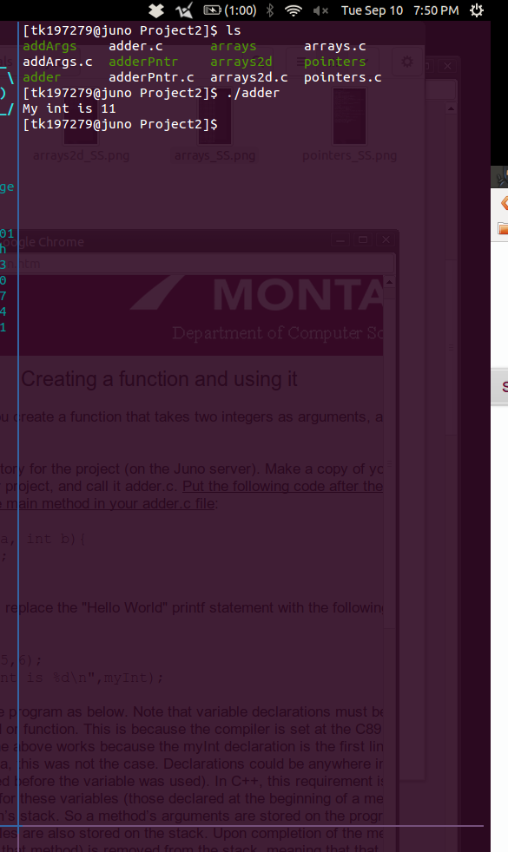

Execute arrays.c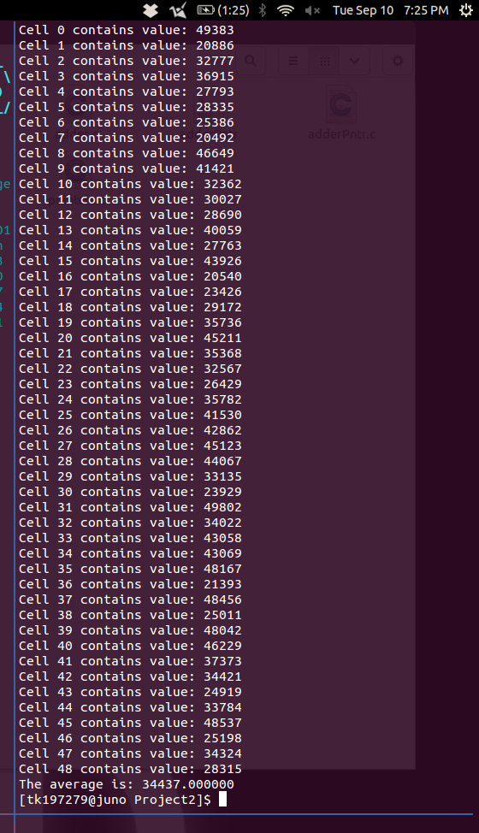

Execute adderPntr.c

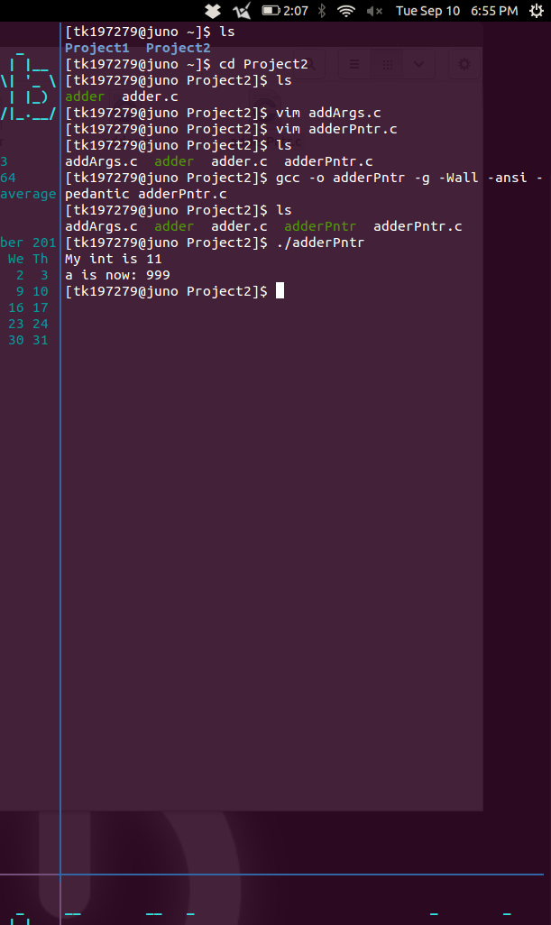

Execute arrays2d.c

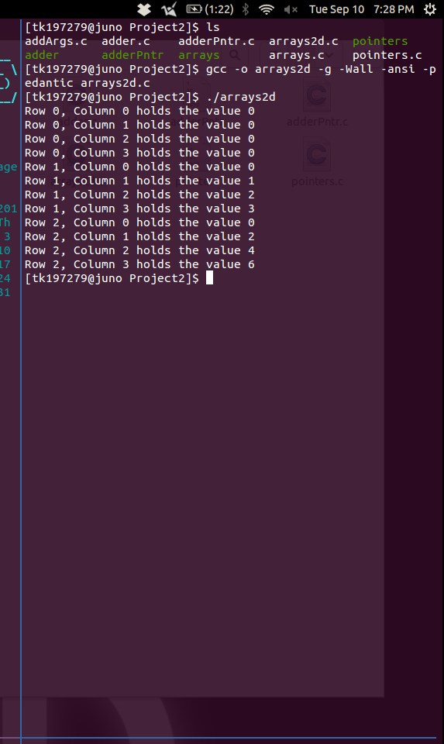

Execute addArgs.c

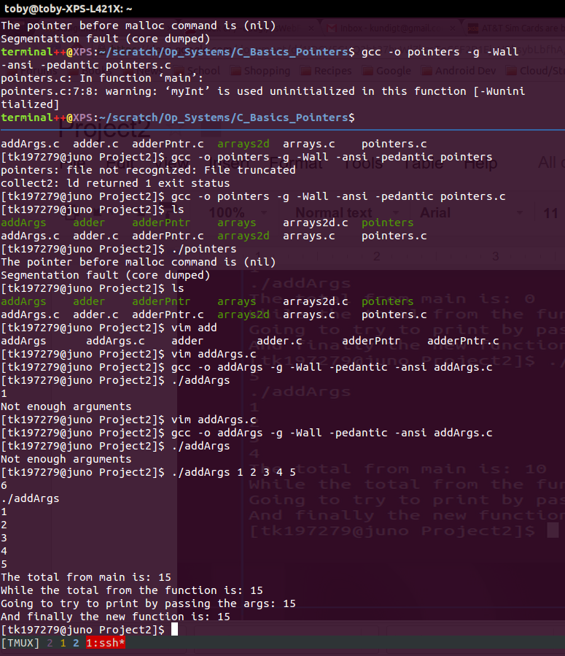

Execute pointers.c

