Tobias Kundig

Project 4 “Simulator”

Fall 2013

Dr. Douglas Raiford

October 10, 2013

First part

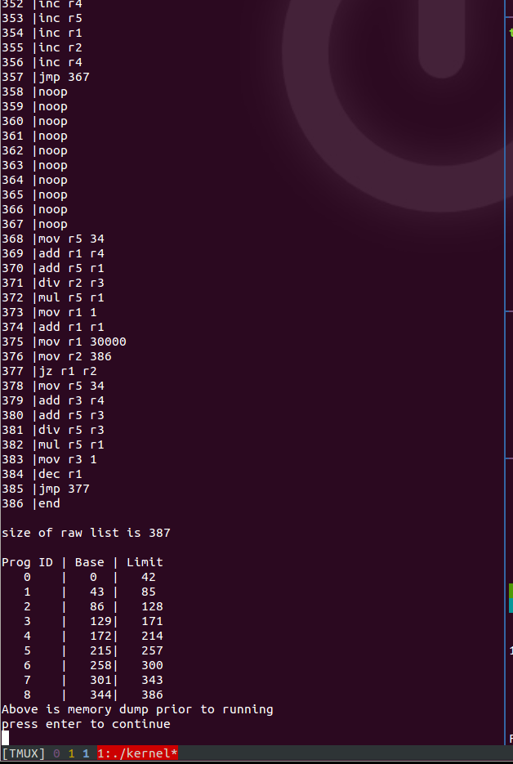

Second part finishing to completion

