Интерполяция

1. Линейная интерполяция по двум точкам



$$P_{1}=l_{0}\left(x\right)f\left(x_{0}\right)+l_{1}\left(x\right)f\left(x_{1}\right)$$

$$l_{0}\left(x\right)=\frac{x-x_{1}}{x_{0}-x_{1}}, l_{1}\left(x\right)=\frac{x-x_{0}}{x_{1}-x_{0}}$$

$l_{0}\left(x\right)and l_{1}\left(x\right)$ are linear in $x$.



$$l_{0}\left(x_{0}\right)=1, l_{0}\left(x_{1}\right)=0$$

$$l_{1}\left(x_{0}\right)=0, l_{1}\left(x_{1}\right)=1$$

$$l_{i}\left(x_{j}\right)=δ_{ij}, i,j=0,1$$

$$P_{1}=\sum_{i=0}^{1}{l_{i}\left(x\right)f\left(x_{i}\right)}$$

1. Квадратичная интерполяция по трем точкам



$$P_{2}=l_{0}\left(x\right)f\left(x_{0}\right)+l_{1}\left(x\right)f\left(x_{1}\right)+l_{1}\left(x\right)f\left(x_{1}\right)$$

$$l_{0}\left(x\right)=\frac{(x-x_{1})(x-x_{2})}{{(x}_{0}-x_{1}){(x}_{0}-x_{2})}, l_{1}\left(x\right)=\frac{(x-x_{0})(x-x_{2})}{{(x}_{1}-x_{0}){(x}_{1}-x_{2})}, l_{2}\left(x\right)=\frac{(x-x_{0})(x-x_{1})}{{(x}_{2}-x_{0}){(x}_{2}-x_{1})}$$

Check that again

$$l_{i}\left(x_{j}\right)=δ_{ij}, i,j=0,1,2$$

$$P_{2}=\sum_{i=0}^{2}{l_{i}\left(x\right)f\left(x_{i}\right)}$$

$$l_{j}\left(x\right)=\frac{\left(x-x_{0}\right)…\left(x-x_{j-1}\right)\left(x-x_{j+1}\right)…(x-x_{N-1})}{{(x}_{j}-x_{0})…{(x}_{j}-x_{j-1}){{(x}_{j}-x_{j+1})…(x}_{j}-x_{N-1})}$$

Procedure

P=0;

For(j=0;j<N;k++)

$l[j]=1$;

for(k=0;k<N;k++)

If(k!=j)

$l\left[j\right]=l\left[j\right]*\frac{z-x[k]}{x[j]-x[k]}$// internal loop to find $l\left[j\right]$

$P=P+f\left[j\right]*l[j]$.

Задание

Sometimes linear interpolation is used between each pair of the experimental points as demonstrated

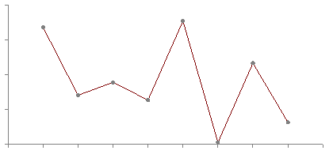

Linear interpolation between each pair of adjacent points.

This is not often convenient since such procedure results in discontinuities at each point.

**Exercise**

Propose algorithm to connect the adjacent points by cos- functions as demonstrated in the diagram below

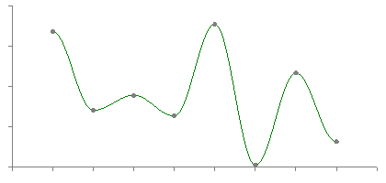

Hint:

For two points $x_{0}$ =0 and $x_{1}$ =1 we can introduce the following basic functions

$$l_{0}(x)=(1+\cos{xπ)/2}, l_{1}(x)=(1-\cos{xπ)/2}$$

Check, that

$$l_{0}\left(0\right)=1, l_{0}\left(1\right)=0$$

$$l_{1}\left(0\right)=0, l_{1}\left(1\right)=1$$

Now generalise this approach for any values of points on *x*.

Then, the cosine interpolation for these points is written in a similar way we discussed for a linear interpolation:

$${f(x)=l}_{0}\left(x\right)f\left(x_{0}\right)+l_{1}\left(x\right)f\left(x_{1}\right)$$

Приложение

Пример интерполяционной функции для программирования на С++

double interpol(double z, int N)

{

double fun=0 ;

double x[100],f[100],l[100];

int i,j;

cout<<"give"<<N<<" numbers for x and f "<<endl;

for(i=0;i<N;i++)

{

cin>>x[i]>>f[i];

}

for(i=0;i<N;i++)

{

l[i]=1;

for(j=0;j<N;j++)

{

if(j!=i)

l[i]=l[i]*((z-x[j])/(x[i]-x[j]));

}

fun=fun+l[i]*f[i];

}

return fun;

}