|  |  |  |  |  |  |
| --- | --- | --- | --- | --- | --- |
| ****Project Type: NCIS Pledge a Ribbon Campaign Microsite**** | | | | ****Date:** 05 Jan 2021** | |
| ****Project Requirements:**** | ****Client’s Name:**** | | | | |
| ****Brand / Product / Campaign / Industry:**** | | | | |
| ****Deadlines** (Date / Time)**:**** | | | | |
|  |  |  | | **22 Feb 2021** |
| ****Development**** | ****Internal UAT**** | ****Client UAT**** | | ****LIVE**** |
| ****Comments / Special Instructions:**** | | | | | |

1. **Sitemap**

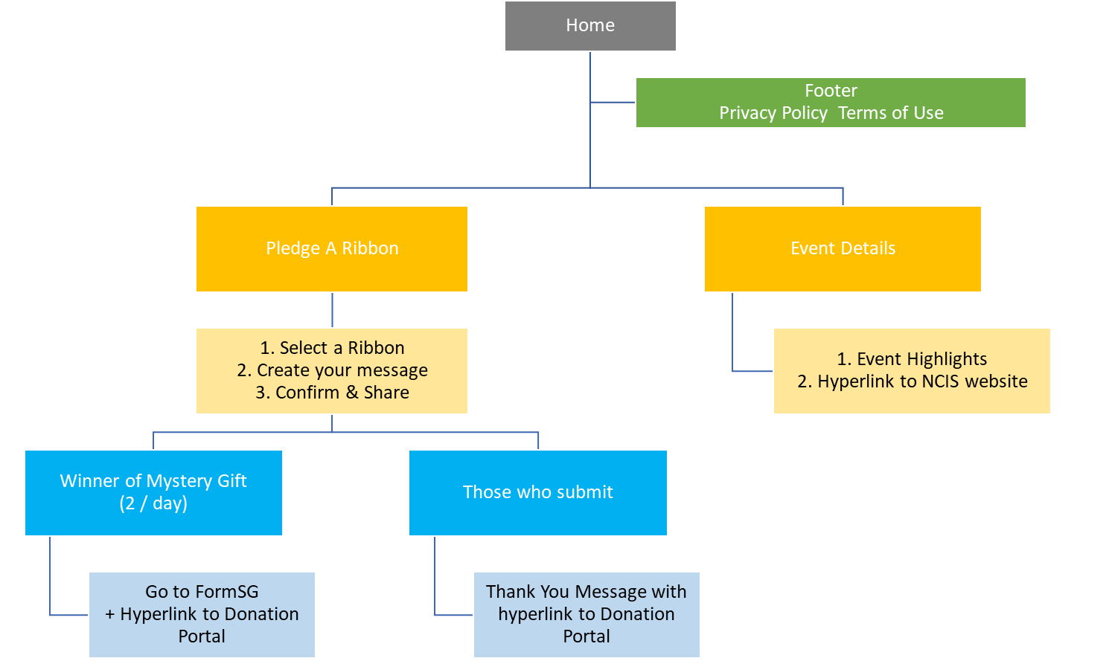

1. **Homepage**

* 2021 Ribbon Challenge information, Jar, Ribbons counter, Sponsor logos.

1. **Event Details**

* Static page with short writeup, and link to NCIS website.

1. **Mystery Gift**

* There will be 2 mystery gifts giveaway to users who pledged successfully.
* Lucky users will be directed to FormSG to fill in their particulars.

1. **USER FLOW (WITHOUT MYSTERY GIFT) (website / mobile / tablet)**

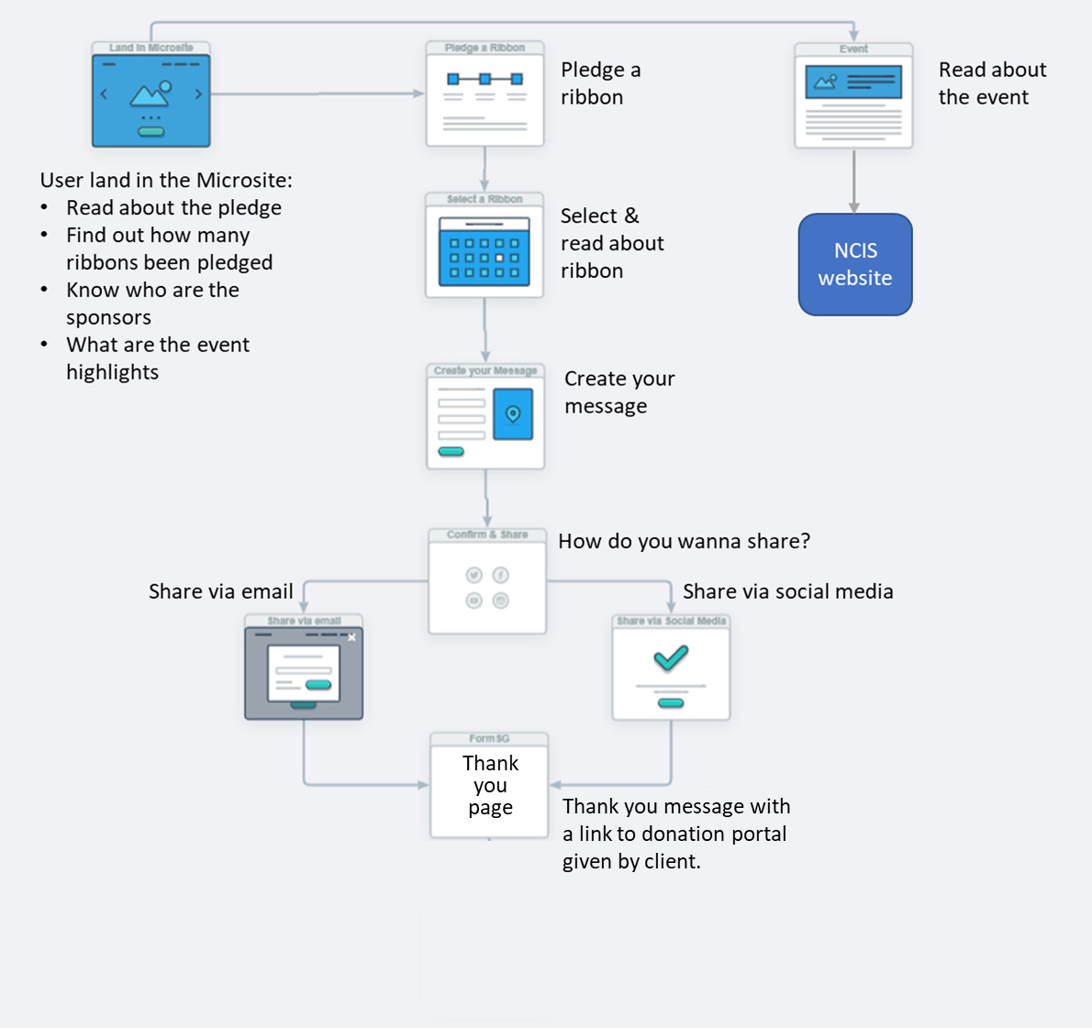

1. **USER FLOW (WITH MYSTERY GIFT) (website / mobile / tablet)**

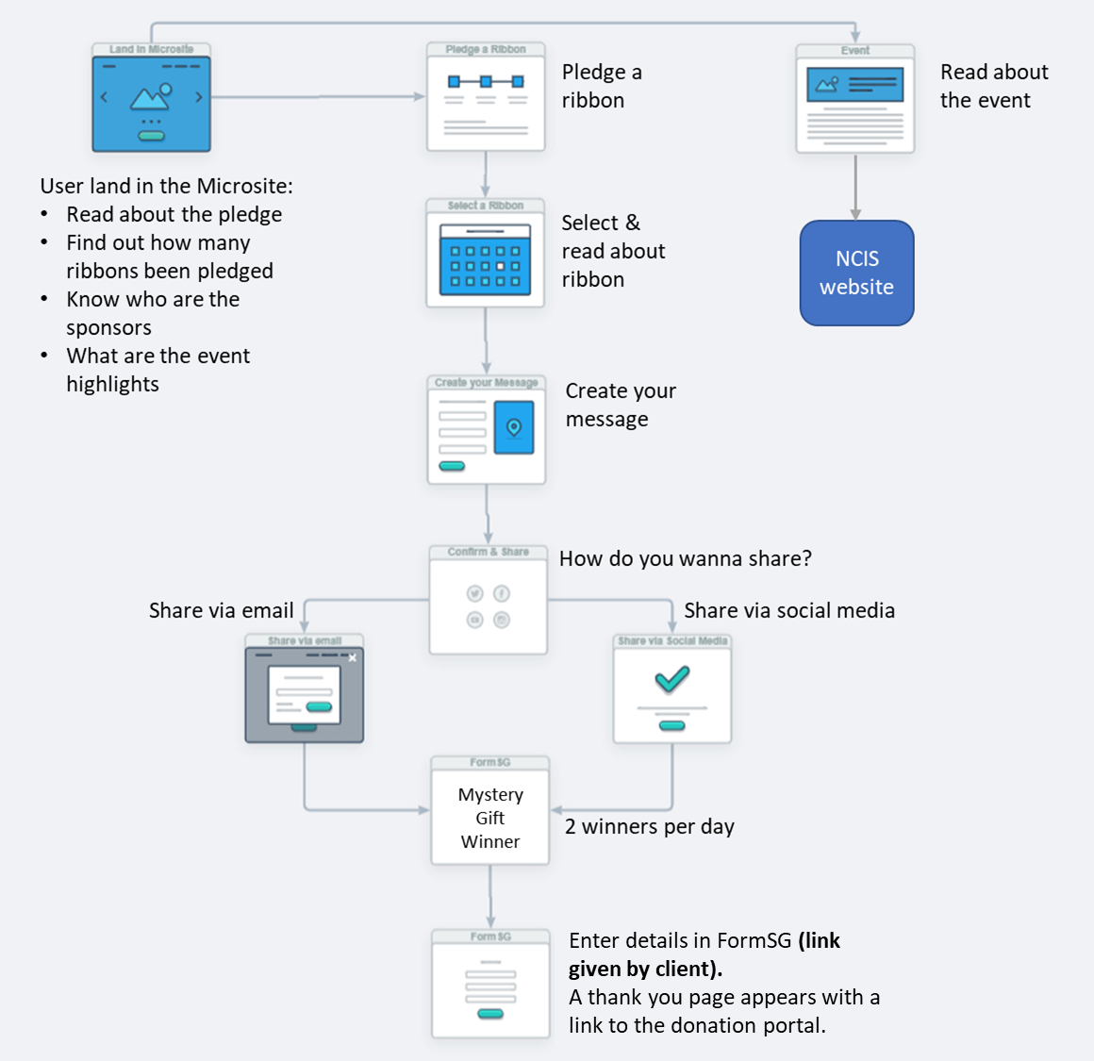

1. **USER FLOW (On-Premise)**

* Pledge info will be placed on-site with a QR code.
* Users to scan QR code to go to campaign microsite to take part in the pledge.

1. **HOMEPAGE**

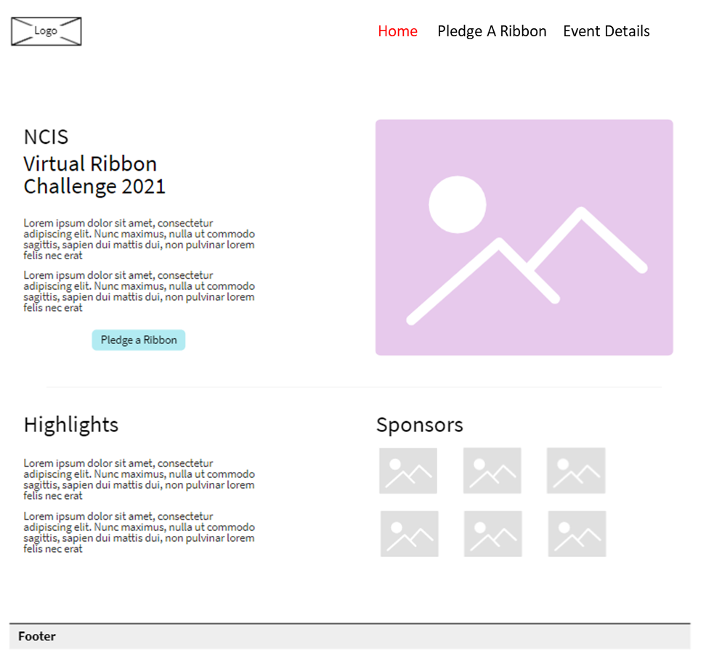

**Note: This is a wireframe to confirm the functionalities of the page, actual design may vary**

|  |  |  |
| --- | --- | --- |
| **ITEM** | **SPECIFICATIONS / DETAILS** | **REMARKS** |
| **About the Challenge** | Texts | NCIS to provide the contents |
| **Counter** | * Display the total no. of ribbons collected * Date |  |
| **Pledge A Ribbon** | * Hyperlink to Send a Ribbon page |  |
| **Highlights** | * Event highlights / forum info | NCIS to provide |
| **Sponsor Logos** | * Lists of sponsors | NCIS to provide |
| **Footer** | * Privacy Policy & Terms of Use | NCIS to provide |

1. **Send a Ribbon > Select Your Ribbon and Create your Message**

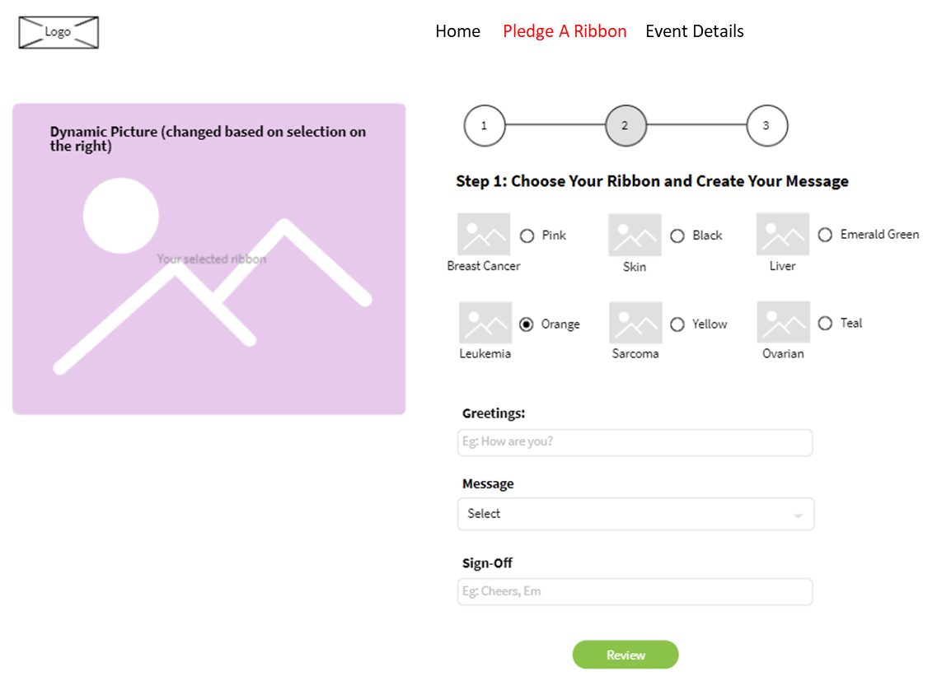

**Note: This is a wireframe to confirm the functionalities of the page, actual design may vary**

|  |  |  |
| --- | --- | --- |
| **ITEM** | **SPECIFICATIONS / DETAILS** | **REQUIREMENTS** |
| **Image on the Left** | Changed based on what was selected on the right. |  |
| **Navigation Panel** | * Indicates the no. of steps of this campaign |  |
| **Select Ribbon Color** | * Select ribbon color (radio button) (**15 ribbon** colors) * When radio button is selected, random fun fact of the ribbon color will pop up | Please provide **3 fun facts** for each color. |
| **Greetings** | * Opening message to the recipient, Eg: **How are you?** |  |
| **Message** | * Drop down selection of pre-defined messages | Please provide the pre-defined **8 messages** for users to select |
| **Sign-Off** | * Closing, eg. **Cheers, Sender’s Name** |  |
| **Review** | * Click review to go to next step |  |

**Note: Recipient will receive a hyperlink to view the message on the website**

|  |  |  |
| --- | --- | --- |
| **ITEM** | **SPECIFICATIONS / DETAILS** | **REQUIREMENTS** |
| **Message in email** | Put in email | Please provide message |

Sample of the popup window of Fun Fact

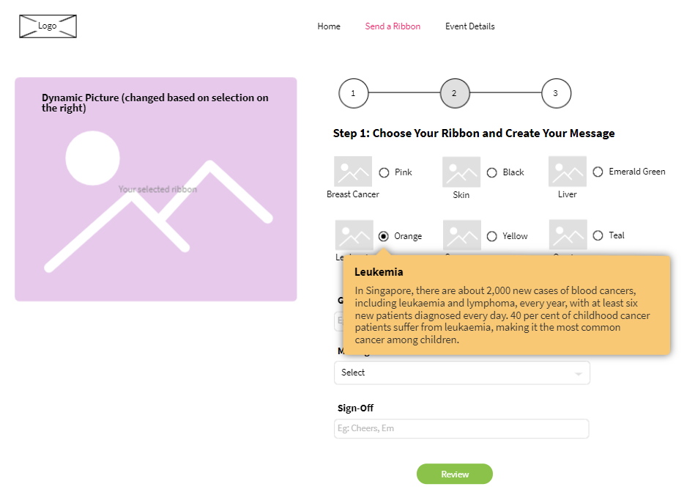

**Note: This is a wireframe to confirm the functionalities of the page, actual design may vary**

1. **Send a Ribbon > Edit / Confirm**

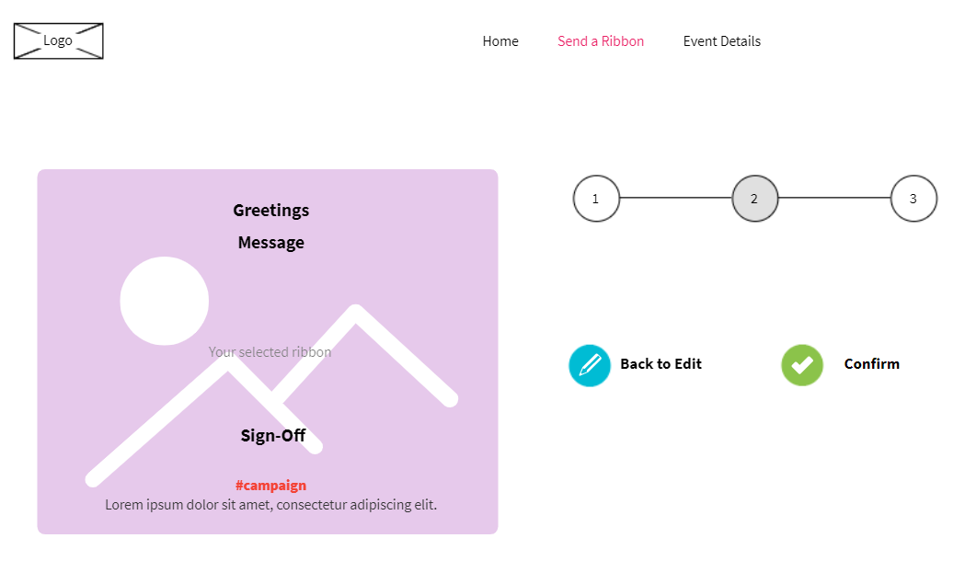

**Note: This is a wireframe to confirm the functionalities of the page, actual design may varies**

|  |  |  |
| --- | --- | --- |
| **ITEM** | **SPECIFICATIONS / DETAILS** | **REQUIREMENTS** |
| **Image on the left** | Dynamic based on what the user input in previous step   * Greetings * Message * Sign-off   Include a campaign hashtag and message | Please provide 5 ribbon images |
| **Edit** | * To go back and edit the message |  |
| **Confirm** | * To proceed to sharing |  |

1. **Send a Ribbon > Share**

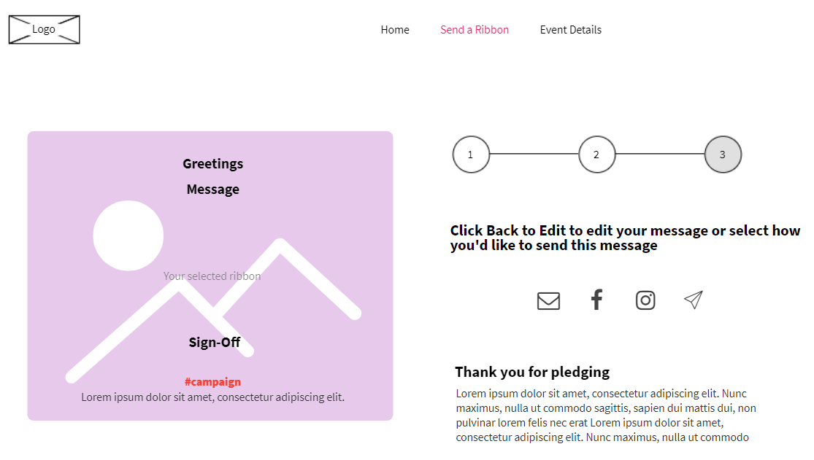

|  |  |  |
| --- | --- | --- |
| **ITEM** | **SPECIFICATIONS / DETAILS** | **REQUIREMENTS** |
| **Image on the left** | Dynamic based on what the user input in previous step   * Greetings * Message * Sign-off   Include a campaign hashtag and message |  |
| **Sharing** | * **Email** – sender to input recipient email; recipient will receive an email with a link to view the message on website. * **Social Sharing** – Steps will be shared with sender how to send via the respective social media / Messaging channels, namely:   **Facebook, Instagram, Twitter, Telegram, Line, WeChat.** |  |
| **Thank you message** | * Thank you message to recipient. * Include an explainer about the campaign / highlights about the campaign. * Include a link to donation portal (URL to be given by the client). |  |

1. **Send a Ribbon > Sharing via Facebook**

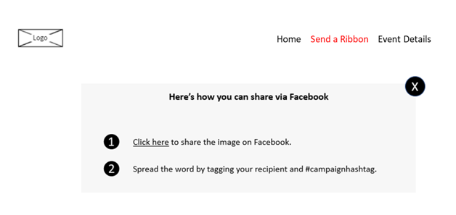

**Note: This is only a wireframe to confirm the functionalities of the page**

|  |  |  |
| --- | --- | --- |
| **ITEM** | **SPECIFICATIONS / DETAILS** | **REQUIREMENTS** |
| **Steps to share** | Depending on the channels that sender selected to share the card, respective instructions will appear |  |
| **Campaign Hashtag** |  | NCIS to provide campaign hashtag (if any). |

1. **Send a Ribbon > Lucky Mystery Gift Winners (only 2 winners per day)**

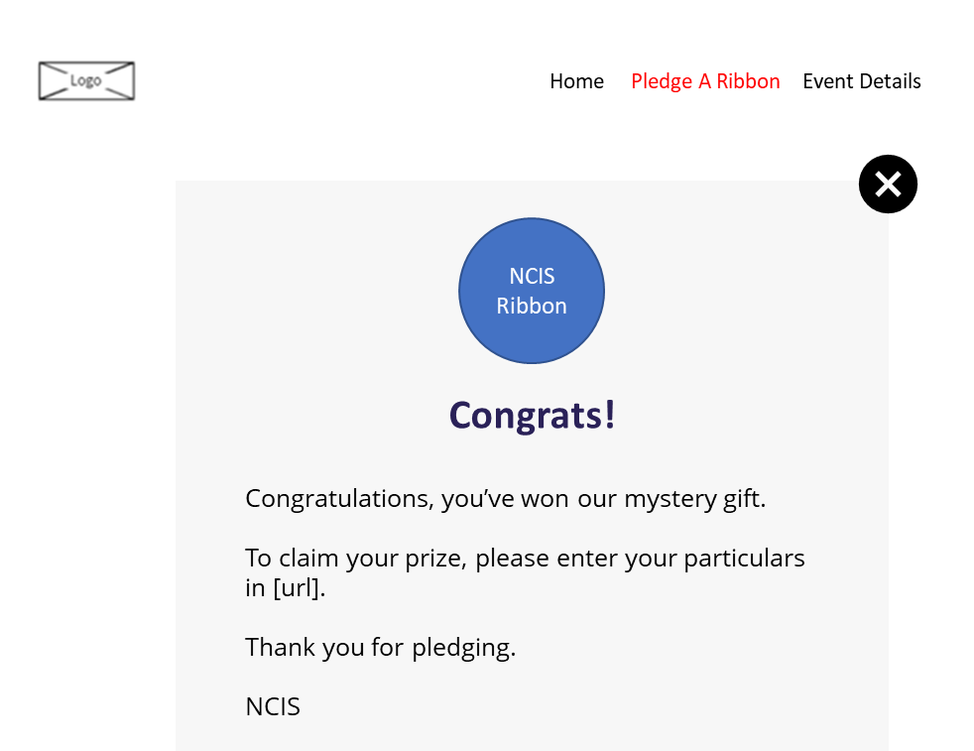

**Note: This is only a wireframe to confirm the functionalities of the page**

|  |  |  |
| --- | --- | --- |
| **ITEM** | **SPECIFICATIONS / DETAILS** | **REQUIREMENTS** |
| **NCIS Ribbon** | Ribbon will be provided |  |
| **[URL]** | Link to FormSG | NCIS to provide |