**CheckEcosse installation notes**

Copy CheckEcosse.zip to the folder of your choice e.g. C:\Apps

Navigate to . C:\Apps and extract the files from CheckEcosse.zip to this folder, i.e. unzip to here.

**The Windows batch file**

The ***CheckEcosseGUI*** program is invoked using the CheckEcosse.bat file:

rem

@set initial_working_dir=%cd%

@chdir /D C:\Apps\AbUniv\GlobalEcosseSuite\setup

start cmd.exe /k "C:\Apps\AbUniv\GlobalEcosseSuite\exes\CheckEcosseGUI.exe"

@chdir /D %initial_working_dir%

The third line changes the current working directory to C:\Apps:\AbUniv\GlobalEcosseSuite\setup where the setup file, check_ecosse_setup.json**,** is expected.

The subsequent line invokes the ***CheckEcosseGUI*** program.

Create a short cut on your desktop to the Windows batch file:

C:\Apps\AbUniv\GlobalEcosseSuite\run\ChckEcssExe.bat

This file can be run from anywhere on your workstation – for convenience you can create a shortcut on your desktop with the Global Ecosse icon file which can be found in:

C:\Apps\AbUniv\GlobalEcosseSuite\images

**Setup and configuration files**

Please check the drives which are available. All workstations using Windows have a C: drive where the Windows OS resides and is called the primary or system drive. Your workstation may well have a secondary drive which is typically the E: drive. In this case it is generally better to use the secondary rather than the primary drive.

The GlobalEcosse suite of Python programs use a setup and one or more configuration files which use *JavaScript Object Notation* aka JSON[1], an open standard data interchange file format. JSON uses human-readable text to store data objects consisting of attribute–value pairs and array data types.

After unzipping CheckEcosse.zip check the model setup file check_ecosse_setup.json as below**:**

{

  "setup": {

    "config_dir": " C:\\Apps\\AbUniv\\GlobalEcosseSuite\\config",

"fname_png": "C:\\Apps\\AbUniv\\GlobalEcosseSuite\\Images\\Tree_of_life.PNG"

  }

}

“config_dir” defines the path for the configuration file

"fname_png" defines the logo image file which will appear in the left hand portion of the interface.

Example of the ***CheckEcosseGUI*** program user interface:

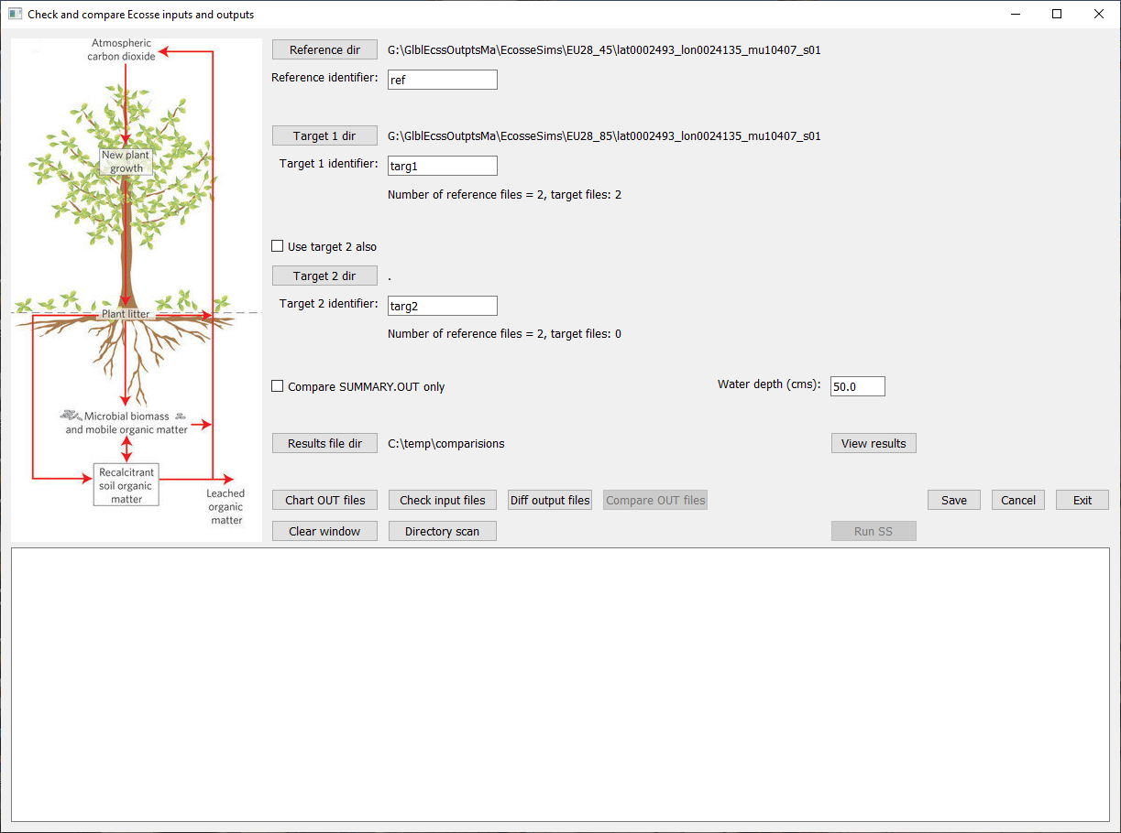

1. See: <https://en.wikipedia.org/wiki/JSON>