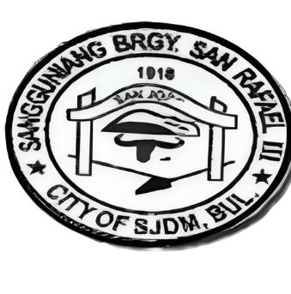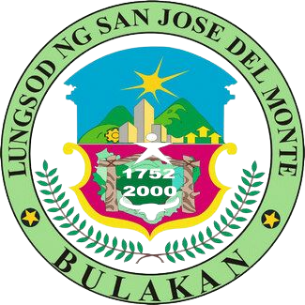REPUBLIC OF THE PHILIPPINES

PROVINCE OF BULACAN

CITY OF SAN JOSE DEL MONTE

BARANGAY SAN RAFAEL III

OFFICE OF THE PUNONG BARANGAY

Email Address: [csjdmsanrafael3@gmail.com](mailto:csjdmsanrafael3@gmail.com)

SANGGUNIANG BARANGAY

{{YEAR}}

{{CAPTAIN}}

Barangay Captain

Barangay Kagawad:

1. HON. {{COFCOPW}}

Comm. On Finance/ Comm. On Public Works

2. HON. {{COHSW}}

Comm. On Health & Solid Waste

3. HON. {{COL}}

Comm. On Livelihood

4. HON. {{COPO}}

Comm. On Peace and Order

5. HON. {{COEB}}

Comm. On Education & Beautification

6. HON. {{COSS}}

Comm. On Social Services

7. HON. {{COSYD}}

Comm. On Sports & Youth Development

8. HON. {{SK}}

Sk Chairman

**NOT VALID W/O DRY SEAL**

INDIGENCY

To Whom It May Concern:

This is to certify that {{NAME}} is bonafide resident of {{ADDRESS}} Barangay San Rafael III City of San Jose Del Monte, Bulacan

This is also certified that the name stated above is belong to the Indigent families based on barangay record and considered belong to poverty level.

This certification is issued for {{PURPOSE}}

Given this 23rd day of October, 2023 at the Office of Punong Barangay of Barangay San Rafael III, City of San Jose Del Monte, Bulacan.

CERTIFIED BY:

_______________

**HON. NORMA B. LLAMOSO**

PUNONG BARANGAY