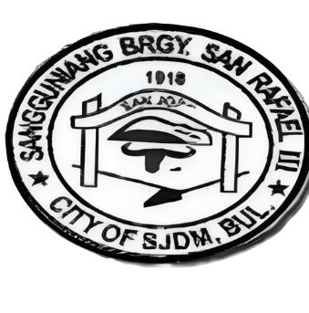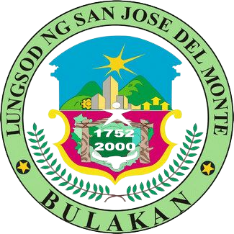

REPUBLIC OF THE PHILIPPINES

PROVINCE OF BULACAN

CITY OF SAN JOSE DEL MONTE

BARANGAY SAN RAFAEL III

OFFICE OF THE PUNONG BARANGAY

Email Address: [csjdmsanrafael3@gmail.com](mailto:csjdmsanrafael3@gmail.com)

CERTIFICATION

(First Time Jobseekers Assistance Act- RA-11261)

**NOT VALID W/O DRY SEAL**

This is to certify that Mr./Ms {{NAME}} a resident of

{{ADDRESS}} Brgy. San Rafael III, CSJDM, Bulacan, SINCE

BIRTH his/her rights, including the duties and

Responsibilities accorded by RA 11261 through the Oath of Undertaking he/she has signed and executed in the

Presence of our Barangay Official.

Signed this ____ day of __________,____, In the City/

Municipality of San Jose Del Monte, Bulacan.

CERTIFIED BY: ATTESTED BY:

_______________ ______________

HON. NORMA B. LLAMOSO ARLENE JOY T. ESPIRITU

Punong Barangay Barangay Secretary