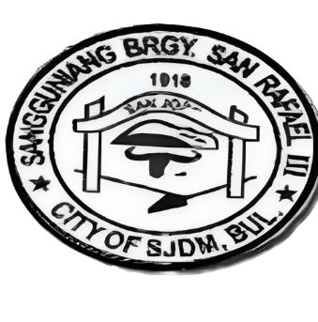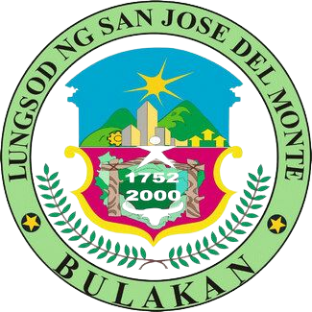REPUBLIC OF THE PHILIPPINES

PROVINCE OF BULACAN

CITY OF SAN JOSE DEL MONTE

BARANGAY SAN RAFAEL III

OFFICE OF THE PUNONG BARANGAY

Email Address: [csjdmsanrafael3@gmail.com](mailto:csjdmsanrafael3@gmail.com)

BARANGAY CLEARANCE

To Whom It May Concern:

This is to certify that the person whose name, signature and thumb mark print below has requested a Record Clearance from this office and the result(s) is/are listed below.

Name: {{NAME}}

Address: {{ADDRESS}}

Birthday: {{BIRTHDAY}}

BIRTHPLACE: {{BIRTHPLACE}}

SEX: {{SEX}}

Civil Status: {{CIVILSTATUS}}

Citizenship: {{CITIZENSHIP}}

Remarks: NO DEROGATORY RECORDS

PURPOSE: {{PURPOSE}}

ISSUED THIS 23RD DAY OF October, 2023

_______________

SIGNATURE OF REQUESTOR

CERTIFIED BY:

_________________________

HON. NORMA B. LLAMASO

PUNONG BARANGAY

SANGGUNIANG BARANGAY

{{YEAR}}

{{CAPTAIN}}

Barangay Captain

Barangay Kagawad:

1. HON. {{COFCOPW}}

Comm. On Finance/ Comm. On Public Works

2. HON. {{COHSW}}

Comm. On Health & Solid Waste

3. HON. {{COL}}

Comm. On Livelihood

4. HON. {{COPO}}

Comm. On Peace and Order

5. HON. {{COEB}}

Comm. On Education & Beautification

6. HON. {{COSS}}

Comm. On Social Services

7. HON. {{COSYD}}

Comm. On Sports & Youth Development

8. HON. {{SK}}

Sk Chairman

Right

Left

**NOT VALID W/O DRY SEAL**