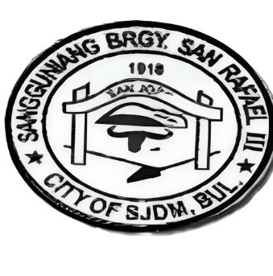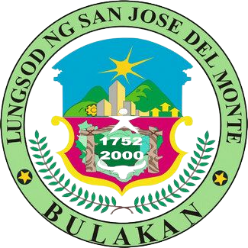REPUBLIC OF THE PHILIPPINES

PROVINCE OF BULACAN

CITY OF SAN JOSE DEL MONTE

BARANGAY SAN RAFAEL III

OFFICE OF THE PUNONG BARANGAY

Email Address: [csjdmsanrafael3@gmail.com](mailto:csjdmsanrafael3@gmail.com)

SANGGUNIANG BARANGAY

{{YEAR}}

{{CAPTAIN}}

Barangay Captain

Barangay Kagawad:

1. HON. {{COFCOPW}}

Comm. On Finance/ Comm. On Public Works

2. HON. {{COHSW}}

Comm. On Health & Solid Waste

3. HON. {{COL}}

Comm. On Livelihood

4. HON. {{COPO}}

Comm. On Peace and Order

5. HON. {{COEB}}

Comm. On Education & Beautification

6. HON. {{COSS}}

Comm. On Social Services

7. HON. {{COSYD}}

Comm. On Sports & Youth Development

8. HON. {{SK}}

Sk Chairman

OATH OF UNDERTAKING

**I** {{NAME}} , {{AGE}}years of age, resident of {{ADDRESS}} Barangay San Rafael III, City of San Jose Del Monte Bulacan for {{YEARS}}(years/months), availing the benefits of Republic Act 11261, otherwise known as the First Time Jobseekers Act of 2019, do hereby declare, agree and undertake to abide and be bound by the following:

1. That this is the first time that I will actively look for a job, and therefore requesting that a Barangay Certification be issued in my favor to avail the benefits of the law;

2. That I am aware that the benefit and privilege/s under the said law shall be valid only for one (1) year from the date that the Barangay Certificate is issued;

3. That I can avail the benefits of the law only once;

4. That I understand that my personal information shall be included in the Rooster/List of First Time Jobseekers and will not be used for any unlawful purpose;

5. That I will inform and/or report to the Barangay personality through text or other means, or through my family/relatives once I get employed, and

6. That I am not a beneficiary of the Job Start Program under R.A No. 11261 and not for any other purpose;

7. That if issued the requested Certification, I will not use the same in any fraud, and neither falsifies nor helps and/or assist in the fabricators of the said certification;

8. That this undertaking is made solely for the purpose of obtaining a Barangay Certification consistent with the objectives of R.A No. 11261 and not for any other purpose;

9. That I consent to the use of my personal information pursuant to the Data Privacy Act and other applicable laws, rules, and regulations.

Signed this 17th day of OCTOBER, 2023 in the City of San Jose del Monte, Bulacan

{{NAME}}

**FIRST TIME JOB SEEKER NAME**

Attested by: Witnessed by:

___________________ ________________________

ARLENE JOY T. ESPIRITU HON. NORMA B. LLAMOSO

**NOT VALID W/O DRY SEAL**