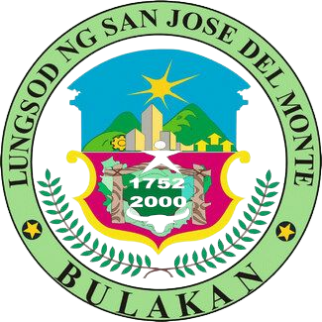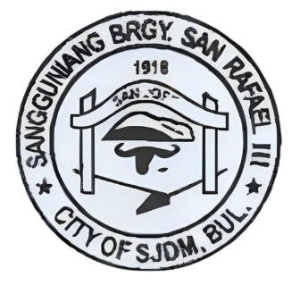REPUBLIC OF THE PHILIPPINES

PROVINCE OF BULACAN

CITY OF SAN JOSE DEL MONTE

BARANGAY SAN RAFAEL III

OFFICE OF THE PUNONG BARANGAY

Email Address: [csjdmsanrafael3@gmail.com](mailto:csjdmsanrafael3@gmail.com)

BARANGAY BUSINESS CLEARANCE

To Whom It May Concern:

This is to certify that undersigned approved herein application of Jericho T. Ogayon, with the address of Blk smth, Barangay San Rafael III, CSJDM, Bulacan for a permit and license to operate/ renew a business.

BUSINESS NAME: BUSINESS ADDRESS:

It is further certified that the subject business is not a nuisance to public safety and order. Moreover, the above name applicant pledge to abide with the existing laws, ordinances, rules and regulations pertaining to said activity.

This is being issue upon request of

_________________ Presentation to Said Permit and Licensing Office of This City prior To The Issuance of Any License or Permit for Said Business/Activity Pursuant to sec 152 Par @ Of the Local Government Code.

Issued this 09th Day of October, 2023

CERTIFIED BY:

_______________

**HON. NORMA B. LLAMOSO**

PUNONG BARANGAY

**NOT VALID W/O DRY SEAL**

SANGGUNIANG BARANGAY

2018-2023

NORMA B. LLAMOSO

Barangay Captain

Barangay Kagawad:

1. HON. ZENAIDA S. DELA CRUZ

Comm. On Finance/ Comm. On Public Works

2. HON. TERESITA C. MERCENE

Comm. On Health & Solid Waste

3. HON. SHIRLEY C. ESPINA

Comm. On Livelihood

4. HON. CELSO O. BAGSIK III

Comm. On Peace and Order

5. HON. RENER S. CABALES

Comm. On Education & Beautification

6. HON. MOISES D. CUACOYES

Comm. On Social Services

7. HON. AUDIE DETOMAL

Comm. On Sports & Youth Development

8. HON. JOMARIE SANTOMIN

Sk Chairman