

EduFit: Tutor and Student Connection System
Final Release Document

– Da Nang, Fall26 –

Record of changeS
Date | A*  M, D | In charge | Change Description
13/11/2026 | A | Trần Minh Hiếu (Leader) | Created the Final Release Document skeleton from the template: cover page, record of changes, table of contents and section headings.
13/11/2026 | M | Trần Minh Hiếu (Leader) & SE Team | Completed Deliverable Package, Installation Guides (9 sections), and full User Manual (10 workflows, 28 subsections) aligned with system implementation.
*A - Added M - Modified D - Deleted

Table of Contents
I. Deliverable Package
II. Installation Guides
1. System Requirements
2. Deployment Architecture
3. Environment Configuration
4. Installation with Docker Compose
5. Installation for Local Development
6. Database Initialization and Demo Data
7. Third-party Integrations
8. Cloud Deployment
9. Installation Verification and Troubleshooting
III. User Manual
1. Overview
2. Account, Profile and Onboarding
3. Tutor Verification
4. Tutor Discovery and Matching
5. Connection and Parent-Student Link
6. Scheduling and Sessions
7. Learning Plan and Progress Tracking
8. Payment and Wallet
9. Review and Notification
10. System Administration

Deliverable Package
The deliverables included in this final release package represent the complete, production-ready source code, database migration assets, specification artifacts, and automated verification suites of the EduFit platform.
No. | File | Notes
1 | G1-EDUFIT_SourceCode_v1.0.0.zip | Full backend modules (Java 21, Spring Boot), frontend (Next.js 16), Docker Compose, configuration files.
2 | G1-EDUFIT_DatabaseScripts_v1.0.0.sql | Flyway migration scripts V1.01-V1.34 and demo journey seed data.
3 | G1-EDUFIT_SRS_Final_v1.0.docx | Final Software Requirement Specification document.
4 | G1-EDUFIT_SDS_Final_v1.0.docx | Final Software Design Specification document.
5 | G1-EDUFIT_Product_Backlog.xlsx | Final status of all epics, user stories, and acceptance criteria.
6 | G1-EDUFIT_Issues_Report.xlsx | Project issue, bug, and defect tracking log across all sprints.
7 | G1-EDUFIT_Master_Test_Plan_and_Report.pdf | Test cases, 979 frontend Vitest results, backend JUnit/Testcontainers results, ArchUnit architecture report.
Package files follow the standard naming convention: [GroupCode]-[ProjectCode]_[Artifact]_[Version], where GroupCode is G1 and ProjectCode is EDUFIT.
Other related deliverables:
Tagged source code: https://github.com/SWT301EDUFIT/EduFit/releases/tag/v1.0.0-final
Demonstration: Live system inspection and automated verification suites (979 frontend unit/integration tests and backend multi-module test suites verified).

Installation Guides
This guide provides comprehensive instructions for deploying and running EduFit across containerized environments (Docker Compose), local development setups, and cloud hosting.

System Requirements
EduFit is engineered to run in both containerized environments (via Docker Compose) and bare-metal local development environments. The host machine must satisfy the following minimum and recommended requirements:
• Hardware Specifications: Minimum 4 CPU cores, 8 GB RAM (16 GB recommended when running Docker Compose with backend, frontend, PostgreSQL, and Mailpit simultaneously), and at least 15 GB free disk space.
• Operating System: Cross-platform compatibility: Windows 10/11 (with WSL2 enabled for optimal Docker performance), macOS 12+ (Apple Silicon or Intel), or Linux (Ubuntu 22.04 LTS or newer).
• Backend Runtimes: Java Development Kit (OpenJDK) version 21 LTS (or newer) and Apache Maven 3.9+ (Maven Wrapper ./mvnw is pre-configured in the repository).
• Frontend Runtimes: Node.js version 20 LTS (or newer) and npm version 10+.
• Container Engine: Docker Engine version 24.0+ and Docker Compose v2.20+ (included in Docker Desktop).
• Required Open Network Ports: Port 3000 (Frontend Next.js), Port 8080 (Backend Spring Boot API), Port 5432 (PostgreSQL database), Port 8025 (Mailpit Web UI), and Port 1025 (Mailpit SMTP server).

Deployment Architecture
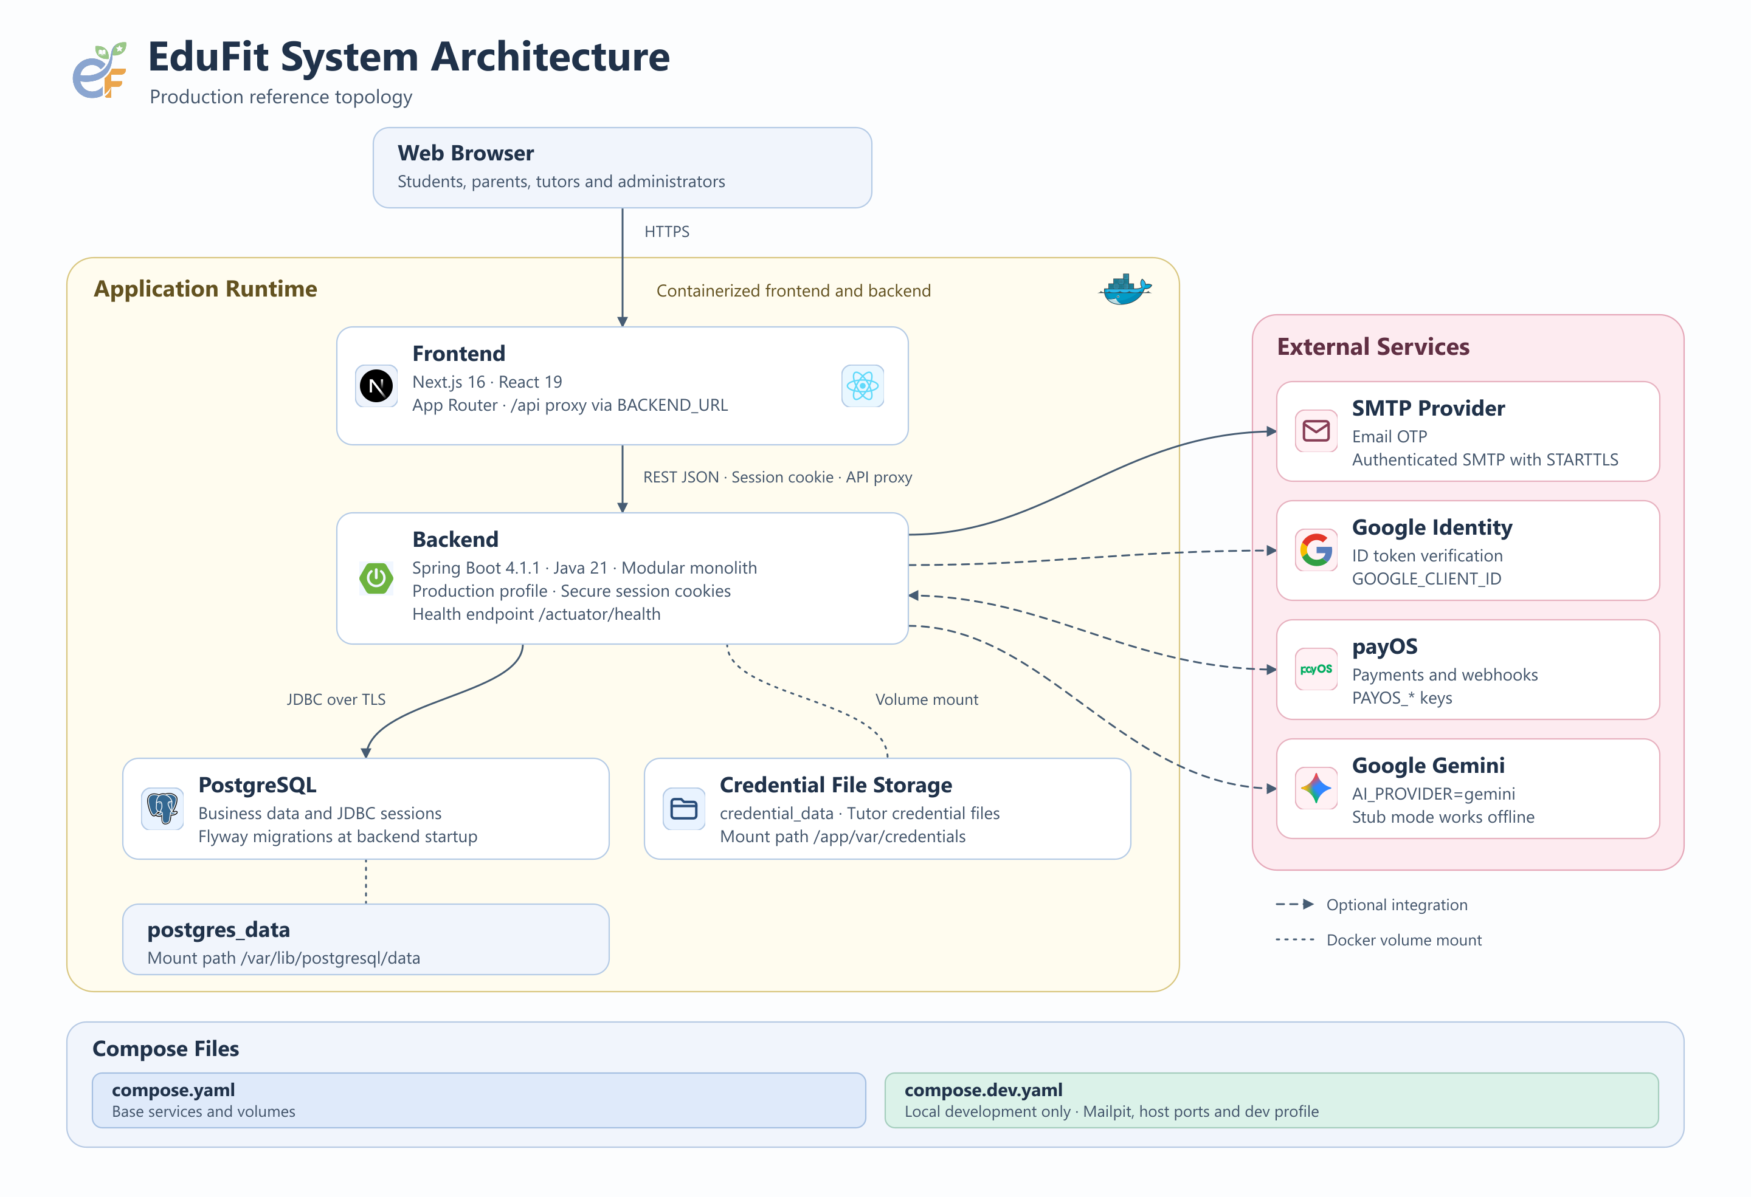
Figure 1. Docker Compose deployment of EduFit (nginx, frontend, backend, PostgreSQL, Mailpit)
As illustrated in Figure 1, the EduFit system architecture follows a clean multi-tier containerized topology:
• Presentation Layer (Frontend): Next.js 16 (React 19, TypeScript, Tailwind CSS v4) operating under the App Router paradigm. It provides server-side rendering for landing/public pages and responsive client workspaces for interactive portals. API requests are routed securely via an internal reverse proxy mechanism to prevent CORS complications.
• Application Core Layer (Backend): Spring Boot 4.1.1 built on Java 21, organized as a strict Modular Monolith. The application isolates business domains (IAM, Profile, Verification, Discovery, Connection, Scheduling, Progress, Payment, Review, Notification) behind clear facade interfaces, enforced at build time via ArchUnit.
• Data Persistence Layer: PostgreSQL 17 database storing all transactional records, state machine progressions, and schema migrations managed deterministically via Flyway. Tutor credentials and verification documents are managed via an abstracted storage volume (/var/credentials).
• External Integrations: Google Identity Services (OAuth2 Sign-In token verification), payOS Payment Gateway (secure QR payment links and authenticated webhook reconciliation), Google Gemini 4 Argon / 2.5 Pro (grounded tutor matching recommendations and automated profile drafting), and SMTP/Mailpit (transactional email and 6-digit OTP dispatch).

Environment Configuration
The platform utilizes environment variables for all operational configurations. An .env.example file is provided in the project root. The primary configuration parameters include:
• Database Settings: POSTGRES_DB=edufit, POSTGRES_USER=edufit, POSTGRES_PASSWORD=edufit_secret, SPRING_DATASOURCE_URL=jdbc:postgresql://postgres:5432/edufit.
• Profile & Security: SPRING_PROFILES_ACTIVE=dev (enables full demo seeds and verbose logging) or prod. Session management utilizes HTTP-only secure cookie EDUFIT_SESSION with 60-minute inactivity timeout.
• Google OAuth2: GOOGLE_CLIENT_ID and GOOGLE_CLIENT_SECRET for OAuth2 authentication.
• payOS Payment Gateway: PAYOS_CLIENT_ID, PAYOS_API_KEY, and PAYOS_CHECKSUM_KEY for cryptographic transaction signing and webhook verification.
• AI Integration: GEMINI_API_KEY for powering Gemini LLM intelligent match reasoning and automated bio generation.
• SMTP / Mail Delivery: SMTP_HOST=mailpit, SMTP_PORT=1025 for local development, or authenticated production SMTP providers.
• Frontend URL: NEXT_PUBLIC_API_URL=http://localhost:8080/api and NEXT_PUBLIC_ENABLE_DEMO_LOGIN=true.

Installation with Docker Compose
The fastest and most reliable way to spin up the entire EduFit ecosystem is via Docker Compose:
Step 1: Clone Repository: git clone https://github.com/SWT301EDUFIT/EduFit.git && cd EduFit
Step 2: Prepare Environment File: Copy the template environment configuration: cp .env.example .env (adjust API credentials if external services are tested live).
Step 3: Launch Containers: Execute the compose orchestration command: docker compose up --build -d
Step 4: Verify Running Services: Access the application endpoints once containers reach healthy status:
- Frontend Portal: http://localhost:3000
- Backend API Health: http://localhost:8080/actuator/health
- Interactive Swagger API Documentation: http://localhost:8080/swagger-ui.html
- Mailpit Email Inbox (OTP & Notifications): http://localhost:8025

Installation for Local Development

Database and Mail Server
Start only the infrastructure services (PostgreSQL 17 and Mailpit) using the specialized dev compose profile:
Command: docker compose -f compose.dev.yaml up -d postgres mailpit
This exposes PostgreSQL on host port 5432 and Mailpit Web UI on port 8025 while keeping backend and frontend on bare metal for rapid hot-reloading.

Backend (Spring Boot)
Run the Spring Boot application using the pre-configured Maven Wrapper:
Step 1: Navigate to backend: cd backend
Step 2: Run Spring Boot Dev Profile: ./mvnw spring-boot:run -Dspring-boot.run.profiles=dev (Windows: .\mvnw.cmd spring-boot:run -Dspring-boot.run.profiles=dev)
The backend will automatically apply all Flyway migrations (V1.01 through V1.34) and seed the complete demo scenario.

Frontend (Next.js)
Run the Next.js frontend development server:
Step 1: Navigate to frontend: cd frontend
Step 2: Install dependencies: npm install
Step 3: Start development server: npm run dev
Open http://localhost:3000 to interact with the web application.

Database Initialization and Demo Data
EduFit enforces schema versioning through Flyway migrations located in backend/app/src/main/resources/db/migration. On clean launch with the dev profile, migration V1.34 seeds a complete realistic ecosystem:
• Seed Dataset Scope: 100 verified tutors with diverse subjects and teaching levels, 80 students with personalized learning needs, 40 parents with active family link relationships, 3 active tutoring classes, scheduled and completed sessions across various state machine lifecycles, and escrow payment histories.
• Demo Credentials: All pre-seeded demo accounts share the uniform testing password: Password123@
• Student Demo: student.demo@edufit.vn (Trần Minh Anh) - Has active learning needs, class connections, and upcoming session calendar.
• Tutor Demo: tutor.demo@edufit.vn (Nguyễn Hoàng Lan) - Fully verified KYC tutor with offerings, teaching schedules, and pending connection requests.
• Parent Demo: parent.demo@edufit.vn (Trần Văn Hưng) - Linked parent account with pre-funded wallet balance for escrow settlements.
• Administrator Demo: admin.demo@edufit.vn (Quản Trị Viên EduFit) - Full administrative privileges for KYC verification queue, dispute resolution, and audit log inspection.

Third-party Integrations

Google Sign-In
Google Identity Services is implemented via Google OAuth 2.0. In Google Cloud Console, configure an OAuth 2.0 Client ID with Authorized redirect URIs set to http://localhost:8080/login/oauth2/code/google and Authorized JavaScript origins set to http://localhost:3000. Set GOOGLE_CLIENT_ID and GOOGLE_CLIENT_SECRET in .env.

payOS Payment Gateway
payOS provides domestic VietQR automated payment reconciliation. In the payOS Dashboard, obtain the Client ID, API Key, and Checksum Key. Configure the Webhook URL pointing to http://<your-host>:8080/api/payments/webhook. The platform cryptographically verifies the SHA256 checksum on all incoming webhook payloads before executing state transitions.

Google Gemini AI
Gemini AI (Google AI Studio) powers contextual AI matching explanations and automated tutor profile bio drafting. Provide a valid GEMINI_API_KEY in .env. If the key is omitted or external API quotas are exceeded, the backend gracefully activates a built-in deterministic heuristic fallback mechanism without disrupting user flow.

SMTP Email
Transactional emails and 6-digit OTP codes are delivered via standard SMTP. For local testing, Mailpit captures all outbound emails without forwarding to external servers (viewable at http://localhost:8025). In production, set SMTP_HOST, SMTP_PORT, SMTP_USERNAME, and SMTP_PASSWORD to a live mail provider (e.g., SendGrid, Gmail SMTP).

Cloud Deployment
EduFit is pre-configured for automated cloud deployment on Render.com via the root render.yaml blueprint:
• Backend Service: Deployed as a containerized Docker Web Service running the production profile with JDBC connection pooling and secure HTTP cookies.
• Database: Managed PostgreSQL 17 instance with automated daily snapshots and SSL encryption.
• Frontend Service: Node.js Web Service running Next.js standalone output with edge CDN caching.

Installation Verification and Troubleshooting
To verify that the installation succeeded, execute the following diagnostic checks:
1. Health Endpoint: curl http://localhost:8080/actuator/health returns {"status":"UP"}.
2. Database Tables: docker compose exec postgres psql -U edufit -d edufit -c "\dt" confirms that all 25 core tables have been created by Flyway.
3. Frontend Render: Navigate to http://localhost:3000 and confirm that the landing page renders with zero console errors.
Common Troubleshooting Scenarios:
• Port Conflict (5432 already in use): A local PostgreSQL service is already active on the host. Stop it via 'sudo service postgresql stop' or change the host port mapping in compose.yaml.
• Flyway Migration Checksum Mismatch: Occurs if migration scripts were altered after initial run. Execute 'docker compose down -v' to purge the volume and restart clean.
• Next.js Missing Dependencies: Run 'npm install' inside the frontend directory if packages like motion or lottie-web report missing declarations.

User Manual
This user manual provides step-by-step guidance for all four user roles (Student, Parent, Tutor, and Administrator) across the 10 core operational workflows of the EduFit platform.

Overview

System Introduction
EduFit is an end-to-end EdTech software-as-a-service platform designed to connect reputable Tutors with Students and Parents. Unlike generic marketplace platforms, EduFit establishes an ecosystem of verified credentials (KYC), intelligent AI-driven matchmaking, strict double-booking prevention, continuous learning plan tracking with milestones, and transparent tuition escrow management.

User Roles and Access
The platform enforces Role-Based Access Control (RBAC) across four distinct roles:
• Student: Creates learning needs, explores verified tutors, runs AI matching, submits connection requests, proposes sessions, and tracks milestone progress.
• Parent: Links to student accounts, initiates tutor matching on behalf of their child, monitors class schedules, funds the family wallet, and releases tuition escrow.
• Tutor: Submits professional credentials for verification, configures subject offerings and teaching rates, manages class rosters, designs personalized learning plans, and withdraws earnings.
• Administrator: Reviews KYC submissions in the verification queue, oversees dispute cases, manages system catalogs (subjects, grade levels, topics), and audits administrative activity logs.

Workflow Map
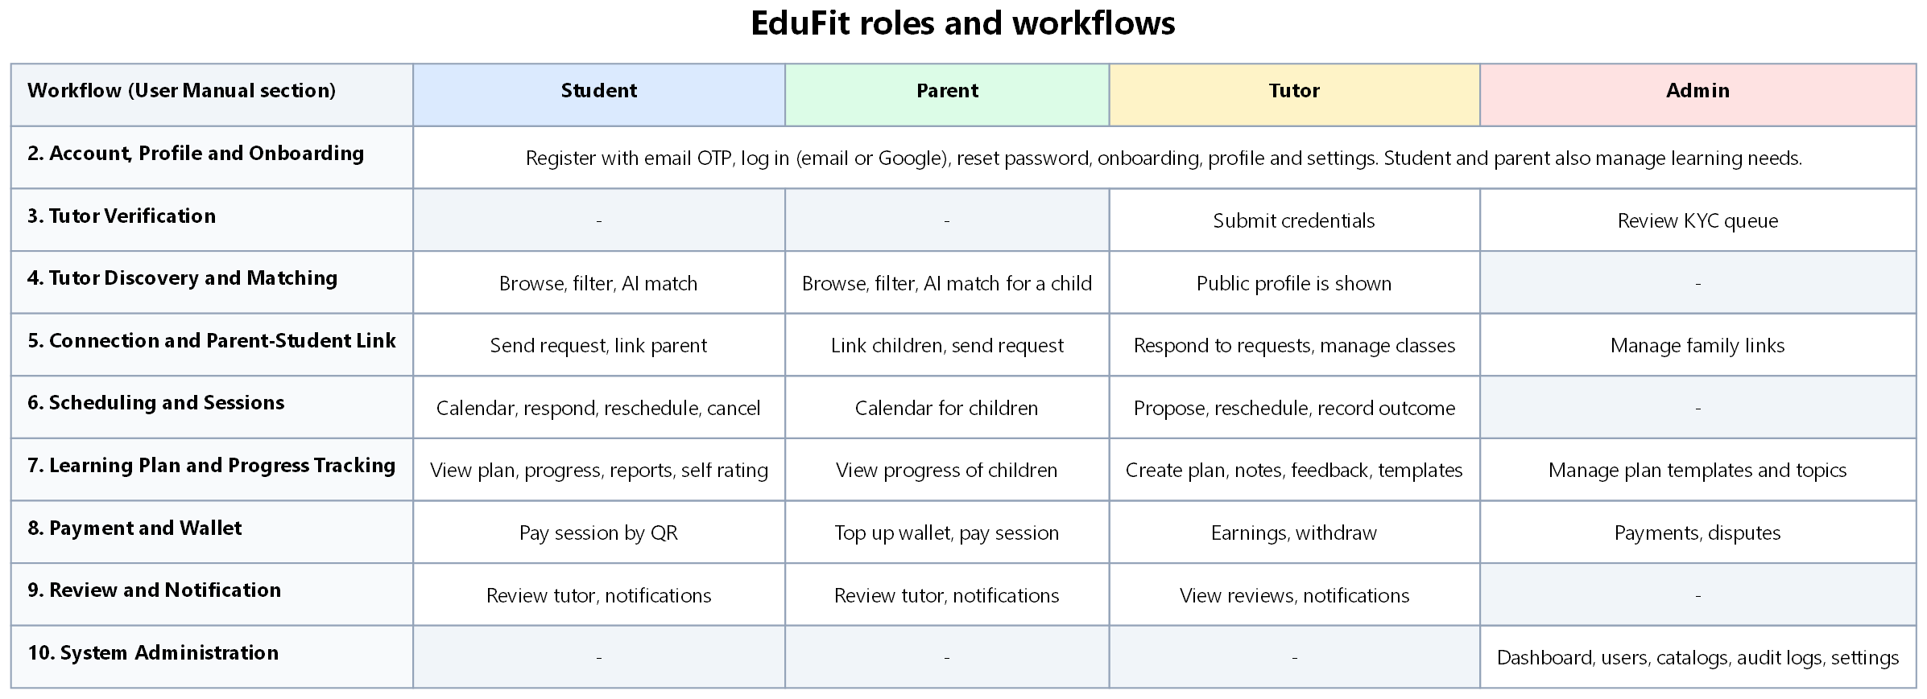
Figure 2. Workflow map: user roles and the main workflows of EduFit
Figure 2 details the cross-cutting workflow matrix of EduFit, illustrating how each role participates across the 10 major business workflows described throughout this manual.

Account, Profile and Onboarding

Register an Account with Email OTP
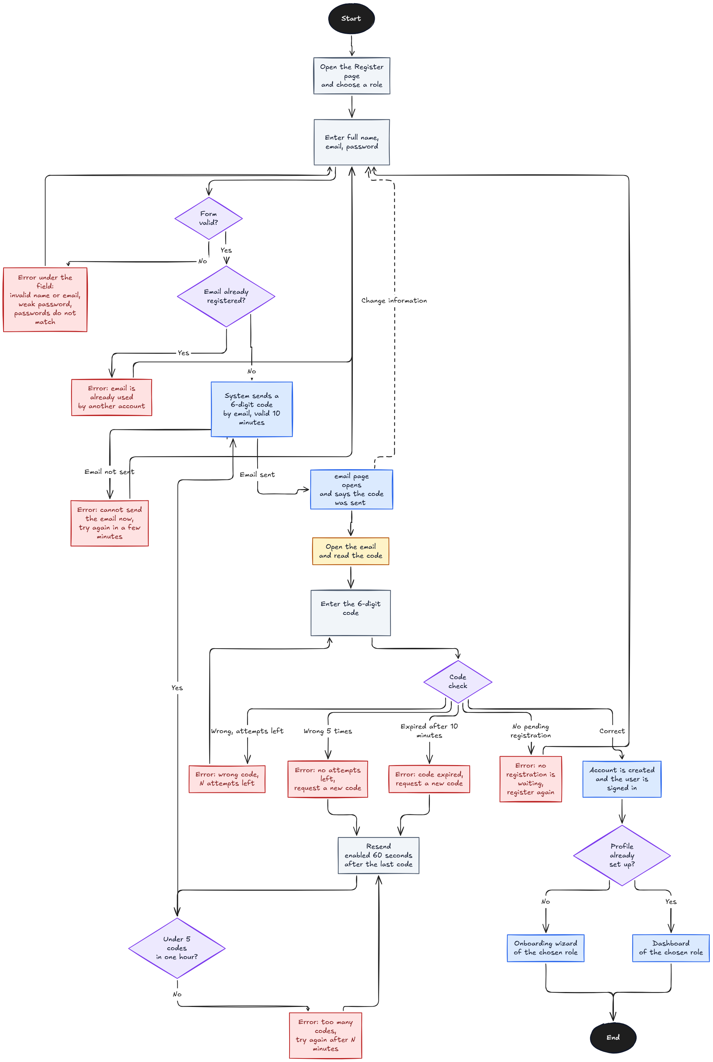
Figure 3. Register an account with email OTP
As modeled in Figure 3, user registration requires two-factor email OTP validation to eliminate fraudulent registrations:
Step 1: Navigate to the Register page (/register) and choose a primary role (Student, Parent, or Tutor).
Step 2: Enter full name, valid email address, and strong password meeting NIST guidelines.
Step 3: The system validates uniqueness and dispatches a 6-digit OTP code (valid for 10 minutes) via email.
Step 4: Enter the 6-digit OTP on the verification screen. Upon successful verification, the account is activated and the user is redirected to the onboarding wizard.

Log In, Log Out and Google Sign-In
Users authenticate using their registered email and password or via Google Sign-In. On successful login, the server establishes an HTTP-only secure cookie session (EDUFIT_SESSION). Logging out invalidates the server-side session immediately. If demo login is enabled, convenient one-click shortcut buttons are available on the login screen.

Reset and Change Password
If a password is forgotten, users click 'Forgot Password' on the login screen, enter their email to receive a 6-digit OTP, verify the OTP, and define a new secure password. Active users can change their password anytime within Account Settings.

Complete Onboarding (Student, Parent, Tutor)
New accounts must complete role-tailored onboarding wizards: Students specify their grade level and target subjects; Parents configure family child profiles; Tutors enter educational background, years of experience, and hourly rates before accessing the main dashboard.

Manage Profile, Avatar and Settings
Users can update their personal information, upload an avatar (image formats sanitized with MIME-type inspection), manage notification preferences (email/push toggles), and configure security parameters.

Manage Learning Needs (Student, Parent)
Students or linked Parents define Learning Needs by specifying the target subject, education level (Grades 1-12, University), learning goals, budget constraints, and weekly availability slots (Mon-Sun, morning/afternoon/evening). These structured needs serve as inputs to the AI Smart Match engine.

Tutor Verification

Submit Credentials (Tutor)
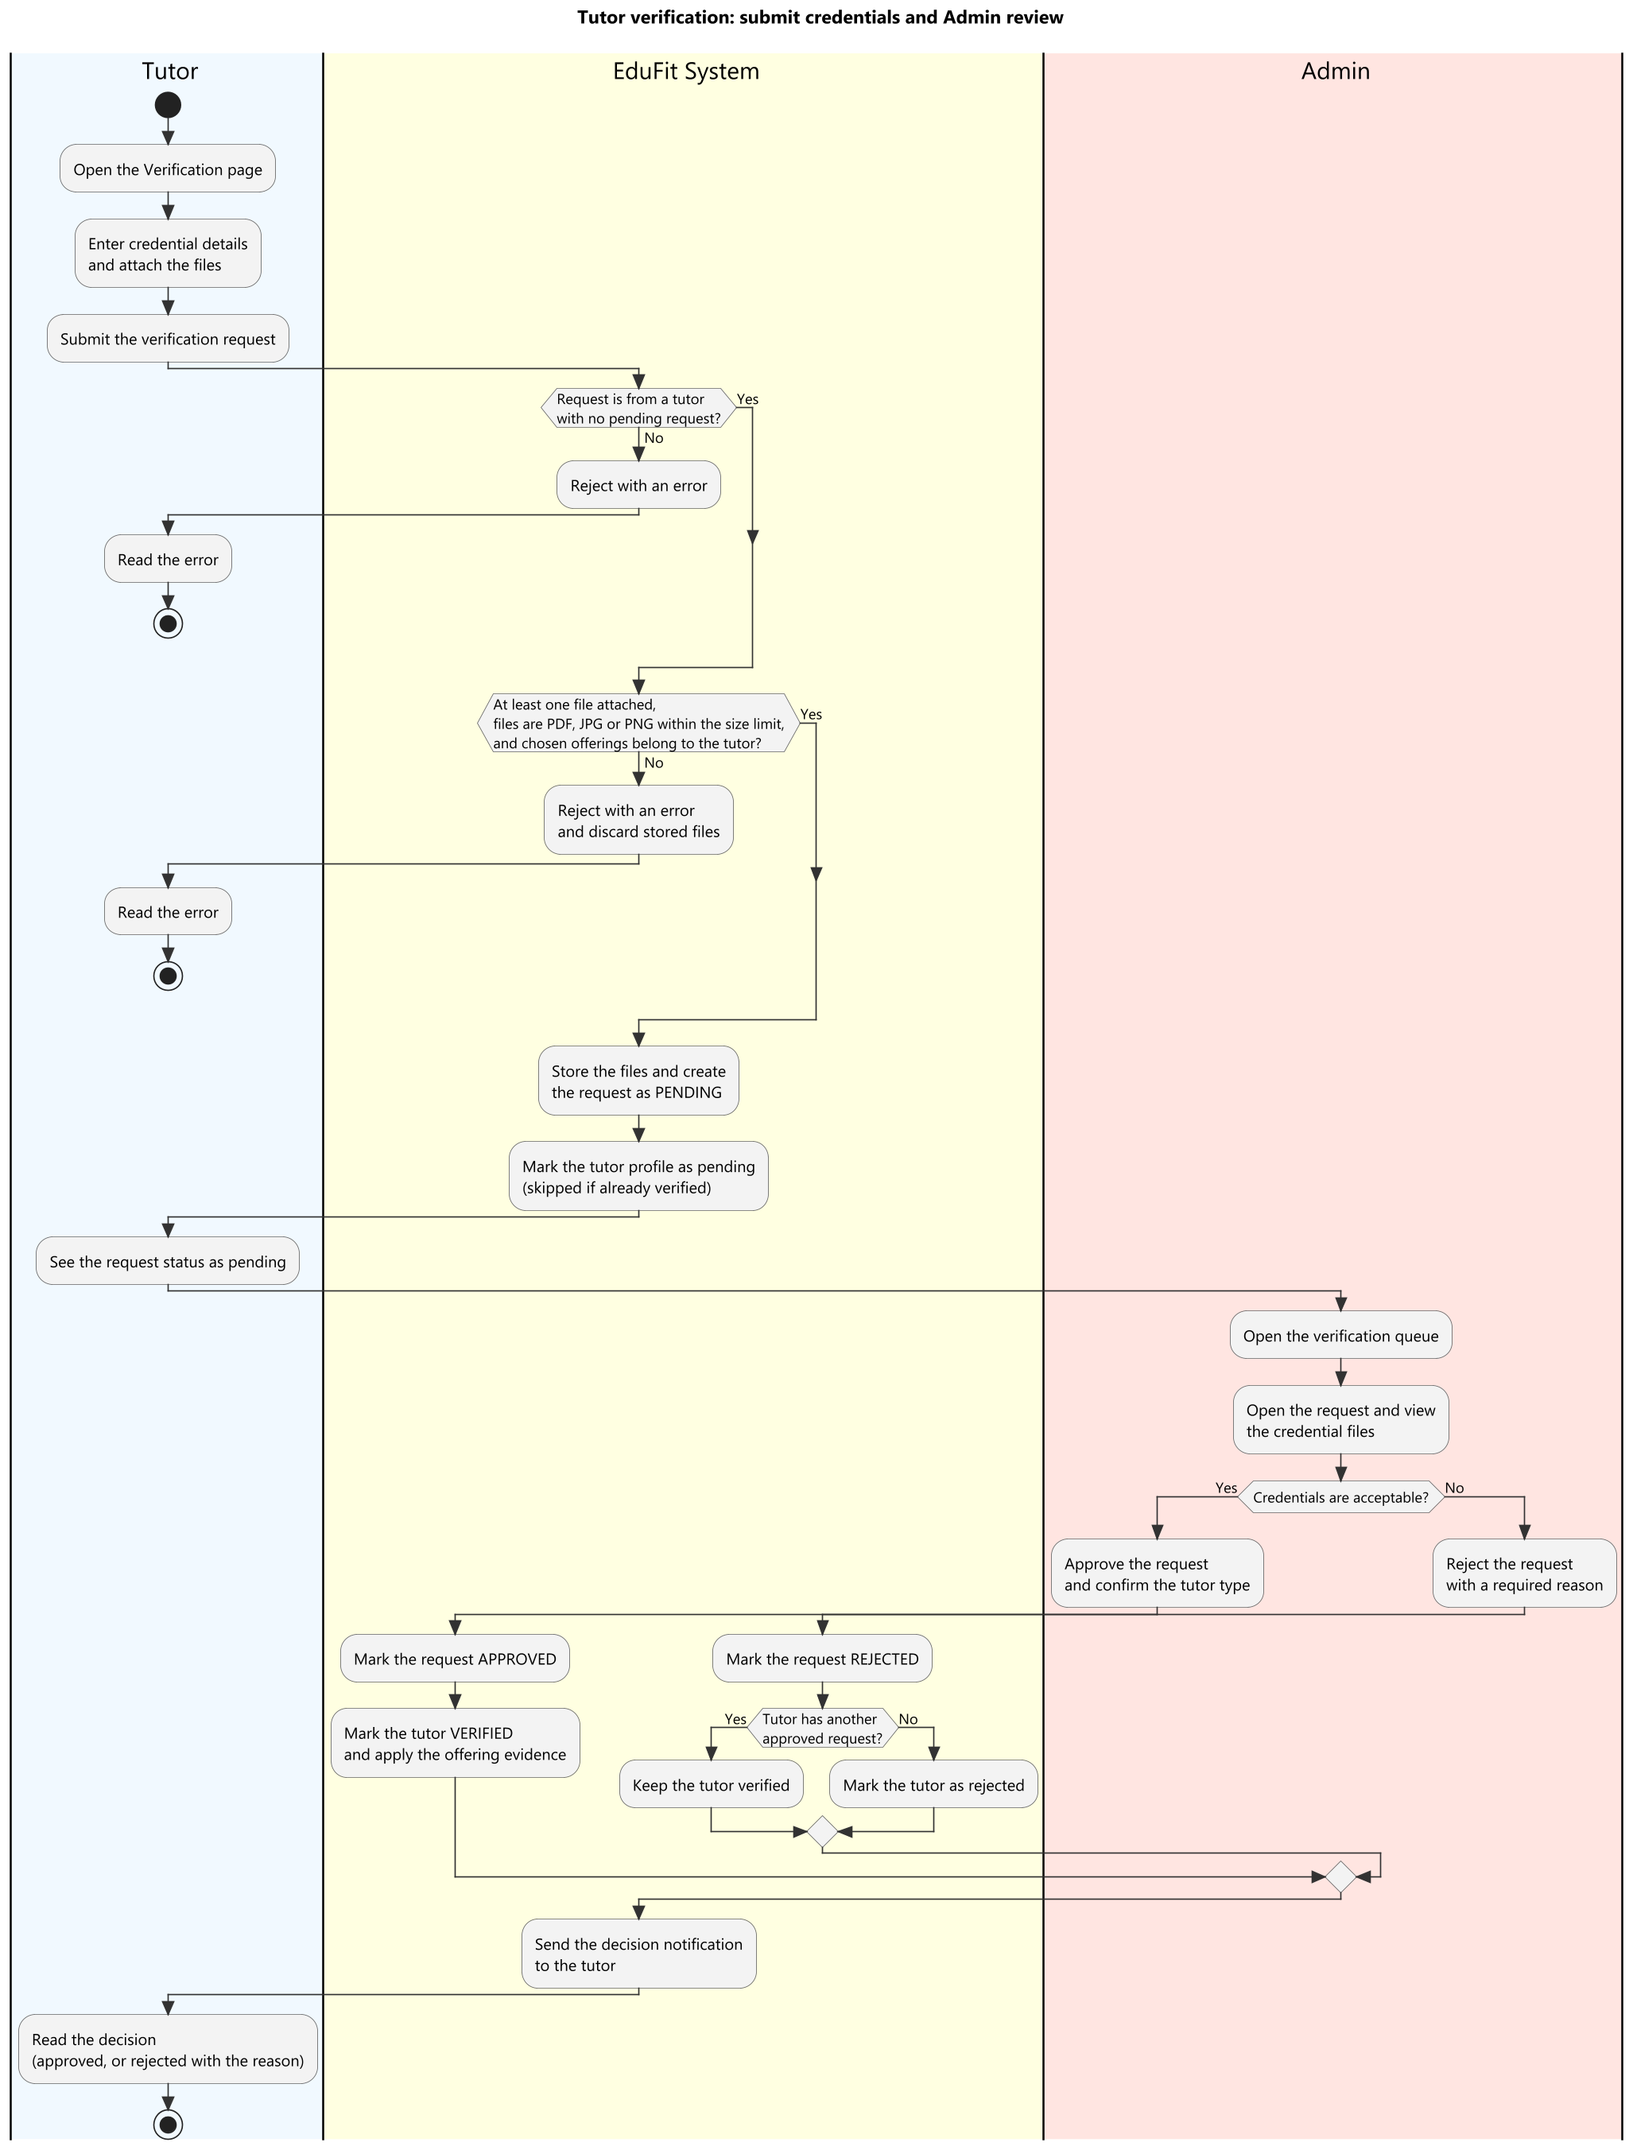
Figure 4. Swimlane: tutor submits credentials and Admin reviews them
Figure 4 details the rigorous Tutor KYC verification workflow required before any tutor profile can appear in public search results:
Tutor Submission: The tutor navigates to /tutor/verification, specifies their academic degree or certification type, and uploads scanned document files (PDF/PNG/JPEG, max 5MB). The platform performs magic bytes inspection to reject disguised binaries.
Admin Review Queue: Administrators access /admin/verification-queue to inspect pending credentials, verify issuing institutions, and either Approve (granting VERIFIED status) or Reject with a mandatory explanatory feedback note.

Review Credentials in the Verification Queue (Admin)

Tutor Discovery and Matching

Browse and Filter Tutors
Learners can browse the public tutor catalog (/tutors) using multi-criteria filters: subject catalog, grade range, hourly tuition slider, minimum star rating, and weekly availability schedules.

View a Tutor Profile
The Tutor Detail Page (/tutors/[id]) displays the tutor's verified badges, academic credentials, biography, teaching philosophy, list of offered subjects with hourly pricing, and verified reviews from past students.

AI Smart Match
EduFit features an advanced hybrid AI Matching algorithm. The engine computes a 5-factor scoring model (Subject match, Grade suitability, Schedule overlap, Tuition budget fit, and Tutor rating), identifies top candidate tutors, and leverages Google Gemini to generate natural-language explanations explaining exactly why each tutor is recommended.

Connection and Parent-Student Link

Send a Connection Request (Student, Parent)
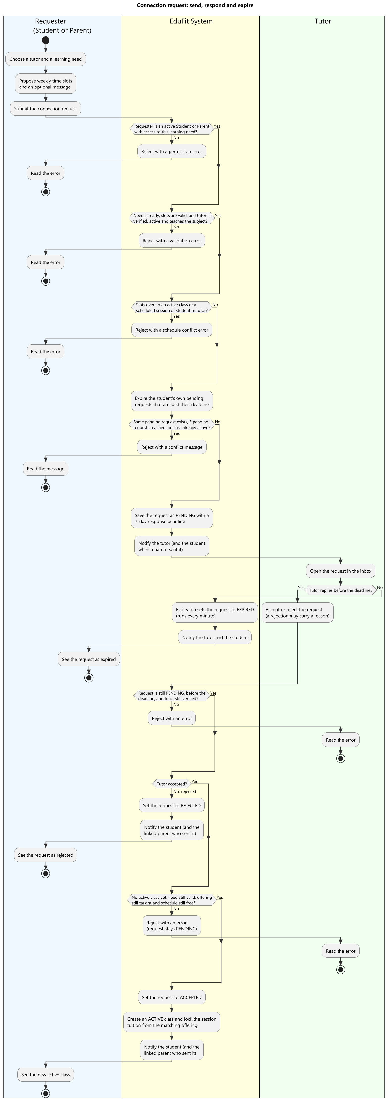
Figure 5. Swimlane: connection request from a student or parent to a tutor
As depicted in Figure 5, the Connection workflow formalizes the agreement between student and tutor:
Sending Request: A student or parent selects a verified tutor, links an existing Learning Need, proposes weekly recurring slots, and submits the request. The request enters PENDING status with a 7-day expiration deadline.
Tutor Acceptance: The tutor reviews incoming requests in their dashboard inbox. Upon clicking Accept, the system verifies schedule availability, locks the agreed hourly tuition, and initializes an ACTIVE tutoring class.

Respond to a Connection Request (Tutor)

Manage Classes

Link a Parent and a Student Account
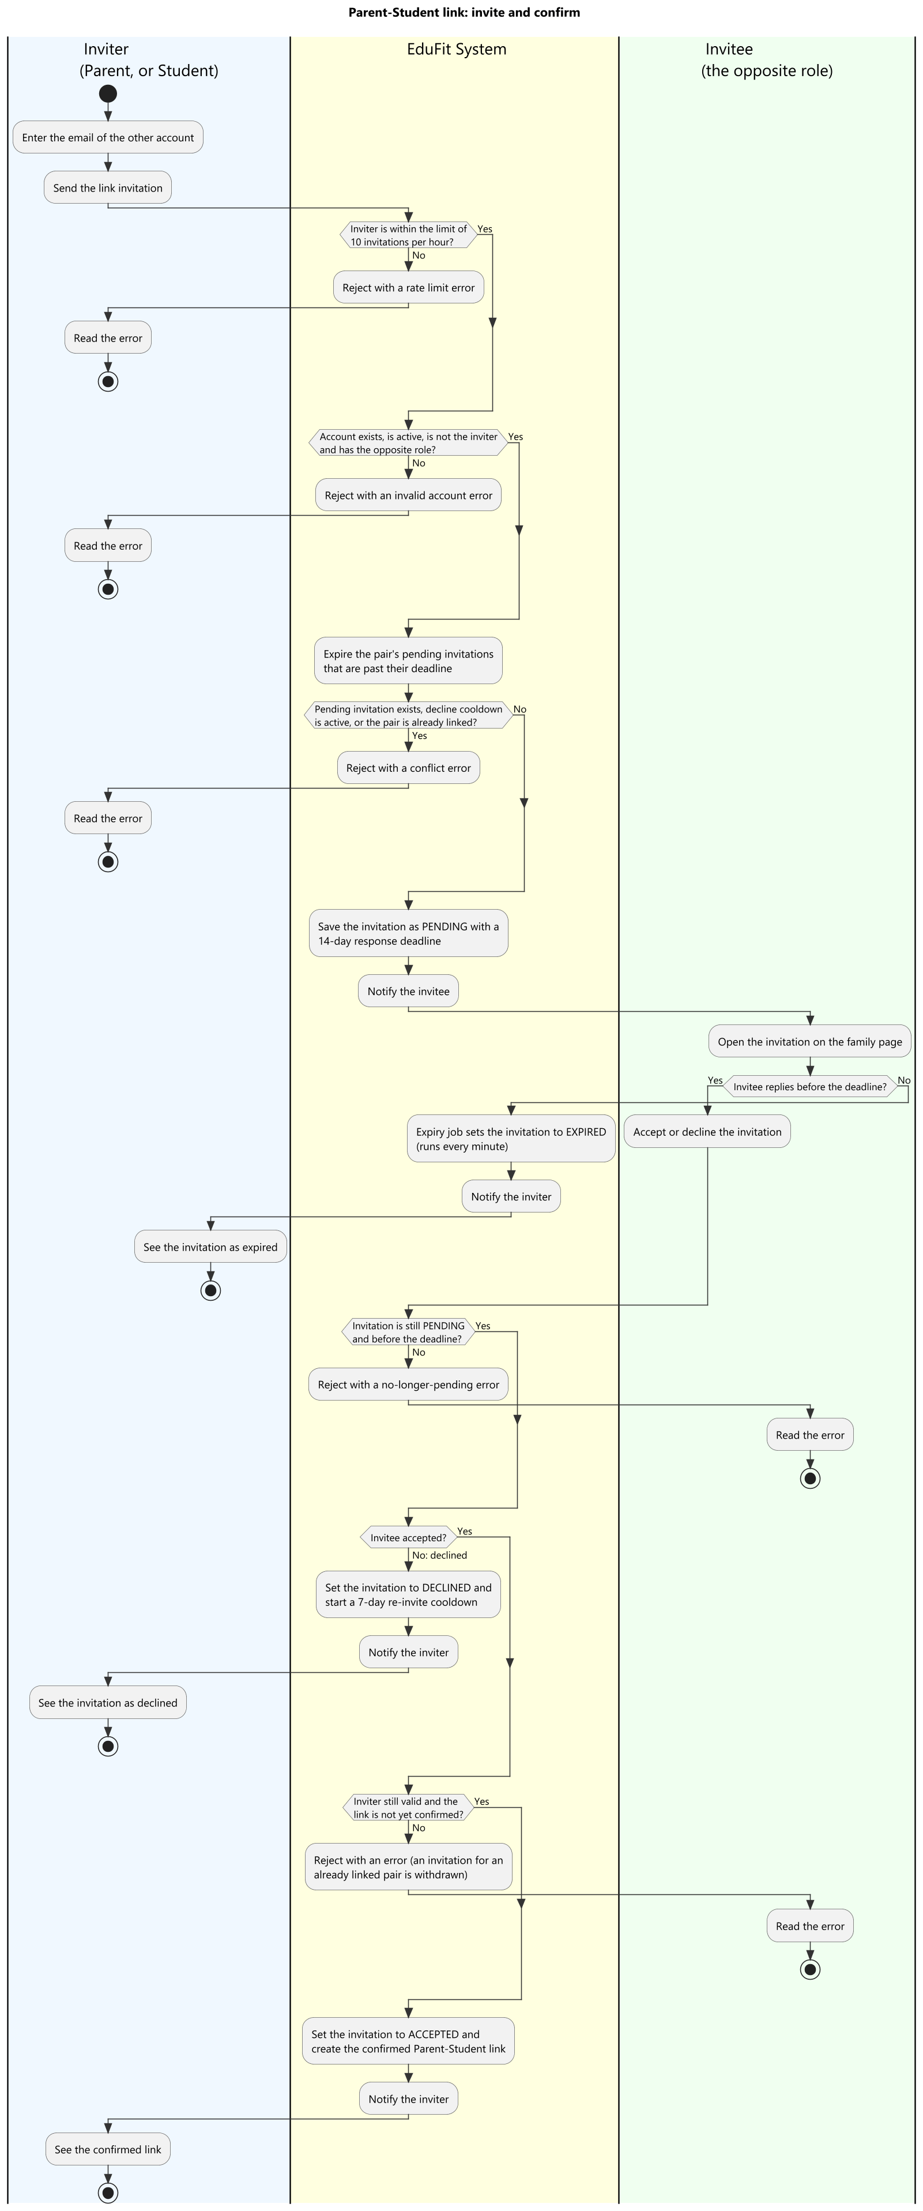
Figure 6. Swimlane: link a parent and a student account by invitation
Figure 6 shows the mutual-consent process for linking Parent and Student accounts:
Initiation: Either party submits the other's registered email address on the Family Linking page (/parent/children or /student/family).
Confirmation: The invited recipient receives a system invitation card and confirms the link. Once active, parents gain supervisory view of learning progress, schedules, and tuition billing.

Scheduling and Sessions

View the Calendar (Week Grid and Timeline)
The Scheduling view (/schedule) presents an interactive weekly calendar grid and chronological timeline. It displays all scheduled sessions, color-coded by class and status, with automated double-booking prevention ensuring no participant has overlapping sessions.

Propose and Respond to a Session
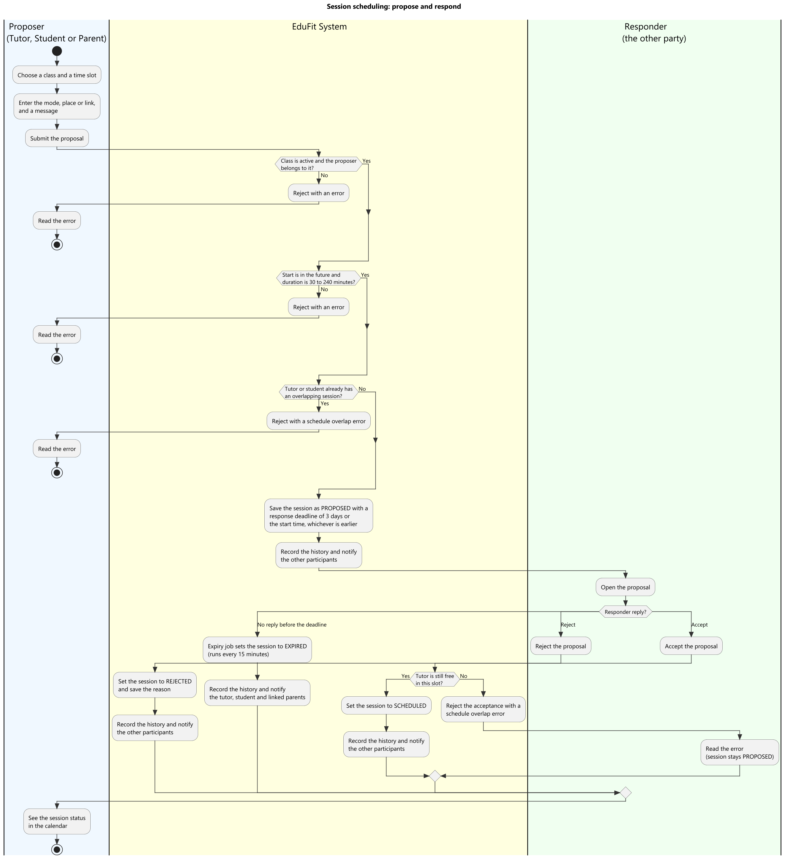
Figure 7. Swimlane: propose a session and respond to the proposal
Figure 7 illustrates the session booking workflow. A tutor, student, or parent proposes an individual session within an active class. The counterparty receives a notification and accepts or rejects the proposed time slot within 3 days.

Reschedule and Cancel a Session
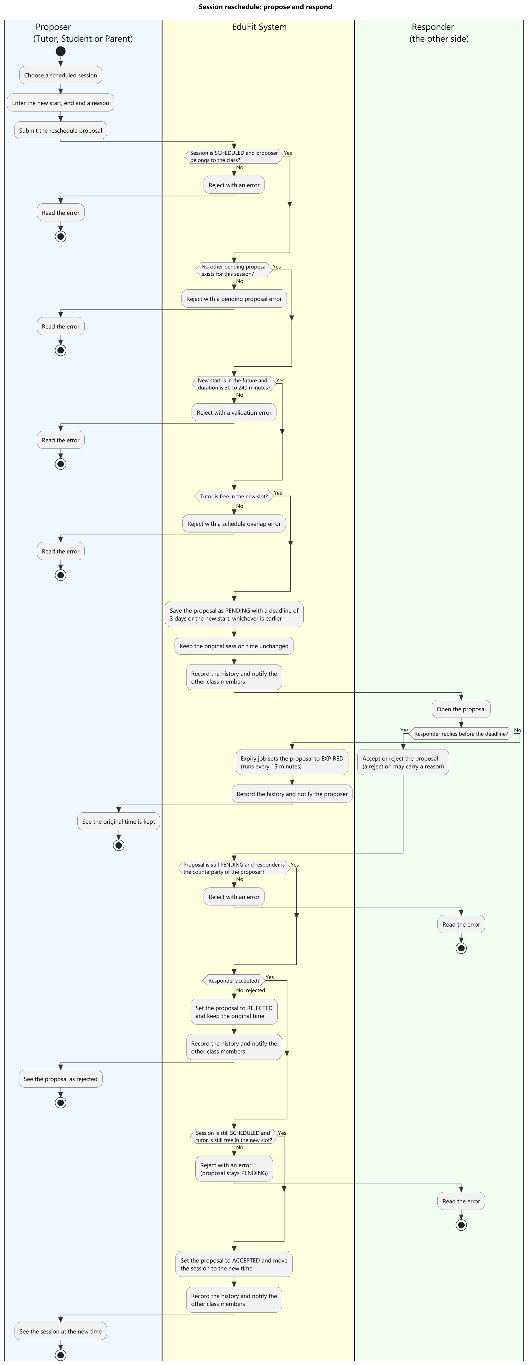
Figure 8. Swimlane: reschedule a session
Figure 8 outlines the Reschedule workflow. Either party can request to reschedule an upcoming session to a new future time slot. The counterparty must accept the proposal before the start time; otherwise, the original session time is preserved.
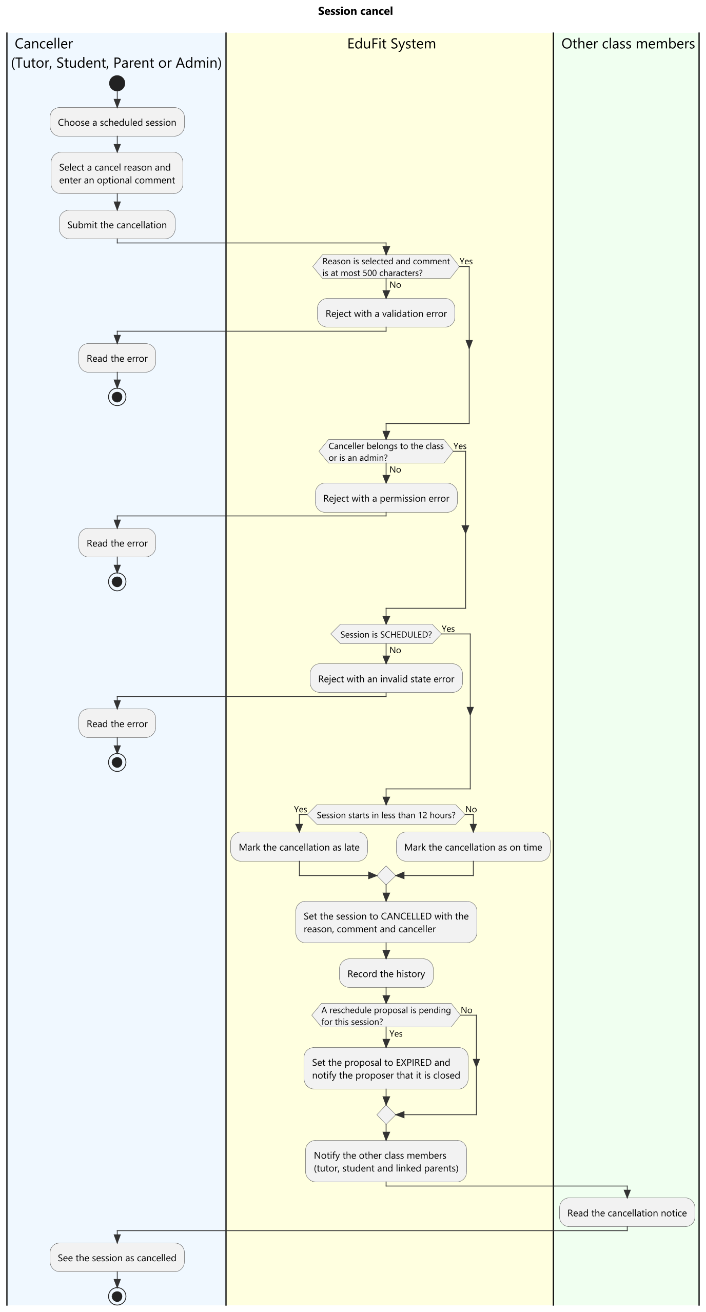
Figure 9. Swimlane: cancel a session
Figure 9 illustrates the session cancellation policy. Sessions can be cancelled by any participant with a mandatory reason note. Cancellations occurring less than 12 hours before scheduled start are flagged as Late Cancellations for policy tracking.

Record a Session Outcome (Tutor)
Following a session, the tutor marks attendance (COMPLETED, STUDENT_ABSENT, or TUTOR_ABSENT), inputs teaching duration, and submits feedback notes. This action initiates the 24-hour payment settlement review window.

Learning Plan and Progress Tracking

Create a Learning Plan with Milestones (Tutor)
Tutors design structured learning plans divided into sequential milestones (e.g., Foundation, Intermediate Mastery, Exam Preparation). Each milestone contains target topics, completion criteria, and estimated hours.

Use Plan Templates and Plan Drafts
To accelerate plan creation, tutors can select standard curriculum templates curated by administrators or utilize AI Plan Drafting to generate a tailored syllabus draft based on the student's learning goals.

Write Session Notes and Feedback

Track Progress on the Dashboard (Student, Parent)
Students and parents monitor academic progression through interactive dashboards featuring milestone completion percentage bars, session history logs, homework submission tracking, and periodic evaluation reports.

View Period Reports

Payment and Wallet

Pay for a Session via payOS QR (Student, Parent)
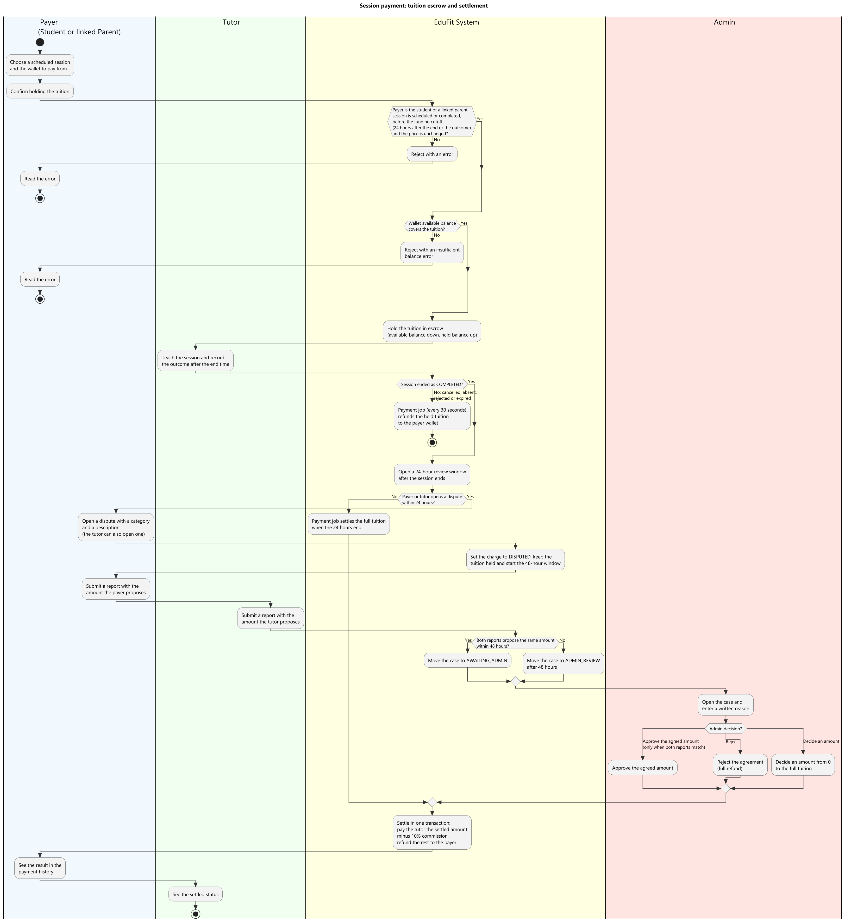
Figure 10. Swimlane: session tuition escrow and settlement
Figure 10 details the secure tuition escrow mechanism protecting both parties:
Escrow Hold: Before or upon session completion, tuition is deducted from the payer's wallet and held in secure system escrow.
Review Window & Settlement: A 24-hour post-session review window opens. If no dispute is filed, the scheduled payment job automatically settles the tuition: 90% is credited to the tutor's available balance and 10% is allocated as platform commission.

Top Up and Check the Wallet (Parent)
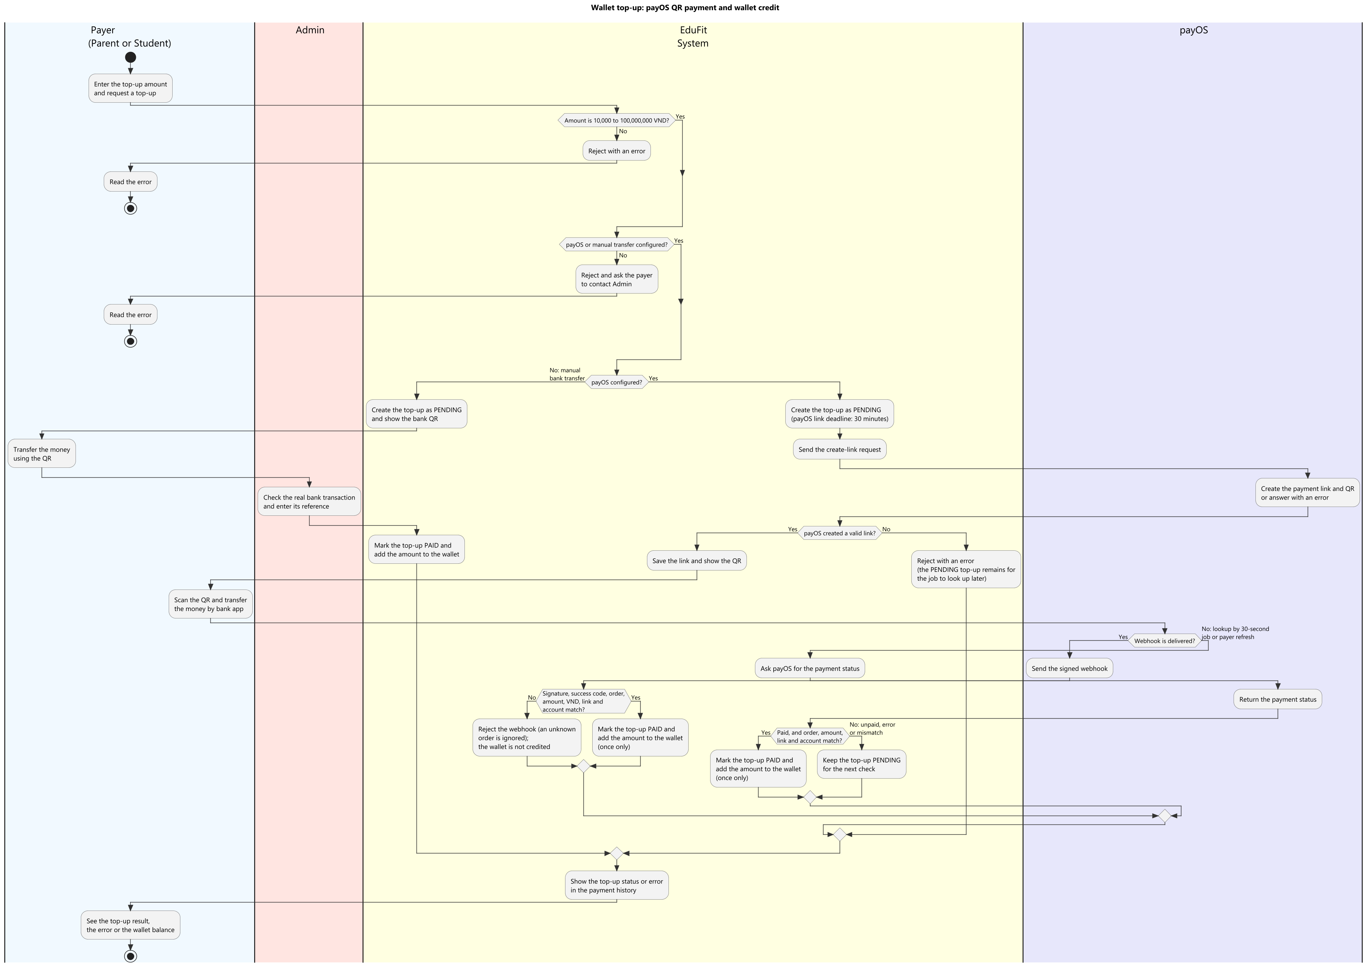
Figure 11. Swimlane: top up the wallet through payOS
Figure 11 shows the instant wallet top-up via payOS. The payer enters an amount (min 10,000 VND), generates a dynamic VietQR payment code, scans with any banking app, and receives instant wallet credit upon cryptographic webhook verification.

View Earnings and Withdraw (Tutor)
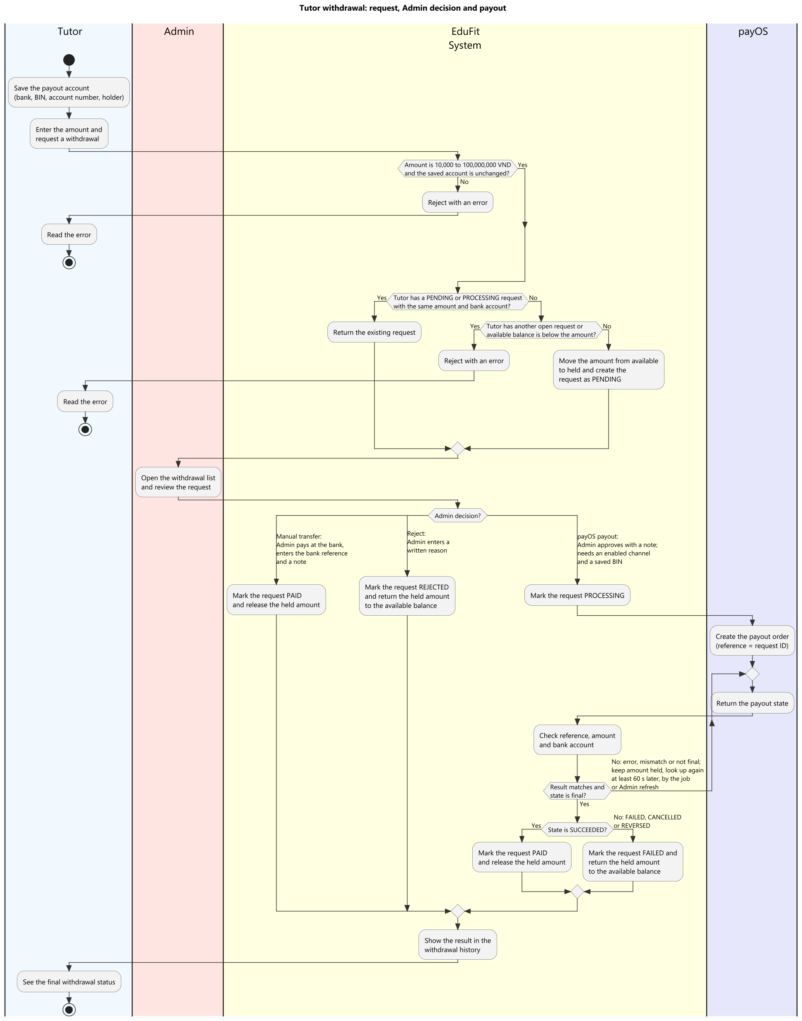
Figure 12. Swimlane: tutor withdraws earnings
Figure 12 details the Tutor Withdrawal process. Tutors save their bank account details and submit a payout request. Administrators review the payout in /admin/payments and confirm bank transfer, releasing the held funds.

Review and Notification

Review a Tutor
Upon completing sessions, students and parents can submit star ratings (1-5 stars) and qualitative feedback comments. Verified reviews are published on the tutor's public profile to assist future learners.

Read Notifications
EduFit delivers real-time notifications for connection requests, schedule proposals, session reminders, payment confirmations, and KYC status updates via an interactive in-app notification center.

System Administration

Admin Dashboard
The Administrator Dashboard (/admin/dashboard) aggregates platform KPIs in real time: Total Users (segmented by role), Active Tutoring Classes, Completed Sessions, and Pending KYC Verification Queue counts.

Manage Users, Tutors, Learners and Family Links

Manage Catalogs, Topics and Plan Templates
Administrators manage the academic foundation of the platform: adding or updating subjects and grade levels (/admin/catalogs), curating standardized topic taxonomies (/admin/topics), and authoring curriculum plan templates (/admin/plan-templates).

Handle Payments and Disputes
In the event of session disputes (e.g., tutor tardiness or student disputes), administrators inspect claims in /admin/disputes, review tutor notes and session timings, and make binding financial settlement decisions (full refund, partial settlement, or tutor release).

View Audit Logs and System Settings
The Audit Logs view (/admin/audit-logs) provides an immutable, paginated trail of all sensitive administrative actions (KYC approvals, user suspensions, dispute arbitrations) for security compliance and traceability.

