Train 100 epochs

|  |  |  |  |  |
| --- | --- | --- | --- | --- |
| Features | Best mAP val | mAP WSI | f2-Score | f2-Score(NMS) |
| WO Normalize && HSV | 0.906 | 0.113 | 0.202 (conf = 0.714) | 0.379 (conf = 0.627) |
| Normalize && HSV | 0.917 | 0.041 | 0.141 (conf = 0.721) | 0.319 (conf = 0.773) |

woNormalize && HSV && NMS F2-Score woNormalize && HSV F2-Score

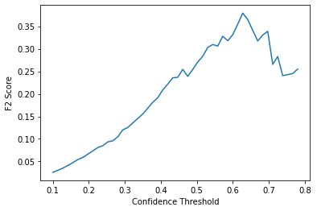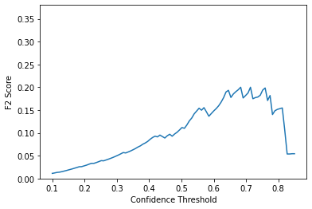

Normalize && HSV && NMS F2-Score Normalize && HSV F2-Score

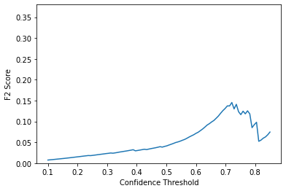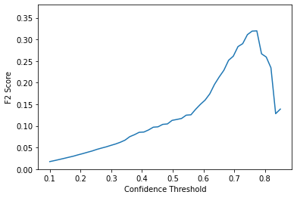

**Data**

Area Ratio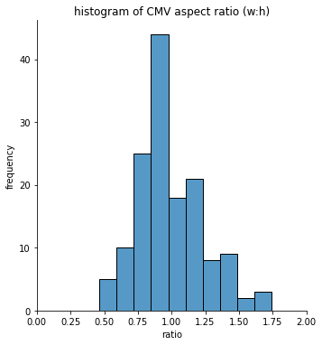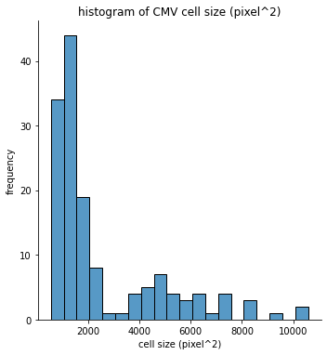

**Validate Data**

Area Ratio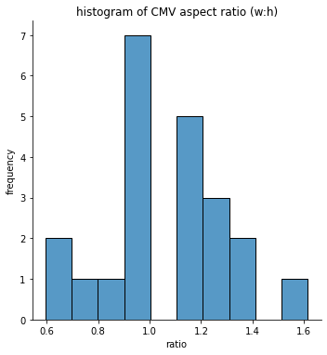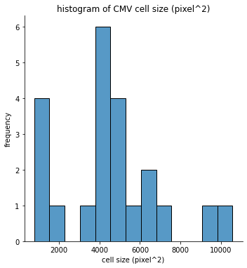

**WO Normalize && HSV (conf = 0.714)**

Area Ratio

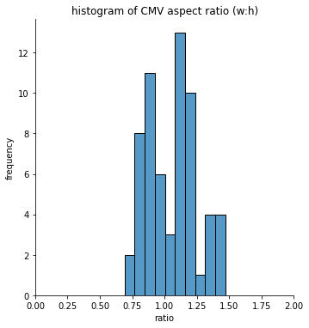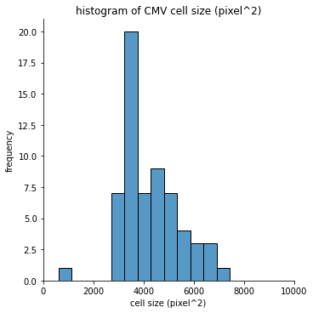

Score: 0.202

Precision: 0.097

Recall: 0.273

**WO Normalize && HSV with NMS(conf = 0.627)**

Area Ratio

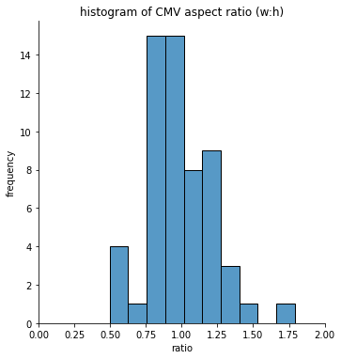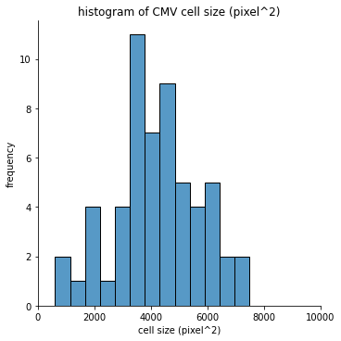

Score: 0.379

Precision: 0.193

Recall: 0.500

**Normalize && HSV(conf = 0.721)**

Area Ratio

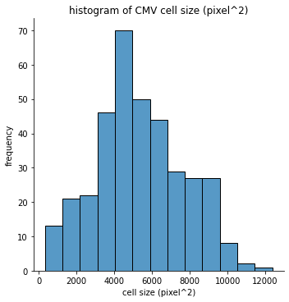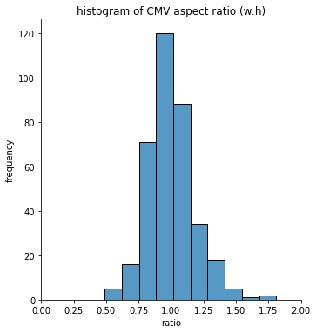

Score: 0.145

Precision: 0.036

Recall: 0.591

**Normalize && HSV with NMS(conf = 0.773)**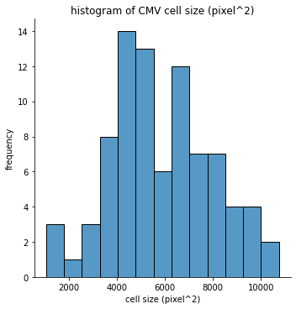

**Area Ratio**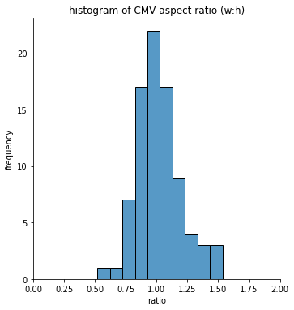

Score: 0.319

Precision: 0.131

Recall: 0.500