College LMS — Frontend Test Plan
Stack: Angular 21 + ASP.NET Core 10 + PostgreSQL + Docker | Browser: Chrome 148 | Environment: Docker Compose (local)
Test Coverage: Authentication · Role-Based Access Control · Progress Dashboard (Innovation) · Deadline Reminders (Innovation) · UX Improvements

Test Cases

ID | Feature | Preconditions | Steps | Expected Result | Actual Result | Evidence
TC01 | Login Form Validation | User on login page. Not logged in. | - Leave Email and Password empty.  - Click Sign in. | Red borders on both fields. 'Email is required' and 'Password is required' messages appear. No navigation. | ✓ PASS | 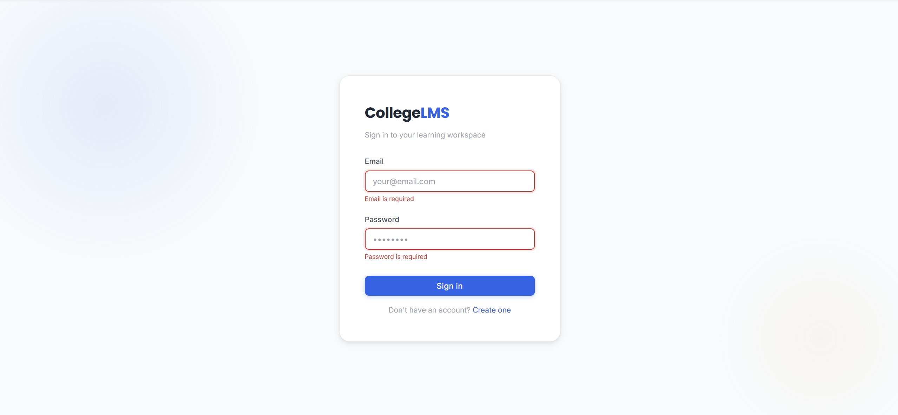
TC02 | Login Invalid Credentials | User on login page. Seeded user: admin@lms.com exists. | - Enter email: admin@lms.com  - Enter password: WrongPass  - Click Sign in. | Error banner 'Invalid credentials. Please try again.' displays. User stays on login page. | ✓ PASS | 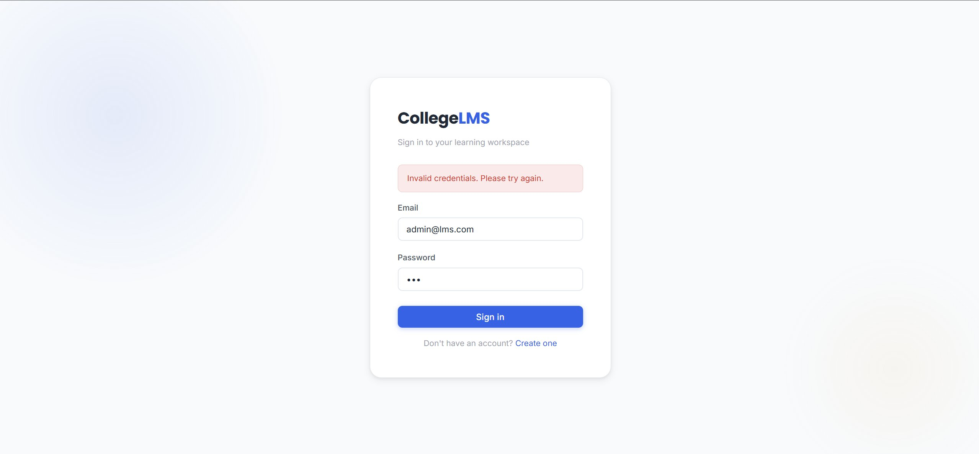
TC03 | Role-Based Navigation | Three accounts: admin@lms.com, instructor@lms.com, student@lms.com. Password: Password123! | - Login as Admin — check sidebar.  - Login as Instructor — check sidebar.  - Login as Student — check sidebar. | Admin: Dashboard, Courses, Attendance, Calendar, Timetable, Notifications, Admin Panel, Users. Instructor: + Assignments, Assessments, Grades. No Admin Panel, no Progress. Student: + Progress. No Attendance, no Admin Panel. | ✓ PASS | Admin: 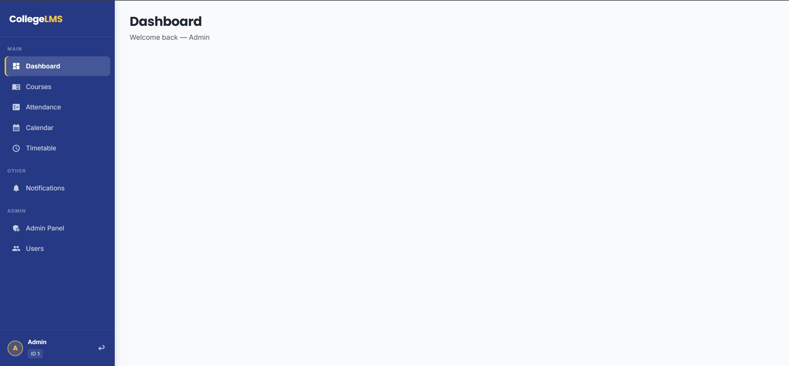  Instructor: 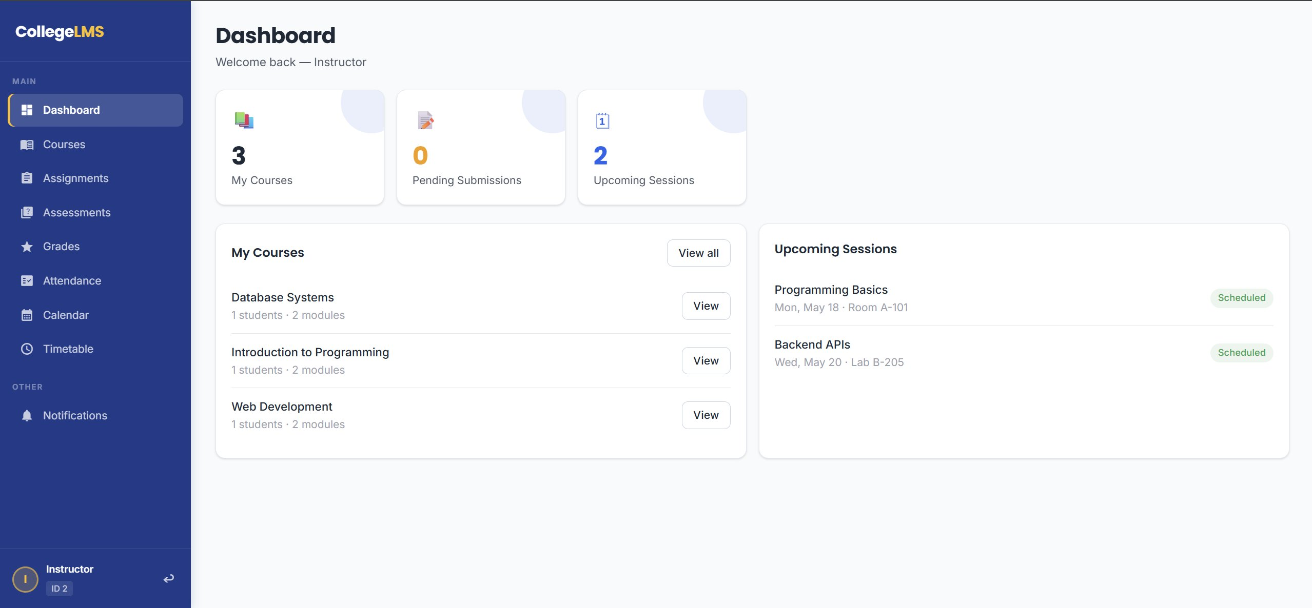  Student: 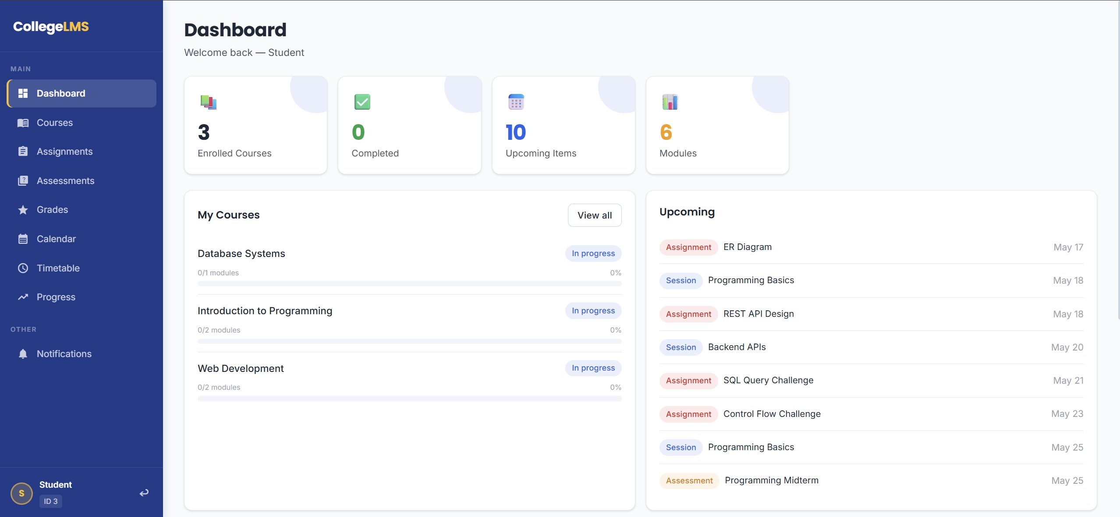
TC04 | Progress Dashboard Charts (Innovation Feature) | Logged in as Student (student@lms.com). Student has submitted assignments and received grades. | - Click Progress in sidebar.  - Observe stat cards.  - Observe Grade Trend chart.  - Observe Submission Rate chart.  - Observe Course Completion bars. | All 4 stat cards show values. Grade Trend line chart renders with data points. Submission Rate doughnut shows %. Course Completion shows progress per course. | ✓ PASS | 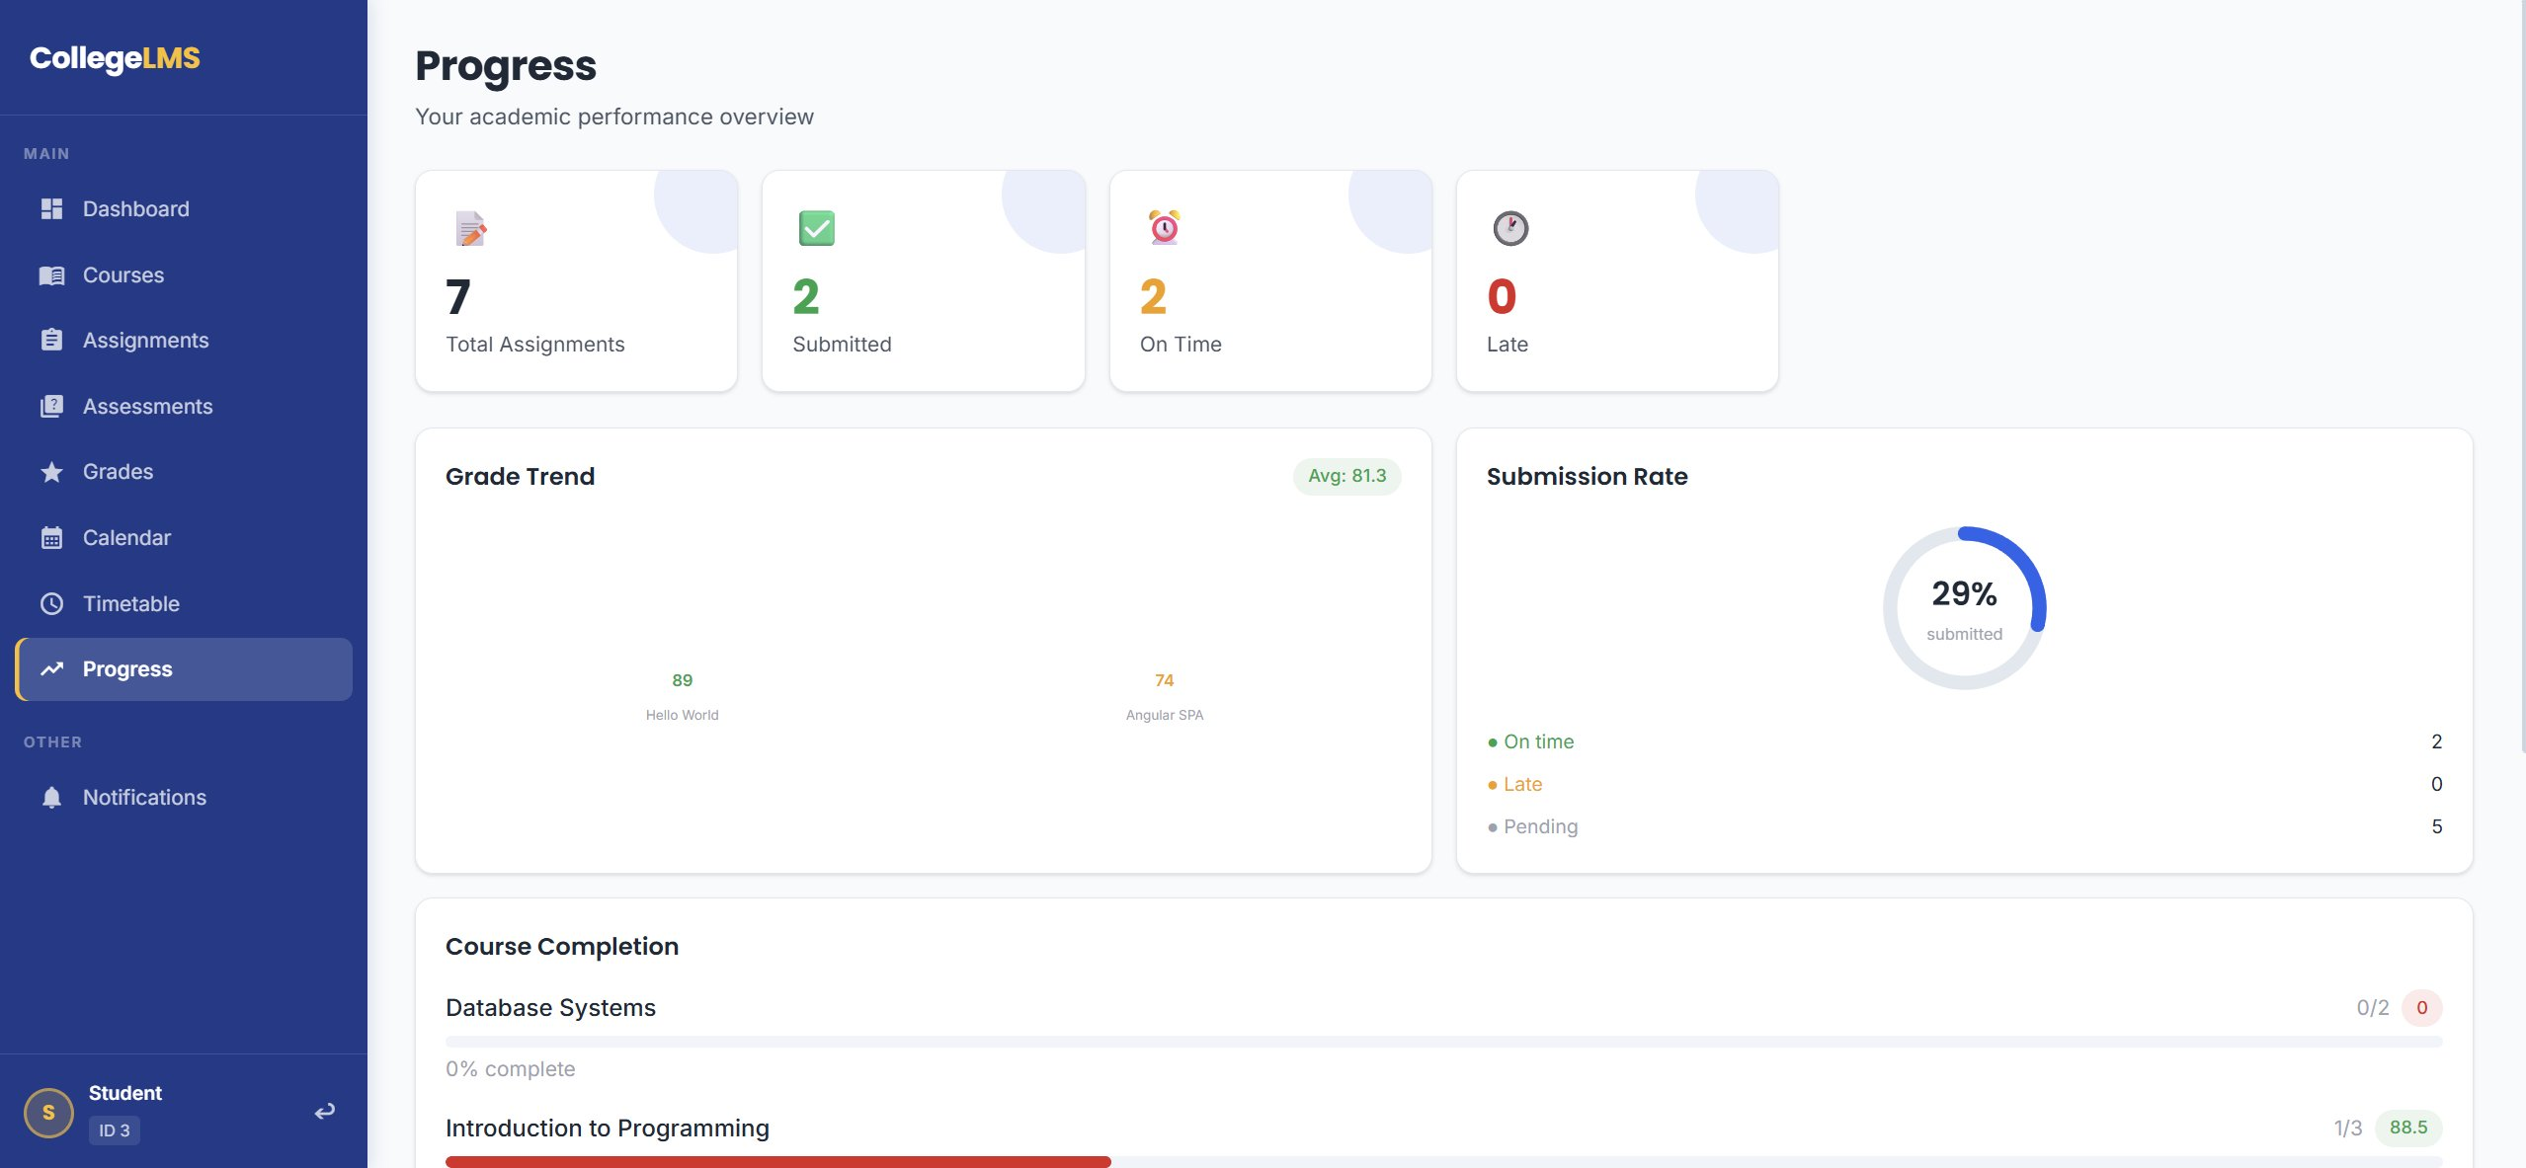
TC05 | Deadline Reminder Notifications (Innovation Feature) | Logged in as Student. Backend reminder service has generated notifications. | - Observe amber badge on Notifications in sidebar.  - Click Notifications.  - Verify unread count matches the badge. | Amber badge shows unread count. Notifications page displays deadline reminders and grade alerts with type badges and timestamps. | ✓ PASS | 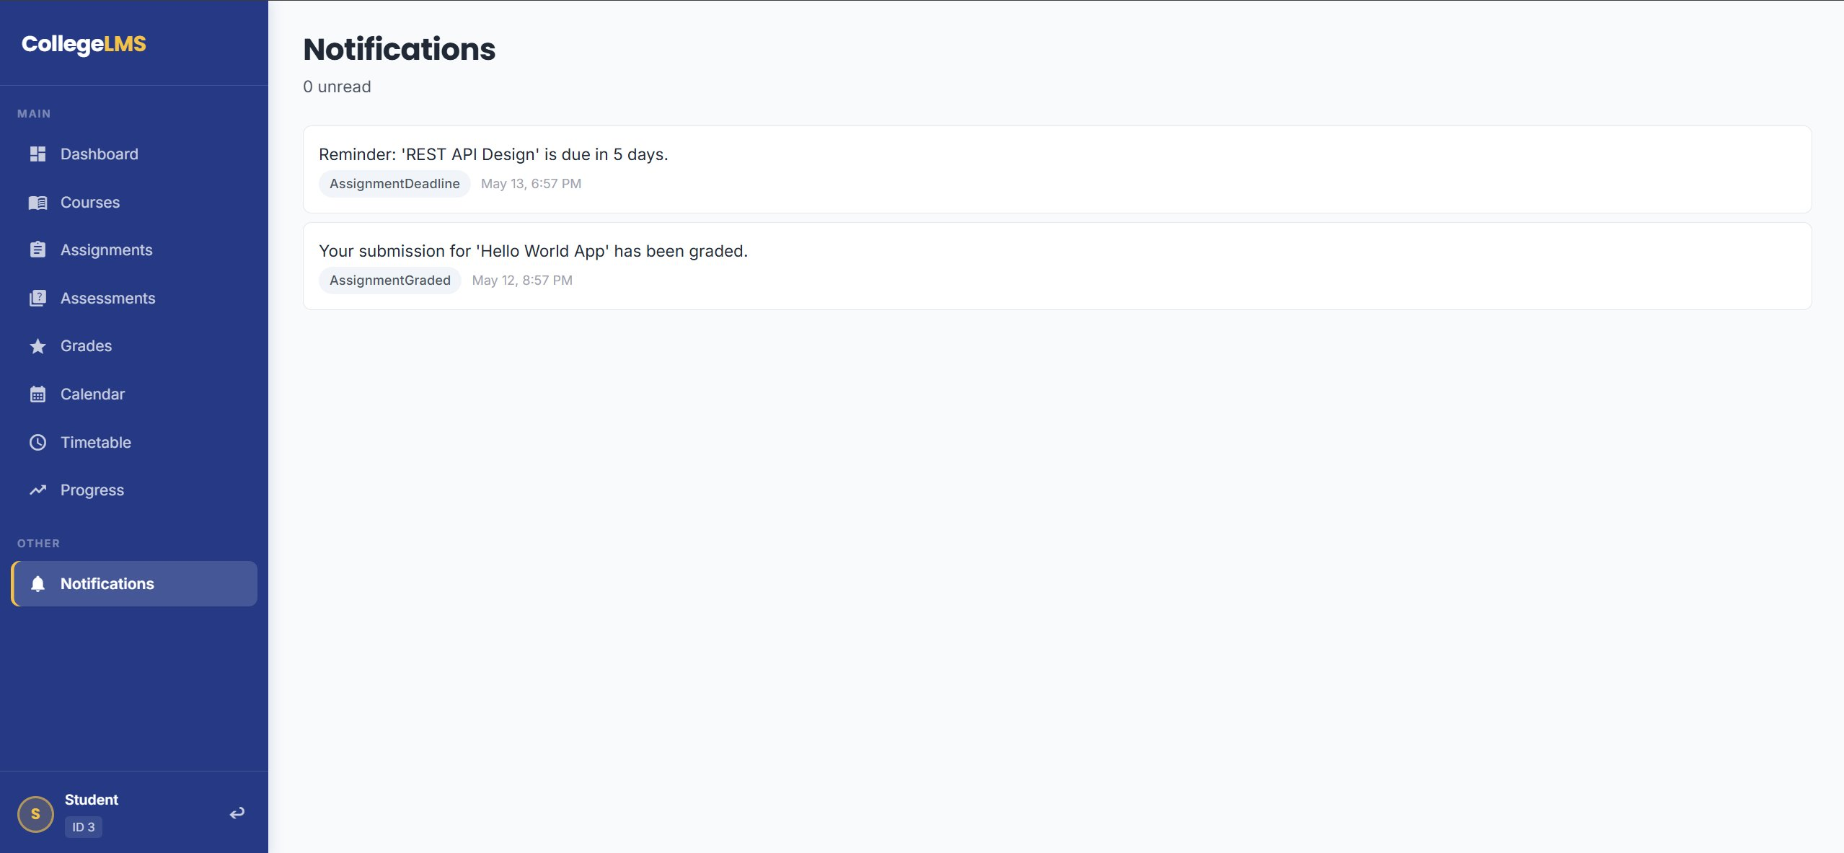
TC06 | Admin Panel Dynamic Dropdowns | Logged in as Admin (admin@lms.com). Instructor user exists in system. | - Navigate to Admin Panel.  - Click Courses tab.  - Click Create Course area.  - Click Instructor field. | Instructor field renders as a dropdown populated with real instructor names from the database. No manual ID entry required. | ✓ PASS | 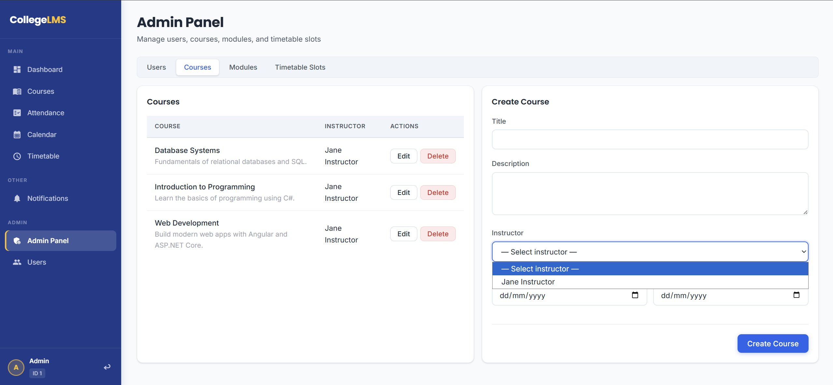

Test Summary
Total: 6 | Passed: 6 | Failed: 0 | Pass Rate: 100%
All test cases passed successfully. Innovation features (Progress Dashboard and Deadline Reminders) verified and functioning as expected.

