# [2024-06-05 11:44:13] Model prediction

Appliance: {'id': 6, 'name': 'microwave'}

Chosen datetime: 2011-04-18 12:59:48

inputs: power_usage, month, day

input_size: 3

hidden_size: [64, 32, 16]

learning_rate: 0.001

neural_network: DeepBinaryClassifier

function: Sigmoid

epochs: 1000

accuracy: 0.81

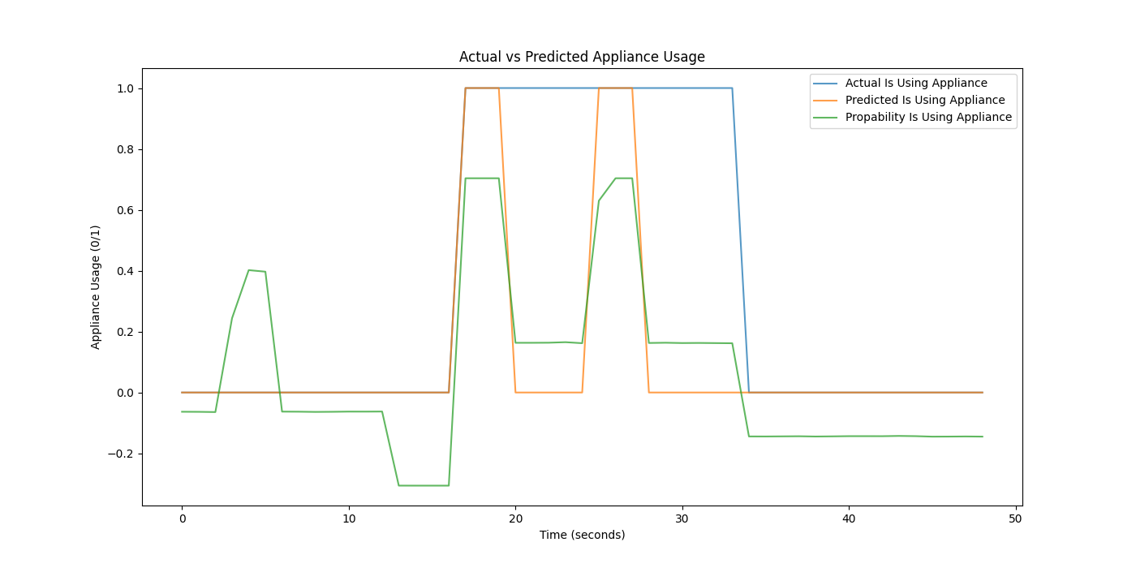

# [2024-06-05 12:43:37] Model prediction

Appliance: {'id': 6, 'name': 'microwave'}

Chosen datetime: 2011-04-18 12:59:48

inputs: power_usage, month, day

input_size: 3

hidden_size: [9, 27, 81, 27, 9]

learning_rate: 0.001

neural_network: DeepBinaryClassifier

function: Sigmoid

epochs: 1000

accuracy: 0.63

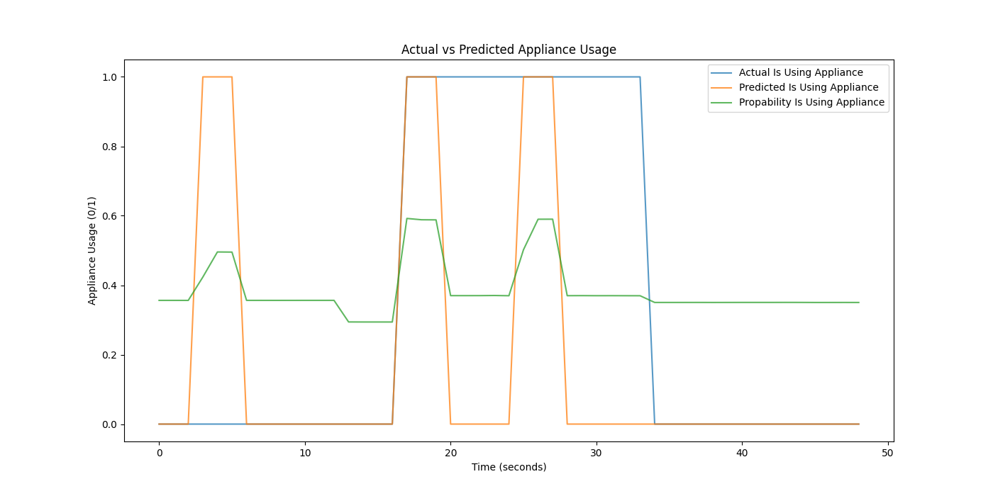

# [2024-06-05 13:48:45] Model prediction

Appliance: {'id': 6, 'name': 'microwave'}

Chosen datetime: 2011-04-18 12:59:48

inputs: power_usage, month, day

input_size: 3

hidden_size: [9, 27, 81, 27, 9]

learning_rate: 0.00025

neural_network: DeepBinaryClassifier

function: Sigmoid

test_size: 0.2

random_state: 42

epochs: 1000

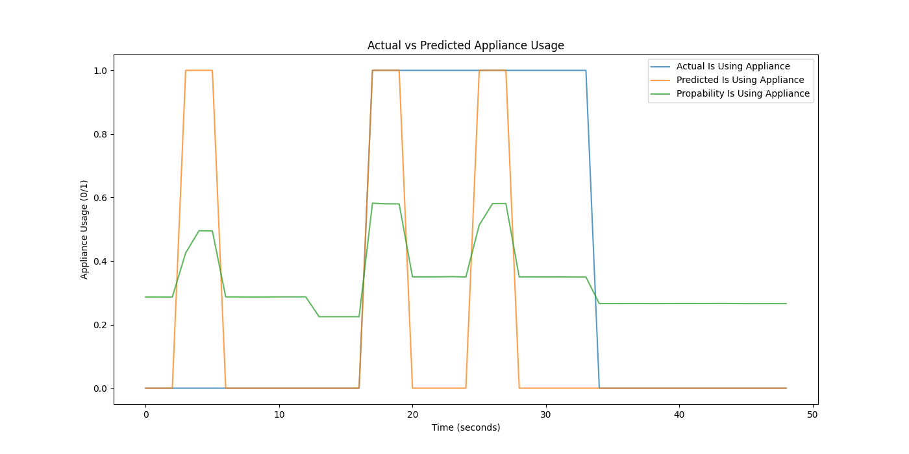

# [2024-06-05 16:18:49] Model prediction

Appliance: {'id': 6, 'name': 'microwave'}

Chosen datetime: 2011-04-18 12:59:48

inputs: power_usage, hour, day

input_size: 3

hidden_size: [81, 81, 81, 27, 9, 3]

learning_rate: 0.0005

neural_network: DeepBinaryClassifier

function: Sigmoid

test_size: 0.2

random_state: 42

accuracy: 0.6424232125282288

epochs: 1000

