**DRAWCON**

Vol No. 13 | March 2033

**CREATIVE PORTFOLIO CATALOG**

Look at our collection of illustrations!

**Illustrations by Franchesca**

**Thompson**

**Illustrations by Franchesca**

**Thompson**

Take a look at some of her artwork!



Feast your eyes on the works of this online illustrator!

## Table of Contents

01 Cover Page

03 Letter from the Editor

05 Princess At War

07 Juntain Bookshop

Advertisement

09 Cora of the Red Keep

11 Butterfly Arthome

Advertisement

02 Table of Contents

04 Illustrations by

Franchesca Thompson

06 Army of Heroines

08 Illustrations by

Martin Waid

10 The Glaive in the

Lake

12 Back Cover

## Letter from the Editor

March 03, 2033

Dear reader,

Welcome to DrawCon, a convention where visual artists gather to meet with one another alongside the big names within the entertainment industry. This catalog is made to show- case some of the illustrations available for purchase, all made by some of our guest creators for this day. We hope you find something that you like here. Enjoy browsing!

Jane West

DR AW CON

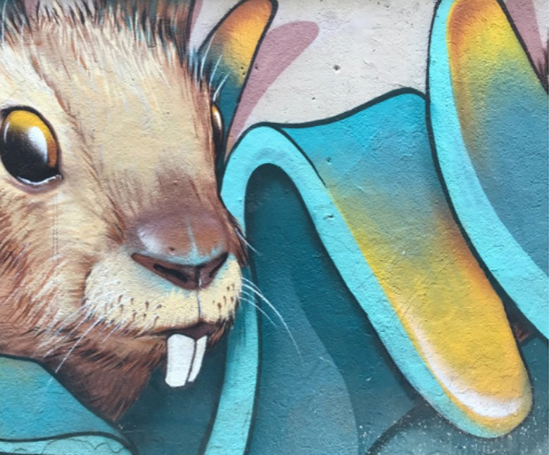

# Illustrations by Franchesca Thompson

By Arthur Wilkes

Franchesca Thompson is a comic book illus- trator and freelance artist who began her ca- reer during art school when she would create illustrations for her school leading up to her network of connections.

She is known for her distinct style that is heavily inspired by eastern animation. Most of the subjects of her art are people and characters. Check out some of her works

along with the prices listed below.

#### 4

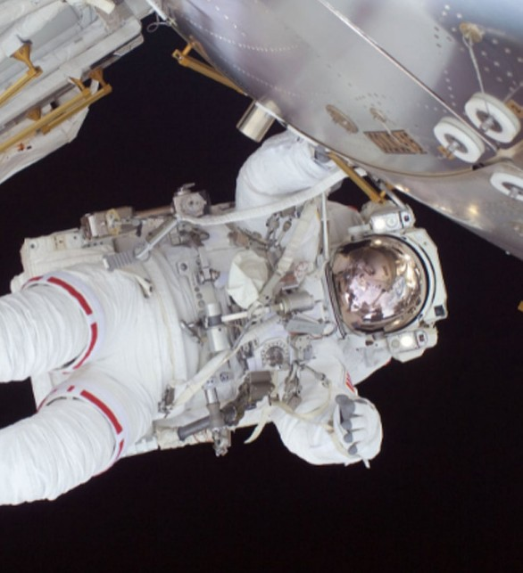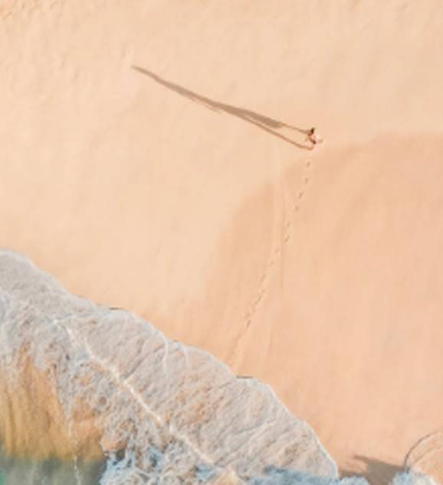

Volume No. 13 | March 2033

##### PRINCESS AT WAR

$ 30

A lady wearing a pink dress while hold- ing a sword and a shield.

##### ASTRONAUT

$ 40

An astronaut floating in outer space with a wire connecting him to his spaceship.

##### CASUAL WALK

$ 35

A lady walking through the city.

#### 5



##### ARMY OF HEROINES

$ 55

A group of female warriors all dressed from different eras standing next to each other.

##### FATHER AND DAUGHTER

$ 45

A father and a daughter bonding together in a park.

##### MYTHOLOGICAL BATTLE

$ 30

A battle between two magical armies.

Volume No. 13 | March 2033

**Juntain Bookshop**

**All the Business**



**Manuals in One Place**

We are a Library Perfect for Business People

Textbooks, business manuals, journals, and many more

Visit our store to buy one now

222 555 7777

[juntainbookshop@email.com](mailto:juntainbookshop@email.com)

@juntainbookshop

DR AW CON



**Illustrations by Martin Waid**

By Edwin Martins

**M**artin Waid is an independent illustrator who was a self-taught art-

ist. He started his career by taking on commissions online, drawing fictional characters that his clients have re- quested.

He now works alongside other online creators making illustrations for web- comics and other online works. Check out some of his work available for purchase below.

#### 8



Volume No. 13 | March 2033

##### CORA OF THE RED KEEP

$ 30

Character from the webcomic ‘Towers of

Perdition’.

##### MR. MONTY

$ 40

Character from the webcomic ‘Detec- tives Fall’.

##### JONATHAN QUACK

$ 29

Character from the webcomic ‘Stuck at Home’.

#### 9

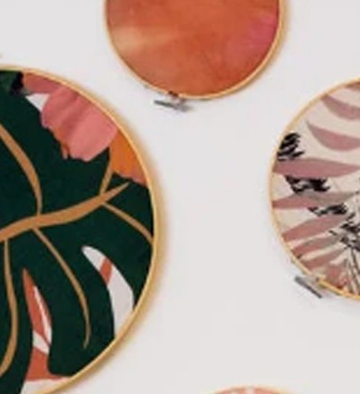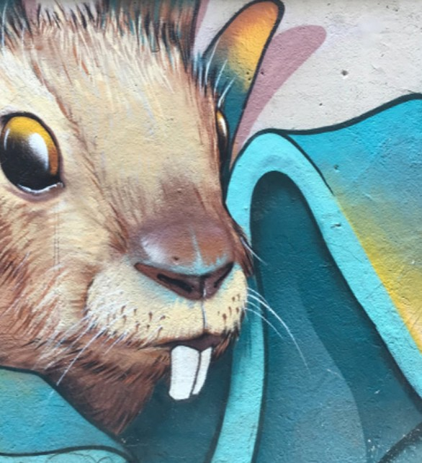

##### THE GLAIVE IN THE LAKE

$ 125

Illustration from a scene from the online visual novel ‘Fateless’.

##### GRANDMASTER ROY

$ 35

Illustration of a character from the on- line visual novel ‘Fateless’.

##### CAR CHASE

$ 32

Illustration from a scene in the webcom- ic ‘Detectives Fall’.

Volume No. 13 | March 2033



**Butterfly Arthome**

### Supplier Of Art Materials

Visit us for everything you need re- garding arts and crafts.

Shopping for art materials has never been this convenient.

Drive to your nearest Butterfly Arth- ome branch today.

222 555 7777

[butterflyarthome@email.com](mailto:butterflyarthome@email.com)

@butterfly_arthome

#### 11



**DRAWCON**

Vol No. 13 | March 2033

DrawCon Publications PUBLISHED March 03, 2033

173 Bluff St., Cumberland MD 21502

Contact Us 222 555 7777

[drawcon@zmail.com](mailto:drawcon@zmail.com) [www.drawcon.com](http://www.drawcon.com/)

Follow Us Facebook: DrawCon

Instagram: @drawcon