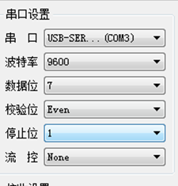**数据格式**

**一．数据读**

**数据发送：**

|  |  |  |  |  |  |  |  |  |  |  |  |  |
| --- | --- | --- | --- | --- | --- | --- | --- | --- | --- | --- | --- | --- |
|  | **1** | **2** | **3** | | | | **数据长度** | | **1** | **校验和** | | **数值** |
| **１个存8位** | |
| ASCII  D0 | STL | 0 | 1 | 0 | 0 | 0 | 0 | 2 | ETX | 5 | 6 | 200K |
| 02H | 30H | 31H | 30H | 30H | 30H | 30H | 32H | 03H | 35H | 36H |
|  | | | | | | | | | | | | |
| ASCII  D5 | STL | 0 | 1 | 0 | 1 | 0 | 0 | 2 | ETX | 5 | 7 |  |
| 02H | 30H | 31H | 30H | 31H | 30H | 30H | 32H | 03H | 35 | 37 |
|  | | | | | | | | | | | | |

**数据反馈：**

|  |  |  |  |  |  |  |  |  |
| --- | --- | --- | --- | --- | --- | --- | --- | --- |
|  | **1** | **数据内容** | | | | **1** | **校验和** | |
| **低8位** | | **高8位** | |
| ASCII  D0 | STL | C | 8 | 0 | 0 | ETX | D | E |
| 02H | 43H | 38H | 30H | 30H | 03H | 44H | 45H |

**二．数据写**

**数据发送：**

|  |  |  |  |  |  |  |  |  |  |  |  |  |  |  |  |  |
| --- | --- | --- | --- | --- | --- | --- | --- | --- | --- | --- | --- | --- | --- | --- | --- | --- |
|  | **1** | **2** | **3** | | | | **数据长度** | | **数据内容** | | | | **1** | **校验和** | | **写入值** |
| **1个存8位** | | **底8** | | **高8** | |
| ASCII  D1 | STL | 1 | 1 | 0 | 0 | 2 | 0 | 2 | C | 8 | 0 | 0 | ETX | 03 | 04 | 200K |
| 02H | 31H | 31H | 30H | 30H | 32H | 30H | 32H | 43H | 38H | 30H | 30H | 03H | 33H | 34H |

**发送成功会反馈ACK （06H） 说明数据写入成功。**

**１，数据请求**

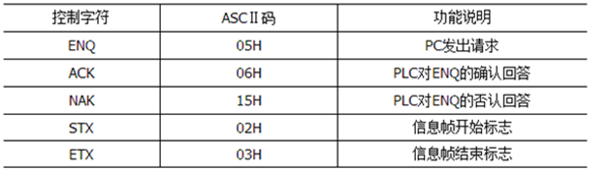

**２.命令**

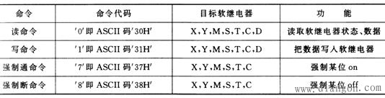

３.数据地址：

D: m_address1*2+1000H; 1000=D0;

1002=D1;

1004=D2;

T: m_address+00C0H; 8位 00C0=T7-T0; 16位 00C0=T15-T0;

00C1=T15-T8; 00C2=T31-T16;

00C2=T23-T16; 00C4=T47-T32;

C: m_address+01C0H;　 8位 01C0=C7-C0; 16位 01C0=C15-C0;

01C1=C15-C8; 01C2=C31-C16;

01C2=C23-C16; 01C4=C47-C32;

S: m_address+0000H; 8位 0000=S7-S0; 16位 0000=S15-S0;

0001=S15-S8; 0002=S31-S16;

0002=S23-S16; 0004=S47-S32;

M: m_address+0100H;　 　 8位 0100=M7-M0; 16位 0100=M15-M0;

0101=M15-M8; 0102=M31-M16;

0102=M23-M16; 0104=M47-M32;

Y: m_address+00A0H; 8位 00A0=Y7-Y0； 16位 00A0=Y15-Y0;

00A1= Y17-Y10； 00A2=Y31-Y16;

00A2 = Y27-Y20； 00A4=Y47-Y32;

X: m_address+0080H;(只能读不能写，输入寄存器必须由外部信号驱动)

m_address元件是指最低位开始后的第N个元件的位置。