**Decision Structures**

In this homework, you should implement a user interface which contains four option like is displayed below:

1. Find the number with maximum number of digits.
2. Find the number with maximum number of divisors.
3. Find and display all numbers in given range which are divided by three.
4. Finish working with the program.

**Instructions:**

1. For the first task, ask the user to enter how many numbers are needed for the calculation. Every number you should get using randomly in the range from 1 to 1,000,000. Every given number and result must be displayed in the Python Shell window. If there are several equal numbers, output the first of them. For calculation, you can't use string methods.
2. For the second task, ask the user to enter how many numbers are needed for the calculation. Every number you should get using randomly in the range from 100 to 200. Every given number and result must be displayed in the Python Shell window. 1 and the number itself are not considered.
3. For the third task, ask the user to enter the first and last number of a range. If there are several equal numbers, output the first of them.
4. The user interface must ask the user to repeat enter the next number of the menu while zero won't be entered.

**Examples for testing and output:**

**Menu**

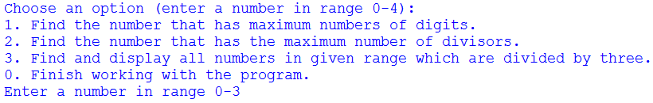

**Task 1:**

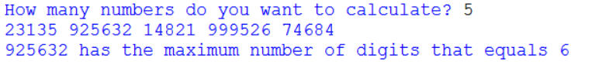

**Task 2:**

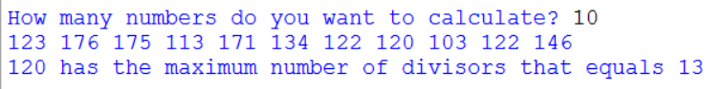

**Task 3:**

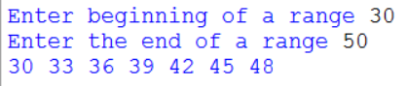

**Input validation for Task 3**

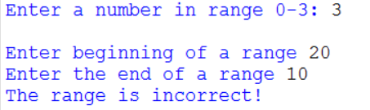

**Input validation for menu**



**End of the program**

