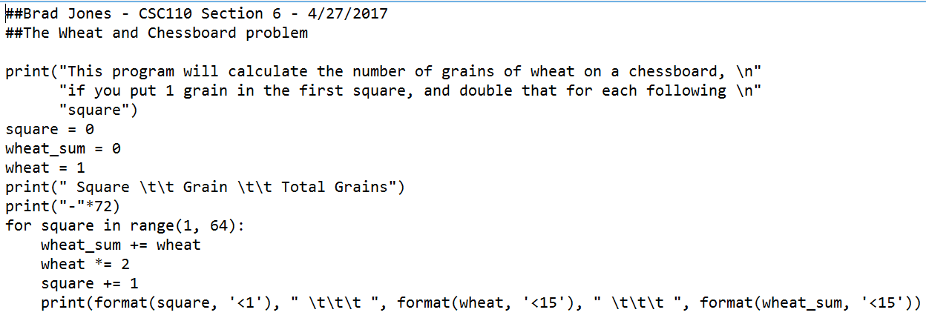

Square counts the squares, wheat starts at 1 and is increased by the power of 2 every loop. Wheat_sum tallies up the wheat in each square.

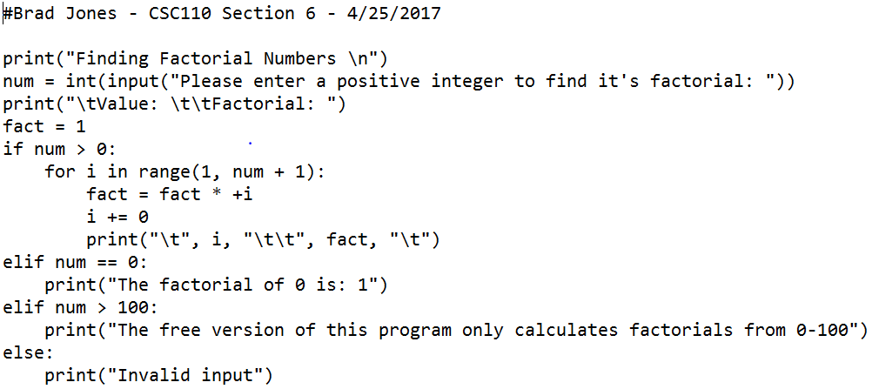

I counts the loops, fact contains the factorial of I. prints vertical table

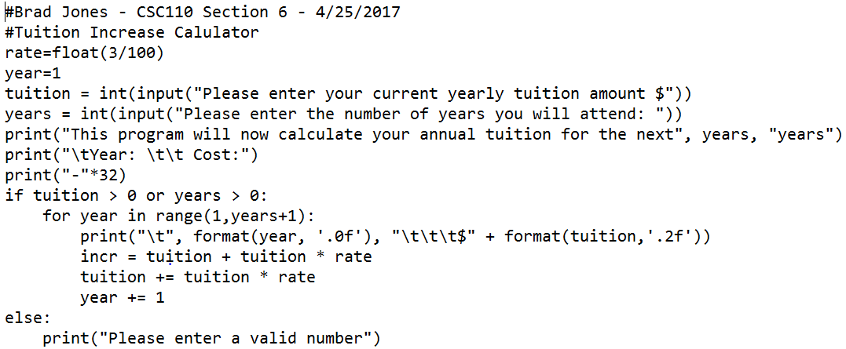

Incr calculates the rate change per year, then adds it to the original tuition. The loop then compounds the rate on the new overall total

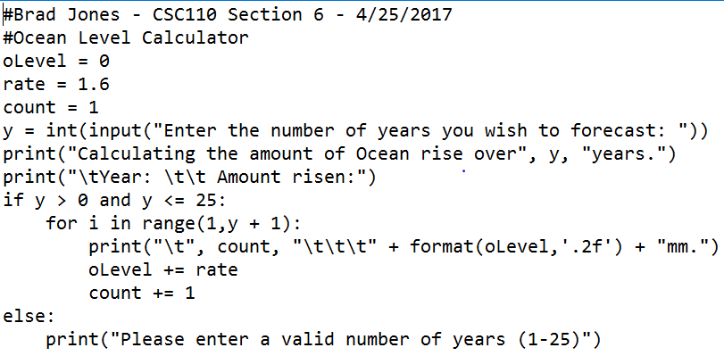

Same as the last basically