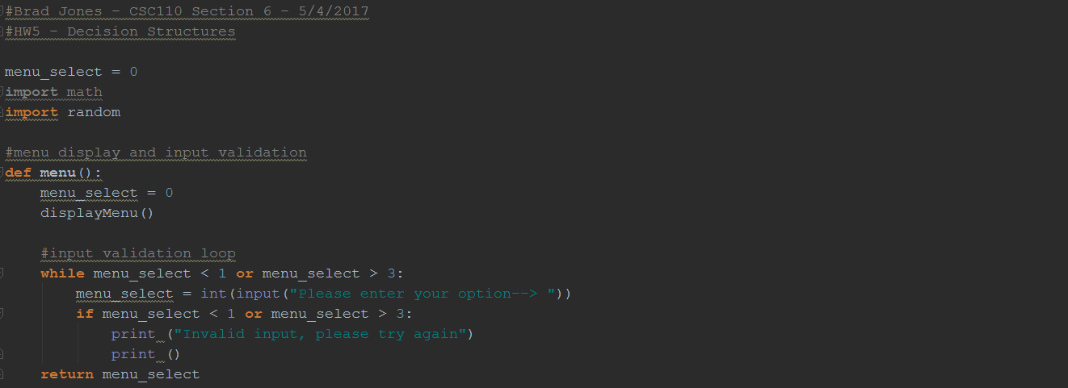

Menu_select set to 0, Menu() calls displayMenu()

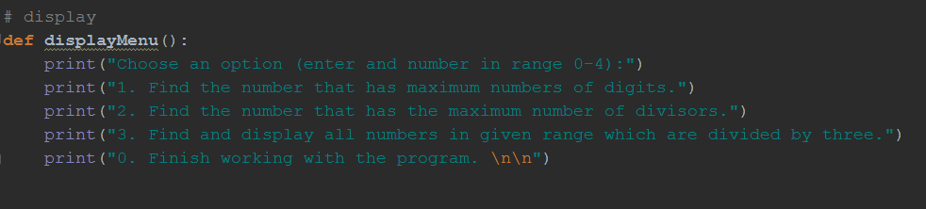

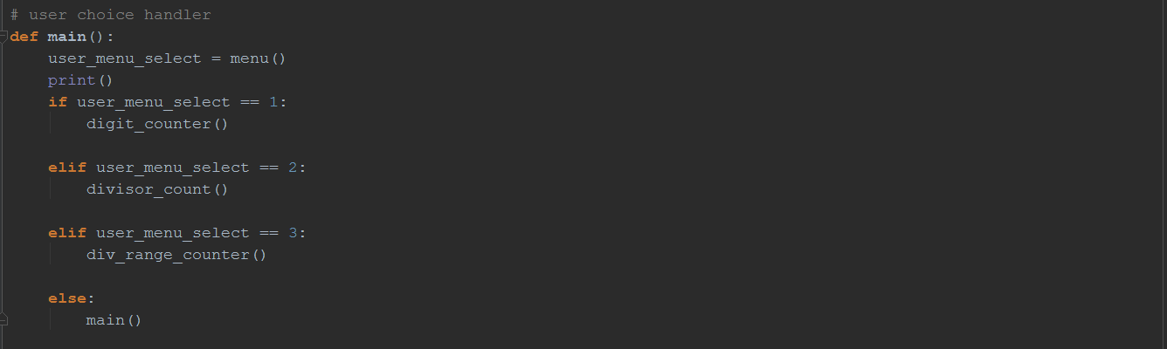

Ties Menu_selection to the functions they preform

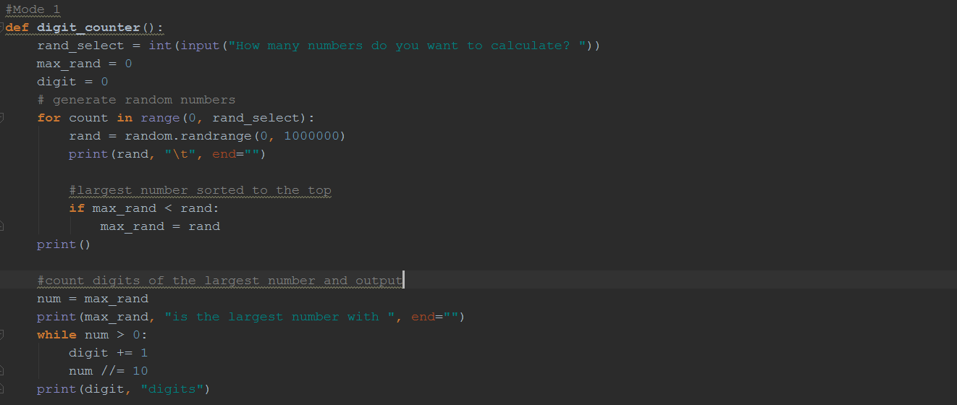

Loops through the random numbers and counts the digits. If the new number has a higher digit count, max_rand is updated

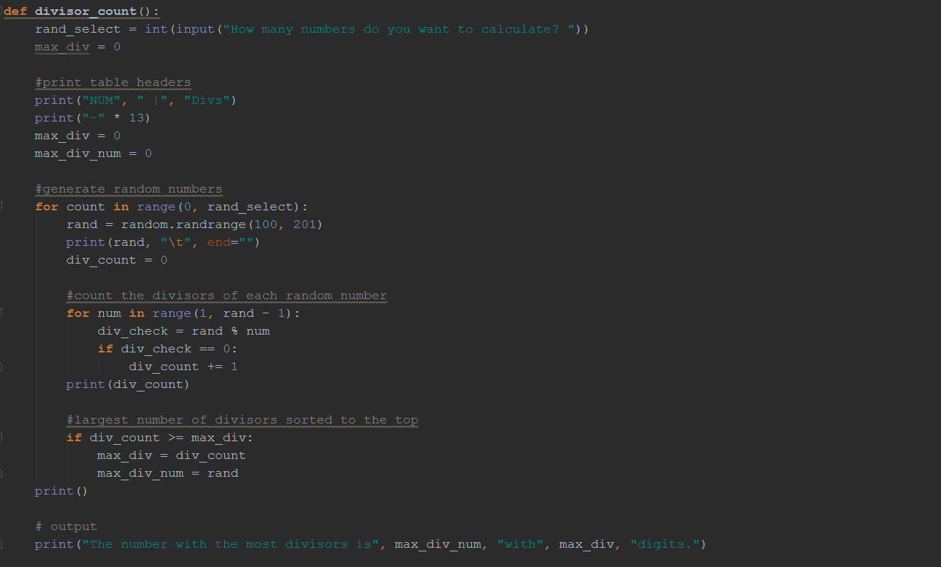

Generates the random numbers. For each number, loop divides it by every number from 0 to itself. If number % loopcounter == 0, its is a divisor. Div count accumulates number of divisors. If div_count is higher than the div_count previous, max_div updated with new value

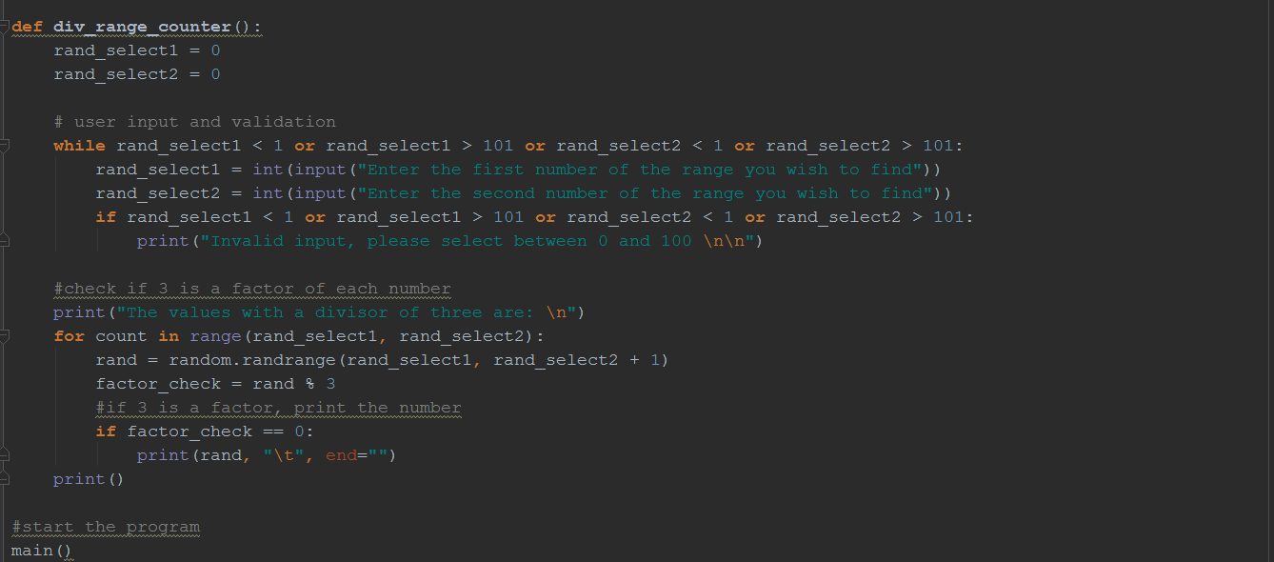

Input validation for user range of numbers. Loops through the range checking for divisors. If number % 3 == 0 then number has a factor of 3

Then start program