Brad Jones – CSC110 Weather Report

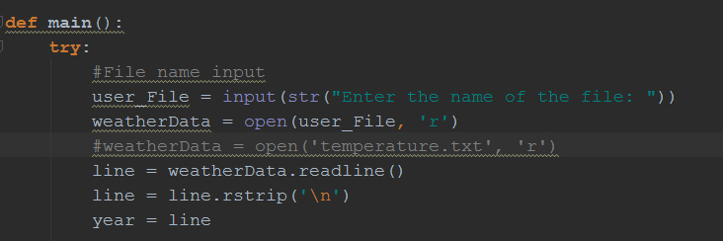

Collecting the file name from the user, reading the first line, removing the break, and saving the year

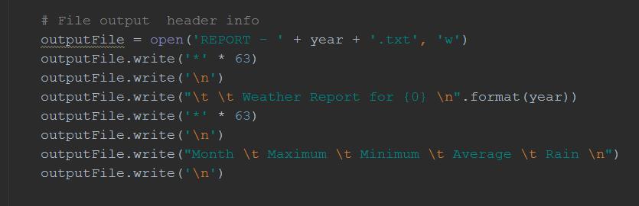

Creating the header info for the output file. Needed to put near the start so info can print during the loops

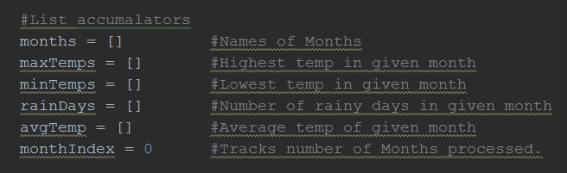

Using lists to hold info from the file. Month index tracks the loop counts. If months[0] is January, then maxTemp[0] should also match to January.

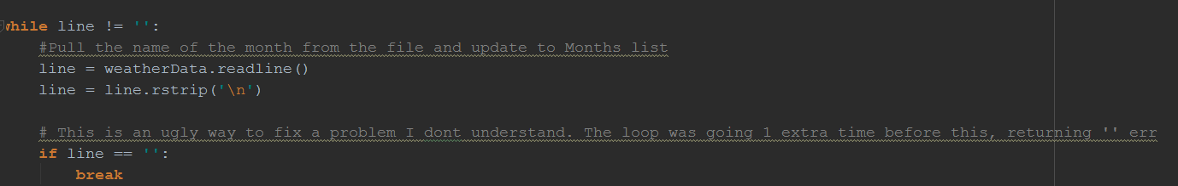

I was having a strange error here where the loop would go 1 past the desired amount, resulting in empty info being passed to the months[], and then causing an error. The fix I have here seems to work, but I’m sure its not optimal

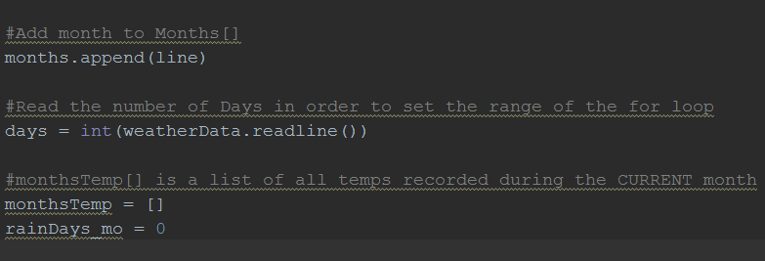

Adding to the months list. Setting days as the second line within the WHILE loops. Days used later to set range for the for loop, and to calculate the average

Initializing monthsTemp[] to be used within the upcoming For loop

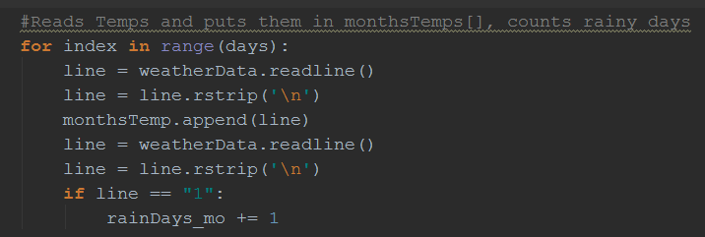

This for loop works through an entire month at a time. Reads the temp and puts all temps for the month in a new list. Then counts rainy days and accumulates them

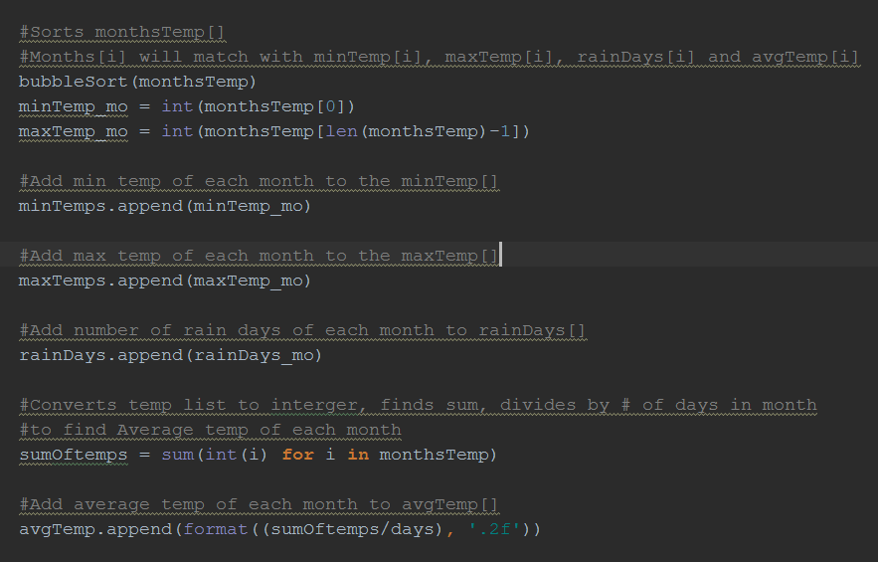

Using a bubble sort on all the temps for the month, then assigning the 0 index (the lowest) to the min temp list, the last index (the largest) to the maxTemp list. Etc etc

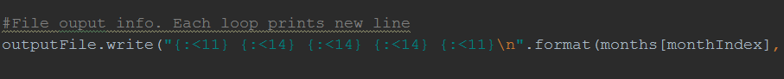



When for loops are finished, writes 1 month line in output file by writing one element of each list at the current index.

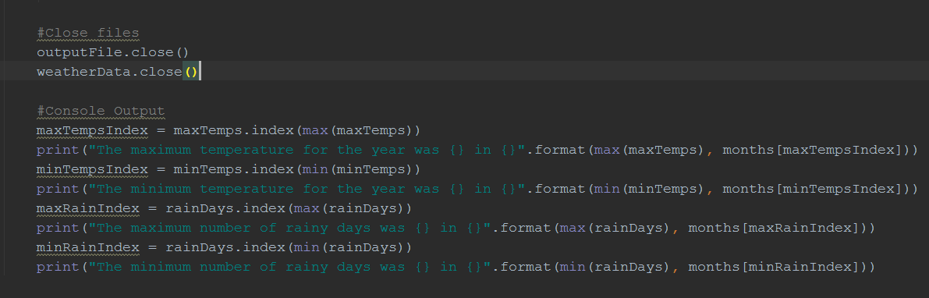

I know this is not exactly how you wanted us to track the months in which the mins and max’s take place, but at least it looks clean. I did a lot of reading on Format after last weeks HW.

Here is an alternate way to find the index of certain items ins a lsit:

“For index, item in enumerate(items):

Print(index,item)

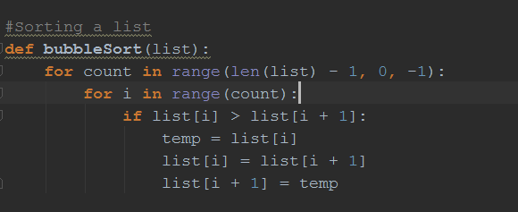

Just bubble sorting. The internet suggested that crawling backwards through the range is somehow better than simply “for count in range(len(list)), but I don’t know why, or even if that is true.