Brad Jones

CSC 111

5/5/2017

# Networking Worksheet

1. ISP: Xfinity
2. URL: <https://www.xfinity.com/>
3. Internal IP: 10.0.0.19
4. External IP: 24.17.16.222
5. Current Data Rate: 46 Mbps down / 6.78 Mbps up
6. 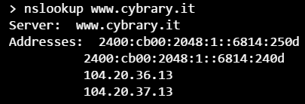

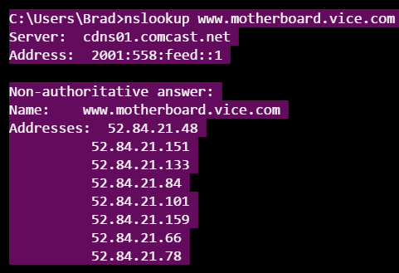

1. 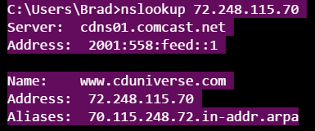

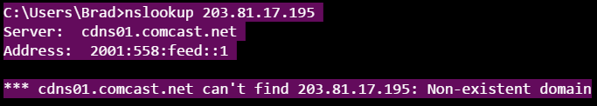

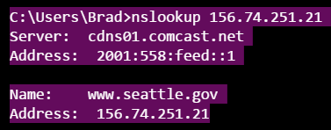

[www.cduniverse.com](http://www.cduniverse.com)

dingus.northseatte.edu (Apache 2 test page)

1. 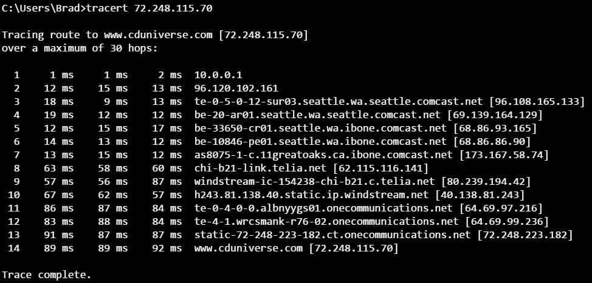

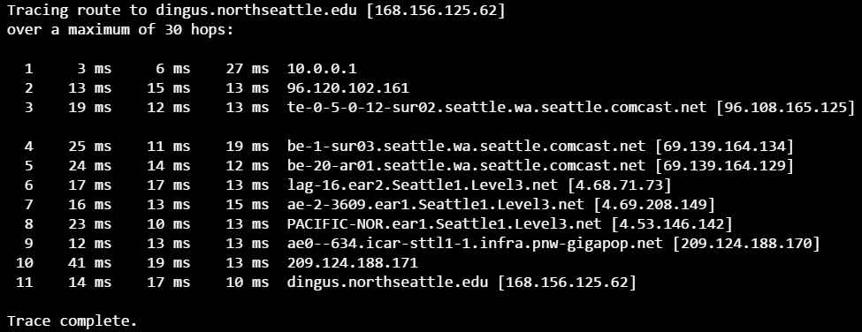

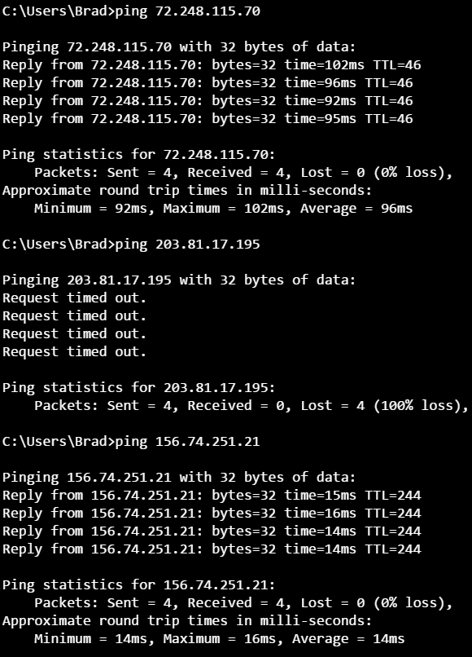

1. Security: AVG, Malware-Bytes, Windows Defender, Windows Firewall. My firewall is configured with an access control list, which only recognizes my personal hardware based on its MAC address. Also I have a media and virtual machine server which is pubic facing, on a separate (internal) network, within a DMZ, which I access from a vpn service (or ssh)
2. 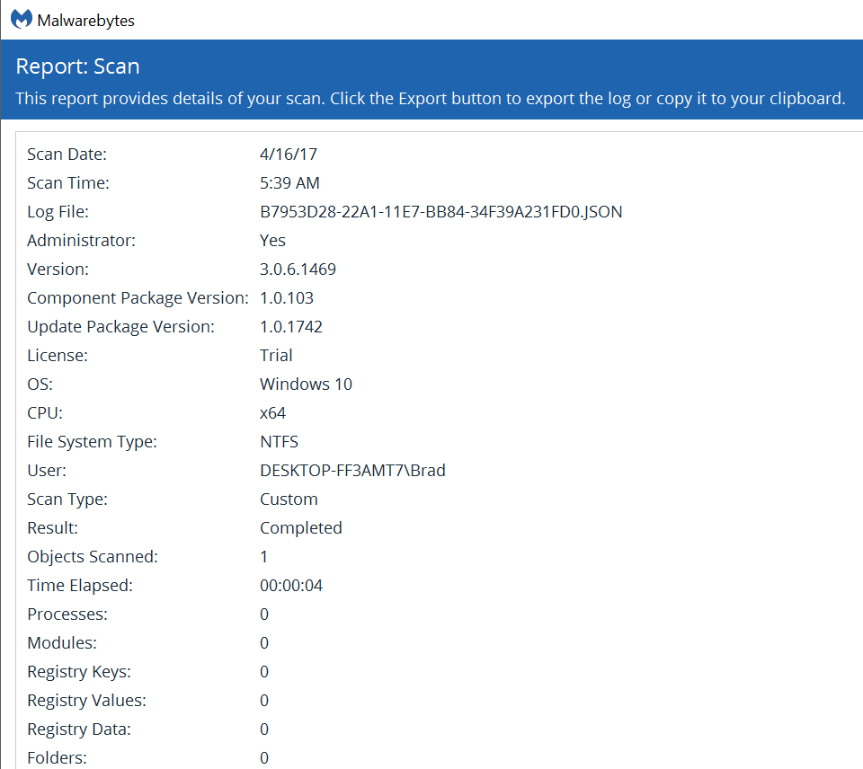

Optional: I’m not at school but I’m assuming NSCC has at least a T3 or T1 connection. I’m sure its faster overall, but I’ve never gotten great speed from any client machine.