Lección 1
Ejercicio 1
SELECT title FROM movies;
SELECT director FROM movies;
SELECT director,title FROM movies;
SELECT year,title FROM movies;
SELECT * FROM movies;
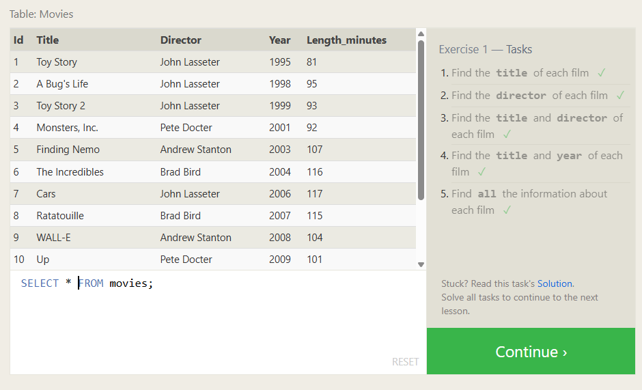

Lección 2
Ejercicio 1
SELECT * FROM movies where id=6;
SELECT * FROM movies where year between 2000 and 2010;
SELECT * FROM movies where year not between 2000 and 2010;
SELECT * FROM movies where year limit 5;
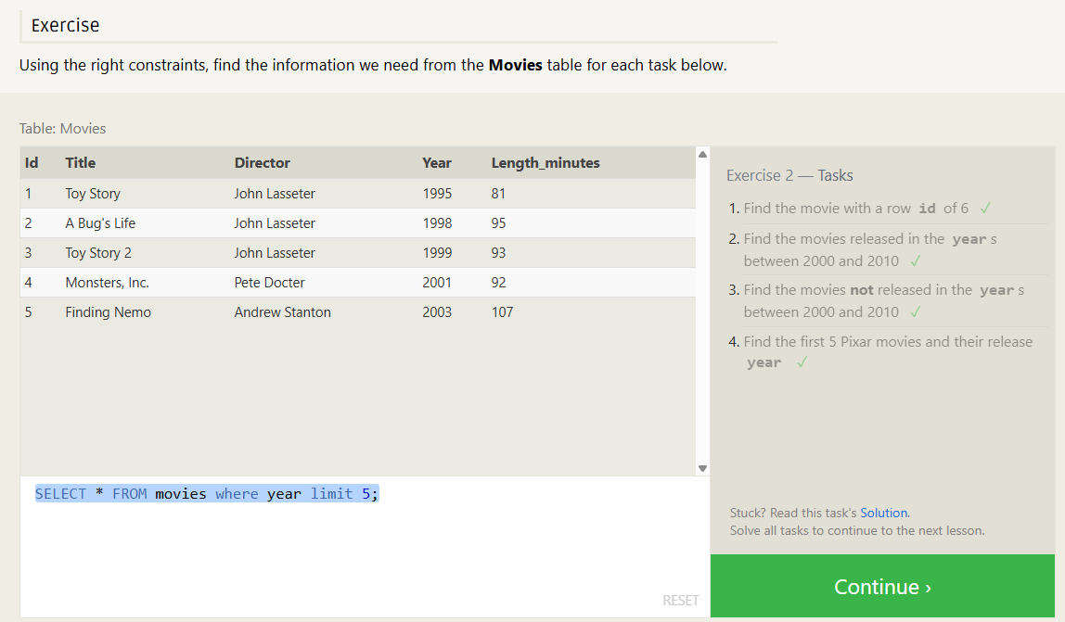

Lección 3
Ejercicio 1
SELECT * FROM movies where TITLE like "Toy Story%";
SELECT * FROM movies where Director like "John Lasseter";
SELECT * FROM movies where Director <> "John Lasseter";
SELECT * FROM movies where title like "WALL-%";
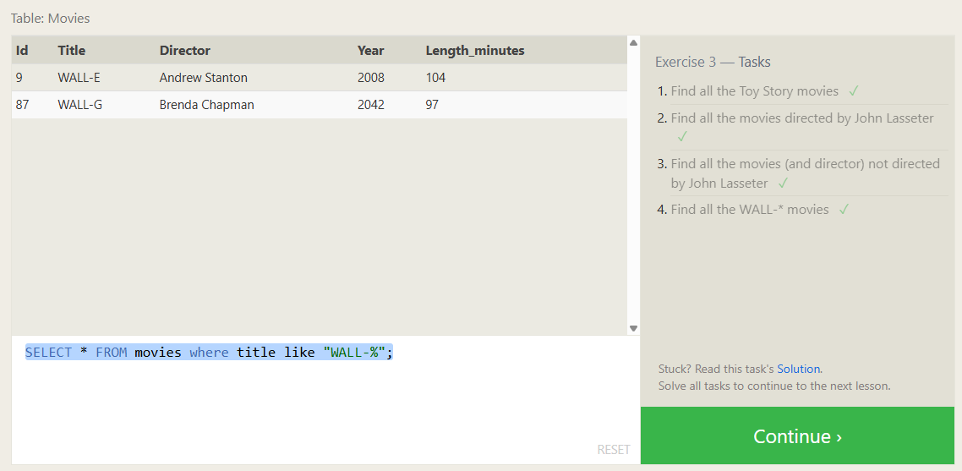

Leccion 4
Ejercicio 1
SELECT * FROM movies group by Director;
SELECT title, year FROM movies ORDER BY year DESC LIMIT 4;
SELECT title FROM movies ORDER BY title ASC LIMIT 5;
SELECT title FROM movies ORDER BY title ASC LIMIT 5 offset 5;
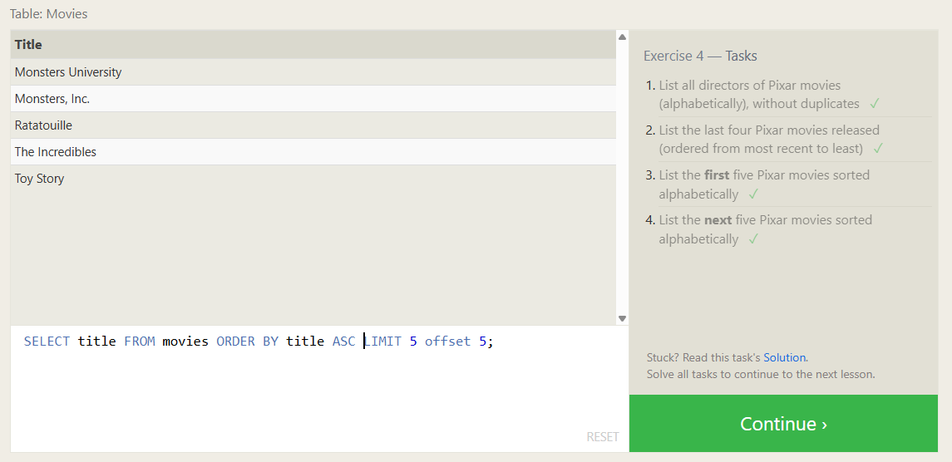

Lección 5
Ejercicio 1
SELECT city, population FROM north_american_cities WHERE country = "Canada";
SELECT city, latitude FROM north_american_cities WHERE country = "United States" ORDER BY latitude DESC;
SELECT city, longitude FROM north_american_cities WHERE longitude < -87.629798 ORDER BY longitude ASC;
SELECT city, population FROM north_american_cities WHERE country LIKE "Mexico" ORDER BY population DESC LIMIT 2;
SELECT city, population FROM north_american_cities WHERE country LIKE "United States" ORDER BY population DESC LIMIT 2 OFFSET 2;
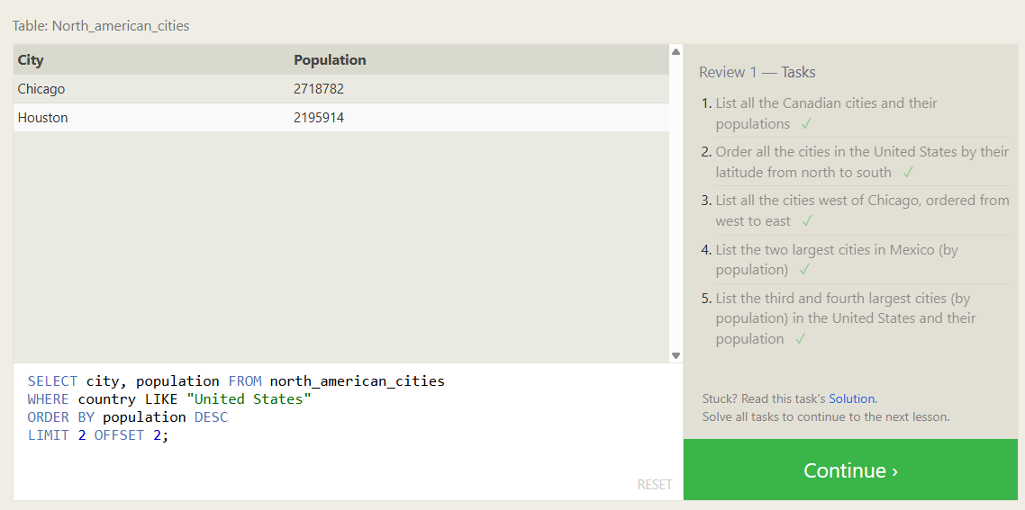

Lección 6
Ejercicio 1
SELECT title, domestic_sales, international_sales FROM movies JOIN boxoffice ON movies.id = boxoffice.movie_id;
SELECT title, domestic_sales, international_sales FROM movies JOIN boxoffice
ON movies.id = boxoffice.movie_id WHERE international_sales > domestic_sales;
SELECT title, rating FROM movies JOIN boxoffice ON movies.id = boxoffice.movie_id ORDER BY rating DESC;
